Triple SELEX Approach for the Selection of a Highly Specific RNA Aptamer binding Homoeriodictyol

Janis Hoetzel¹, Cristina Bofill-Bosch¹, Andres W. Martinez², Martin M. Rudolph¹, Florian Groher¹, Beatrix Suess^{1,3}*

¹ Fachbereich Biologie, TU Darmstadt, Schnittspahnstrasse 10, 64287 Darmstadt, Germany
² Department of Chemistry and Biochemistry, California Polytechnic State University, San Luis Obispo, CA 98407, USA
³ Centre for Synthetic Biology, TU Darmstadt, 64287 Darmstadt, Germany

Supplementary material

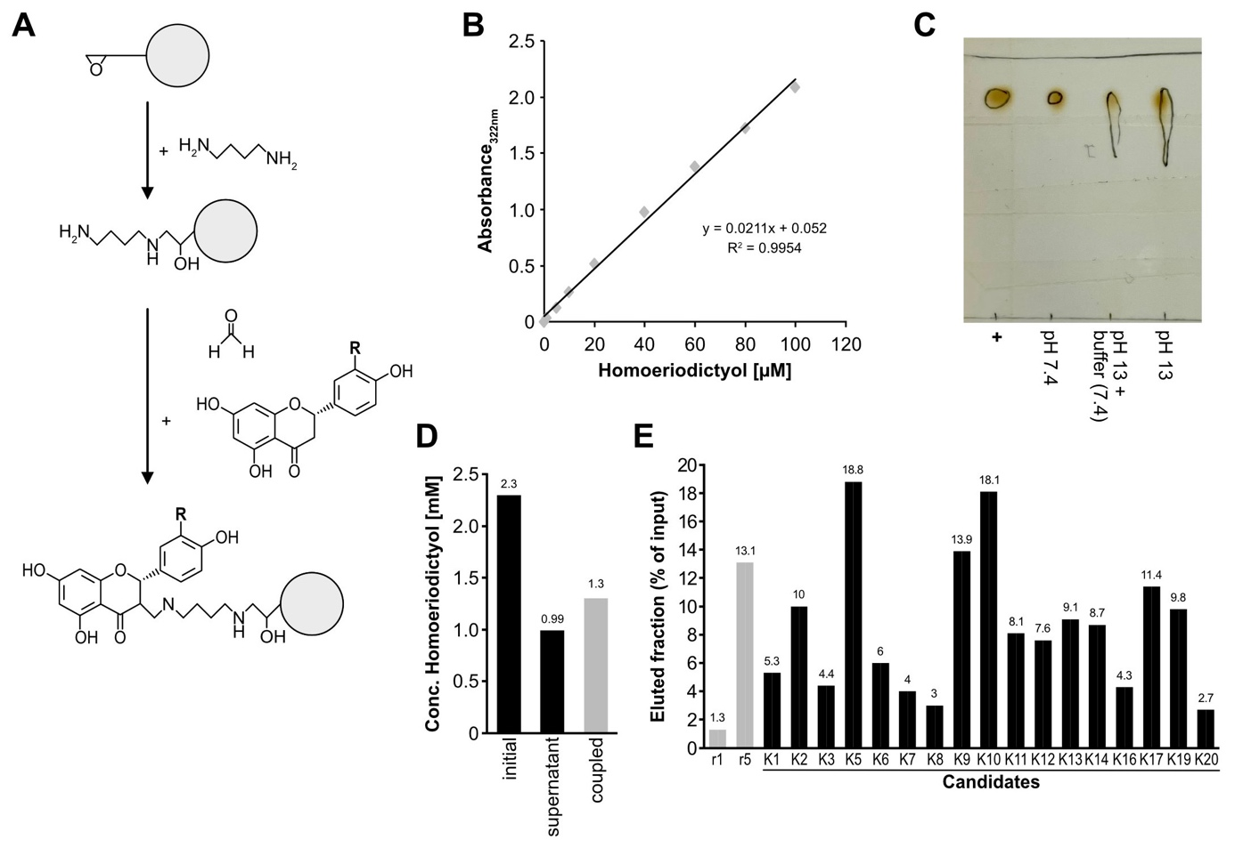
Supplementary Figure S1
A) Coupling strategy for homoeriodictyol. In a first step, a 1,4-butandiol linker was added to the epoxy-activated sepharose. In a second step, the homoeriodictyol was coupled by a Mannich reaction to the 1,4-butandiol linker, to finally immobilize the homoeriodictyol on the sepharose. B) Standard curve of homoeriodictyol concentration and absorbance at 322 nm wavelength. C) Thin layer chromatography of homoeriodictyol incubated at different pH values. Shown are samples of homoeriodictyol dissolved in methanol (+), dissolved in buffer at pH 7.4, first dissolved in pH 13 with subsequent addition of buffer at pH 7.4 and dissolved at pH 13. The smear in both setups with initial dissolving at pH 13 indicate degradation of homoeriodictyol. D) Concentration measurements of the homoeriodictyol solution before and after coupling reaction to sepharose. Values are given in mM and the value of cupled fraction is calculated from the difference between the initial concentration and in the supernatant after the coupling. E) Binding assay results of the 17 measured candidates from the first column-based selection. Transcription from the initial round 1 (r1) and the round showing increased binding (r5) are shown as controls.

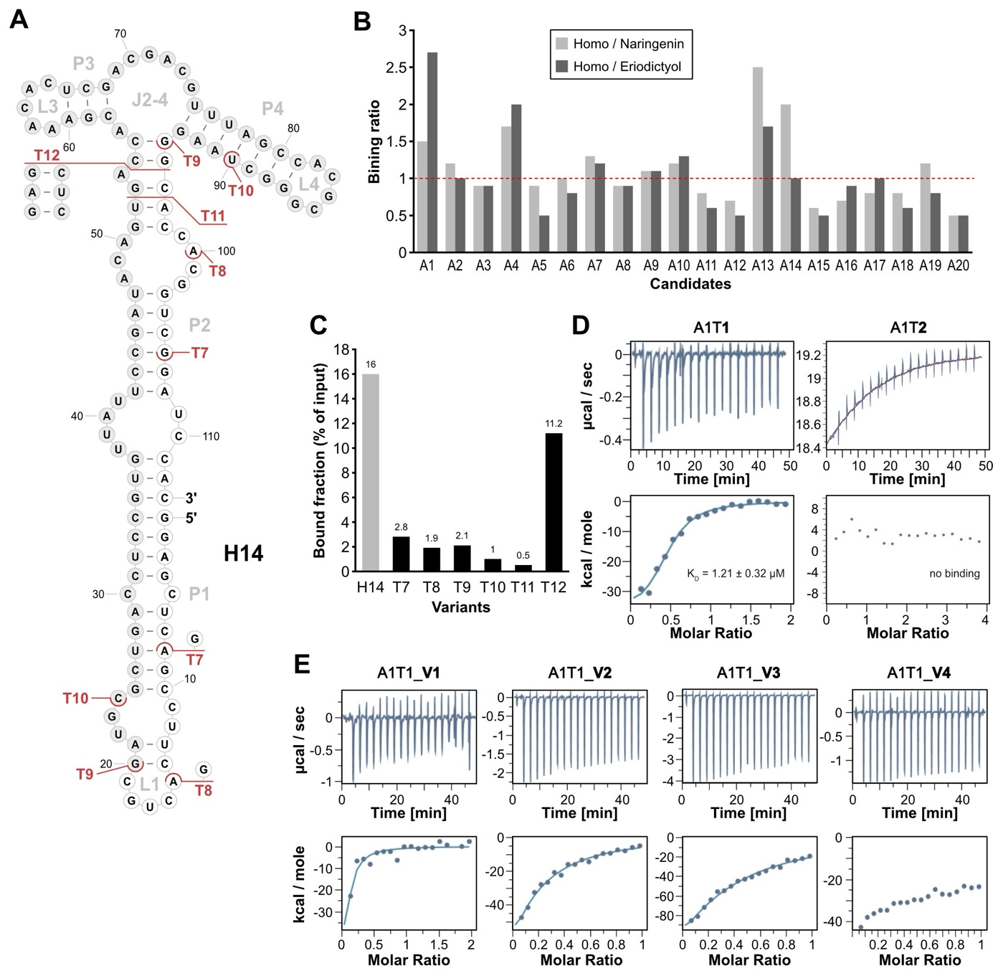
Supplementary Figure S2
A) Depiction of the secondary structure of H14 as predicted by RNAfold.(Lorenz et al., 2011) White background of nucleotides indicates sections of the constant regions while grey background indicates parts of the randomized region. The modifications of the aptamer are indicated in red, showing the truncations T7 to T12. B) Binding specificity assay of 20 candidates from the last round of Capture-SELEX. Shown are the ratios of bound fraction to homoeriodictyol vs. naringenin (light grey) and homoeriodictyol vs. eriodictyol (dark grey). Highlighted by a red line is the value 1 indicating no discrimination, values >1 indicate binding preference to homoeriodictyol over the respective derivative. C) Binding assay to homoeriodictyol of truncations of H14 (T7-T12) in comparison with the full-length apamter H14. D) Representative Isothermal Titration Calorimetry (ITC) results of truncation T1 and T2 of aptamer A1 with homoeriodictyol. Shown are the thermograms and titration curves of the three measurements. For T1 the mean K_{D} with standard deviation over three measurements is given. E) Isothermal Titration Calorimetry (ITC) results of A1T1 mutants V1-V4 with homoeriodictyol. Shown are the thermograms and titration curves of the three measurements.

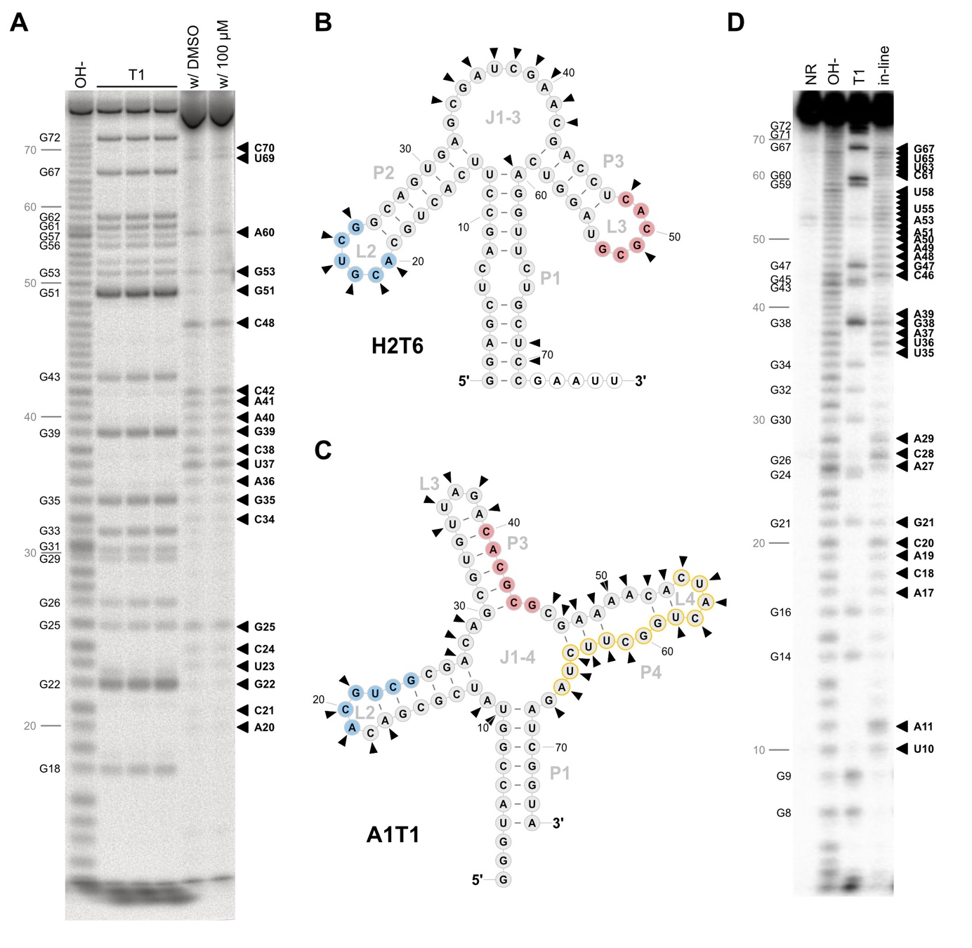
Supplementary Figure S3
A) Denaturating Polyacrylamid gel of the in-line probing of H2T6. Shown are the alkaline-digest (OH⁻), three reactions of RNase T1 digest, in-line reaction without homoeriodictyol and in-line reaction with 100 µM homoeriodictoyl. Nucleotide positions are indicated on the left in grey and the G positions in black. Positions showing reactivity are indicated by a black arrowhead on the right with naming of the respective nucleotide position. B) Two-dimensional depiction of H2T6 with the reactive positions indicated by black arrowheads. The identified motifs are indicated in blue (motif 1) and red (motif 2). The nucleotide positions with white background indicate an added linker sequence for the in-line probing. C) Two-dimensional depiction of A1T1 with the reactive positions indicated by black arrowheads. The identified motifs are indicated in blue (motif 1) and red (motif 2), and the docking sequence is highlighted by yellow circles. D) Denaturating Polyacrylamid gel of the in-line probing of A1T1. Shown are a non-reacted sample, the alkaline-digest (OH⁻), a RNase T1 digest and the in-line reacted sample. Nucleotide positions are indicated on the left in grey and the G positions in black. Positions showing reactivity are indicated by a black arrowhead on the right with naming of the respective nucleotide position.

Supplementary Table S1
Parameters & results of the column-based SELEX using the N64 library
Round | Pre-selection | Buffer washes [CV] | Counter-selection | Eluent | Bound fraction | Background
1 | Yes | 10 | - | 20 mM EDTA | 0.04% | 0.88%
2 | Yes | 10 | - | 20 mM EDTA | 0.3% | 0.05%
3 | Yes | 10 | - | 20 mM EDTA | 0.3% | 0.07%
4 | Yes | 10 | - | 20 mM EDTA | 0.8% | 0.33%
5 | Yes | 10 | - | 20 mM EDTA | 9.5% | 3.3%
6 | Yes | 10 | Eriodictyol | 20 mM EDTA | 0.9% | 0.2%
7 | Yes | 10 | Eriodictyol | 20 mM EDTA | 1.6% | 0.21%
8 | - | 10 | - | 20 mM EDTA | 14.2% | 6.96%
9 | - | 10 | - | 1 mM Homo | 5.6% | 11.16%
10 | - | 10 | - | 1 mM Homo | 9.3% | 9.1%
11 | - | 10 | - | 1 mM Homo | 8.8% | 9.1%

Supplementary Table S2
Parameters & results of the column-based SELEX using the N74 library
Round | Pre-selection | Buffer washes [CV] | Counter-selection | Eluent | Bound fraction | Background
1 | Yes | 10 | - | 20 mM EDTA | 0.28% | 0.28%
2 | Yes | 10 | - | 1 mM Homo | 0.18% | 0.35%
3 | Yes | 10 | - | 1 mM Homo | 0.16% | 0.2%
4 | - | 10 | - | 1 mM Homo | 0.5% | 0.39%
5 | - | 10 | - | 1 mM Homo | 2.5% | 1.82%
6 | - | 20 | - | 1 mM Homo | 1.76% | 1.04%
7 | - | 20 | - | 1 mM Homo | 2.64% | 1.11%
8 | - | 25 | - | 1 mM Homo | 4.44% | 2.11%
9 | - | 25 | - | 1 mM Homo | 5.29% | 2.23%
10 | - | 25 | Eriodictyol | 1 mM Homo | 4.78% | 1.51%
11 | - | 25 | - | 1 mM Homo | 5.46% | 2.31%
12 | - | 25 | - | 1 mM Homo | 6.56% | 2.49%
13 | - | 25 | - | 1 mM Homo | 8.87% | 3.35%

Supplementary Table S3
Parameters & results of the Capture-SELEX using the doped Capture-SELEX pool
Round | Wash steps | Counter-selection | Eluent | Specific elution | Background
1 | 3 | - | 1 mM Homo | 0.34% | 0.39%
2 | 3 | - | 1 mM Homo | 0.61% | 0.65%
3 | 3 | - | 1 mM Homo | 0.92% | 1.19%
4 | 3 | - | 1 mM Homo | 0.65% | 0.88%
5 | 3 | - | 1 mM Homo | 1.25% | 1.41%
6 | 3 | - | 1 mM Homo | 0.5% | 0.41%
7 | 3 | - | 1 mM Homo | 1.61% | 1.56%
8 | 3 | - | 1 mM Homo | 2.13% | 1.23%
9 | 3 | - | 1 mM Homo | 5.97% | 0.73%
10 | 3 | Eriodictyol, Naringenin | 1 mM Homo | 1.3% | 1.09%
11 | 3 | Eriodictyol, Naringenin | 1 mM Homo | 2.87% | 0.44%
12 | 3 | Eriodictyol, Naringenin | 1 mM Homo | 1.43% | 0.54%
13 | 3 | Eriodictyol, Naringenin | 1 mM Homo | 1.91% | 0.6%
14 | 3 | Eriodictyol, Naringenin | 1 mM Homo | 6.61% | 0.89%

Supplementary Table S4
Oligonucleotides and barcodes used for Illumina sequencing of Column-based SELEX rounds

 | Name | Round | Barcode | Sequence (5'->3')
 | N74_NGS_fwd | - | - | GGGAGACGCAACTGAATGAA
 | N74_NGS_rev1 | 1 | AAAA | TTTTGTGGATCCGACCGTGGTGCC
 | N74_NGS_rev2 | 2 | AGAG | CTCTGTGGATCCGACCGTGGTGCC
 | N74_NGS_rev3 | 3 | TCTC | GAGAGTGGATCCGACCGTGGTGCC
 | N74_NGS_rev4 | 4 | ATAT | ATATGTGGATCCGACCGTGGTGCC
 | N74_NGS_rev5 | 5 | GAGA | TCTCGTGGATCCGACCGTGGTGCC
 | N74_NGS_rev6 | 6 | GGGG | CCCCGTGGATCCGACCGTGGTGCC
 | N74_NGS_rev7 | 7 | GCGC | GCGCGTGGATCCGACCGTGGTGCC
 | N74_NGS_rev8 | 8 | GTGT | ACACGTGGATCCGACCGTGGTGCC
 | N74_NGS_rev9 | 9 | TTTT | AAAAGTGGATCCGACCGTGGTGCC
 | N74_NGS_rev10 | 10 | CGCG | CGCGGTGGATCCGACCGTGGTGCC
 | N74_NGS_rev11 | 11 | CCCC | GGGGGTGGATCCGACCGTGGTGCC
 | N74_NGS_rev12 | 12 | CTCT | AGAGGTGGATCCGACCGTGGTGCC
 | N74_NGS_rev13 | 13 | TATA | TATAGTGGATCCGACCGTGGTGCC
 | N74_NGS_rev14 | 14 | TGTG | CACAGTGGATCCGACCGTGGTGCC

Supplementary Table S5
Oligonucleotides and barcodes used for Illumina sequencing of Capture-SELEX rounds

 | Name | Round | Barcode | Sequence (5'->3')
 | CAP_SEL_NGS_fwd1 | 1 | TGAACG | GATGAACGGGGCAACTCCAAGCTAGATCTACCGGT
 | CAP_SEL_NGS_fwd2 | 2 | ACCAGA | GAACCAGAGGGCAACTCCAAGCTAGATCTACCGGT
 | CAP_SEL_NGS_fwd3 | 3 | TATGCC | GATATGCCGGGCAACTCCAAGCTAGATCTACCGGT
 | CAP_SEL_NGS_fwd4 | 4 | TCTGGA | GATCTGGAGGGCAACTCCAAGCTAGATCTACCGGT
 | CAP_SEL_NGS_fwd5 | 5 | CTAGCA | GACTAGCAGGGCAACTCCAAGCTAGATCTACCGGT
 | CAP_SEL_NGS_fwd6 | 6 | TTCTCC | GATTCTCCGGGCAACTCCAAGCTAGATCTACCGGT
 | CAP_SEL_NGS_fwd7 | 7 | CGAGTT | GACGAGTTGGGCAACTCCAAGCTAGATCTACCGGT
 | CAP_SEL_NGS_fwd8 | 8 | TGTCAG | GATGTCAGGGGCAACTCCAAGCTAGATCTACCGGT
 | CAP_SEL_NGS_fwd9 | 9 | ACTTCC | GAACTTCCGGGCAACTCCAAGCTAGATCTACCGGT
 | CAP_SEL_NGS_fwd10 | 10 | GGAGAA | GAGGAGAAGGGCAACTCCAAGCTAGATCTACCGGT
 | CAP_SEL_NGS_fwd11 | 11 | ATGAGG | GAATGAGGGGGCAACTCCAAGCTAGATCTACCGGT
 | CAP_SEL_NGS_fwd12 | 12 | CGCTAT | GACGCTATGGGCAACTCCAAGCTAGATCTACCGGT
 | CAP_SEL_NGS_fwd13 | 13 | CACGAA | GACACGAAGGGCAACTCCAAGCTAGATCTACCGGT
 | CAP_SEL_NGS_fwd14 | 14 | AATCGG | GAAATCGGGGGCAACTCCAAGCTAGATCTACCGGT
 | CAP_SEL_NGS_fwd15 | CE10 | AGGTGT | GAAGGTGTGGGCAACTCCAAGCTAGATCTACCGGT
 | CAP_SEL_NGS_fwd16 | CE11 | AGGCAA | GAAGGCAAGGGCAACTCCAAGCTAGATCTACCGGT
 | CAP_SEL_NGS_fwd17 | CE12 | GTTACG | GAGTTACGGGGCAACTCCAAGCTAGATCTACCGGT
 | CAP_SEL_NGS_fwd18 | CE13 | GGATCT | GAGGATCTGGGCAACTCCAAGCTAGATCTACCGGT
 | CAP_SEL_NGS_fwd19 | CE14 | GTCCAA | GAGTCCAAGGGCAACTCCAAGCTAGATCTACCGGT
 | CAP_SEL_NGS_fwd20 | 10* | GACATG | GAGACATGGGGCAACTCCAAGCTAGATCTACCGGT
 | CAP_SEL_NGS_fwd21 | - | GTGGTT | GAGTGGTTGGGCAACTCCAAGCTAGATCTACCGGT

