Supplemental Data

Kinetically selective and potent inhibitors of HDAC8
Markus Schweipert¹, Niklas Jänsch¹, Wisely Oki Sugiarto¹, Franz-Josef Meyer-Almes^{1,*}
¹ Department of Chemical Engineering and Biotechnology, University of Applied Sciences Darmstadt, 64295 Darmstadt, Germany

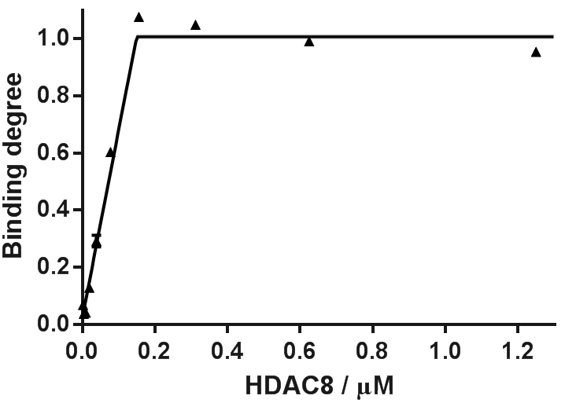
Fig. S1: Active site titration of 200nM compound 10 with HDAC8 indicating stoichiometric binding and completely binding active enzyme.

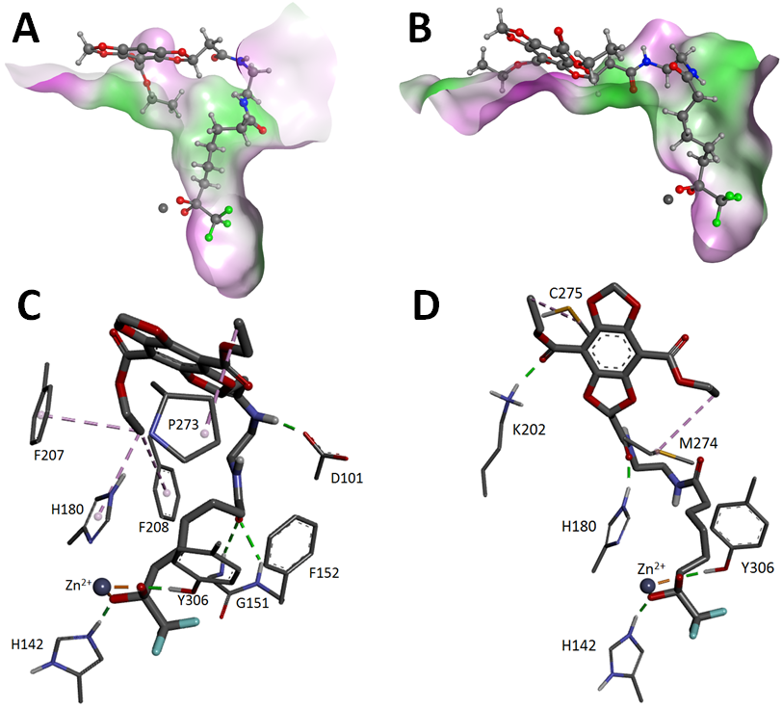
Fig. S2: Best docking poses of 10 in closed (A/C) and wide-open HDAC8 (B/D). The surface of the binding pockets (A/B) is colored by hydrophobicity (green: lipophilic, white: neutral, magenta: hydrophilic). Ligand interaction (C/D) with target residues are colored as follows: H-bonds: green, metal-complexation: orange, alkyl-alkyl/pi interactions: magenta.

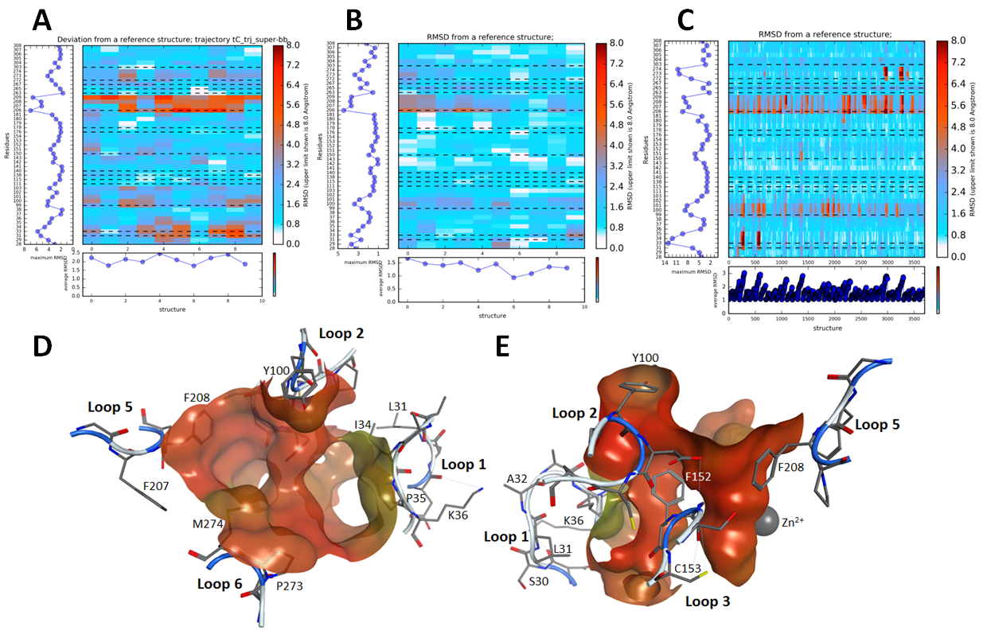
Fig. S3: Binding site flexibility of HDAC8. A) tCONCOORD-TRAPP analysis (Stank et al., 2017). B) RIPlig-TRAPP analysis. C) L-RIP-TRAPP analysis. The red regions denote high and white/light blue regions low deviations of the respective residue from the reference structure (PDB-ID: 1T64). D) Top view and E) side view of both binding pockets with surrounding amino acids of enhanced flexibility. The surface of the binding pockets is colored according to B-factors (B-factor of 10 corresponds to red and 35 to green).

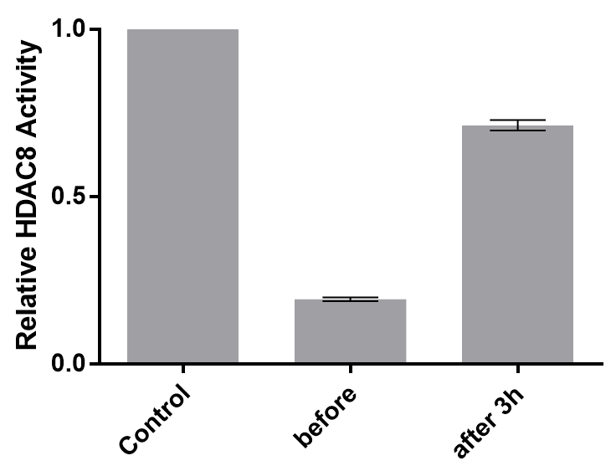
Fig. S4: Dialysis of a preformed complex between HDAC4 and compound 10. Relative enzyme acitivty of preformed complexes between HDAC8 and indicated compounds before and after 3h dialysis against assay buffer at 4⁰C. The control, free HDAC8, was used to normalize the measured enzyme activity. Shown are means and standard errors, n=3.

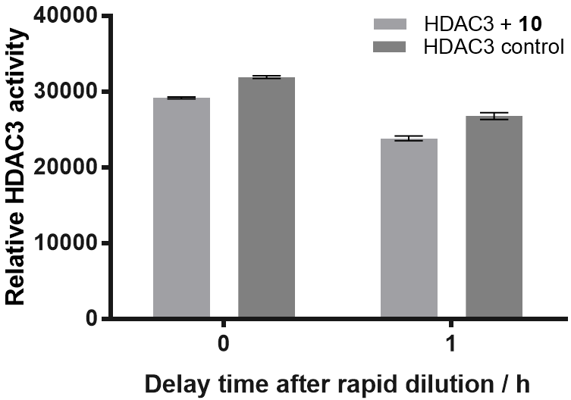

Fig. S5: Rapid dilution of complex between HDAC3 and 10. 600 nM 10 and about 100 nM HDAC3 were incubated for 1 h at 4⁰C before rapid 1:100 dilution. The HDAC3 control contained no inhibitor. The enzyme activity was determined right after and 1 h after rapid dilution according to the standard assay protocol. The fluorescence of the AMC product is a measure of the relative HDAC3 activity and was measured with indicated delay time after rapid dilution. The data show that 10 dissociates faster than the dilution and assay time of about 30 min.

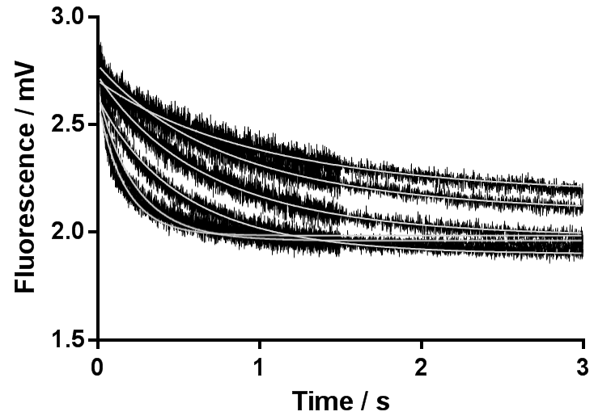
Fig. S6: Stopped-Flow-Kinetics of PCI-34051 binding to HDAC8. 300nM binding active HDAC8 were mixed with 0.3, 0.5, 0.7, 1.0, 2.5 and 3.5 µM of the inhibitor. The intrinsic tryptophan fluorescence of HDAC8 (Exc. 285, Em. > 300 nm) is quenched by PCI-34051. The fluorescence is measured as voltage of the photomultiplier in mV and plotted versus time. 98100 data points were analyzed simultaneously using global fit analysis and COPASI program. The association and dissociation rates of PCI-34051 from HDAC8 were determined to be 1.7*10⁶ M⁻¹s⁻¹ and 0.26 s⁻¹, respectively. Slightly different offset values were considered by corresponding individual fit parameters.

Selection of the most likely binding mechanism for DBD-ligands to HDAC8:
Tab. S1: Global fit analysis of DBD-ligands applying the one-step-binding model
Rate constants | 8 | 9 | 10
Global Fit Analysis
k₁ / M⁻¹s⁻¹ | 452 ± 3 | 1930 ± 40 | 4400 ± 100
k₋₁/ s⁻¹ | (6.1 ± 0.6) *10⁻⁵ | (5.3 ± 9.6)*10⁻⁵ | (1.0 ± 0.1)*10⁻⁴
RT / h | 4.3 ± 0.5 | 5 ± 9 | 2.8 ± 0.3
Experimental Data
k_{on_app} / (M⁻¹s⁻¹) | 374±4 | 1690±20 | 7040±530
RT / h * | 1.9 ± 0.1 | 3.3 ± 0.5 | > 25
*competitive displacement kinetics, RT: residence time = 1/k₋₁
In case of a one-step-binding mechanism, k₁ (global fit) should agree with k_{on_app}. For this model, there is only for 8 and 9 a reliable agreement between fitted and experimental data.

Tab. S2: Error sum of Squares of global data fit of indicated model to data sets of binding kinetics of DBD-ligands 8, 9 and 10 to HDAC8.
Model | 8 | 9 | 10
One-step | 2.7 | 3.4 | 3.2
IF | 2.7 | 3.4 | 3.2
CS | 2.7 | 3.4 | 2.5

The one-step model has two fit parameters, whereas IF- and CS-model have 4 parameters. The most likely models are highlighted in red. For 8 and 9 there is no improvement in terms of error sum of squares from the simple one-step-binding model (2 parameter) to the more complex IF- and CS-models (4 parameter). Thus, the one-step model appears to be most likely. In contrast, the error sum of square for the CS-model of the binding kinetics of 10 is significantly lower than for the other models. In this case, Akaike’s information criterion(Akaike, 1974) and F test were used to calculate the probability for the most likely model:
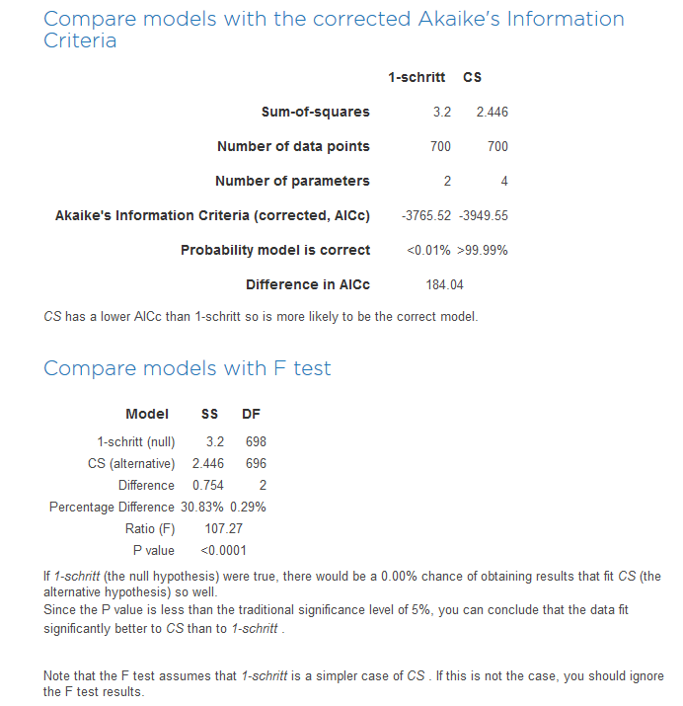

Table S3: Docking results of 10 to different crystal structures of HDAC8
PDB-ID | GBVI/WSA dG Score | Metal complexation | H-bonds | Hydrophobic interactions
1T69 (closed) | -23 | bidentate | H142, Y306, G151, D101 | F207, F208, H180, P273
1T64 (sub-open) | -25 | bidentate | H142, Y306, Y100, K33 | Y100, F152, Y306, W141, I34, P35
1VKG (wide-open) | -21 | bidentate | H142, Y306, K202 | M274, C275

Table S4: IC₅₀-values of reference compounds against HDAC8 (see Fig. 1):
Compound | IC₅₀ / µM
SAHA | 5.8 ± 0.4
Trichostatin A (TSA) | 0.41 ± 0.03
PCI-34051 | 0.027 ± 0.002

References:
Akaike, H. (1974). A New Look at the Statistical Model Identification. IEEE Transactions on Automatic Control 19, 716-723.
Stank, A., Kokh, D. B., Horn, M., Sizikova, E., Neil, R., Panecka, J., Richter, S. and Wade, R. C. (2017). TRAPP webserver: predicting protein binding site flexibility and detecting transient binding pockets. Nucleic Acids Res.

