Supplementary Information: Facile generation of antibody heavy and light chain diversities for yeast surface display by Golden Gate Cloning

Lukas Roth¹⁺, Julius Grzeschik¹⁺, Steffen C. Hinz¹, Stefan Becker², Lars Toleikis², Michael Busch³, Harald Kolmar¹, Simon Krah²* and Stefan Zielonka²*

¹Institute for Organic Chemistry and Biochemistry, Technische Universität Darmstadt, Alarich-Weiss-Strasse 4, D-64287 Darmstadt, Germany
²Protein Engineering and Antibody Technologies, Merck KGaA, Frankfurter Strasse 250, D-64293 Darmstadt, Germany
³Discovery Pharmacology, Merck KGaA, Frankfurter Strasse 250, D-64293 Darmstadt, Germany

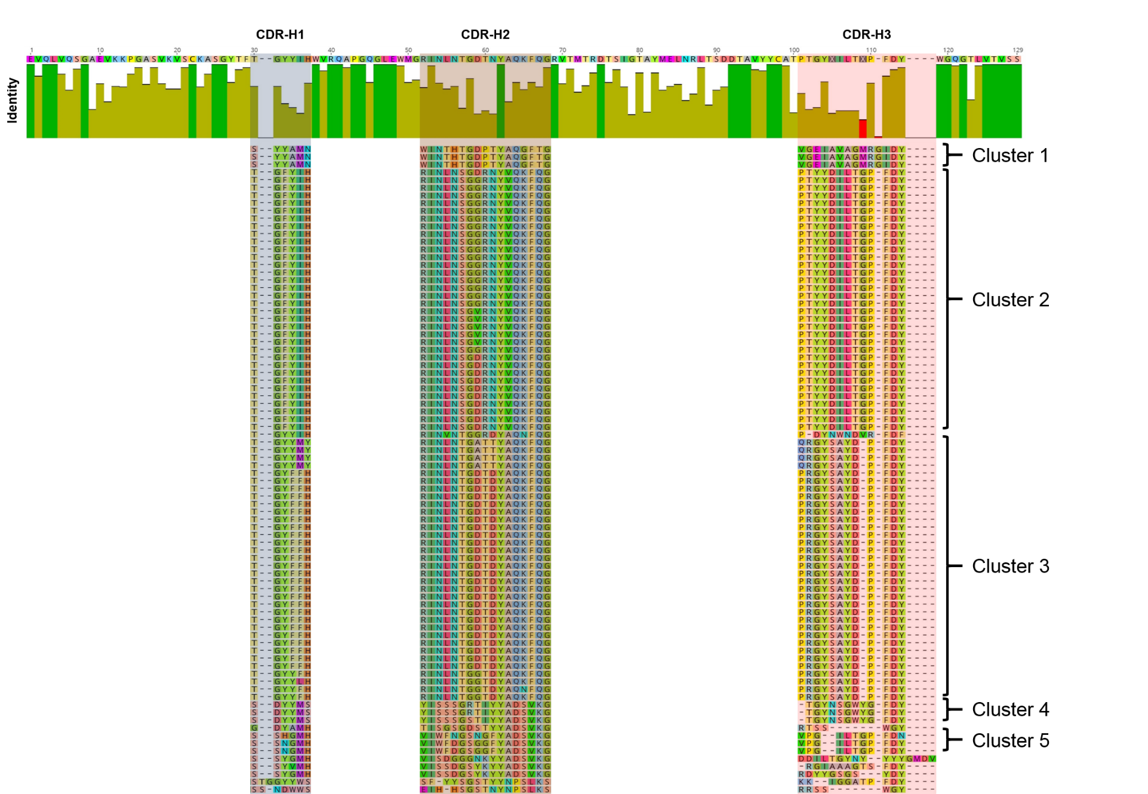
Supplementary Figure 1: Multiple sequence alignment of domain VH for GGC-derived library after enrichment against CEACAM6. CDR-H1, CDR-H2 and CDR-H3 are highlighted as well as clones falling into distinct sequence clusters. Alignment was performed using Geneious Alignment, Cost Matrix (1.0/0.0), Gap open penalty: 12, Gap extension penalty 3 and Refinement iterations 1 using Geneious 10.0.5 software (www.geneious.com).
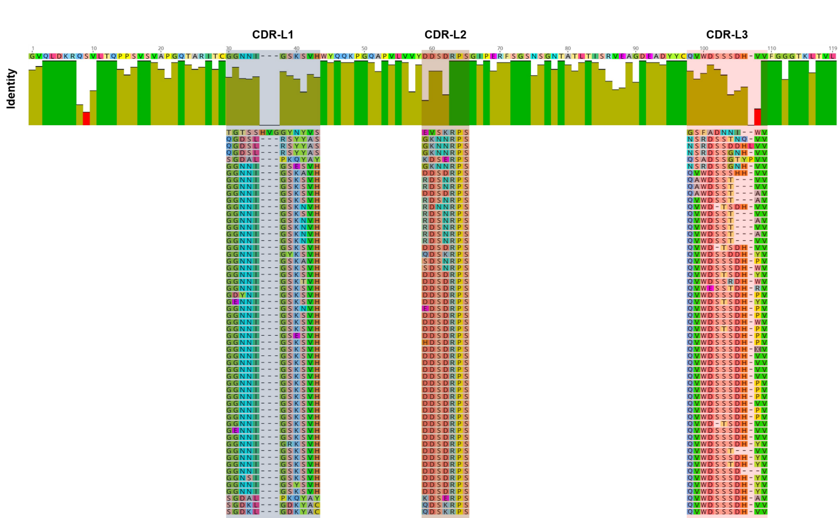
Supplementary Figure 2: Multiple sequence alignment of VLλ for GGC-derived library after enrichment against CEACAM6. CDR-L1, CDR-L2 and CDR-L3 are highlighted. Alignment was performed using Geneious Alignment, Cost Matrix (1.0/0.0), Gap open penalty: 12, Gap extension penalty 3 and Refinement iterations 1 using Geneious 10.0.5 software (www.geneious.com).
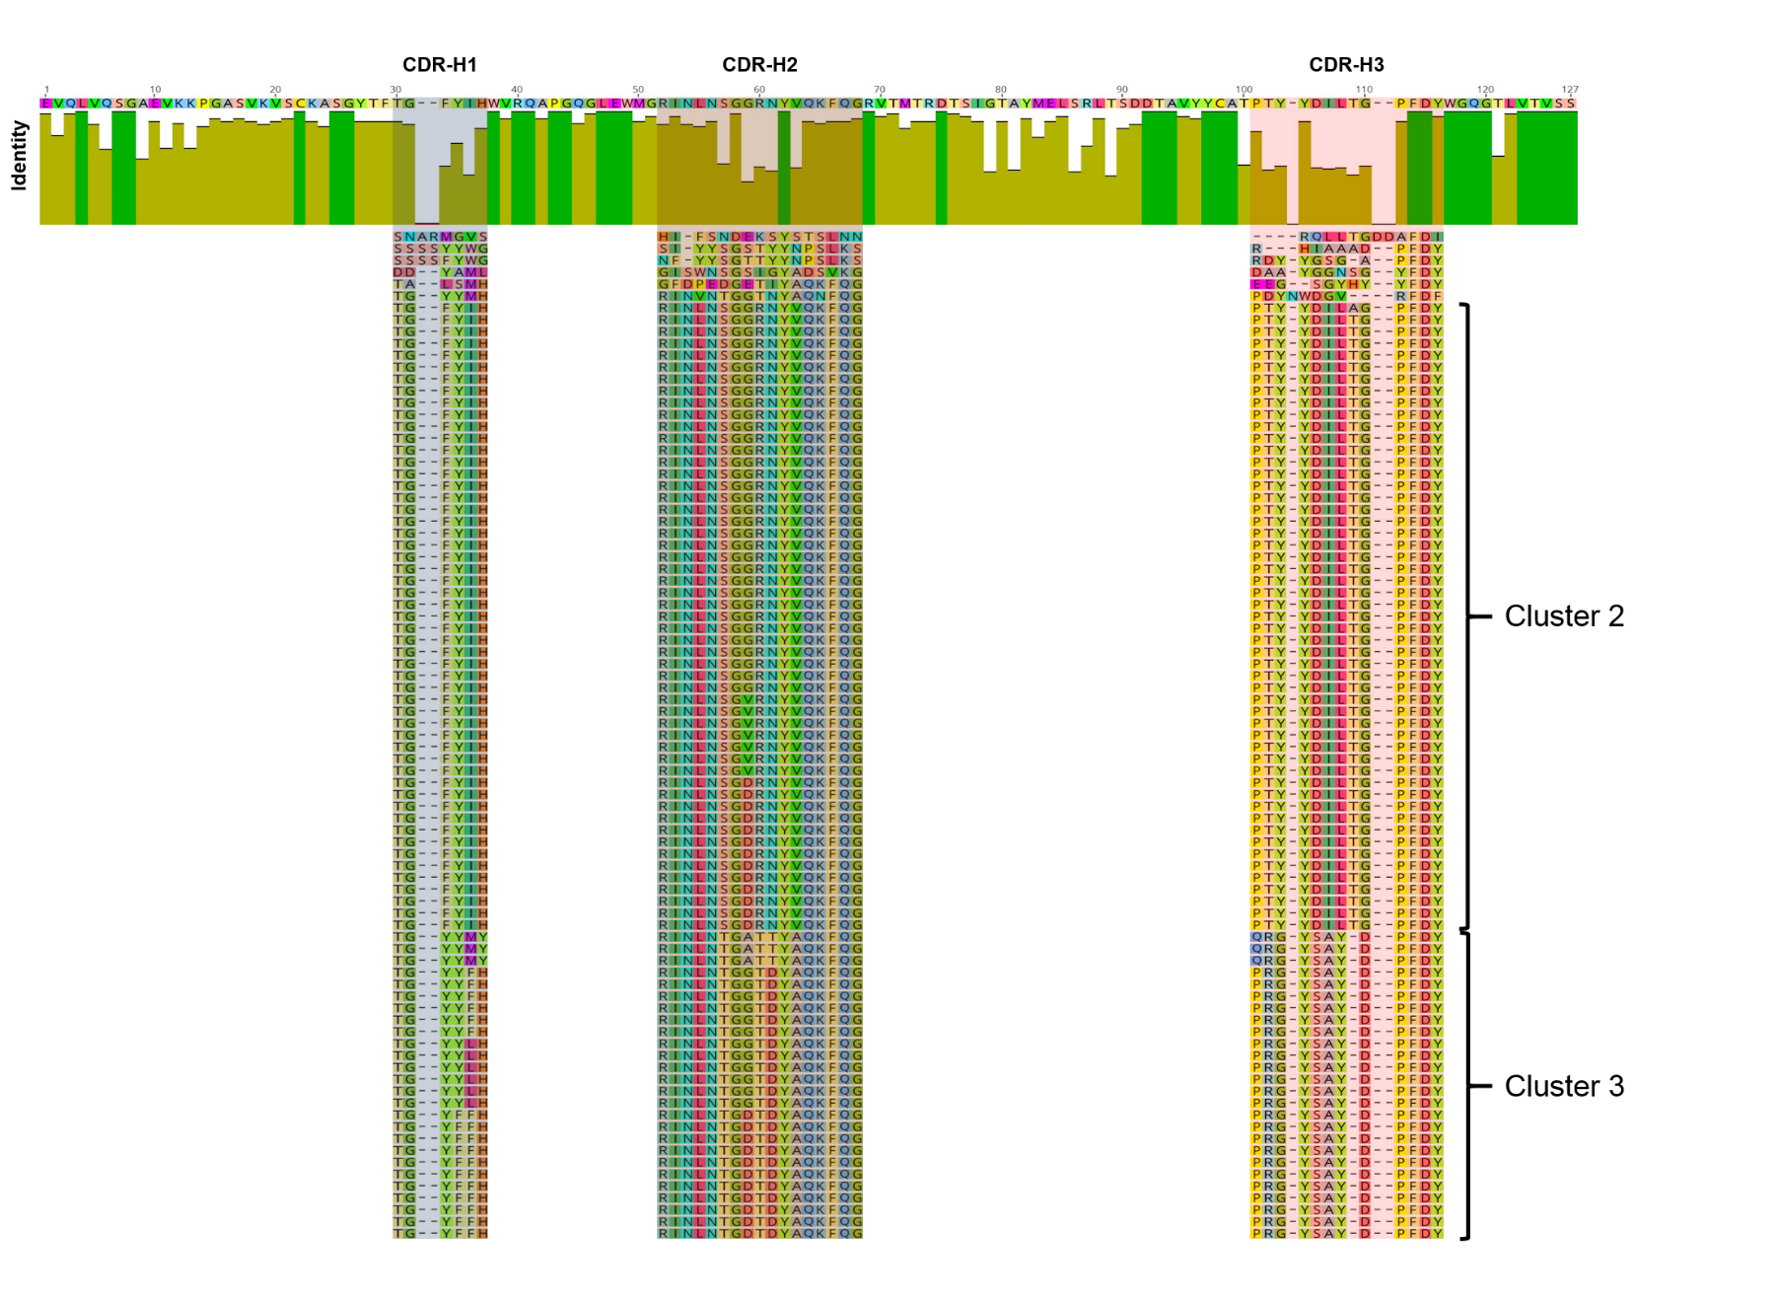
Supplementary Figure 3: Multiple sequence alignment of domain VH for YM-derived library after enrichment against CEACAM6. CDR-H1, CDR-H2 and CDR-H3 are highlighted as well as clones falling into distinct sequence clusters. Alignment was performed using Geneious Alignment, Cost Matrix (1.0/0.0), Gap open penalty: 12, Gap extension penalty 3 and Refinement iterations 1 using Geneious 10.0.5 software (www.geneious.com).

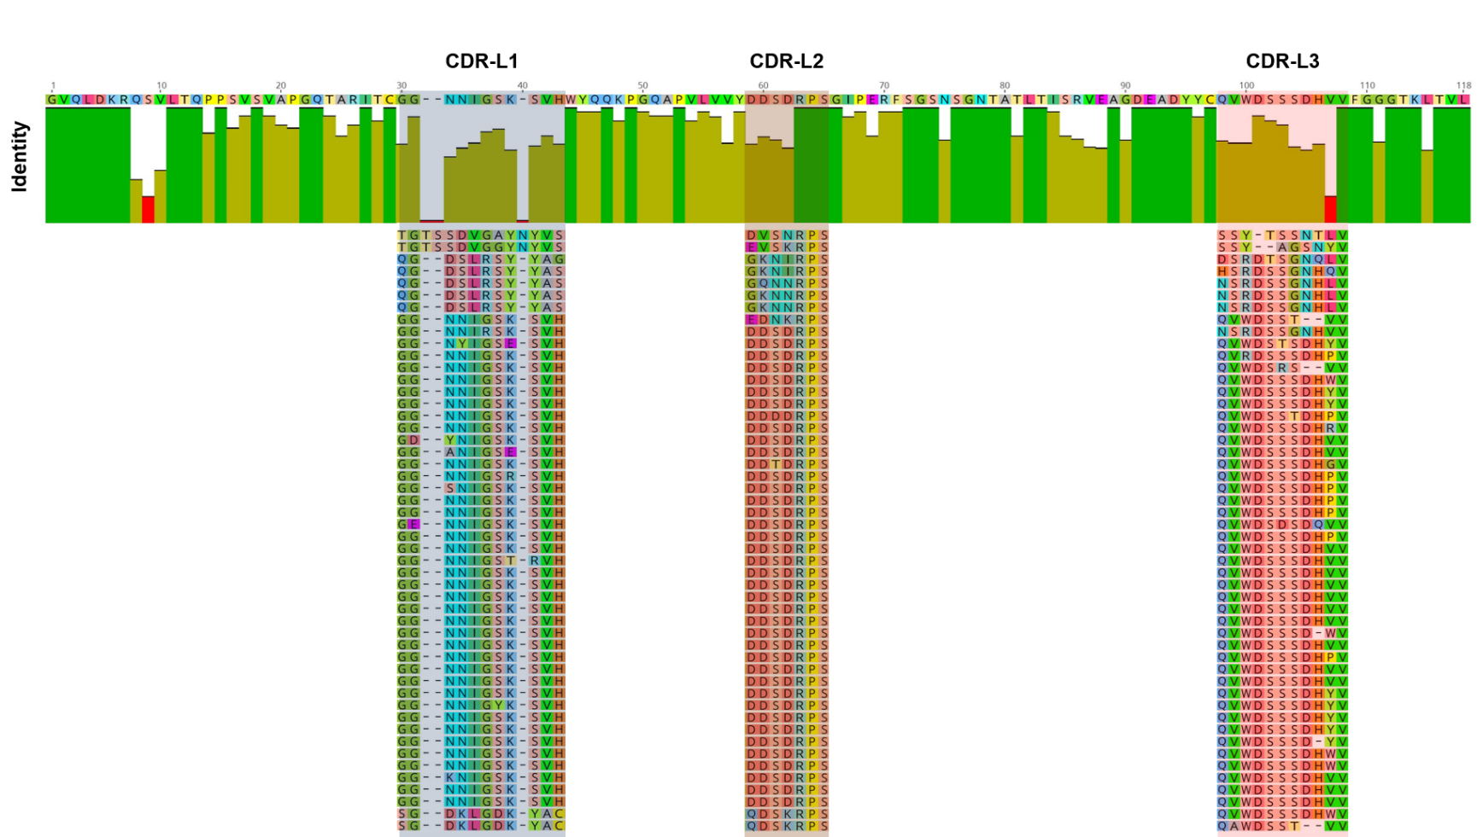
Supplementary Figure 4: Multiple sequence alignment of VLλ for YM-derived library after enrichment against CEACAM6. CDR-L1, CDR-L2 and CDR-L3 are highlighted. Alignment was performed using Geneious Alignment, Cost Matrix (1.0/0.0), Gap open penalty: 12, Gap extension penalty 3 and Refinement iterations 1 using Geneious 10.0.5 software (www.geneious.com).
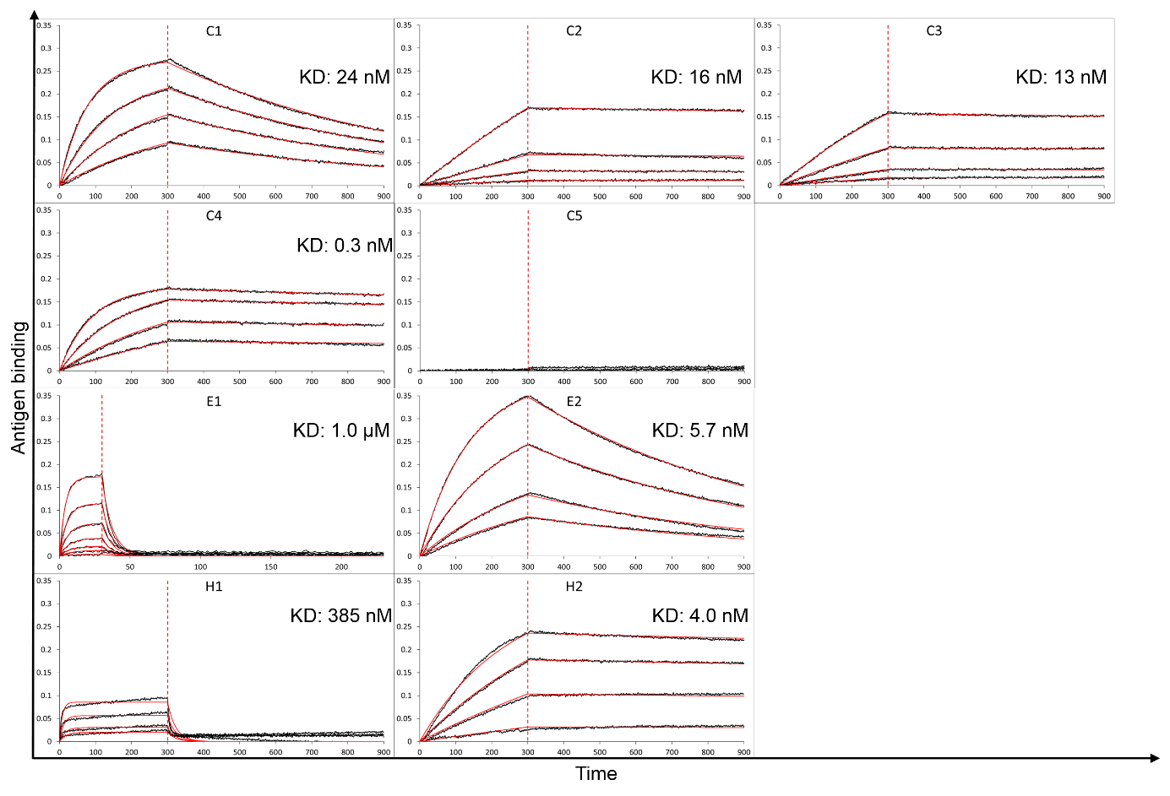
Supplementary Figure 5: Binding kinetics of human IgG variants (C1 – C5) and chimeric chicken/human IgG moieties (E1, E2, H1, H2) as determined by Bio-Layer Interferometry and an Octet® RED96 system. C1-C5: Cluster representatives selected against CEACAM6, E1, E2: Variants obtained from EGFR library, H1, H3: Molecules derived from hCG library sorting. Fitting (red lines) of binding curves (colored lines) was calculated using a 1:1 binding model and Savitzky-Golay filtering.

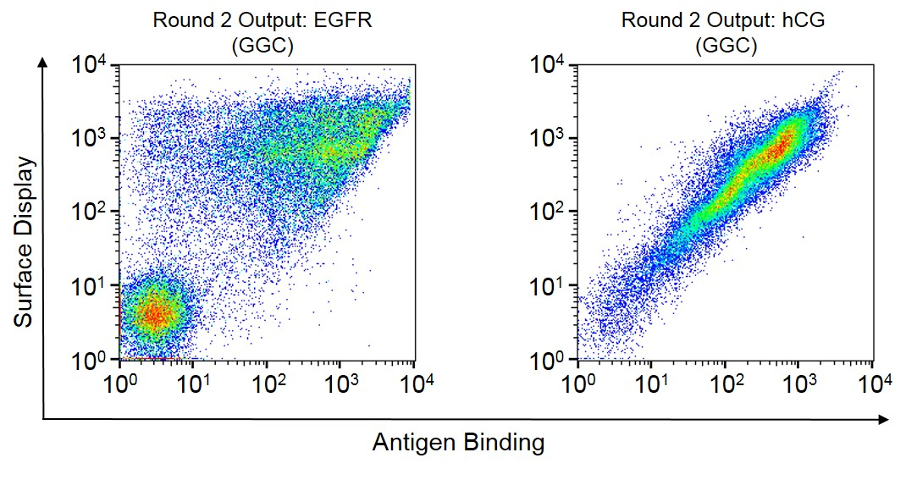
Supplementary Figure 6: Screening output of chimeric chicken/human YSD Fab immune libraries. Cells were stained after two rounds of sorting for antigen binding and Fab surface expression.

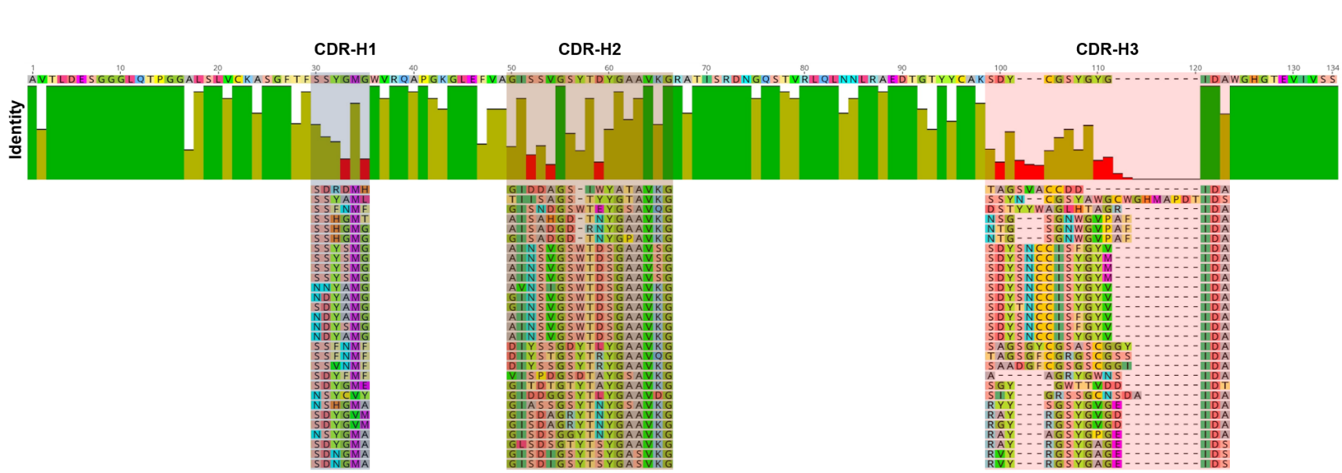
Supplementary Figure 7: Multiple sequence alignment of domain VH for GGC-derived chimeric chicken/human Fab library after enrichment against EGFR. CDR-H1, CDR-H2 and CDR-H3 are highlighted. Alignment was performed using Geneious Alignment, Cost Matrix (1.0/0.0), Gap open penalty: 12, Gap extension penalty 3 and Refinement iterations 1 using Geneious 10.0.5 software (www.geneious.com).
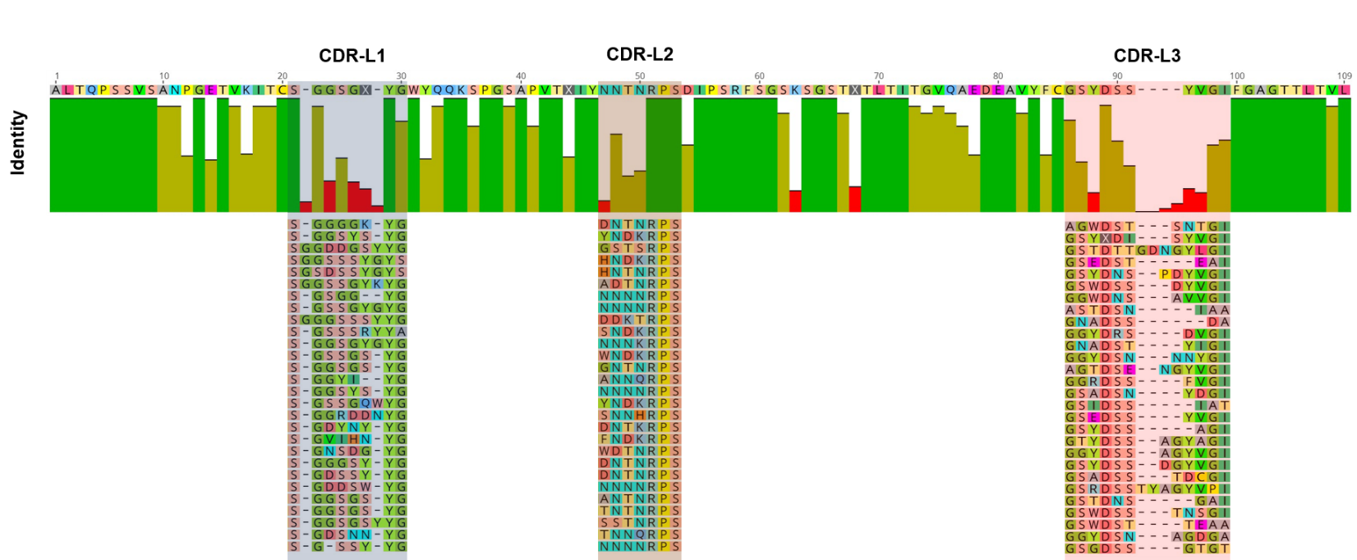
Supplementary Figure 8: Multiple sequence alignment of VL for GGC-derived chimeric chicken/human Fab library after enrichment against EGFR. CDR-L1, CDR-L2 and CDR-L3 are highlighted. Alignment was performed using Geneious Alignment, Cost Matrix (1.0/0.0), Gap open penalty: 12, Gap extension penalty 3 and Refinement iterations 1 using Geneious 10.0.5 software (www.geneious.com).
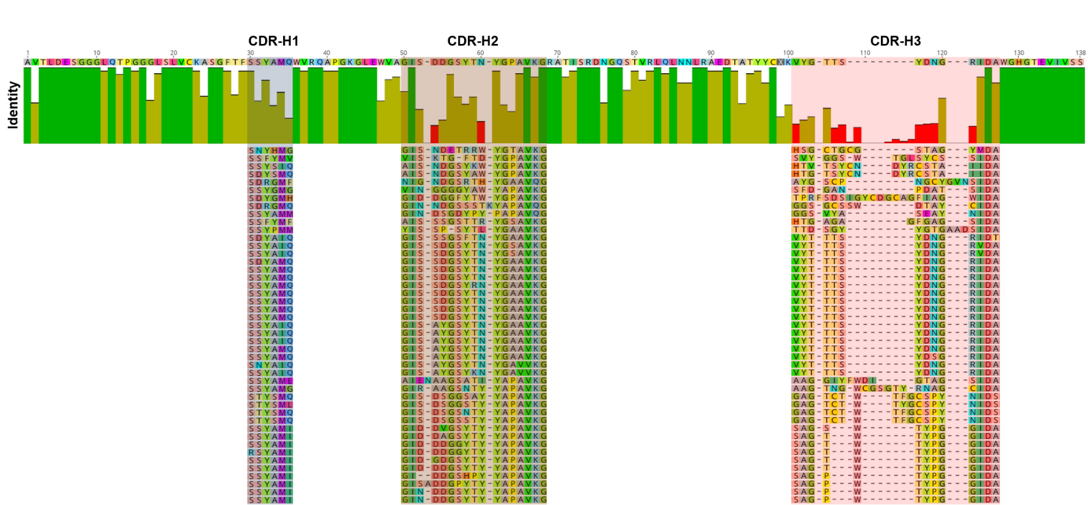
Supplementary Figure 9: Multiple sequence alignment of domain VH for GGC-derived chimeric chicken/human Fab library after enrichment against hCG. CDR-H1, CDR-H2 and CDR-H3 are highlighted. Alignment was performed using Geneious Alignment, Cost Matrix (1.0/0.0), Gap open penalty: 12, Gap extension penalty 3 and Refinement iterations 1 using Geneious 10.0.5 software (www.geneious.com).
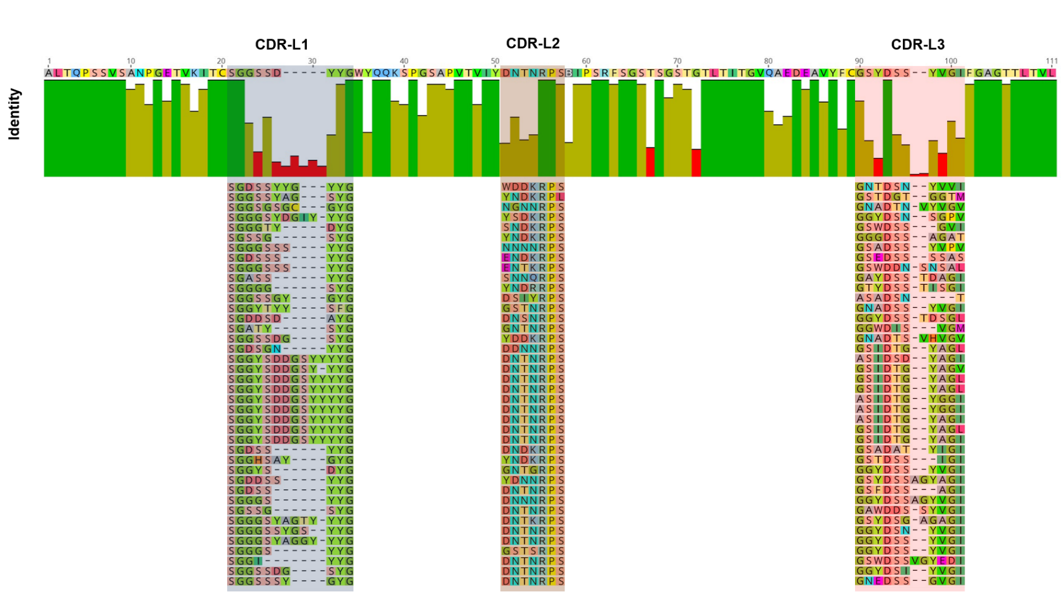
Supplementary Figure 10: Multiple sequence alignment of VL for GGC-derived chimeric chicken/human Fab library after enrichment against hCG. CDR-L1, CDR-L2 and CDR-L3 are highlighted. Alignment was performed using Geneious Alignment, Cost Matrix (1.0/0.0), Gap open penalty: 12, Gap extension penalty 3 and Refinement iterations 1 using Geneious 10.0.5 software (www.geneious.com).
Supplementary Table 1: Comparison of the functionality of VH and VL clones in YSD libraries constructed by GGC or the YM approach.
Library | Functionality [%]
Library | VH repertoire | VLλ repertoire
Golden Gate Cloning (GGC) | 90.4 | 78.8
Conventional (YM) | 92.1 | 73.2

Supplementary Table 2: Oligonucleotide primers used in this study.
Name | Sequence (5′–3′)
1GGC_VH_up
  GCGCGCGCGGTCTCTAGGTGAGGTBCAGCTGGTGCAGTCTGG
2GGC_VH_up | GCGCGCGCGGTCTCTAGGTGARRTSCAGCTGGTRCARTCTGG
3GGC_VH_up | GCGCGCGCGGTCTCTAGGTGAGRTCACCTTGAAGGAGTCTGG
4GGC_VH_up | GCGCGCGCGGTCTCTAGGTGARGTGCAGCTGGTGGAGTCTGG
5GGC_VH_up | GCGCGCGCGGTCTCTAGGTGAGGTGCAGCTGKTGGAGWCYSG
6GGC_VH_up | GCGCGCGCGGTCTCTAGGTGAGGTGCARCTGCAGGAGTCGGG
7GGC_VH_up | GCGCGCGCGGTCTCTAGGTGAGSTGCAGCTRCAGSAGTSSGG
8GGC_VH_up | GCGCGCGCGGTCTCTAGGTGARGTGCAGCTGGTGCAGTCTGG
9GGC_VH_up | GCGCGCGCGGTCTCTAGGTGAGGTACAGCTGCAGCAGTCAGG
1GGC_VH_lo | GCGCGCTGGTCTCTTAGTAGAAGCTGARGAGACRGTGACC
1GGC_VL_up | GCGCGCTGGTCTCTAAGCGACAGTCTGTGCTGACTCAGCCACC
2GGC_VL_up | GCGCGCTGGTCTCTAAGCGACAGTCTGTGYTGACGCAGCCGCC
3GGC_VL_up | GCGCGCTGGTCTCTAAGCGACAGTCTGCCCTGACTCAGCCT
4GGC_VL_up | GCGCGCTGGTCTCTAAGCGATCCTATGWGCTGACWCAGCCACC
5GGC_VL_up | GCGCGCTGGTCTCTAAGCGATCTTCTGAGCTGACTCAGGACCC
6GGC_VL_up | GCGCGCTGGTCTCTAAGCGACTGCCTGTGCTGACTCAGCCC
7GGC_VL_up | GCGCGCTGGTCTCTAAGCGACAGCYTGTGCTGACTCAATCRYC
8GGC_VL_up | GCGCGCTGGTCTCTAAGCGACAGSCTGTGCTGACTCAGCC
9GGC_VL_up | GCGCGCTGGTCTCTAAGCGAAATTTTATGCTGACTCAGCCCCA
10GGC_VL_up | GCGCGCTGGTCTCTAAGCGACAGRCTGTGGTGACYCAGGAGCC
11GGC_VL_up | GCGCGCTGGTCTCTAAGCGACAGSCWGKGCTGACTCAGCCACC
1GGC_VL_lo | GCGCGCGGTCTCTGTCCTAGGACGGTSASCTTG
1YM_VH_up | TGTTTTTCAATATTTTCTGTTATTGCTAGCGTTTTAGCAGGGGAGGTBCAGCTGGTGCAGTCTGG
2YM_VH_up | TGTTTTTCAATATTTTCTGTTATTGCTAGCGTTTTAGCAGGGGARRTSCAGCTGGTRCARTCTGG
3YM_VH_up | TGTTTTTCAATATTTTCTGTTATTGCTAGCGTTTTAGCAGGGGAGRTCACCTTGAAGGAGTCTGG
4YM_VH_up | TGTTTTTCAATATTTTCTGTTATTGCTAGCGTTTTAGCAGGGGARGTGCAGCTGGTGGAGTCTGG
5YM_VH_up | TGTTTTTCAATATTTTCTGTTATTGCTAGCGTTTTAGCAGGGGAGGTGCAGCTGKTGGAGWCYSG
6YM_VH_up | TGTTTTTCAATATTTTCTGTTATTGCTAGCGTTTTAGCAGGGGAGGTGCARCTGCAGGAGTCGGG
7YM_VH_up | TGTTTTTCAATATTTTCTGTTATTGCTAGCGTTTTAGCAGGGGAGSTGCAGCTRCAGSAGTSSGG
8YM_VH_up | TGTTTTTCAATATTTTCTGTTATTGCTAGCGTTTTAGCAGGGGARGTGCAGCTGGTGCAGTCTGG
9YM_VH_up | TGTTTTTCAATATTTTCTGTTATTGCTAGCGTTTTAGCAGGGGAGGTACAGCTGCAGCAGTCAGG
1YM_VH_lo | GGAGGAGGGTGCCAGGGGGAAGACCGATGGGCCCTTGGTACTAGCTGARGAGACRGTGACC
1YM_VL_up | GCCAGCATTGCTGCTAAAGAAGAAGGGGTACAACTCGATAAAAGACAGTCTGTGCTGACTCAGCCACC
2YM_VL_up | GCCAGCATTGCTGCTAAAGAAGAAGGGGTACAACTCGATAAAAGACAGTCTGTGYTGACGCAGCCGCC
3YM_VL_up | GCCAGCATTGCTGCTAAAGAAGAAGGGGTACAACTCGATAAAAGACAGTCTGCCCTGACTCAGCCT
4YM_VL_up | GCCAGCATTGCTGCTAAAGAAGAAGGGGTACAACTCGATAAAAGATCCTATGWGCTGACWCAGCCACC
5YM_VL_up | GCCAGCATTGCTGCTAAAGAAGAAGGGGTACAACTCGATAAAAGATCTTCTGAGCTGACTCAGGACCC
6YM_VL_up | GCCAGCATTGCTGCTAAAGAAGAAGGGGTACAACTCGATAAAAGACTGCCTGTGCTGACTCAGCCC
7YM_VL_up | GCCAGCATTGCTGCTAAAGAAGAAGGGGTACAACTCGATAAAAGACAGCYTGTGCTGACTCAATCRYC
8YM_VL_up | GCCAGCATTGCTGCTAAAGAAGAAGGGGTACAACTCGATAAAAGACAGSCTGTGCTGACTCAGCC
9YM_VL_up | GCCAGCATTGCTGCTAAAGAAGAAGGGGTACAACTCGATAAAAGAAATTTTATGCTGACTCAGCCCCA
10YM_VL_up | GCCAGCATTGCTGCTAAAGAAGAAGGGGTACAACTCGATAAAAGACAGRCTGTGGTGACYCAGGAGCC
11YM_VL_up | GCCAGCATTGCTGCTAAAGAAGAAGGGGTACAACTCGATAAAAGACAGSCWGKGCTGACTCAGCCACC
1YM_VL_lo | GGATGGCGGGAACAGAGTGACCGAAGGGGCGGCCTTCGGCTGACCTAGGACGGTSASCTTG
1chic_chim_VH_up | GCGCGCGCGGTCTCTAGGTgccgtgacgttggacgag
2chic_chim_VH_up | GCGCGCGCGGTCTCTAGGTGCCCTGACGTTGGACGAG
1chic_chim_VH_lo | GCGCGCTGGTCTCTTAGTAGAAGCggaggagacgatgacttcggt
1chic_chim_VL_up | GCGCGCTGGTCTCTAAGCGAGCGCTGACTCAGCCGTCCTCG
1chic_chim_VL_lo | GCGCGCGGTCTCTGTCCtaggacggtcagggttgtccc

