The inhibition of the mitochondrial F₁F_{O}-ATPase activity when activated by Ca²⁺ opens new regulatory roles for NAD⁺

Salvatore Nesci, Fabiana Trombetti, Vittoria Ventrella, Maurizio Pirini, Alessandra Pagliarani

Supplementary data

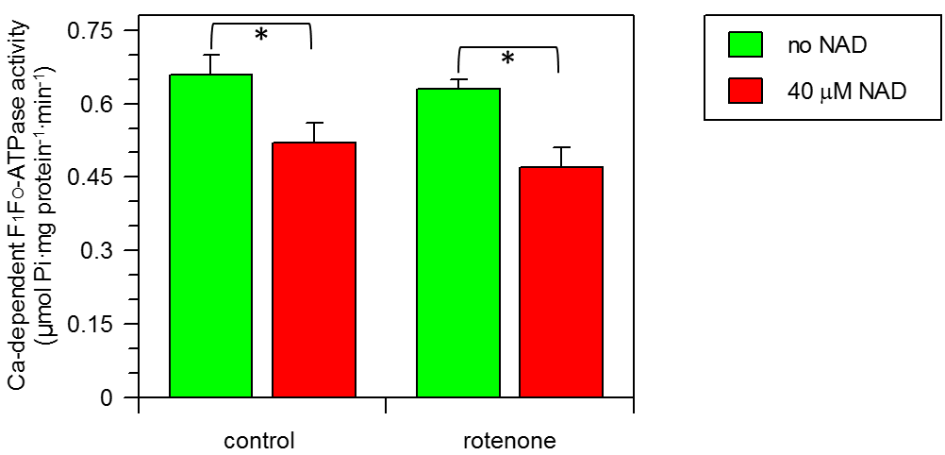
Figure S1 Effect of NAD⁺ on the Ca²⁺-dependent F₁F_{O}-ATPase in absence and in presence of 2.5 μM rotenone. Data represent the mean ± SD (vertical bars) of three distinct experiments. * indicate significantly different values (P≤0.05), evaluated with one way ANOVA followed by SNK test.

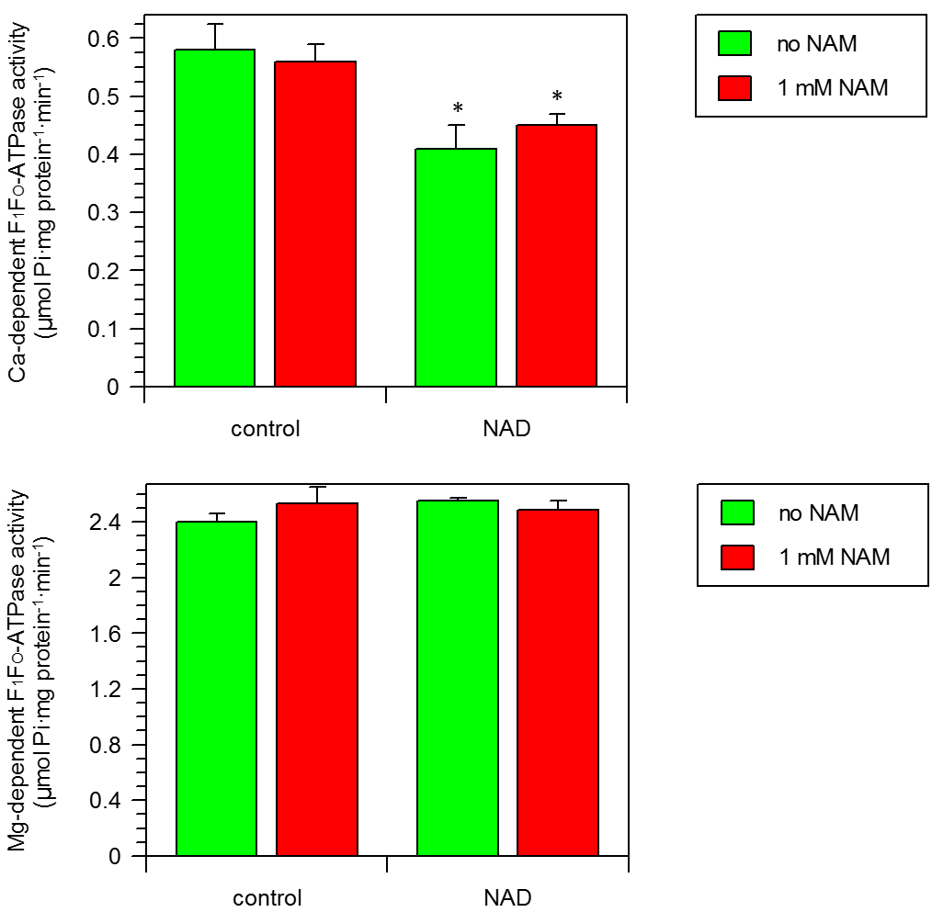
Figure S2 Effect of 40 μM NAD⁺ on the Ca²⁺ and Mg²⁺-dependent F₁F_{O}-ATPase in absence and in presence of 1 mM nicotinamide (NAM). Data represent the mean ± SD (vertical bars) of three distinct experiments. * indicate significantly different values (P≤0.05) from control value without NAD⁺, evaluated with one way ANOVA followed by SNK test.

