**I36T↑T Mutation in South African Subtype C (C-SA) HIV-1 Protease Significantly Alters Protease-Drug Interactions**

Sibusiso B. Maseko, Eden Padayachee, Thavendran Govender, Yasien Sayed, Gert Kruger, Glenn E.M. Maguire and Johnson Lin

**Supplementary material**

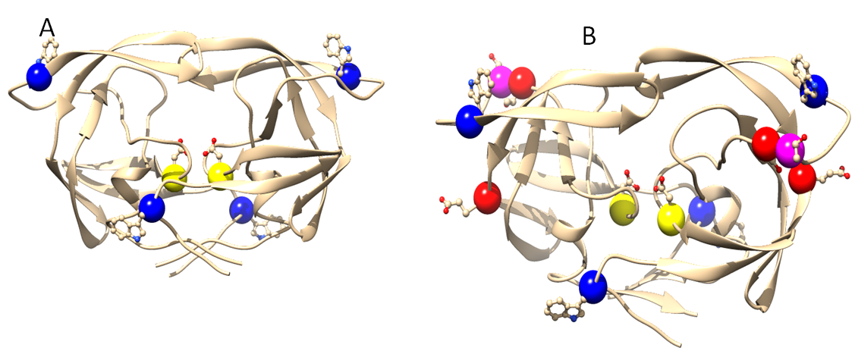

**Figure S1** A ribbon presentation of Wild type C-SA HIV protease (A) and I36T↑T mutant (B).

The Figure shows the positions of the tryptophan within the HIV-1 C-SA protease. Shown in yellow are the aspartic residues (Asp 25.25’). Insertion mutations are shown in pink. The red spheres are amino acid mutations. Trytophan 3 residues are shown in blue. Figure was created using UCSF Chimera version 1.

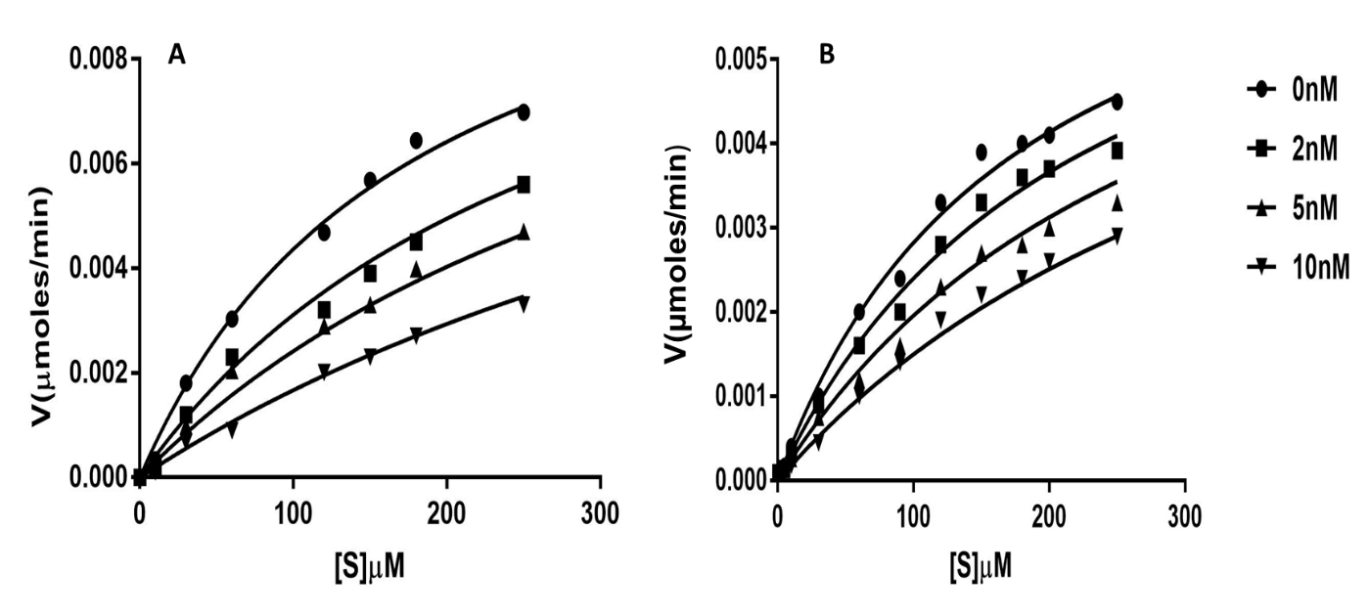

**Figure S2** Inhibition (*K*i) of the protease activities of wild type (A) and I36T↑T (B) by APV.

The reaction mix contained an increasing substrate concentration (0-250 μM); protease enzyme (50 nM), protease inhibitor (0-10 nM) in a 96-well plate with a total volume of 100 µl. (n=3).

**Table S1** Stern Volmer quenching constants (*K*sv) at different temperatures for both wild type (WT) and mutant (36T↑T).

|  |  |  |  |  |  |  |  |  |  |  |  |  |  |  |  |  |  |
| --- | --- | --- | --- | --- | --- | --- | --- | --- | --- | --- | --- | --- | --- | --- | --- | --- | --- |
| Temp. | 293 K | | | 298 K | | | | | 303 K | | | 310 K |  | 293 K | 298 K | 303 K | 310 K |
| APV | Ksv (nM­-1) | | | | | | | | | | | | ATV | Ksv (nM-1) | | | |
| WT | 0.0436  ±0.0042 | | | 0.0867±0.002 | | | | | 0.08724  ±0.0091 | | | 0.0885  ±0.0426 | WT | 0.1040  ±0.0066 | 0.1140  ±0.0021 | 0.1420  ±0.0037 | 0.1720  ±0.0311 |
| I36T↑T | 0.0217  ±0.0050 | | | 0.0805±0.0018 | | | | | 0.08514  ±0.0055 | | | 0.0861  ±0.0199 | I36T↑T | 0.0454  ±0.0074 | 0.0704  ±0.0227 | 0.1400  ±0.0354 | 0.1820  ±0.0021 |
|  | | | | | | | | | | | | | | | | | |
| DRV | 293 K | | | 298 K | | | | | 303 K | | | 310 K | IDV | 293 K | 298 K | 303 K | 310 K |
| WT | 0.0287  ±0.0075 | | | 0.0822±0.0094 | | | | | 0.0813  ±0.0028 | | | 0.1490  ±0.0060 | WT | 0.0067  ±0.0237 | 00.0949±0.087 | 0.0933  ±0.0154 | 0.1090  ±0.0220 |
| I36T↑T | 0.0484  ±0.0038 | | | 0.0508±0.0028 | | | | | 0.0648  ±0.0036 | | | 0.0683  ±0.0033 | I36T↑T | 0.0450  ±0.0107 | 0.0747±0.0021 | 0.0605  ±0.0166 | 0.0883  ±0.0164 |
|  | | | | | | | | | | | | | | | | | |
| LPV | 293 K | | | 298 K | | | | | 303 K | | | 310 K | RTV | 293 K | 298 K | 303 K | 310 K |
| WT | 0.0384  ±0.0161 | | | 0.0572±0.0121 | | | | | 0.1490  ±0.0216 | | | 0.1700  ±0.0158 | WT | 0.0805  ±0.0086 | 0.0828±0.001 | 0.1072  ±0.0015 | 0.1730  ±0.0364 |
| I36T↑T | 0.0208  ±0.0282 | | | 0.0287±0.0086 | | | | | 0.1390  ±0.0272 | | | 0.1730  ±0.0147 | I36T↑T | 0.0356  ±0.0085 | 0.041±0.001 | 0.0795  ±0.0200 | 0.1030  ±0.0021 |
|  | | | | | | | | | | | | | | | | | |
| TPV | | 293 | | | 298 | | | 303 | | | 310 | | SQV | 293 K | 298 K | 303 K | 310 K |
| WT | | 0.0384±0.01 | | | 00.0484±0.01 | | | 0.1072  ±0.0015 | | | 0.1730  ±0.0364 | | WT | 0.0408  ±0.0017 | 0.0686±0.0042 | 0.0669  ±0.0120 | 0.0819  ±0.0011 |
| I36T↑T | | 0.0156  ±0.0085 | | | 0.0366±0.0004 | | | 0.0795  ±0.0200 | | | 0.1030  ±0.0021 | | I36T↑T | 0.0106  ±0.0033 | 00.0217±0.005 | 0.0711  ±0.0033 | 0.0933  ±0.0018 |
| NFV | | | 293 | | | 298 | 303 | | | 310 | | | NFV | 293K | 298K | 303K | 310K |
| I36T↑T | | | 0.0484  ±0.0038 | | | 0.0561±0.002 | 0.0648  ±0.0036 | | | 0.0683  ±0.0033 | | | WT | 0.0450  ±0.0107 | 0.0759±0.002 | 0.0605  ±0.0166 | 0.0883  ±0.0164 |