Chemopreventive and hepatoprotective roles of adiponectin (SULF2 inhibitor) in hepatocelluar carcinoma

Mohammed M. H. Al-Gayyar, Ahmed Abbas and Ahmed M Hamdan

Supplementary data

Supplementary data 1 Primer sets used for the detection of human and rat genes expression.

Name | Sequence | Amplicon size | Annealing temperature
Human GAPDH F369 | 5’-AGAAGGCTGGGGCTCATTTG-3’ | 258 bp | 58°C
Human GAPDH R626 | 5’-AGGGGCCATCCACAGTCTTC-3’
Rat GAPDH 165F | 5`- CCATCAACGACCCCTTCATT-3` | 193 bp | 58°C
Rat GAPDH 358R | 5`- CACGACATACTCAGCACCAGC-3`
Human FGF-2 F2896 | 5’-AAAGCAGGAGGATCGCTTGA-3’ | 94 bp | 58°C
Human FGF-2 R2989 | 5’-CCACCATGCCTGGCTATTTT-3’
Rat FGF-2 70F | 5`- ATTTCCAAAACCTGACCCGAT -3` | 98 bp | 60°C
Rat FGF-2 168R | 5`- AACTTTCTCCCTTCCTGCCTTT -3`
Human E-Cd F4252 | 5`- TTGGGATTACAGACATGAGCC -3` | 135 bp | 56°C
Human E-Cad R4346 | 5`-AGAGTTTGAGGTTACAGTGAGC -3`
Rat E-Cad F4252 | 5`- GCGTGCCCTTTGTATGTAGTTTG -3` | 94 bp | 60°C
Rat E-Cad R4346 | 5`- ACAGTTCCGATTGCTTGCCTT -3`
Human nfκb F982 | 5`-ACCCTGACCTTGCCTATTTG-3` | 144 bp | 56°C
Human nfκb R1104 | 5`-GAAAAGCTGTAAACATGAGCCG-3`
Rat nfκb F45 | 5`- GGAAGTGAGAGAGTGAGCGAGAG -3` | 78 bp | 60°C
Rat nfκb R123 | 5`- GGGTGGCGAAACCTCCTC -3`

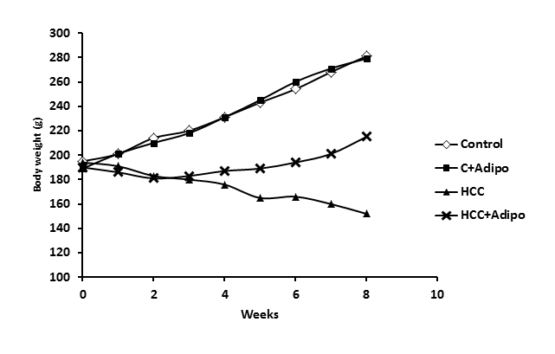
Supplementary data 2 Body weight of different rats groups during the experiment.

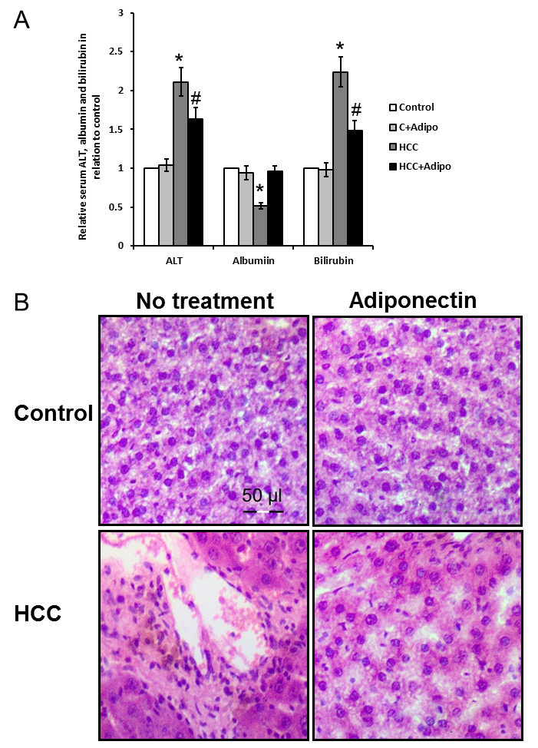

Supplementary data 3 Hepatoprotective effects of adiponectin.
(A) Statistical analysis of liver function markers. (B) Histopathological examination of liver sections of different treated groups stained by H/E. *Significant difference as compared with the rest of the groups at P<0.05. #Significant difference as compared with the control groups at P<0.05.
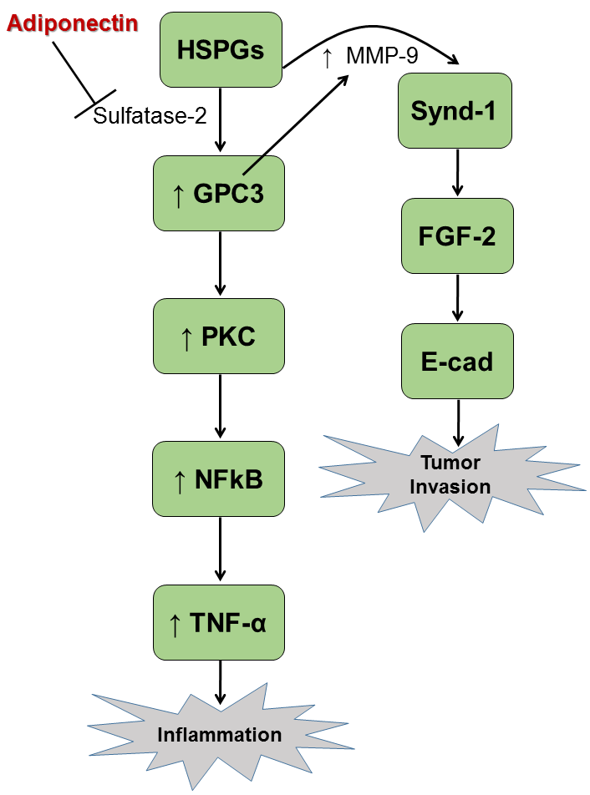

Supplementary data 4 Schematic presentation of mechanism of action of adiponectin in Hepatocellular Carcinoma
Glypican-3 (GPC3) is highly expressed in HCC cells and tissues. GPC3 regulates migration, adhesion and actin cytoskeleton organization in mammary tumor cells through Wnt signaling modulation. Protein kinase C (PKC) can catalyze many biochemical reactions for cellular constituents. PKC helps malignant transformation by enhancing multiple cellular signaling pathways. PKC activates NF-κB protein complex, which participates in many biological functions like cell survival, inflammation, angiogenesis, progression and metastasis. Activated NF-κB protein complex is translocated from the cytoplasm to the nucleus, where it interacts with and expresses specific target genes. The abnormal activity of nfκb gene expression is noticed in some inflammatory mediators such as TNF-α, which is considered the initiating factors in hepatocarcinogenesis. TNF-α is the link between inflammation and cancer. TNF-α participated in the development of the tissue structure modification necessary for tumor growth and metastasis. We found significant elevation in the gene expression of nfκb and the protein expression of PKC and TNF-α in HCC in vivo and in vitro that was blocked by adiponectin.

