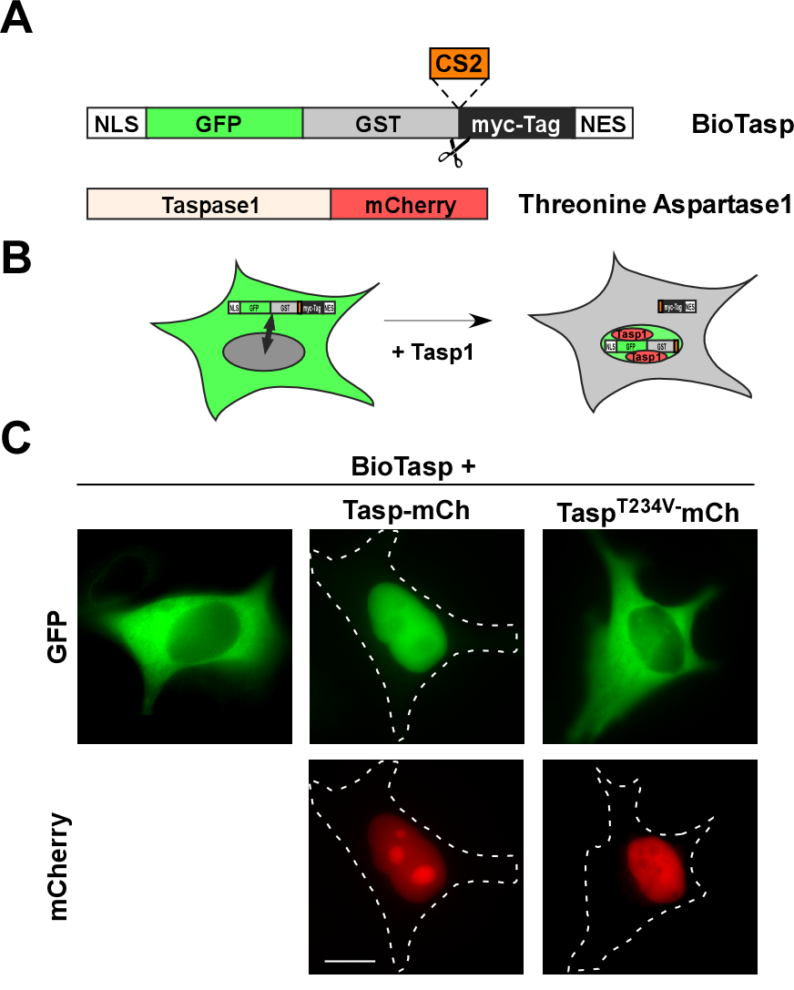
Supporting Information

Figure S1 Principle of the cell-based biosensor assay (BioTasp).
A. The fluorescent biosensor BioTasp is composed of the SV40 nuclear localization signal (NLS), GFP (BioTasp_{R}: mCherry), GST, the MLL cleavage site CS2 (aa KISQLD↓GVDD), a myc-tag and a nuclear export signal (NES). Co-transfection with active Threonine Aspartase1 expression constructs results in proteolytic cleavage of the BioTasp at the CS2 site. B. Expression of the BioTasp in living cells to a predominantly cytoplasmic fluorescent signal, but due to counteracting and sophistically balanced transport signals (NLS and NES) the biosensor shuttles between nucleus and cytoplasm. Cleavage of the biosensor by Threonine Aspartase1 results in loss of the NES and thus, nuclear accumulation. C. Specific cellular localization of BioTasp expressed in HeLa cells. Whereas expression of wild type Tasp-mCherry (middle panel) resulted in nuclear translocation, the inactive mutant Tasp^{T234V}-mCherry (right) prevented cleavage and nuclear redistribution of the fluorescent biosensor. Scale bars, 10 µm. Dashed lines mark cytoplasmic cell boundaries obtained from the corresponding phase contrast images.

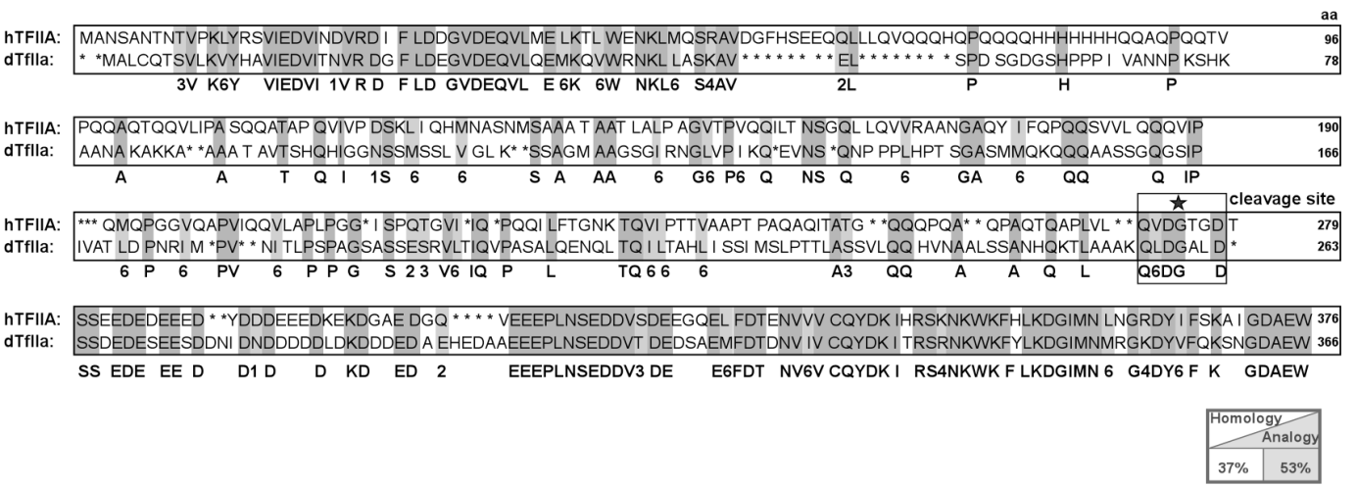

Figure S2 Protein sequence alignment of human and Drosophila TFIIA.
Alignment of amino acid sequences of human (hTFIIA) and Drosophila TFIIA (dTFIIA) revealed an overall protein homology of 37% and 53% of analogous aa. The proteins contain highly conserved domains, but the cis-cleavage site slightly differs in positions P² and P^{2'}-P^{3'}. Dark grey/bold: consensus sequence of conserved aa residues. Similarity groups of aa according to their chemical properties in light grey: 1=DE; 2=NQ; 3=ST; 4=KR; 5= FYW; 6= LIVM. Asterisk and box indicates cis-cleavage site in hTasp processing.

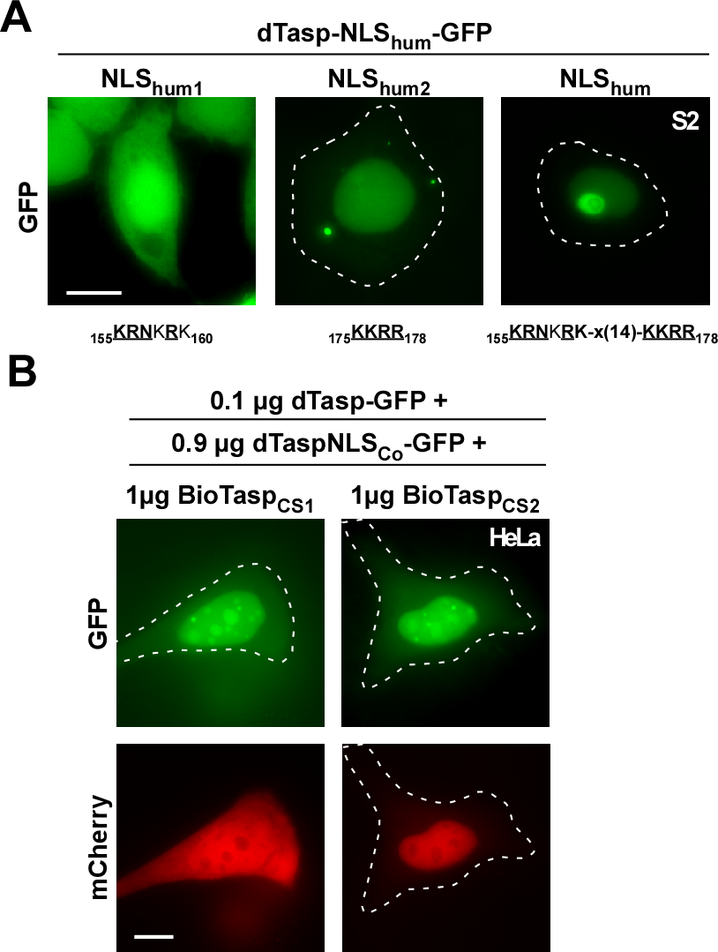

Figure S3 Drosophila Threonine Aspartase1 exists predominantly as a monomer in living cells.
A. Introduction of the human NLS restores nucleolar targeting of dTasp. Stepwise mutation of the dTasp aa sequence into a functional bipartite NLS is indicated, critical aa underlined. Localization in living Drosophila S2 transfectants was analyzed by fluorescence microscopy. B. Co-transfection of the humanized NLS chimera did not affect the cleavage activity of dTasp, CS2 cleavage was favored compared to CS1. HeLa cells were transfected with 1 µg of BioTasp_{CS1} or BioTasp_{CS2}, 0.1 µg dTasp-GFP together with 0.9 µg of dTasp-NLS_{hum}-GFP chimera and analyzed 24 h later. Localization in living HeLa transfectants was analyzed by fluorescence microscopy. Scale bars, 10 µm.

