Supplementary Material
Supercritical carbon dioxide extraction of crude tall oil: an alternative upgrading approach
Dennis Marvin Janek Möck et al.
DOI 10.1515/hf-2024-0126

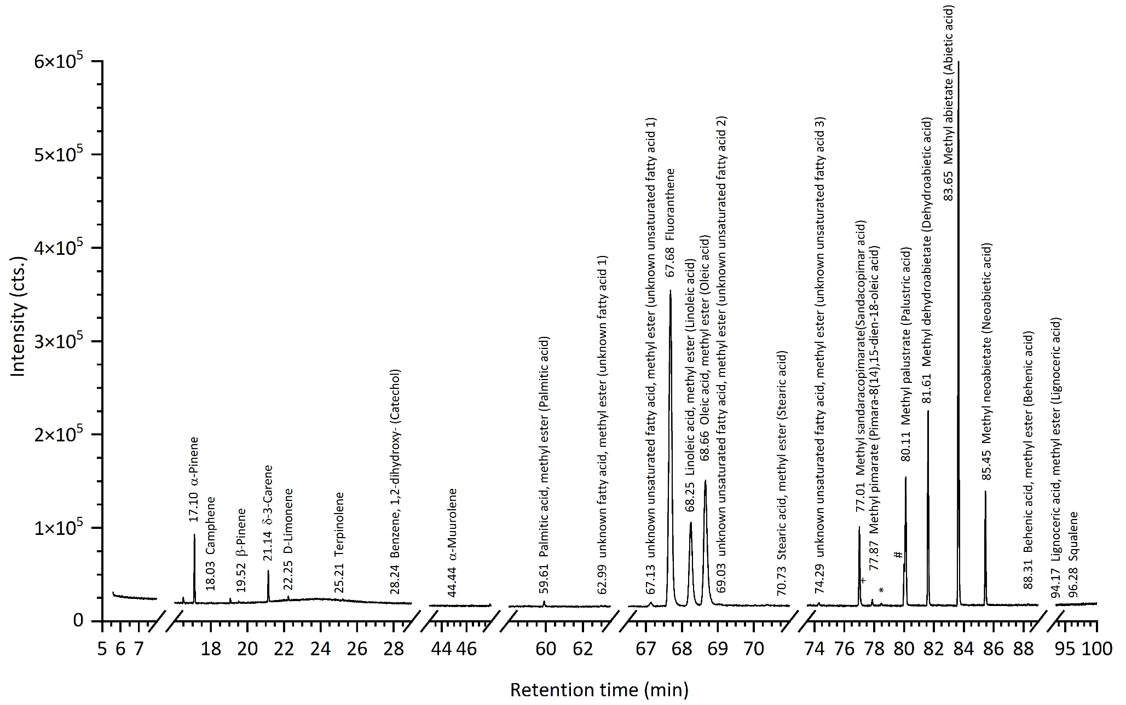
Supplementary Figure S1: GC-FID chromatogram of crude tall oil with MS identification and retention time (min), + 77.11 trans-3,5-Dyhydroxystilbene, * 78.47 unknown unsaturated fatty acid 4, # 80.00 Methyl-7,15-Isopimaradien-18-oate (Isopimaric acid).

