**Supplementary Material**

**The impact of site on tree form, wood properties, and lumber quality of plantation-grown *Pinus patula***

Jaco-Pierre van der Merwe et al.

DOI 10.1515/hf-2023-0075

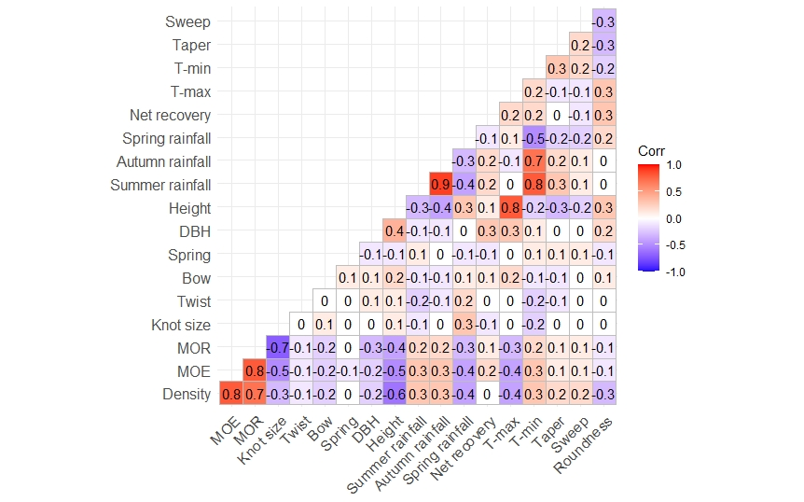

**Supplemental Figure S1:** Correlation plot with tree variables including tree height (Height), diameter at breast height (DBH), weighted tree taper, sweep, roundness, lumber properties including, density, dynamic MOE, MOR, knot size ratio, twist, bow, and spring, and climatic variables including annual maximum temperature (Tmax), minimum temperature (Tmin), summer rainfall, autumn rainfall, and spring rainfall.

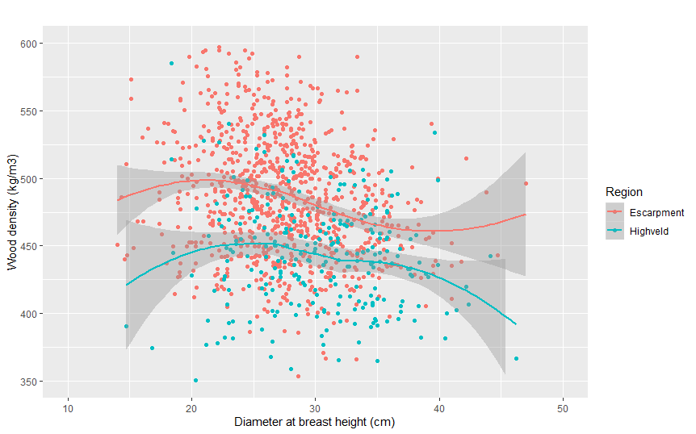

**Supplemental Figure S2:** Wood density plotted against diameter at breast height (DBH) and grouped according to the Lowveld Escarpment (Escarpment) and Highveld forestry regions of South Africa, including mean values and standard error. The data was sourced from x-ray densitometry measurements done on P. patula increment cores from a previous regional study (Van der Merwe et al. 2023a).

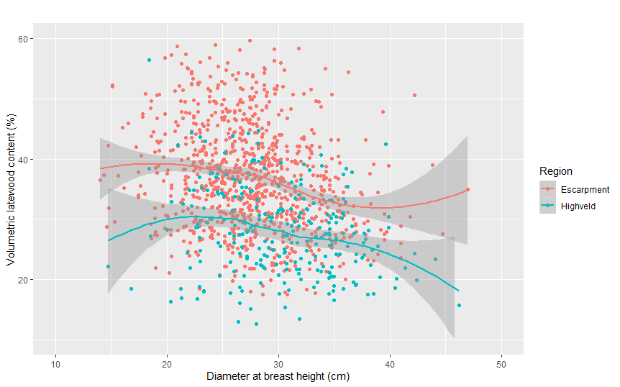

**Supplemental Figure S3:** Wood latewood content percentage plotted against diameter at breast height (DBH) and grouped according to the Lowveld Escarpment (Escarpment) and Highveld forestry regions of South Africa, including mean values and standard error. The data was sourced from x-ray densitometry measurements done on P. patula increment cores from a previous regional study (Van der Merwe et al. 2023a).

**Supplemental Table S1:** Implemented silviculture practices applied over the life cycle of the sample plots, including thinning and pruning activities.

|  |  |  |  |
| --- | --- | --- | --- |
| **Activity** | **Age** | **Aim** | **Method** |
| Establishment geometry | 0 years | 3 meters x 3 meters (1 111 seedlings per hectare) | Manual planting |
| First thinning | 10–13 years | Reduce remaining trees to 800 trees per hectare | Line thinning |
| Second thinning | 14–17 years | Reduce remaining trees to 500 trees per hectare | Selective thinning |
| First pruning | 3–5 years | Remove branches up to a height of 1.5 meters | Manual pruning saw |
| Second pruning | 5–7 years | Remove branches up to a height of 3.5 meters | Manual pruning saw |
| Third pruning | 7–10 years | Remove branches up to a height of 5.5 meters | Manual pruning saw |

**Supplemental Table S2:** Final dimensions of lumber boards produced during chipper canter milling.

|  |  |  |  |  |
| --- | --- | --- | --- | --- |
| **Thin-end diameter** | **Thickness x width** | | | |
| **38 mm x 114 mm** | **38 mm x 152 mm** | **50 mm x 152 mm** | **19 mm x 76 mm** |
| 11-12 cm | 0 | 0 | 0 | 4 |
| 13-14 cm | 1 | 0 | 0 | 2 |
| 15-16 cm | 2 | 0 | 0 | 2 |
| 17-19 cm | 2 | 1 | 0 | 0 |
| 20-21 cm | 0 | 3 | 0 | 2 |
| 22-25 cm | 0 | 1 | 2 | 2 |

**Supplemental Table S3:** Step by step imputation method, using the decision tree-based package 'missForest'.

|  |  |
| --- | --- |
| **Sequence** | **Action** |
| Step 1 – Identify the missing/ damaged boards | Missing/damaged boards were identified. At the mill, cutting patterns are assigned to logs according to diameter, as seen in Supplemental Table 3. Therefore, the difference in the present to non-present boards represent the missing/ damaged boards, which was lost. Rows were included into the data set according to these missing boards, while including the available log property data *i.e.* log diameter, taper, sweep, ovality etc. Columns were included to denote the board size according to “1” or “0”, for the column representing a specific board dimension. |
| Step 2 – Allocate lumber board to height position within the tree. | The log thin-end log position was specified as a height percentage within the tree by dividing the log thin-end height by the total tree height. Furthermore, the portion of the log that was pruned, dead crown or live crown was specified. The existing data for the tree that the board was produced from was specified including tree height, dead crown height, live crown height, diameter at 1.3 meters and predicted wood density at 1.3 meters. |
| Step 3 – Specify climate for the tree. | The seasonal climatic was specified for the respective trees according to existing climate models (Van der Merwe et al. 2023c. |
| Step 4 – Data structuring prior to imputation | Columns with missing values associated with the boards was left blank, while existing data associated with the board, log, tree and climatic conditions were included. Missing lumber board values included lumber wood density, modulus of elasticity (MOE), modulus of rupture (MOR), knot area, twist, bow and spring. |
| Step 5 – Imputation | The missing values were imputed using the ‘missForest’ algorithm and imputation accuracies were reported. |
| Step 6 – Determining lumber properties per tree | Lumber properties were volumetrically weighted per tree according to the recovered lumber volume. |

**Supplemental Table S4:** R-packages and functions, and their use in this study.

|  |  |
| --- | --- |
| **R-function** | **Use** |
| ‘qqPlot’ | Determine normality of residuals |
| ‘aov’ | Analysis of variance for tree form, wood properties, lumber recovery and qualtiy for the respective site types |
| **R-package** | **Use** |
| ‘lsmeans’ | Determining least square means and standard errors for tree forms and wood properties for the respective site types |
| ‘TukeyHSD’ | Determine the confidence intervals on the differences between the means, therefore which treatments are statistically different from one another |
| ‘rcompanion’ | Visualisation of principle component analysis |
| ‘lfda’ | Principle component analysis to determine collinearities, association and which variables to include in the final models |
| ‘ggfortify’ | Visualisation of principle component analysis |
| ‘GGally’ | Correlation matrix analysis |

**Supplemental Table S5:** Analysis of variance including sum of squares (Sum Sq), mean squares (Mean sq), F-values, probability values (P-values), and significance levels (Sign.). Independent variables investigated included soil, altitude, and the interaction between soil and altitude. Dependent variables are grouped according to tree and lumber attributes. Tree attributes included tree height, volume, slenderness coefficients (SC), taper (T), sweep (S), roundness, volumetric heartwood percentage (HP), wood density (Density), volumetric latewood percentage (LW) and live crown percentages (LC). Structural lumber attributes included net recovery of the processed logs (net recovery), moisture content percentage (MC), density (Density), modulus elasticity (MOE), modulus of rupture (MOR), knot size ratio, twist, bow and spring.

|  |  |  |  |  |  |  |  |
| --- | --- | --- | --- | --- | --- | --- | --- |
| **Focus** | **Dependent variable** | **Independent variable** | **Sum Sq** | **Mean Sq** | **F-value** | **P-value** | **Sign.** |
| Tree | Height | *Soil* | 722.0 | 361.0 | 63.0 | 0.000 | *** |
| *Altitude* | 3022.0 | 1007.4 | 175.9 | 0.000 | *** |
| *Soil x Altitude* | 1241.0 | 413.6 | 72.2 | 0.000 | *** |
| Volume | *Soil* | 0.3 | 0.1 | 6.7 | 0.001 | ** |
| *Altitude* | 2.3 | 0.8 | 39.7 | 0.000 | *** |
| *Soil x Altitude* | 2.0 | 0.7 | 33.3 | 0.000 | *** |
| SC | *Soil* | 14917.0 | 7458.0 | 70.0 | 0.000 | *** |
| *Altitude* | 38481.0 | 12827.0 | 120.3 | 0.000 | *** |
| *Soil x Altitude* | 6697.0 | 2232.0 | 20.9 | 0.000 | *** |
| Taper | *Soil* | 1.7 | 0.9 | 20.7 | 0.000 | *** |
| *Altitude* | 0.5 | 0.2 | 3.7 | 0.011 | * |
| *Soil x Altitude* | 0.1 | 0.0 | 0.5 | 0.663 | NS |
| Sweep | *Soil* | 1.4 | 0.7 | 21.6 | 0.000 | *** |
| *Altitude* | 0.2 | 0.1 | 2.3 | 0.082 | NS |
| *Soil x Altitude* | 0.2 | 0.1 | 2.2 | 0.092 | NS |
| Roundness | *Soil* | 0.0 | 0.0 | 18.0 | 0.000 | *** |
| *Altitude* | 0.0 | 0.0 | 23.3 | 0.000 | *** |
| *Soil x Altitude* | 0.0 | 0.0 | 3.6 | 0.014 | * |
| HP | *Soil* | 0.9 | 0.5 | 0.5 | 0.603 | NS |
| *Altitude* | 45.5 | 15.2 | 16.5 | 0.000 | *** |
| *Soil x Altitude* | 15.9 | 5.3 | 5.8 | 0.001 | *** |
| Density | *Soil* | 127736.0 | 63868.0 | 64.2 | 0.000 | *** |
| *Altitude* | 103522.0 | 34507.0 | 34.7 | 0.000 | *** |
| *Soil x Altitude* | 10977.0 | 3659.0 | 3.7 | 0.012 | * |
| LW | *Soil* | 4690.0 | 2345.1 | 65.3 | 0.000 | *** |
| *Altitude* | 3688.0 | 1229.3 | 34.2 | 0.000 | *** |
| *Soil x Altitude* | 413.0 | 137.6 | 3.8 | 0.010 | ** |
| LC | *Soil* | 3833.0 | 1916.3 | 19.8 | 0.000 | *** |
| *Altitude* | 7359.0 | 2452.9 | 25.4 | 0.000 | *** |
| *Soil x Altitude* | 1321.0 | 440.2 | 4.6 | 0.004 | ** |
| Lumber boards | Net recovery | *Soil* | 0.1 | 0.0 | 14.2 | 0.000 | *** |
| *Altitude* | 0.0 | 0.0 | 4.4 | 0.005 | ** |
| *Soil x Altitude* | 0.0 | 0.0 | 1.2 | 0.314 | NS |
| MC | *Soil* | 18.6 | 9.3 | 26.1 | 0.000 | *** |
| *Altitude* | 22.4 | 7.5 | 20.9 | 0.000 | *** |
| *Soil x Altitude* | 8.7 | 2.9 | 8.1 | 0.000 | *** |
| Density | *Soil* | 101884.0 | 50942.0 | 65.4 | 0.000 | *** |
| *Altitude* | 126396.0 | 42132.0 | 54.1 | 0.000 | *** |
| *Soil x Altitude* | 5584.0 | 1861.0 | 2.4 | 0.068 | NS |
| MOE | *Soil* | 122670586.0 | 61335293.0 | 49.2 | 0.000 | *** |
| *Altitude* | 179611449.0 | 59870483.0 | 48.1 | 0.000 | *** |
| *Soil x Altitude* | 5291038.0 | 1763679.0 | 1.4 | 0.237 | NS |
| MOR | *Soil* | 10152617.0 | 5076309.0 | 27.3 | 0.000 | *** |
| *Altitude* | 12512332.0 | 4170777.0 | 22.4 | 0.000 | *** |
| *Soil x Altitude* | 645044.0 | 215015.0 | 1.2 | 0.326 | NS |
| Knot size | *Soil* | 39370277.0 | 19685138.0 | 14.8 | 0.000 | *** |
| *Altitude* | 9353924.0 | 3117975.0 | 2.4 | 0.072 | NS |
| *Soil x Altitude* | 5541413.0 | 1847138.0 | 1.4 | 0.245 | NS |
| Twist | *Soil* | 23370.0 | 11685.0 | 13.8 | 0.000 | *** |
| *Altitude* | 2895.0 | 965.0 | 1.1 | 0.334 | NS |
| *Soil x Altitude* | 1006.0 | 335.0 | 0.4 | 0.757 | NS |
| Bow | *Soil* | 397.0 | 198.5 | 4.4 | 0.012 | * |
| *Altitude* | 1276.0 | 425.4 | 9.5 | 0.000 | *** |
| *Soil x Altitude* | 463.0 | 154.4 | 3.5 | 0.017 | * |
| Spring | *Soil* | 1947.0 | 973.4 | 5.4 | 0.005 | ** |
| *Altitude* | 559.0 | 186.4 | 1.0 | 0.378 | NS |
| *Soil x Altitude* | 746.0 | 248.8 | 1.4 | 0.249 | NS |

**Supplemental Table S6:** Means and standard error for tree variables including tree height, volume, slenderness coefficient, live crown percentage (LC), roundness, volumetric heartwood percentage (HP), wood density (density), and latewood percentage (LW), according to soil parent material and altitude. The first value in the dependent variable column shows the mean value and the second the standard error. Superscript represents Tukey significance.

|  |  |  |  |  |  |  |  |  |  |  |
| --- | --- | --- | --- | --- | --- | --- | --- | --- | --- | --- |
| **Region** | **Soil** | **Altitude** | **Height (m)** | **Volume (m³)** | **SC (.)** | **LC (%)** | **Roundness (.)** | **HP (%)** | **Density (kg/m³)** | **LW (%)** |
| Highveld | Granite | 1,500 – 1,699 | $$25.3±{0.3}^{b}$$ | $$0.514±{0.019}^{bcd}$$ | $$103±1^{b}$$ | 39.7 $±{1.3}^{de}$ | $$0.937±{0.002}^{ab}$$ | $$1.0±{0.1}^{bcd}$$ | $$449±4^{c}$$ | $$29.4±{0.8}^{c}$$ |
| 1,700 – 1,899 | $$25.8±{0.3}^{b}$$ | 0.542 $±{ 0.019}^{b}$ | $$102±1^{b}$$ | $$42.1±{1.3}^{d}$$ | $$0.940±{0.002}^{a}$$ | $$1.0±{0.1}^{bcd}$$ | $$459±4^{bc}$$ | $$31.4±{0.8}^{bc}$$ |
| Lowveld Escarpment | Dolomite | 1,100 – 1,299 | $$23.6±{0.3}^{c}$$ | $$0.455±{0.018}^{cde}$$ | $$98±1^{b}$$ | $$36.0±{1.3}^{e}$$ | $$0.945± {0.002}^{a}$$ | $$1.2±{0.1}^{bc}$$ | $$459±4^{bc}$$ | $$31.3±{0.8}^{bc}$$ |
| 1,300 – 1,499 | $$23.4±{0.3}^{c}$$ | 0.516 $±{ 0.018}^{bcd}$ | $$90±1^{c}$$ | 41.6 $±{1.3}^{de}$ | 0.940 $± {0.002}^{ab}$ | $$1.2±{0.1}^{b}$$ | $$499±4^{a}$$ | $$38.8±{0.8}^{a}$$ |
| 1,500 – 1,699 | 21.0 $± {0.3}^{d}$ | 0.439 $± {0.017}^{def}$ | $$84±1^{d}$$ | $$50.5±{1.2}^{ab}$$ | $$0.925±{0.002}^{d}$$ | $$0.8±{0.1}^{bcd}$$ | $$503±4^{a}$$ | $$39.8±{0.7}^{a}$$ |
| Shale | 1,100-1,299 | 30.5 $±{ 0.4}^{a}$ | $$0.746±{0.021}^{a}$$ | $$113±2^{a}$$ | $$43.1±{1.5}^{cd}$$ | $$0.935±{0.002}^{abc}$$ | $$1.9±{0.2}^{a}$$ | $$472±5^{b}$$ | $$33.8±{0.9}^{b}$$ |
| 1,300 – 1,499 | $$22.9±{0.3}^{c}$$ | 0.517 $± {0.020}^{bc}$ | $$89±2^{cd}$$ | $$47.1±{1.4}^{bcd}$$ | 0.928 $± {0.002}^{cd}$ | $$1.0±{0.1}^{bcd}$$ | $$511±4^{a}$$ | $$41.3±{0.8}^{a}$$ |
| 1,500 – 1,699 | $$20.3±{0.3}^{d}$$ | 0.409 $± {0.019}^{ef}$ | $$83±1^{d}$$ | $$48.6±{1.3}^{abc}$$ | $$0.923±{0.002}^{d}$$ | $$0.6±{0.1}^{cd}$$ | 499 $±4^{a}$ | $$38.9±{0.8}^{a}$$ |
| 1,700 – 1,899 | 17.8 $± {0.4}^{e}$ | 0.354 $±{ 0.021}^{f}$ | 72 $±2^{e}$ | $$52.0±{1.5}^{a}$$ | $$0.932±{0.002}^{bcd}$$ | $$0.4±{0.2}^{d}$$ | $$496±4^{a}$$ | 38.4 $±{0.9}^{a}$ |

**Supplemental Table S7:** Means and standard error for tree form variables including sweep and taper according to soil geology. The first value in the dependent variable column shows the mean value and the second the standard error. Superscript represents Tukey significance.

|  |  |  |  |
| --- | --- | --- | --- |
| **Region** | **Soil** | **Sweep (cm/m)** | **Taper (cm/m)** |
| Highveld | Granite | $$0.46±{0.02}^{c}$$ | $$0.37±{0.02}^{c}$$ |
| Lowveld Escarpment | Dolomite | $$0.62±{0.02}^{a}$$ | 0.46 $± {0.01}^{b}$ |
| Shale | $$0.56±{0.02}^{b}$$ | 0.52 $± {0.01}^{a}$ |

**Supplemental Table S8:** Means and standard error for tree taper according to altitude. The first value in the dependent variable column shows the mean value and the second the standard error. Superscript represents Tukey significance.

|  |  |
| --- | --- |
| **Altitude range (m)** | **Taper (cm/m)** |
| 1,100 – 1,299 | $$0.54±{0.02}^{c}$$ |
| 1,300 – 1,499 | $$0.61±{0.02}^{a}$$ |
| 1,500 – 1,699 | 0.57 $± {0.02}^{ac}$ |
| 1 700 – 1,899 | $$0.51±{0.02}^{c}$$ |