**Supplementary Material**

**Structural comparison of different isolated eucalyptus lignins and analysis of its their interaction mechanism with bovine serum albumin solution under QCM-D**

Haonan Zhang et al.

DOI 10.1515/hf-2022-0170

# Calculation of lignin C9 units and linkages based on 2D-HSQC NMR

## 1.1 C9 units and linkages of MWL and KL calculation formulas

2D HSQC NMR data were analyzed with Bruker topspin 4.0. According to the integration method in literature, cross-peaks G2 region of guaiacyl (G) signal was used as an internal standard to calculate the amount of C9 unit (Sette et al. 2011, Zhang et al. 2007).

The quantitative results from 2D HSQC NMR spectra are calculated based on per100 Ar (Li et al. 2018, Wen et al. 2013a, Wen et al. 2013b). Eucalyptus milled wood lignin (SMWL) and kraft lignin (SKL) is the G, S-type lignin, the total aromatic areas are defined as:

Eq. S1. C9 = G2 + 0.5S2,6

Eq. S2. G=G2/C9*100%

Eq. S3. S= 0.5S2,6/C9*100%.

Then, the quantitative contents of internal linkages are calculated as:

Eq. S4. β-O-4 (%) = (Aα)/C9*100%

Eq. S5. β-β (%) = 0.5 (Bα)/C9*100%

Eq. S6. β-5 (%) = (Cα)/C9*100%

Eq. S7. β-1 (%) = (Dα)/C9*100%.

## 1.2 C9 units and linkages of LC, LR and LP calculation formulas

Because the LC, LR and LP structure has been proven to be heavily grafted with phenolic derivatives, the cross-peak region G2 in the benzene ring of guaiacyl (G) unit in the original lignin has been shifted, and the cross-peak region G5 partially overlaps with this position. The G2 and G5 regions, however, are disturbed by other cross-peaks and no clear conclusions can be drawn. Besides, the mechanism of lignin grafting phenolic derivatives proved that benzyl carbocation normally located at the Cα side chain attacking the electron-rich position C5 of the guaiacyl (G) unit (the ortho position of the phenolic hydroxyl group) to form lignin self-condensation structures (AG). Therefore, the C9 unit of LC, LR and LP can no longer use the cross-peak region G2 or G5 as the internal standard. However, the G6 of the benzene ring in the MWL, LC, LR and LP all belong to the same independent signal region, and the C-H signals of benzene ring in the grafted phenolic derivatives do not belong to this region. In order to improve the accuracy of quantitative calculation, the cross-peak regions of position C6 is selected as the internal standard of the C9 unit after comparative analysis. 2D HSQC spectra were integrated using appropriate clusters of signals representative of all C9 phenyl propane units for semiquantification of aromatic and side chain ratios.

The total aromatic areas are defined as:

Eq. S8. C9 = G6 + GX6 + 0.5S2,6.

Contents of aromatic units are relative (%):

Eq. S11. G = (G6 + GX6)/C9*100%

Eq. S12. S = 0.5 S2,6/C9*100%.

Then, the quantitative contents of internal linkages are calculated as:

Eq. S15. A (%) = (Aα)/C9*100%

Eq. S16. B (%) = 0.5 (Bα)/C9*100%

Eq. S17. C (%) = (Cα)/C9*100%

Eq. S18. D (%) = (Dα)/C9*100%

Eq. S20. AX (%) = (AXα)/C9*100%

In the formula, X represents C, R and P in *p*-cresol, resorcinol and pyrogallol respectively.

# 2. Supplementary figures and tables

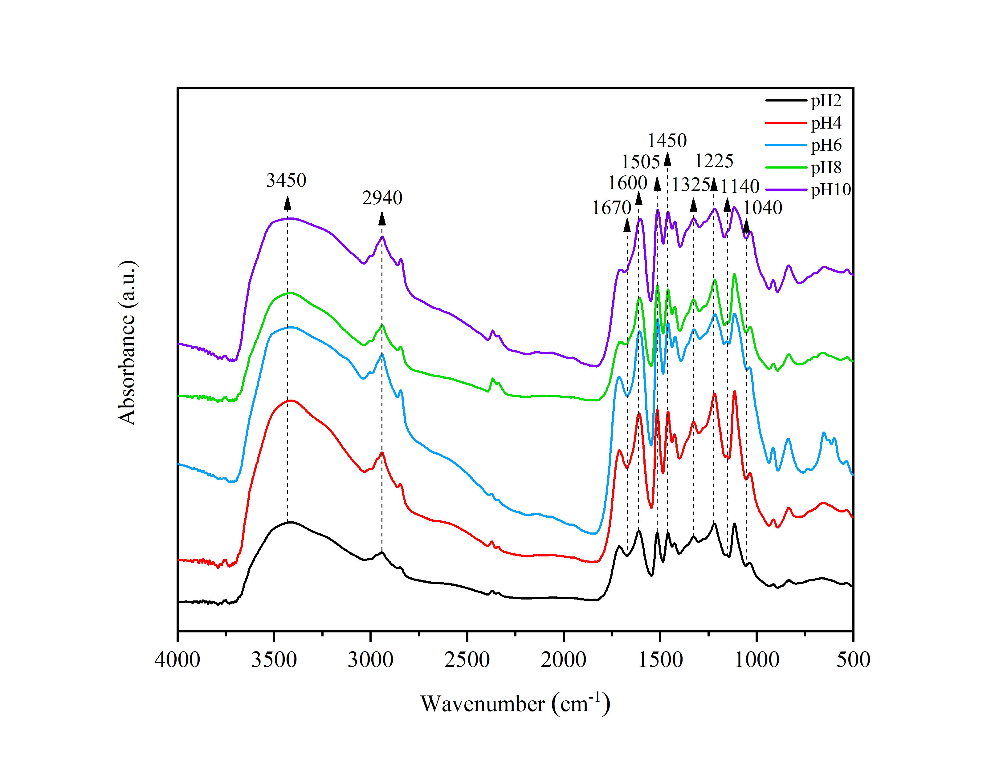

**Supplementary Figure S1:** The FT-IR spectra of kraft lignin classified at different pH.

|  |
| --- |
|  |

**Supplementary Figure S2:** Prediction of 2D-HSQC NMR signals (δC/δH ppm) of SC, GC, SR, GR, SP and GP structures with ChemBioDraw Ultra.



**Supplementary Figure S3:** Molecular weight of eucalyptus LC and 2nd derivatives.

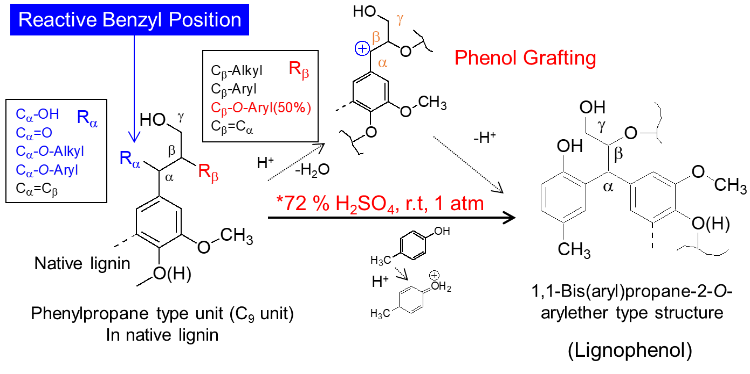

**Supplementary Figure S4:** Reaction path of lignin to lignophenols.

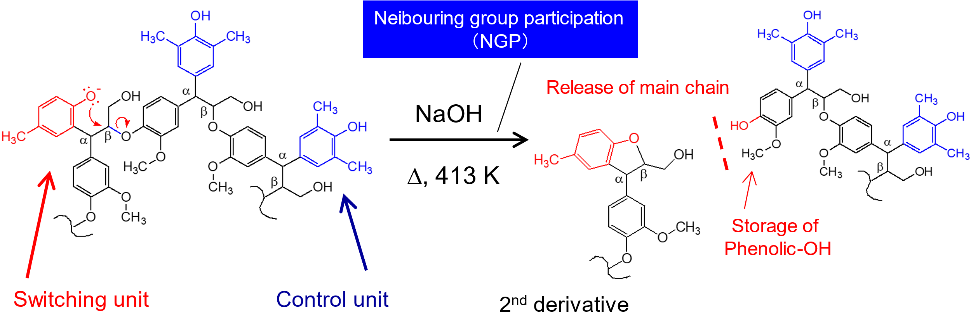

**Supplementary Figure S5:** Reaction path of LC to 2nd derivatives.

**Supplementary Table S1:** Composition analysis of eucalyptus (%).

|  |  |  |  |  |  |  |  |  |
| --- | --- | --- | --- | --- | --- | --- | --- | --- |
| **Species** | **Ash** | **Extract** | | | | **Klason lignin** | **Acid soluble lignin** | **Whole cellulose** |
| **Cold water** | **Hot water** | **Benzyl/alcohol** | **1%NaOH** |
| Australian eucalyptus | 0.30 | 2.81 | 3.47 | 1.81 | 14.07 | 21.81 | 2.40 | 81.42 |

## 

**Supplementary Table S2:** Assignments of the lignin 13C-1H correlation peaks in the 2D HSQC spectra of MWL, KL, LC, LR and LP.

| **Labels** | **δC/δH (ppm)** | **Assignment** |
| --- | --- | --- |
| ACα | 44.07/4.69  4.71  4.71  4.71 | Cα-Hα in β-O-4 substructures grafted *p*-cresol (AC) |
| ARα | 43.35/4.58 | Cα-Hα in β-O-4 substructures grafted resorcinol (AR) |
| APα | 43.83/4.59 | Cα-Hα in β-O-4 substructures grafted pyrogallol (AP) |
| Cβ | 52.98/3.41 | Cβ-Hβ in phenylcoumaran (C) |
| Bβ | 53.62/3.06 | Cβ-Hβ in β-β (resinol) (B) |
| OCH3 | 55.63/3.73 | C-H in methoxyls (OMe) |
| Aγ | 59.85/3.26 and 3.64 | Cγ-Hγ in β-O-4 substructures (A) |
| Dβ | 59.75/2.75 | Cβ-Hβ in β-1 spirodienone (D) |
| Fγ | 61.35/4.09 | Cγ-Hγ in cinnamyl alcohol end-groups (F) |
| Cγ | 62.20/3.75 | Cγ-Hγ in β-5 phenylcoumaran (C) |
| Bγ | 71.01/3.83 and 4.18 | Cγ-Hγ in β-β resinol (B) |
| Aα | 71.96/4.86 | Cα-Hα in β-O-4 unit (A) |
| Dα | 81.12 /5.08 | Cα-Hα in β-1 spirodienone (D) |
| Bα | 84.87/4.65 | Cα-Hα in β-β resinol (B) |
| Cα | 86.93/5.45 | Cα-Hα in β-5 phenylcoumaran (C) |
| Aβ(G/H) | 83.73/4.29 | Cβ-Hβ in β-O-4 linked to G (A) |
| Aβ(S) | 85.81/4.12 | Cβ-Hβ in acetylated β-O-4 linked to G (A) |
| A′β | 81.57/4.62 | Cβ-Hβ in α oxidized β-O-4 substructures linked to G unit (A) |
| S2,6 | 103.98/6.70 | C2-H2 and C6-H6 in syringyl units (S) |
| S′2,6 | 106.33/7.33 | C2-H2 and C6-H6 in oxidized (Cα=O) syringyl units (S′) |
| SC2,6 | 106.20/6.57 | C2-H2 and C6-H6 in condensed syringyl and *p*-cresol (SC) |
| SR2,6 | 106.05/6.55 | C2-H2 and C6-H6 in condensed syringyl and resorcinol (SR) |
| SP2,6 | 106.05/6.54 | C2-H2 and C6-H6 in condensed syringyl and pyrogallol (SP) |
| G2 | 110.92/6.99 | C2-H2 in guaiacyl units (G) |
| G5 | 115.0/6.95 and 6.71  118.7/6.78 | C5-H5 in guaiacyl units (G) |
| G6 | 118.92/6.79 | C6-H6 in guaiacyl units (G) |
| GP6 | 121.05/6.76 | C6-H6 in condensed guaiacyl and pyrogallol (GP6) |
| AC4′ | 126.77/6.75 | C4′-H4′ in β-O-4 substructures grafted *p*-cresol (AC4′) |
| AC6′ | 129.51/6.95 | C6′-H6′ in β-O-4 substructures grafted *p*-cresol (AC6′) |
| AR3′ | 102.08/6.23  118.7/6.78 | C3′-H3′ in β-O-4 substructures grafted resorcinol (AR3′) |
| AR5′ | 105.92/6.11  118.7/6.78 | C5′-H5′ in β-O-4 substructures grafted resorcinol (AR5′) |
| AR6′ | 129.65/6.99 | C6′-H6′ in β-O-4 substructures grafted resorcinol (AR6′) |
| AP5′ | 106.33/6.19 | C5′-H5′ in β-O-4 substructures grafted pyrogallol (AP5′) |
| AP6′ | 118.68/6.51 | C6′-H6′ in β-O-4 substructures grafted pyrogallol (AP6′) |

## 

**Supplementary Table S3:** Molecular weight of eucalyptus LC and 2nd derivatives.

|  |  |  |  |  |
| --- | --- | --- | --- | --- |
| **Samples** | **Yields of LC der. (%)** | **Mw** | **Mn** | **Mw/Mn** |
| Eucalyptus LC | - | 5319 | 3663 | 1.45 |
| 2nd deriv.120 ºC | 28 | 1798 | 1325 | 1.36 |
| 2nd deriv.140 ºC | 42 | 1227 | 1006 | 1.22 |
| 2nd deriv.170 ºC | 27 | 853 | 762 | 1.12 |

# References

Li, N., Li, Y., Yoo, C.G., Yang, X., Lin, X., Ralph, J., Pan, X. (2018). An uncondensed lignin depolymerized in the solid state and isolated from lignocellulosic biomass: a mechanistic study*.* Green Chemistry 20: 4224-4235.

Sette, M., Wechselberger, R., Crestini, C. (2011). Elucidation of lignin structure by quantitative 2D NMR*.* Chemistry 17: 9529-9535.

Wen, J.L., Sun, S.L., Xue, B.L., Sun, R.C. (2013a). Quantitative structural characterization of the lignins from the stem and pith of bamboo (*Phyllostachys pubescens*)*.* Holzforschung 67: 613–627.

Wen, J.L., Sun, S.L., Xue, B.L., Sun, R.C. (2013b). Recent advances in characterization of lignin polymer by solution-state nuclear magnetic resonance (NMR) methodology*.* Materials 6: 359–391.

Zhang, L., Gellerstedt, G. (2007). Quantitative 2D HSQC NMR determination of polymer structures by selecting suitable internal standard references*.* Magnetic Resonance in Chemistry 45: 37-45.