Supplementary Material
Synergistic improvement to dimensional stability of Populus cathayana via hemicellulose removal/alkali lignin impregnation
Meng Yang et al.
DOI 10.1515/hf-2022-0147

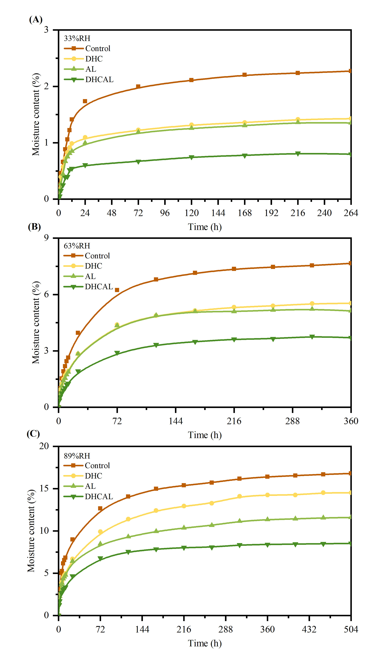
Supplementary Figure S1: Moisture adsorption processes under different RH conditions (25℃).
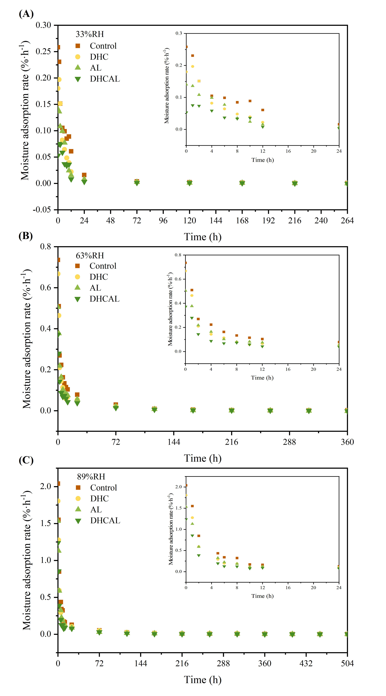
Supplementary Figure S2: Moisture adsorption rates under different RH conditions (25℃).

