**Supplementary Material**

**Flexural behavior of wood in the transverse direction investigated using novel computer vision and machine learning approach**

Shuoye Chen et al.

DOI 10.1515/hf-2022-0096

**Supplementary Table S1:** The detailed augmentation data for model training.

|  |  |
| --- | --- |
| **Parameters used for data augmentation** | **Value** |
| Rotation range | 0.2 |
| Width shift range | 0.05 |
| Height shift range | 0.05 |
| Shear range | 0.05 |
| Zoom range | 0.05 |
| Horizontal flip | True |
| Vertical flip | False |
| Fill mode | Nearest |

**Supplementary Figure S1:** Comparison between large image prediction with and without patch blending algorithm: (a) large image prediction without patch blending algorithm, (b) large image prediction with patch blending algorithm. The yellow arrows indicate the artifacts between two predicted patches.

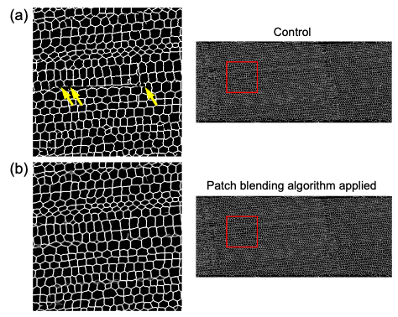

**Supplementary Figure S2:** Illustration and observed results indicating the changes in eccentricity and fitted ellipse aspect ratio are depended on the original shape of the cell wall: (a) theoretical explanation, (b) experimental explanation. The cells were located in the tension part of flat-sawn specimen. The horizontal tension of the wood cell wall induced both an increase in the eccentricity and fitted ellipse aspect ratio of horizontal ellipse-shaped cell and a decrease in the eccentricity and fitted ellipse aspect ratio of vertical ellipse-shaped cell.

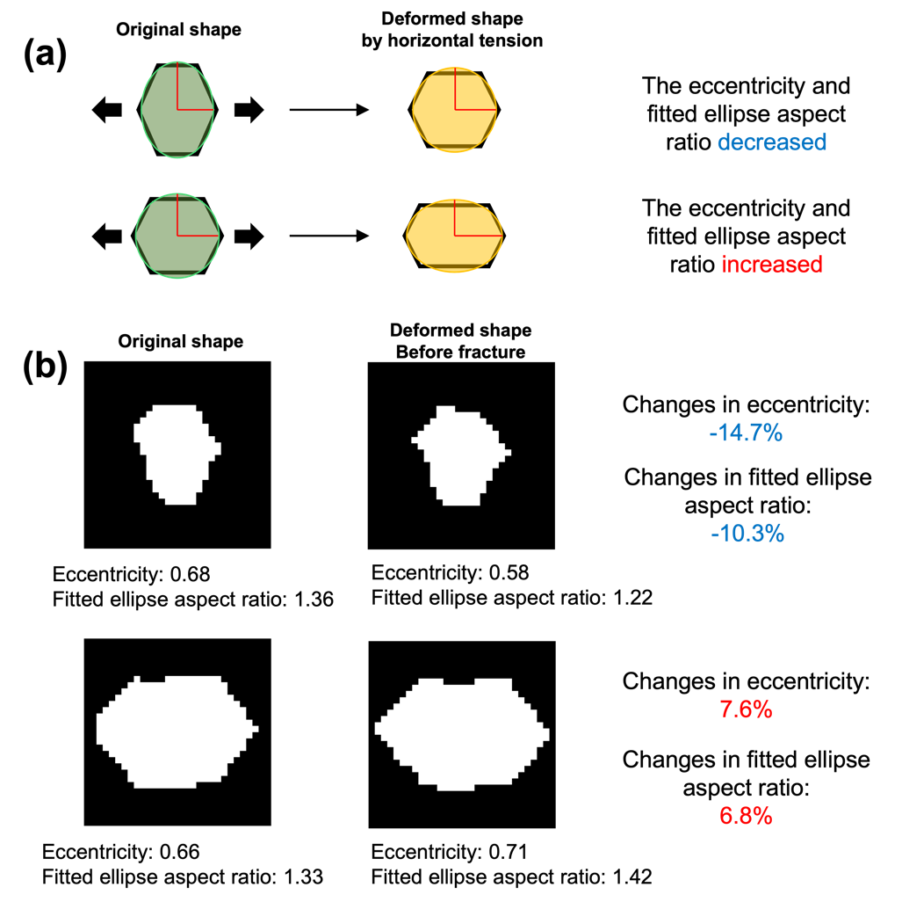

**Supplementary Figure S3:** Intensity of cell wall deformation of flat-sawn specimens during micro three-point bending test evaluated by cell eccentricity, fitted ellipse aspect ratio and bounding box aspect ratio: (a, b, c) changes in eccentricity (%), (d, e, f) changes in fitted ellipse aspect ratio (%), (g, h, i) changes in bounding box aspect ratio (%); (a, d, g) elastic region, (b, e, h) plastic region, (c, f, i) before fracture. The mixture of significant increases and decreases in eccentricity were concentrated in the tension part of the specimen (Supplementary Figure S3b, c). For the same reason, a similar situation was observed in the case of changes in the fitted ellipse aspect ratio (Supplementary Figure S3e, f). For the bounding box aspect ratio (Supplementary Figure S3h, i), the results for the cells located in the central part of the specimen are reasonable. The increase and decrease in the bounding box aspect ratio were observed in the compression part and tension part, respectively. However, the bending test caused the curvature of the specimens, which changed the orientation of the cells located in the surrounding part of the specimens, and thus influenced the reliability of the specimens’ measured bounding box aspect ratio.

**Supplementary Figure S4:** Intensity of cell wall deformation of quarter-sawn specimens during micro three-point bending test evaluated by cell area, eccentricity, and fitted ellipse aspect ratio: (a, b, c) changes in area (%), (d, e, f) changes in eccentricity (%), (g, h, i) changes in fitted ellipse aspect ratio (%); (a, d, g) elastic region, (b, e, h) plastic region, (c, f, i) before fracture. The minor changes in the cell area varied even in the plastic region and before the fracture. And similar to the flat-sawn specimens in Supplementary Figure S3, the changes in the cell eccentricity and fitted ellipse aspect ratio are strongly depended on the original shape of the cells, and both an increase and decrease in the eccentricity and fitted ellipse aspect ratio were observed in the compression and tension part of the specimen, which indicates that these parameters may not be suitable (Supplementary Figure S4e, f, h, i).

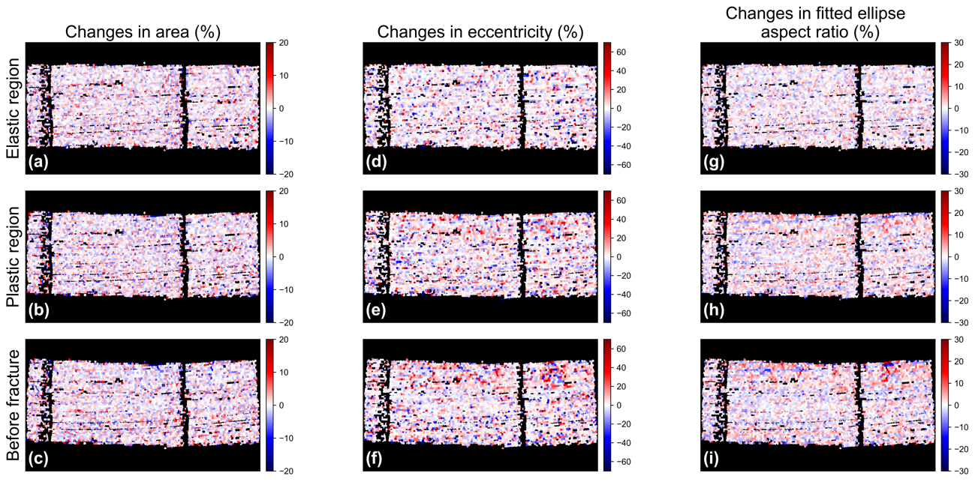

**Supplementary Figure S5:** Intensity of cell wall deformation of rift-sawn specimens during micro three-point bending test evaluated by cell area, eccentricity and bounding box aspect ratio: (a, b, c) changes in area (%), (d, e, f) changes in eccentricity (%), (g, h, i) changes in bounding box aspect ratio (%); (a, d, g) elastic region, (b, e, h) plastic region, (c, f, i) before fracture. The decrease in area was observed both in the compression part and tension part and corresponds to the region exhibiting an increase in eccentricity. Those two parameters were suitable for deformation evaluation. For the bounding box aspect ratio, the changes in the cell orientation led to unreliable cell deformation results (Supplementary Figure S5h, i), as in the case of the flat-sawn specimens.

