**Supplementary material**

**Estimating moisture content variation in kiln dried Pacific coast hemlock**

Sohrab Rahimi et al.

DOI 10.1515/hf-2021-0080

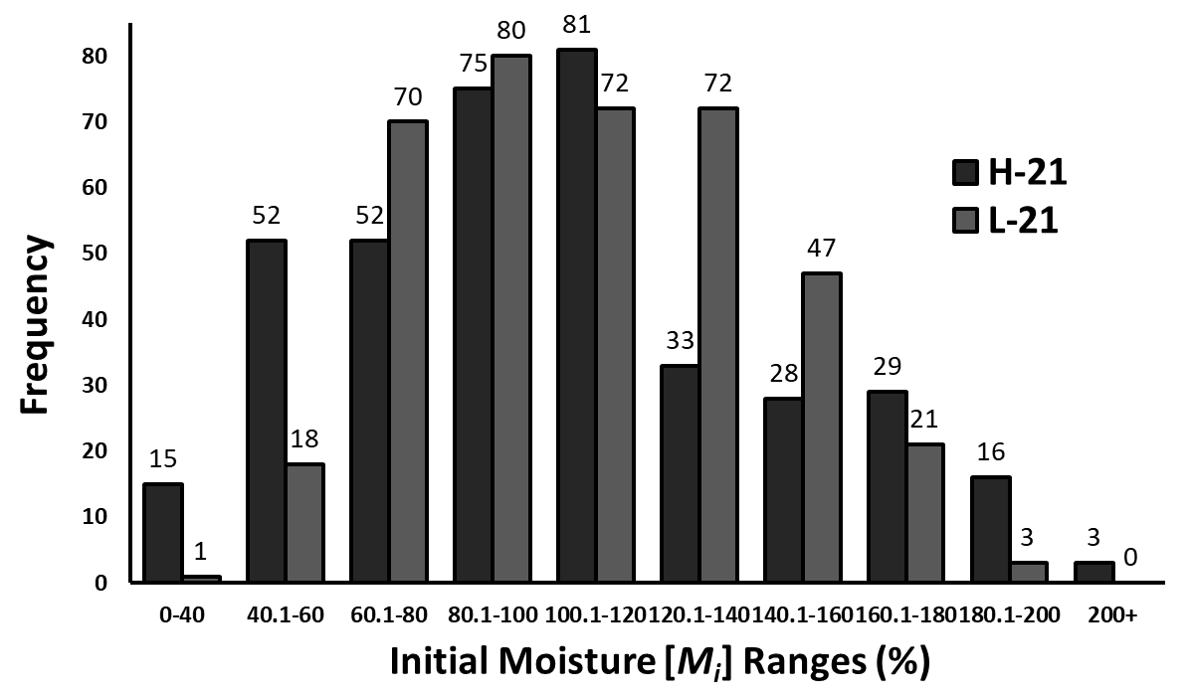

**Supplementary Figure ‎1:** The distributions of Mi in the first (H-21) and second (L-21) drying runs where histogram bars of H-21 are greater than those of L-21 in low (left side) and high (right side) *Mi* classes, which indicates high Mi variation. Also, *Mi* is more right-skewed for H-21 because of the presence of timbers with extremely high *Mi*.

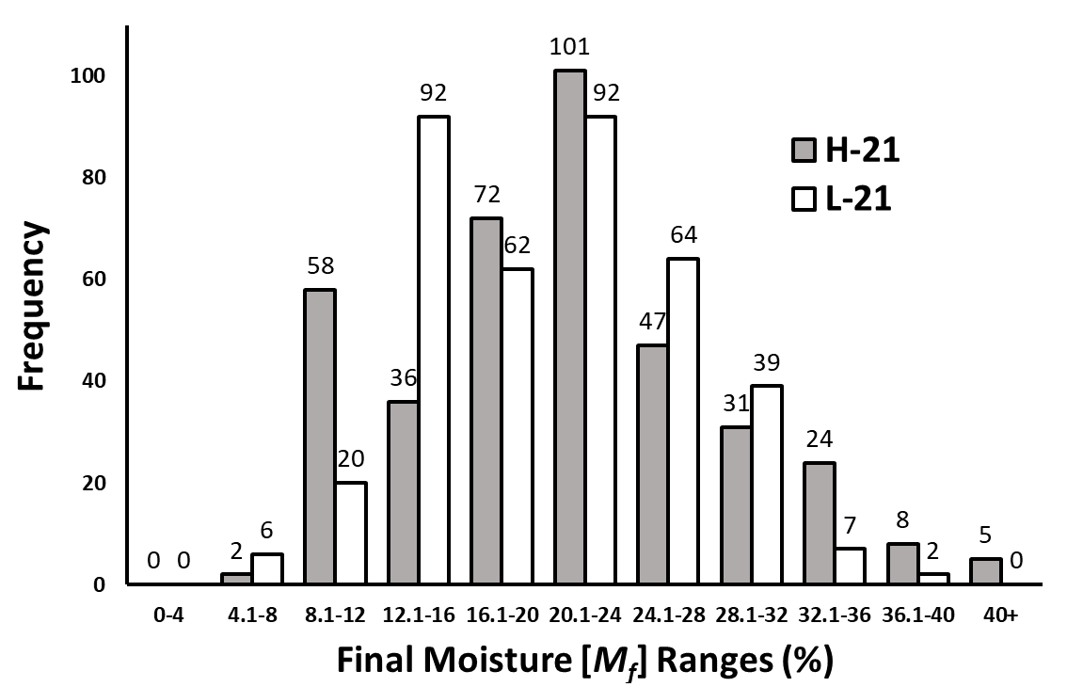

**Supplementary Figure 2:** The distributions of *Mf* in the first (H-21) and second (L-21) drying runs where histogram bars of H-21 are greater than those of L-21 in low (left side) and high (right side) *Mf* classes, which indicates high *Mf* variation. Also, *Mf* is slightly right-skewed because of high *Mt*.

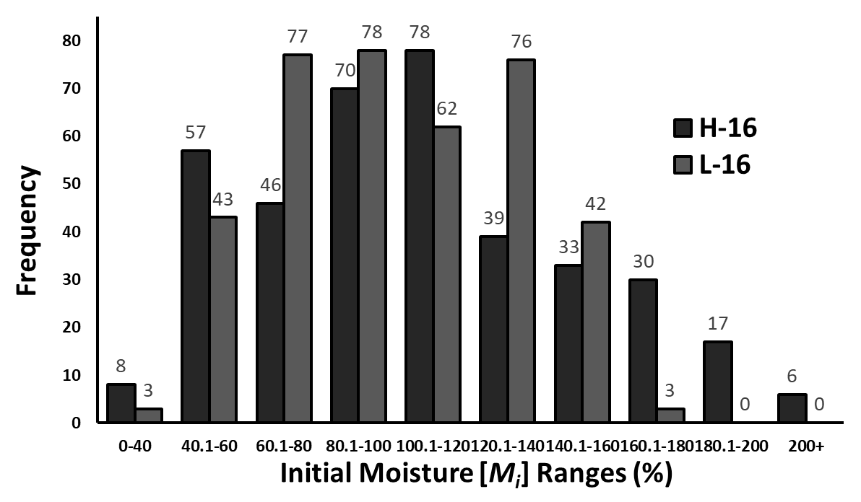

**Supplementary Figure 3:** The distributions of *Mf* in the third (H-16) and fourth (L-16) drying runs where histogram bars of H-16 are greater than those of L-16 in low (left side) and high (right side) *Mf* classes, which indicates high *Mf* variation. Also, *Mi* is more right-skewed for H-16 because of the presence of timbers with extremely high *Mi*.

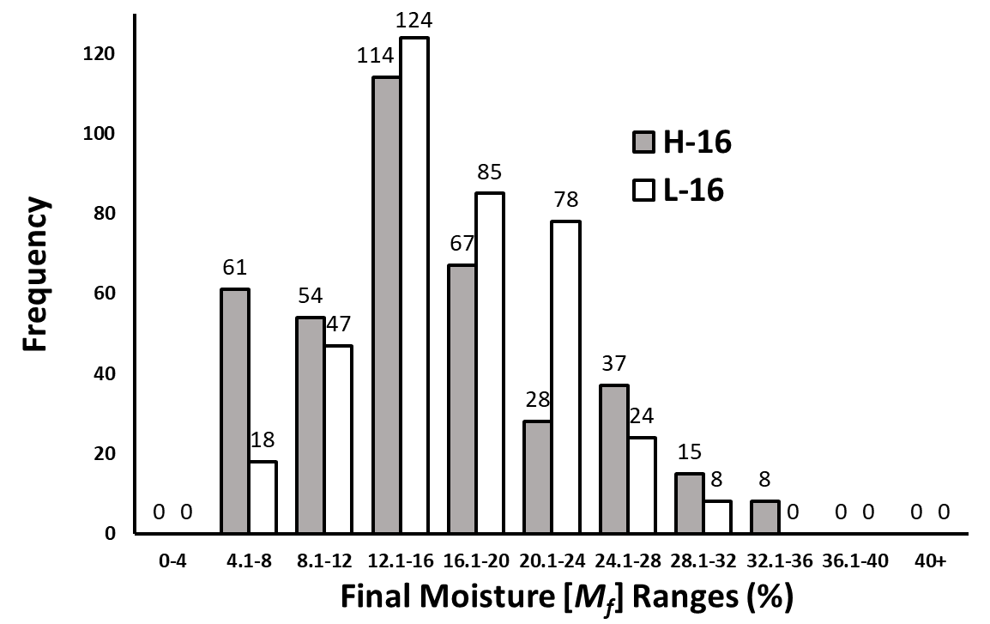

**Supplementary Figure 4:** The distributions of Mf in the third (H-16) and fourth (L-16) drying runs where histogram bars of H-16 are greater than those of L-16 in low (left side) and high (right side) *Mf* classes, which indicates high *Mf* variation. Also, *Mf* is right-skewed because of medium *Mt*.

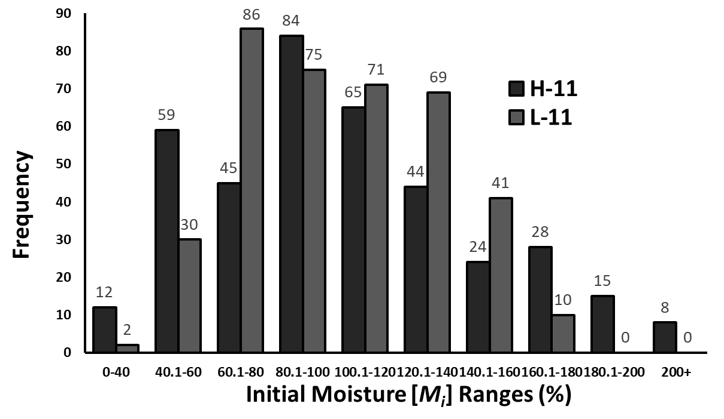

**Supplementary Figure 5:** The distributions of *Mi* in the fifth (H-11) and sixth (L-11) drying runs where histogram bars of H-11 are greater than those of L-11 in low (left side) and high (right side) *Mi* classes, which indicates high *Mi* variation. Also, *Mi* is more right-skewed for H-11 because of the presence of timbers with extremely high *Mi*.

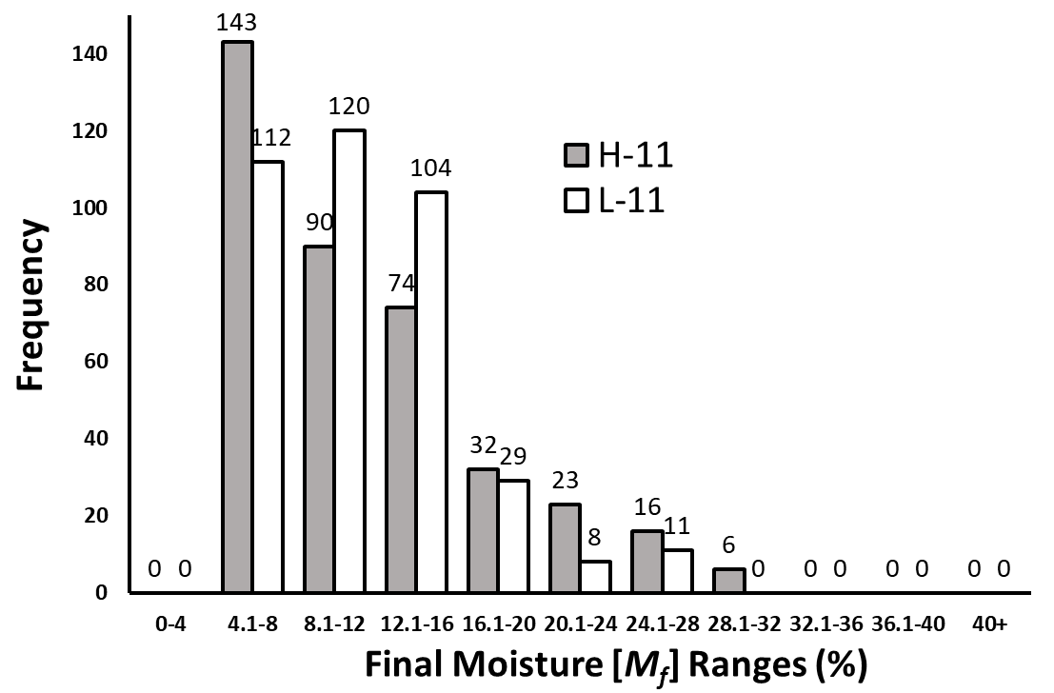

**Supplementary Figure 6:** The distributions of *Mf* in the fifth (H-11) and sixth (L-11) drying runs where histogram bars of H-11 are greater than those of L-11 in low (left side) and high (right side) *Mf* classes, which indicates high *Mf* variation. Also, *Mf* is highly right-skewed because of low *Mt*.