**Supplementary material**

Investigation of the effect of aging on wood hygroscopicity by 2D 1H NMR relaxometry

Leila ROSTOM, Denis COURTIER-MURIAS, Stéphane RODTSand Sabine CARE

DOI 10.1515/hf-2019-0052

**Relationship between EMC by weighing, ${EMC}_{w,x\text{\%}\text{RH}}$ and by NMR experiments, ${EMC}_{NMR,x\text{\%}\text{RH}}$**

As explained in the section “Materials and Methods”, ${EMC}_{NMR,x\text{\%}\text{RH}}$ can be calculated with Eq. 4, as a function of ${EMC}_{w,x\text{\%}\text{RH}}$. The dry mass $M_{dry}$ is determined from the mass of samples at 65%RH by weighing and the mass of water in samples at 65%RH NMR experiments (see Eq. 3). The results for each studied sample are given in Figure S1.

Furthermore, from the mass at 2%RH obtained by weighing Mw,2%RH and the dry mass Mdry calculated with Eq. 3, it is possible to calculate Mw,2%RH / Mdry and ${EMC}_{2\%RH}$ (see Table S1). Note that the ${EMC}_{2\%RH}$ represents EMC related to dry mass at 2%RH. Thanks to these two values, a modeling between ${EMC}_{NMR,x\text{\%}\text{RH}}$ and ${EMC}_{w,x\text{\%}\text{RH}}$.can be given for modern and historic wood materials:

For modern wood: ${EMC}_{NMR,x\%RH}={EMC}_{w, x\%RH}*1.02+1.7$ (S1)

For historic wood: ${EMC}_{NMR,x\%RH}={EMC}_{w, x\%RH}*1.02+2.3$ (S2)

Comparisons between experimental data for each sample and the obtained modeling are given in Figure S1. The average difference between experimental data and predicted data is about 0.4% for modern wood and 0.5% for historic wood. It seems to be slightly higher than the evaluated uncertainties of measurements, but it can be explained by the fact that for some samples, the modeling does not match well with the experimental value. These data may be outliers, as for expressed for the historic or modern wood samples subjected to thermal treatment for 7 days. However, the agreement between these proposed laws (Eq. S1 or Eq. S2) and the experimental data may be considered as very good.

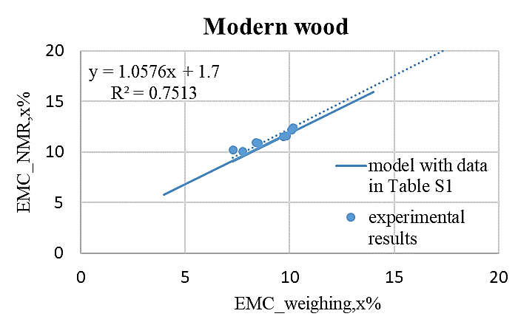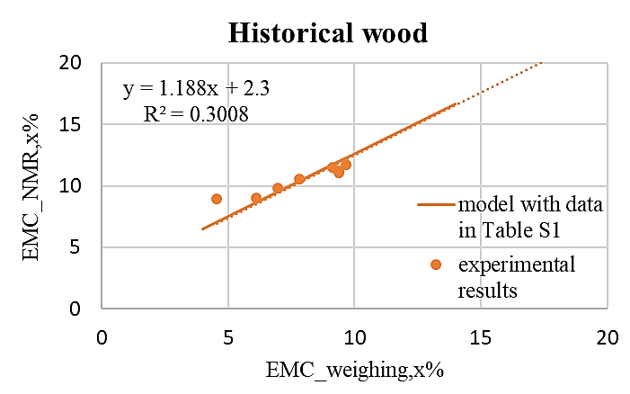

**Figure S1:** Experimental results for ${EMC}_{NMR,65\text{\%}\text{RH}}$ as a function of ${EMC}_{w,65\text{\%}\text{RH}}$. Comparison with the modeling, Eq. S1 and Eq. S2.

**Table S1:** Average mass at 2%RH, Mw,2%RH, dry mass Mdry, Mw,2% / Mdry and ${EMC}_{2\%RH}$ for samples before and after hydric or thermal loads

|  |  |  |  |  |
| --- | --- | --- | --- | --- |
|  | Mass at 2% RH [g]  M2%RH, Mean (SD) | Dry Mass [g]  Mdry, Mean (SD) | Mw,2%RH/Mdry  [-] | EMC2%RH  [%] |
| Modern wood | 0.5835 (0.06) | 0.5738 (0.06) | 1.02 | 1.7 |
| Historic wood | 0.4228 (0.04) | 0.4130 (0.05) | 1.02 | 2.3 |

**Hydric deformation in relation with the moisture content EMC**

As hydric strains may be considered as an indicator of the evolution of the hygroscopicity of wood materials subjected to aging, the dimensions of the samples have been measured at 2% RH, 97% RH and before and after hydric and thermal loadings at 65% RH.

The variation of the samples’ volume between x% RH (65% or 97%) and 2% RH, noted $∆V$ as a function of the variation of mass of the samples between x% RH (65% or 97%) and 2% RH, noted $∆m$ are given in Figure S2. These results showed that the variation of volume is linear with the variation of mass for all samples, without change of the slope of the line before and after aging. In this case, the correlation line logicallypasses through the origin (Figure S2).

If hydric strains (still related to the state at 2% RH) are plotted against EMC related to dry mass, the hydric strains for modern and historical wood materials vary linearly with the moisture content and the abscissa of EMC without variation of volume is then equal to the EMC at 2% RH (Figure S3). The two proposed laws were estimated by means of linear regression analysis obtained from all the results, taking into account the abscissa EMC2%RH (1.7% for modern wood and 2.3% for historic wood). As the slope $β$ of the linear law remains the same before and after aging, the variation of the hydric strains $∆ε$ of the wood materials verifies (Eq. S3):

|  |  |
| --- | --- |
| $$∆ε= β.\left(∆EMC\left(B+C\right)\right)=β.(∆EMC\left(B)+∆EMC(C\right))$$ | (S3) |

where $∆EMC\left(B+C\right)$, $∆EMC\left(B\right)$, $∆EMC\left(C\right)$ represent the variation of moisture content for B+C, B and C.

So, the contribution of each bound water compartment (B or C) on the decrease of hydric deformation at 65%HR after aging may be evaluated by $∆EMC(B or C)$ divided by $∆EMC\left(B+C\right)$.

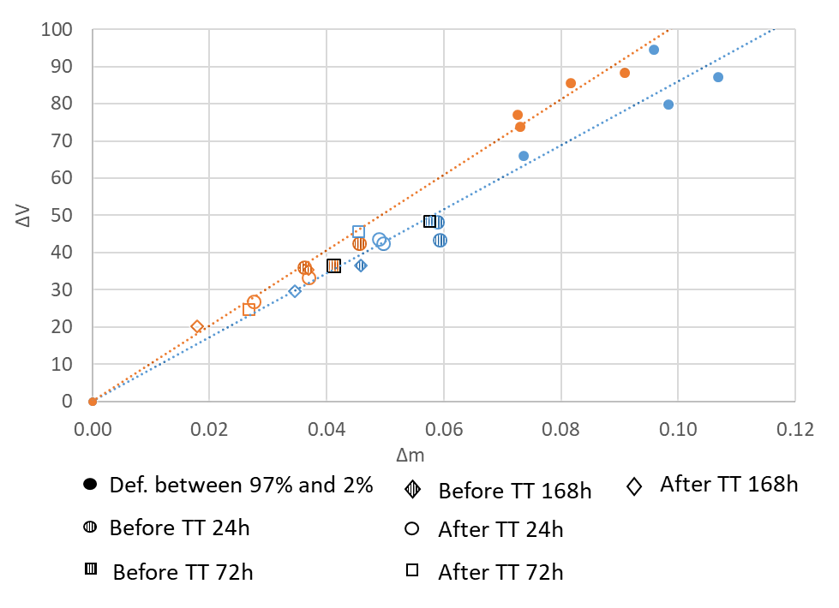

**Figure S2:** Variation of the sample volume between x% RH (65% or 97%) and 2%RH, noted ΔV as a function of the variation of mass of the samples between x% RH (65% or 97%) and 2%RH, noted Δm for modern and historic wood materials.

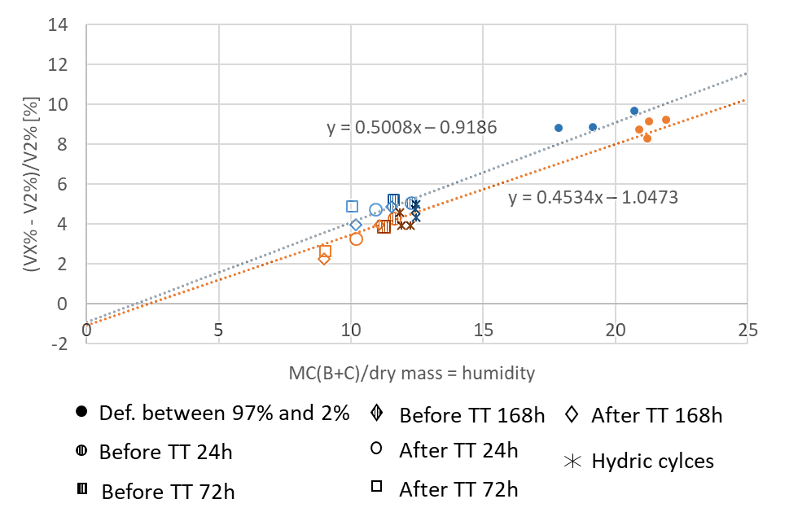

**Figure S3:** Hydric strains related to the state at 2% RH plotted against the moisture content obtained using NMR experiments (Eq. 4) ${EMC}_{NMR,x\%RH}$ for samples before, after thermal treatments, and for the samples subjected to repeated hydric cycles (at 65% RH). The values of the EMC at 97%HR related to dry mass are calculated from Eq. S1 and Eq. S2. In blue the modern wood, in orange the historical wood.