Supporting Information
Synthesis, crystal structure, molecular docking studies and bio-evaluation of some N⁴-benzyl substituted isatin-3-thiosemicarbazones as antiurease and antiglycating agents
Humayun Pervez,^{*,a} Nazia Khan,ª Jamshed Iqbal,^{b} Sumera Zaib,^{b,c} Muhammad Yaqub,ª Muhammad Nawaz Tahir,^{d} Muhammad Moazzam Naseer^{*, e}
ªInstitute of Chemical Sciences, Organic Chemistry Division, Bahauddin Zakariya University, Multan 60800, Pakistan
^{b}Centre for Advanced Drug Research, COMSATS Institute of Information Technology, Abbottabad 22060, Pakistan
^{c}Department of Bioinformatics & Biotechnology, International Islamic University, Islamabad 44000, Pakistan
^{d}Department of Physics, University of Sargodha, Sargodha 45320, Pakistan
^{e}Department of Chemistry, Quaid-i-Azam University, Islamabad 45320, Pakistan

Correspondence: pdhpervez@hotmail.com (H. Pervez); moazzam@qau.edu.pk (M.M. Naseer)

Table of Contents:
- Figure S1.The proposed fragmentation pattern of compound 5i.
- Table S1.Crystallographic data of 5h
- Table S2.Growth inhibition of Lemna aequinocitalis by compounds 5a-o at different concentrations
- Table S3.Brine shrimp (Artemia salina) lethality bioassay for compounds 5a-o
- Table S4.Free binding energy and ADME profile of compounds 5a-o
- Copies of representative ¹H, ¹³C NMR & Mass Spectra.

Figure S1.The proposed fragmentation pattern of compound 5i.

Table S1.Crystallographic data of 5h
Crystal data | 5h
CCDC | 1005938
Chemical formula | C₁₆H₁₃FN₄OS
M_{r} | 328.36
Crystal system, space group | Monoclinic, P2₁/c
Temperature (K) | 296
a, b, c (Å) | 13.9633 (14), 13.7855 (14), 8.2234 (8)
β (°) | 91.048 (7)
V (Å³) | 1582.7 (3)
Z | 4
Radiation type | Mo Kα
μ (mm⁻¹) | 0.22
Crystal size (mm) | 0.32 × 0.28 × 0.25
Data collection
Diffractometer | Bruker Kappa APEXII CCD
Absorption correction | Multi-scan  (SADABS; Bruker, 2005)
T_{min}, T_{max} | 0.934, 0.944
No. of measured, independent and  observed [I> 2σ(I)] reflections | 13380, 3757, 2343
R_{int} | 0.053
(sin θ/λ)_{max} (Å⁻¹) | 0.659
Refinement
R[F²> 2σ(F²)], wR(F²), S | 0.055, 0.134, 1.02
No. of reflections | 3757
No. of parameters | 208
H-atom treatment | H-atom parameters constrained
Δ⟩_{max}, Δ⟩_{min} (e Å⁻³) | 0.29, -0.23

Table S2.Growth inhibition of Lemna aequinocitalis by compounds 5a-oª at different concentrations
Compound | R | 1000  µg/mL  (% G.I) | 100  µg/mL  (% G.I) | 10  µg/mL  (% G.I) | 500  µg/mL  (% G.I) | 50  µg/mL  (% G.I) | 5  µg/mL  (% G.I)
5a | C₆H₅ | − | − | − | 10 | 00 | 00
5b | 2-CH₃C₆H₄ | 100 | 75 | 00 | − | − | −
5c | 3-CH₃C₆H₄ | 10 | 00 | 00 | − | − | −
5d | 4-CH₃C₆H₄ | 15 | 05 | 00 | − | − | −
5e | 2-CH₃OC₆H₄ | 00 | 00 | 00 | − | − | −
5f | 3-CH₃OC₆H₄ | − | − | − | 00 | 00 | 00
5g | 4-CH₃OC₆H₄ | 10 | 05 | 00 | − | − | −
5h | 2-FC₆H₄ | − | − | − | 10 | 00 | 00
5i | 3-FC₆H₄ | 00 | 00 | 00 | − | − | −
5j | 4-FC₆H₄ | 10 | 00 | 00 | − | − | −
5k | 2-ClC₆H₄ | 05 | 00 | 00 | − | − | −
5l | 3-ClC₆H₄ | 15 | 00 | 00 | − | − | − |  | −
5m | 4-ClC₆H₄ | − | − | − | 00 | 00 | 00
5n | 2,4-(Cl)₂C₆H₃ | 10 | 05 | 00 | − | − | −
5o | 3,4-(Cl)₂C₆H₃ | 10 | 05 | 00 | − | − | −
ª The standard drug, paraquat, shows 100% growth inhibition at a concentration of 0.015 µg/mL. G.I: Growth inhibition.
Table S3.Brine shrimp (Artemia salina) lethality bioassay for compounds 5a-o ª

Compound | R | LD₅₀ (M)
5a | C₆H₅ | >3.22 x 10⁻⁴
5b | 2-CH₃C₆H₄ | 3.63 x 10⁻⁵
5c | 3-CH₃C₆H₄ | >3.08 x 10⁻⁴
5d | 4-CH₃C₆H₄ | >3.08 x 10⁻⁴
5e | 2-CH₃OC₆H₄ | >2.94 x 10⁻⁴
5f | 3-CH₃OC₆H₄ | >2.94 x 10⁻⁴
5g | 4-CH₃OC₆H₄ | >2.94 x 10⁻⁴
5h | 2-FC₆H₄ | >3.04 x 10⁻⁴
5i | 3-FC₆H₄ | >3.04 x 10⁻⁴
5j | 4-FC₆H₄ | 2.90 x 10⁻⁵
5k | 2-ClC₆H₄ | >2.90 x 10⁻⁴
5l | 3-ClC₆H₄ | >2.90 x 10⁻⁴
5m | 4-ClC₆H₄ | >2.90 x 10⁻⁴
5n | 2,4-(Cl)₂C₆H₃ | >2.64 x 10⁻⁴
5o | 3,4-(Cl)₂C₆H₃ | 2.31 x 10⁻⁴
Etoposide ^{b} |  | 1.27 x 10⁻⁵
ª Tested at 100, 10, 1 µg/mL; ^{b} The reference anticancer drug.
Table S4.Free binding energy and ADME profile of compounds 5a-o
Compound | Free binding energy | MilogP | TSPA | MW | n_{ON} | n_{OHNH}
5a | -18.0136 | 2.89 | 69.28 | 310.38 | 5 | 3
5b | -19.0561 | 2.87 | 69.28 | 294.36 | 5 | 3
5c | -18.4487 | 3.31 | 69.28 | 324.41 | 5 | 3
5d | -17.8803 | 3.34 | 69.28 | 324.41 | 5 | 3
5e | -19.2291 | 2.90 | 78.51 | 340.41 | 6 | 3
5f | -21.5280 | 2.92 | 78.51 | 340.41 | 6 | 3
5g | -17.1525 | 2.95 | 78.51 | 340.41 | 6 | 3
5h | -18.9164 | 3.01 | 69.28 | 328.37 | 5 | 3
5i | -18.0512 | 3.03 | 69.28 | 328.37 | 5 | 3
5j | -16.9227 | 3.05 | 69.28 | 328.37 | 5 | 3
5k | -19.1458 | 3.52 | 69.28 | 344.83 | 5 | 3
5l | -17.9514 | 3.54 | 69.28 | 344.83 | 5 | 3
5m | -18.1326 | 3.57 | 69.28 | 344.83 | 5 | 3
5n | -17.8227 | 4.17 | 69.28 | 379.27 | 5 | 3
5o | -17.3433 | 4.17 | 69.28 | 379.27 | 5 | 3
MiLogP = octanol/water partition coefficient; TPSA = Topological Polar Surface Area; MW = molecular weight; nON = number of hydrogen acceptors; nOHNH = number ofhydrogen donors.

¹H-NMR spectrum of 5a
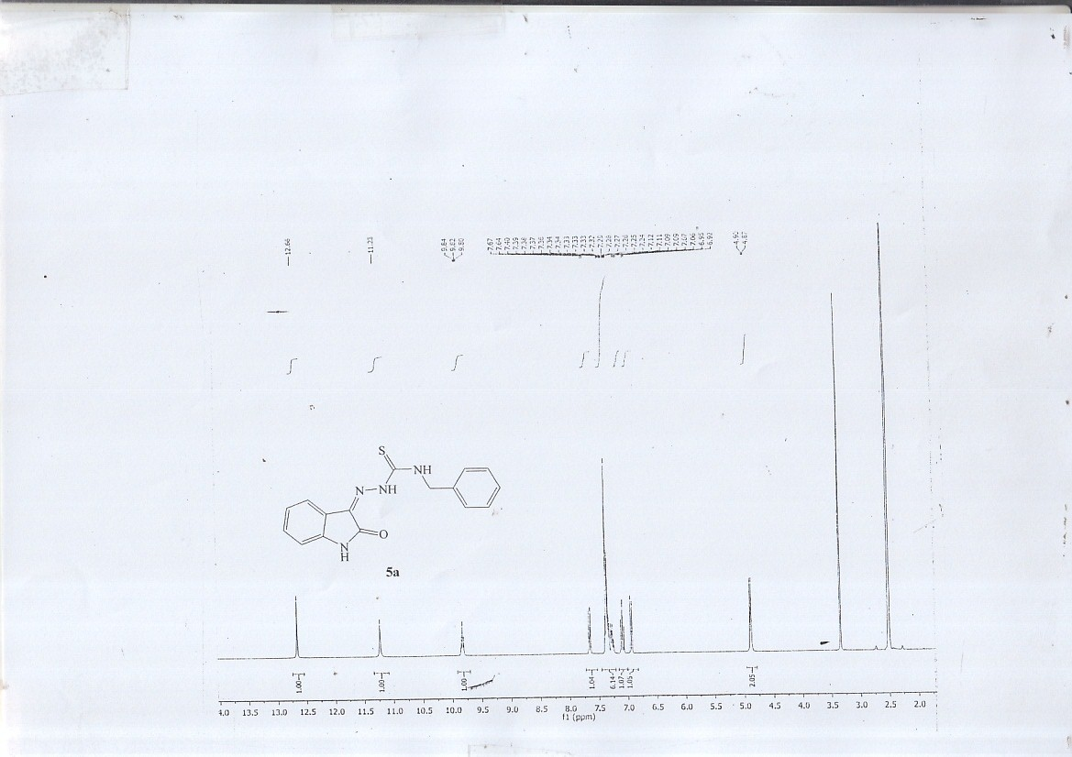

¹H-NMR spectrum of 5c
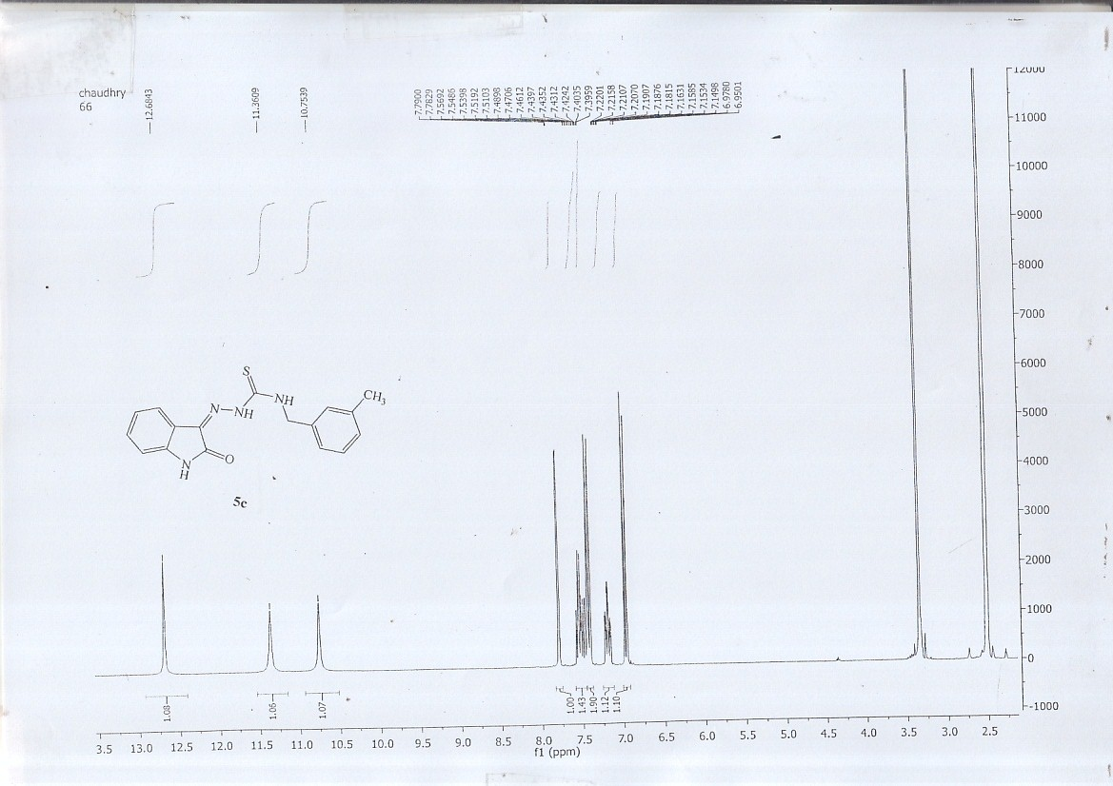

¹H-NMR spectrum of 5f
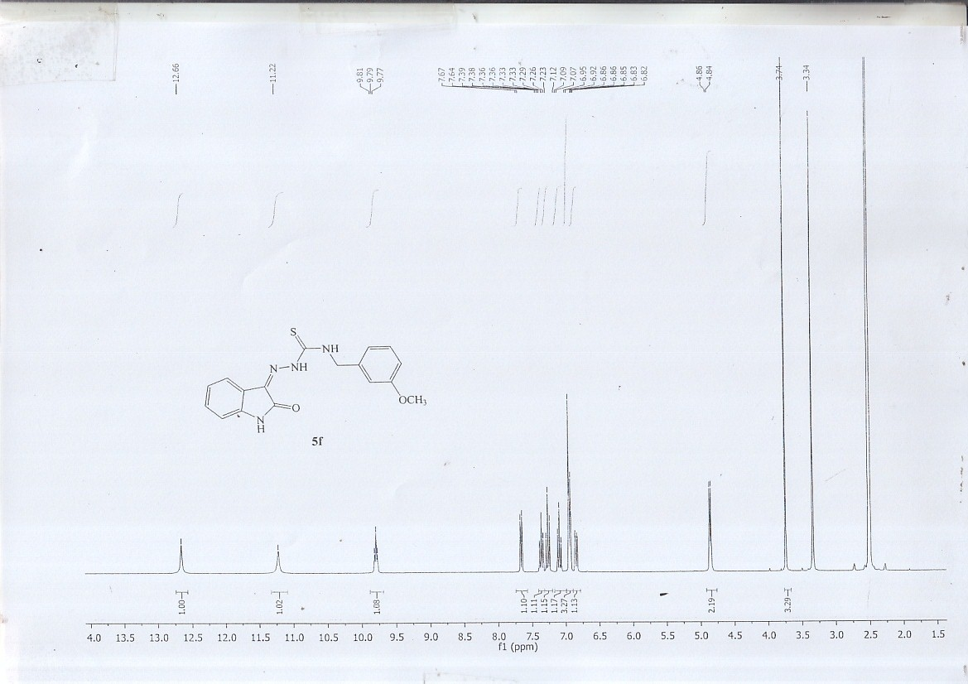

¹H-NMR spectrum of 5g
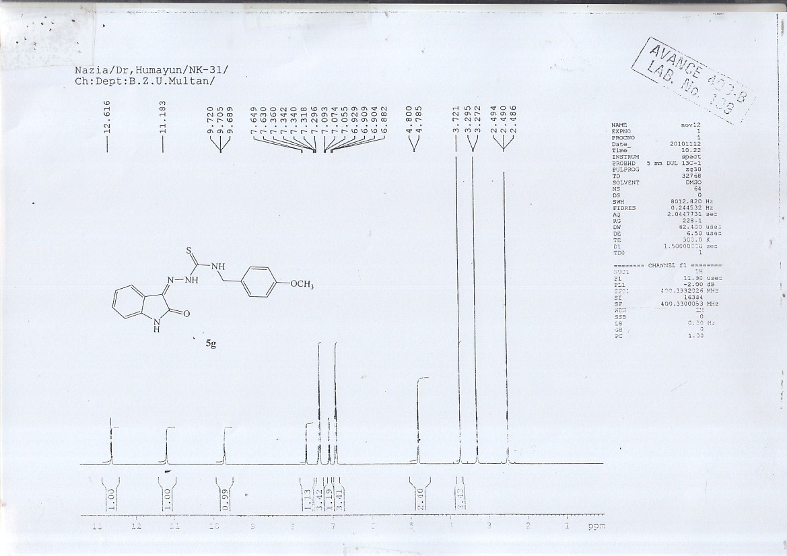

¹H-NMR spectrum of 5h
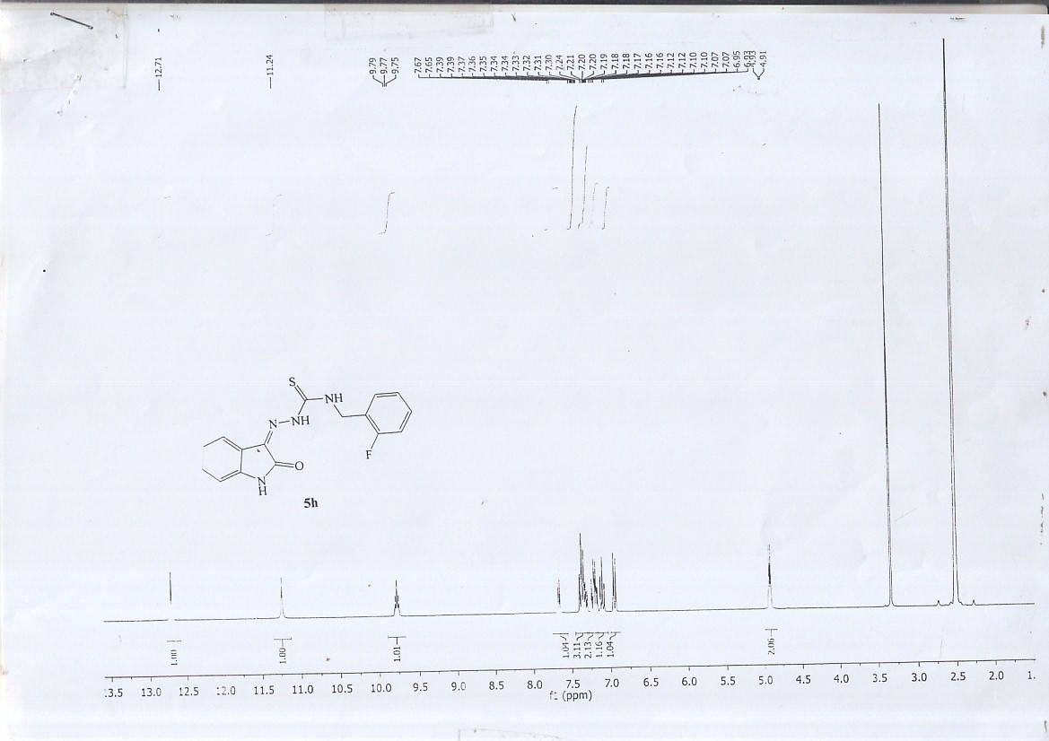

¹H-NMR spectrum of 5k
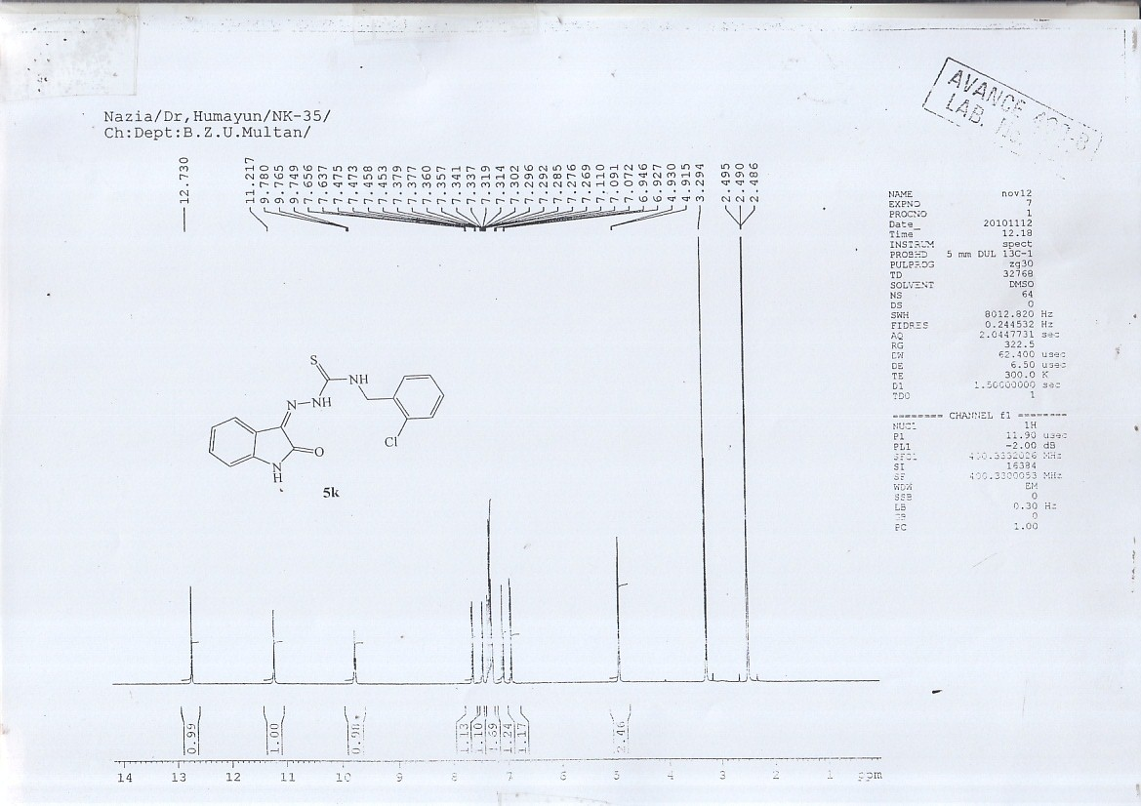

¹H-NMR spectrum of 5l
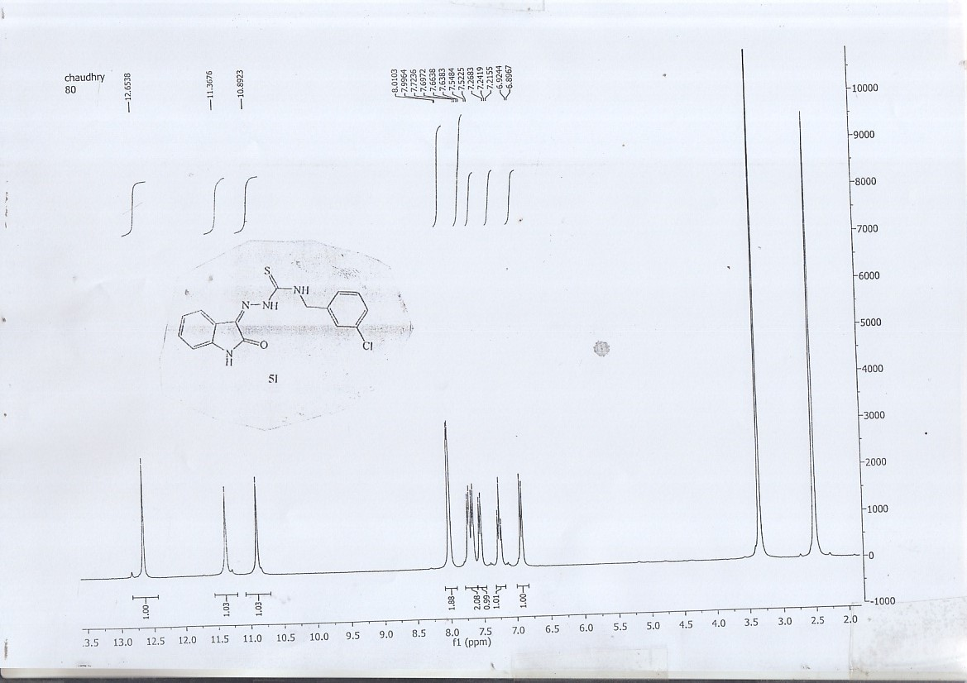

¹H-NMR spectrum of 5o
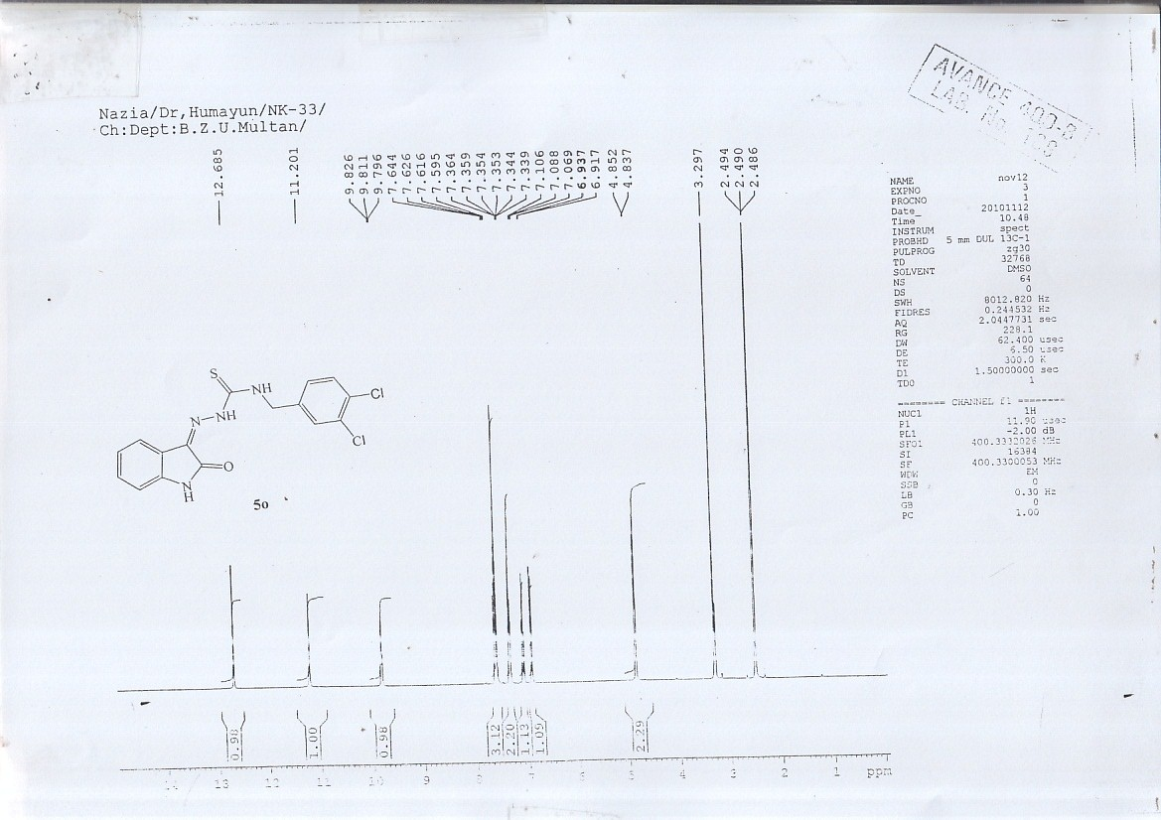

Mass spectrum of 5a
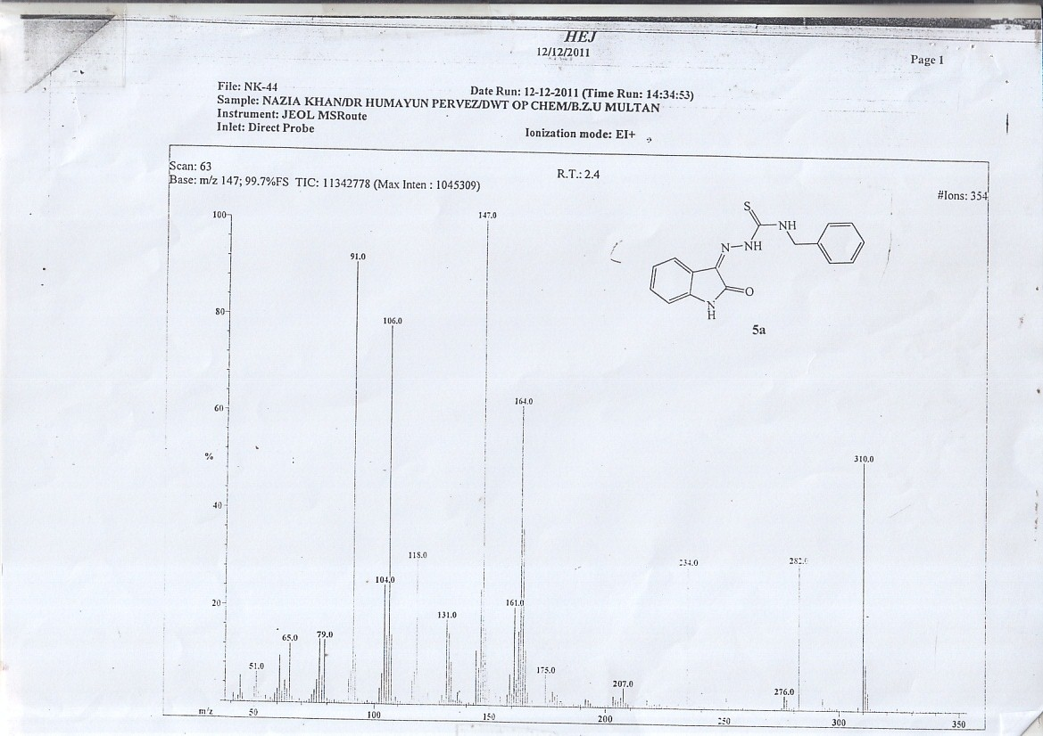

Mass spectrumof 5c
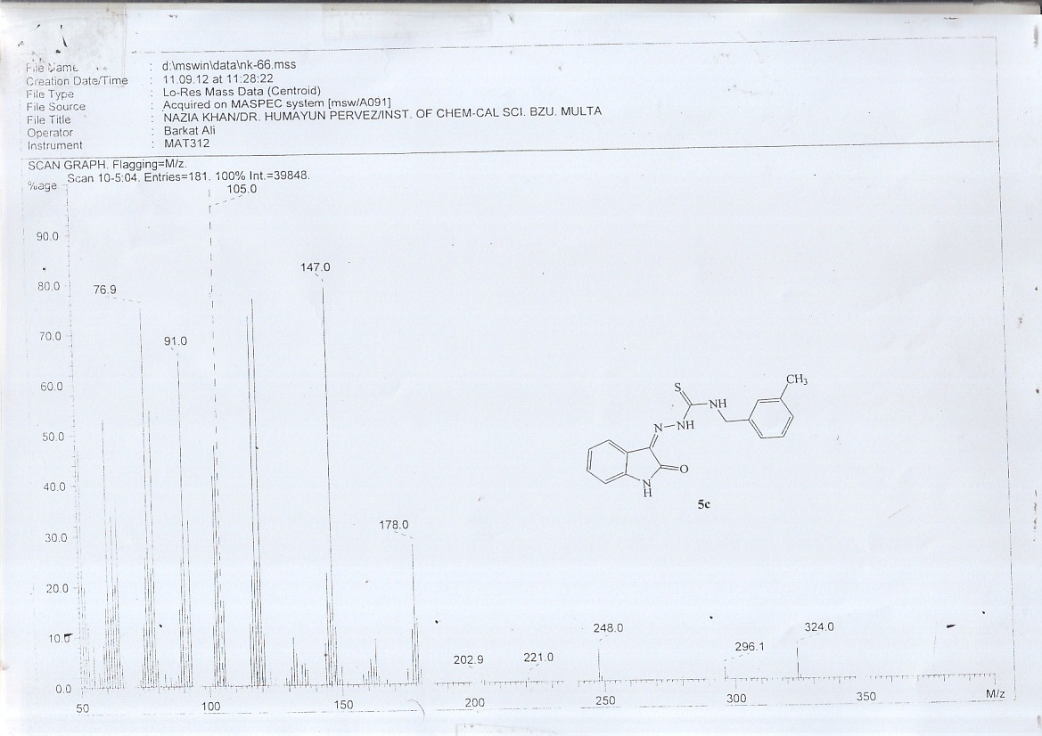

Mass spectrum of 5f
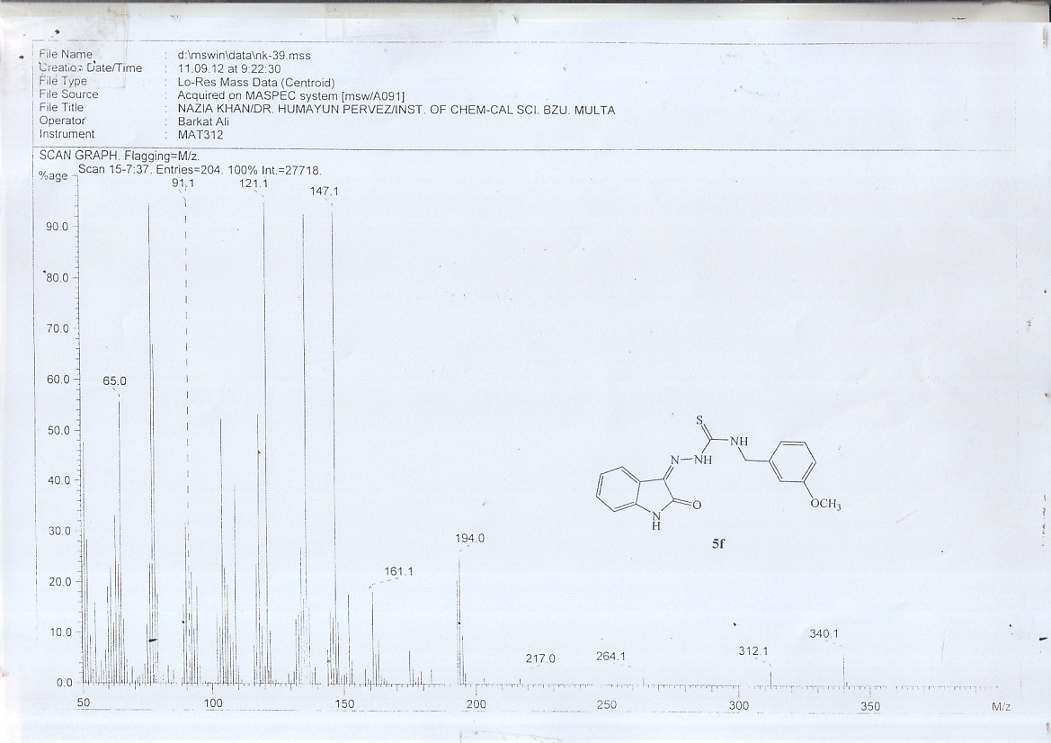

Mass spectrum of 5g
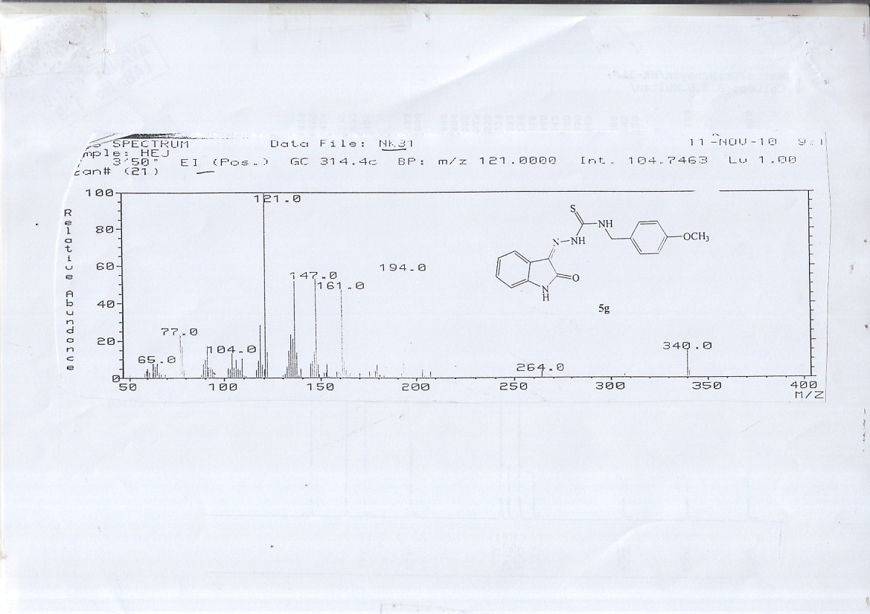

Mass spectrum of 5h
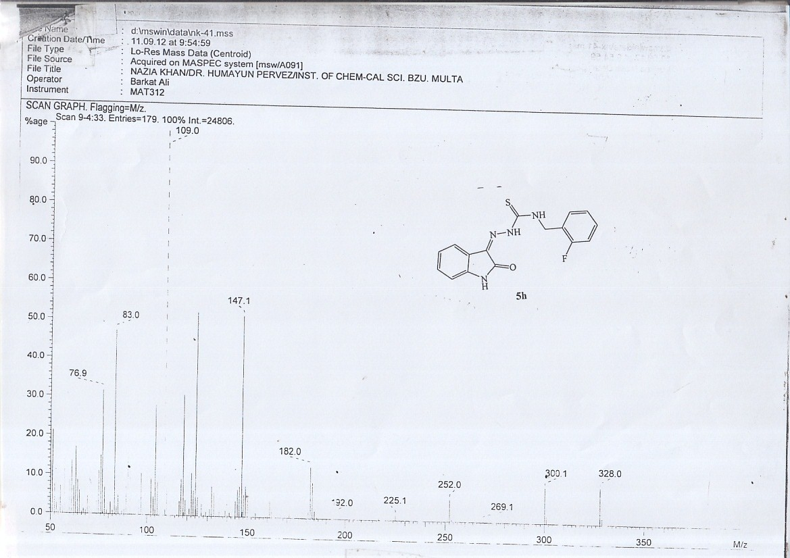

Mass spectrum of 5k
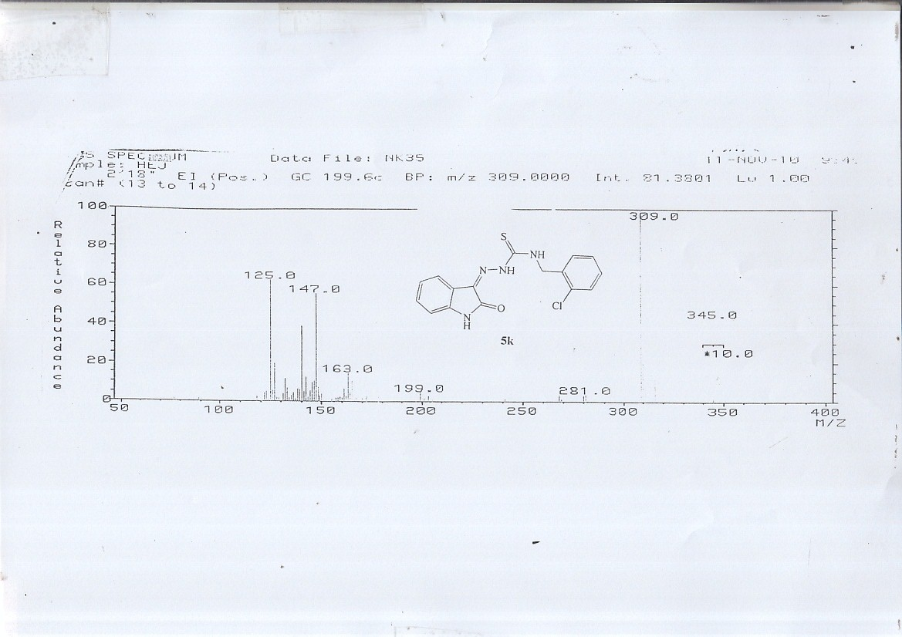

Mass spectrum of 5l
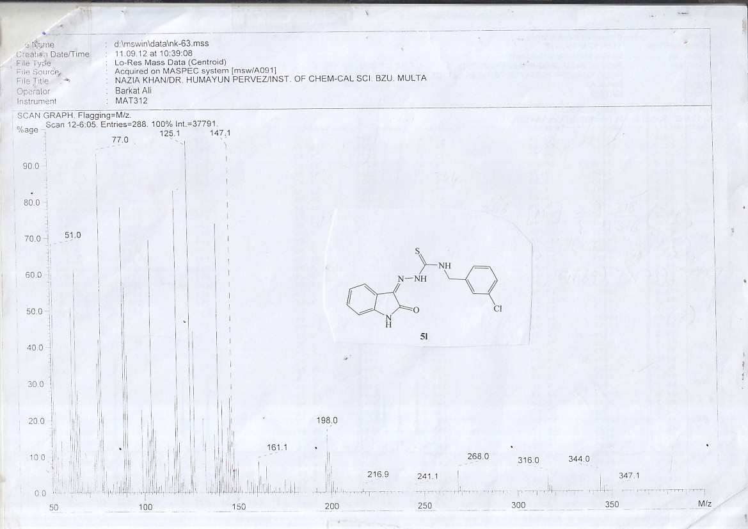

Mass spectrum of 5o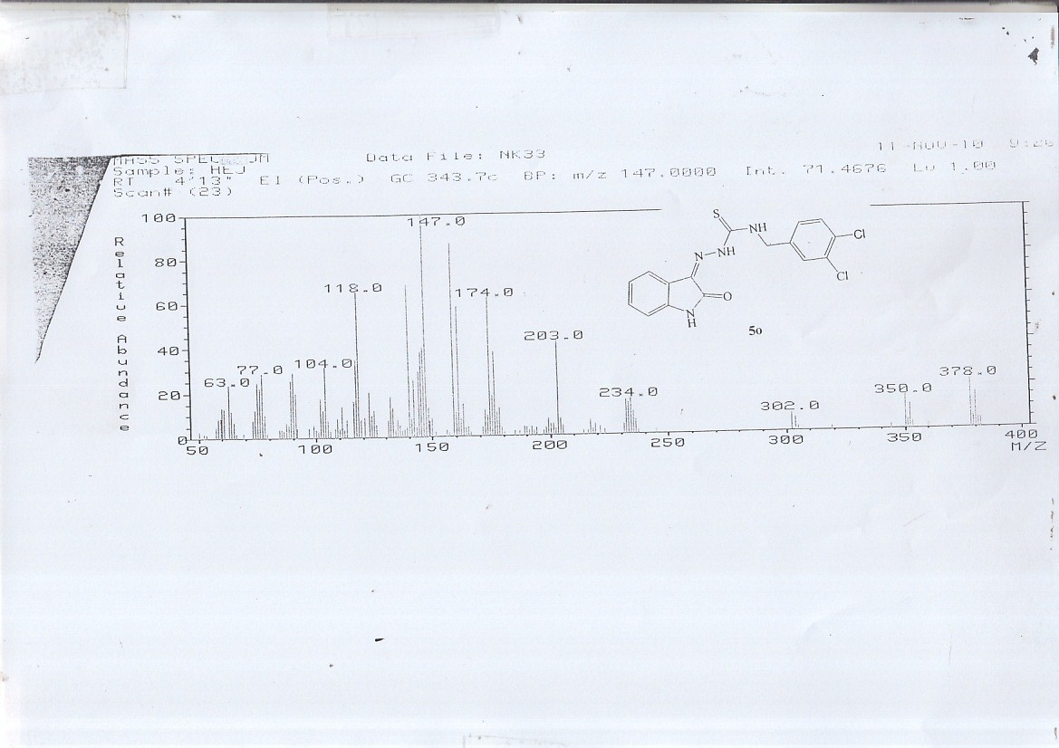

¹³C-NMR spectrum of 5a
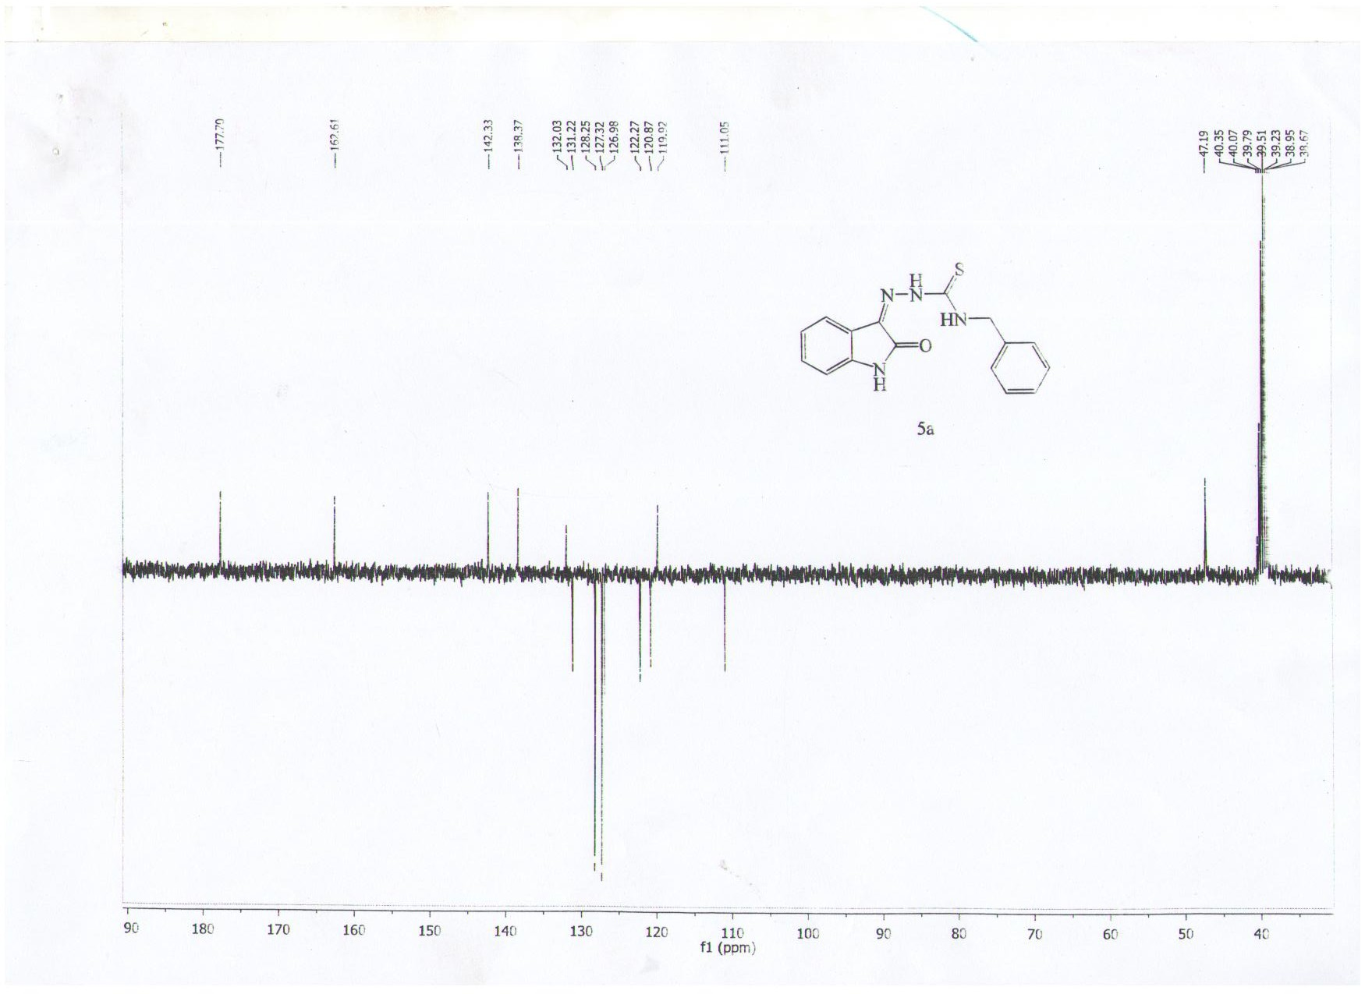

¹³C-NMR spectrum of 5c
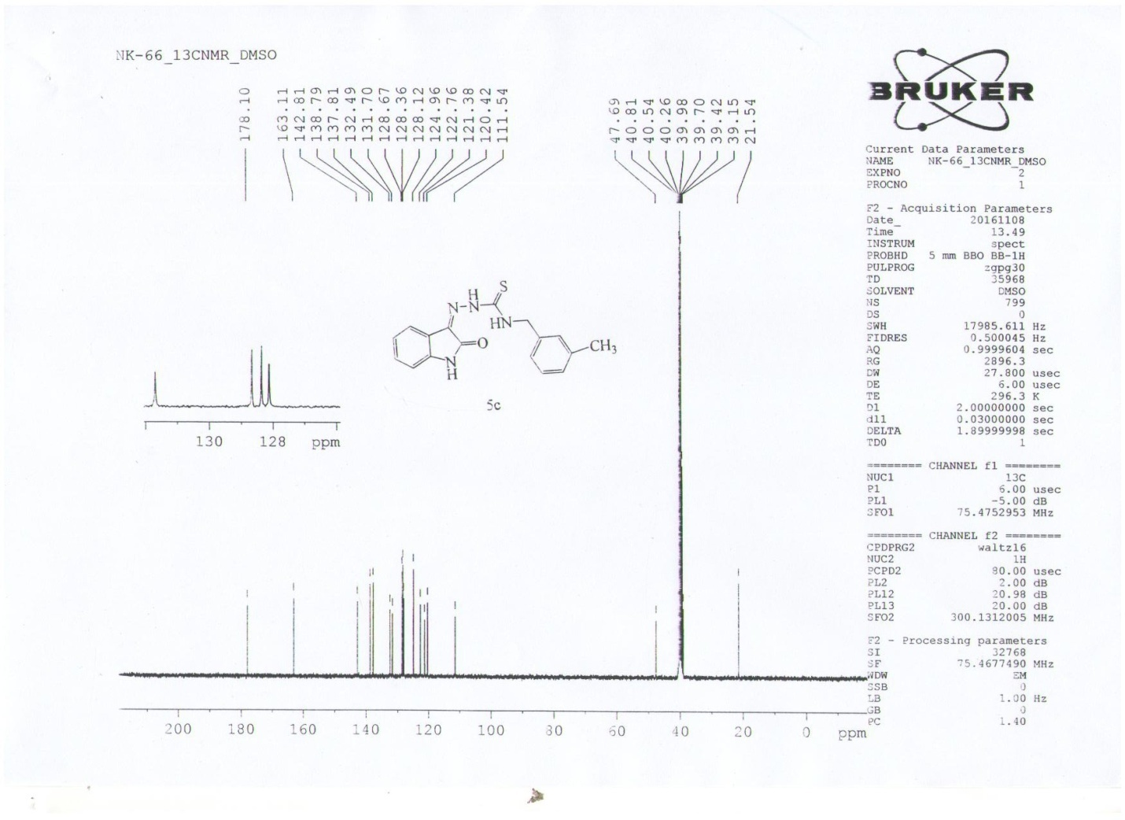

¹³C-NMR spectrum of 5f
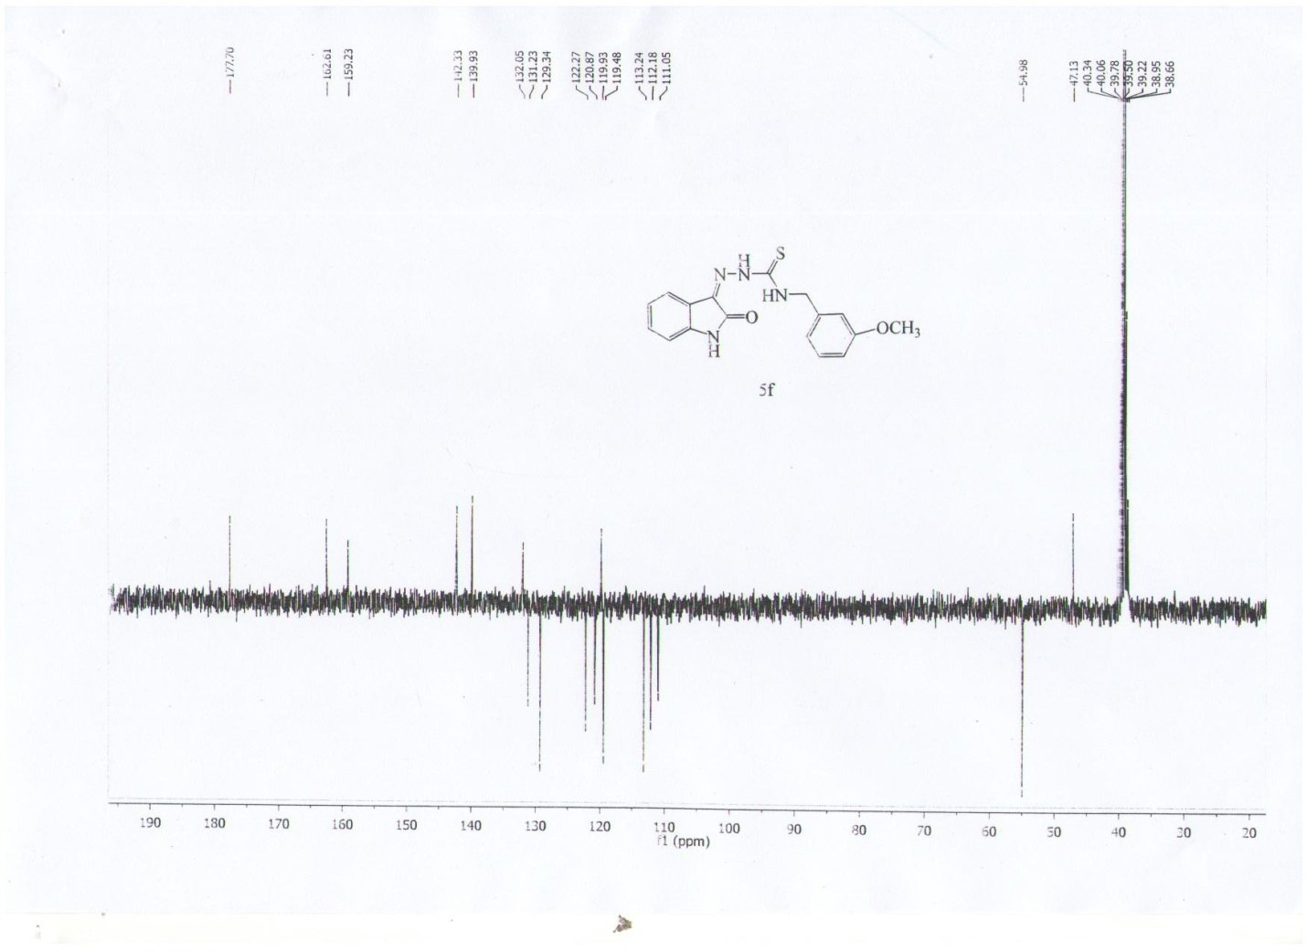

¹³C-NMR spectrum of 5g
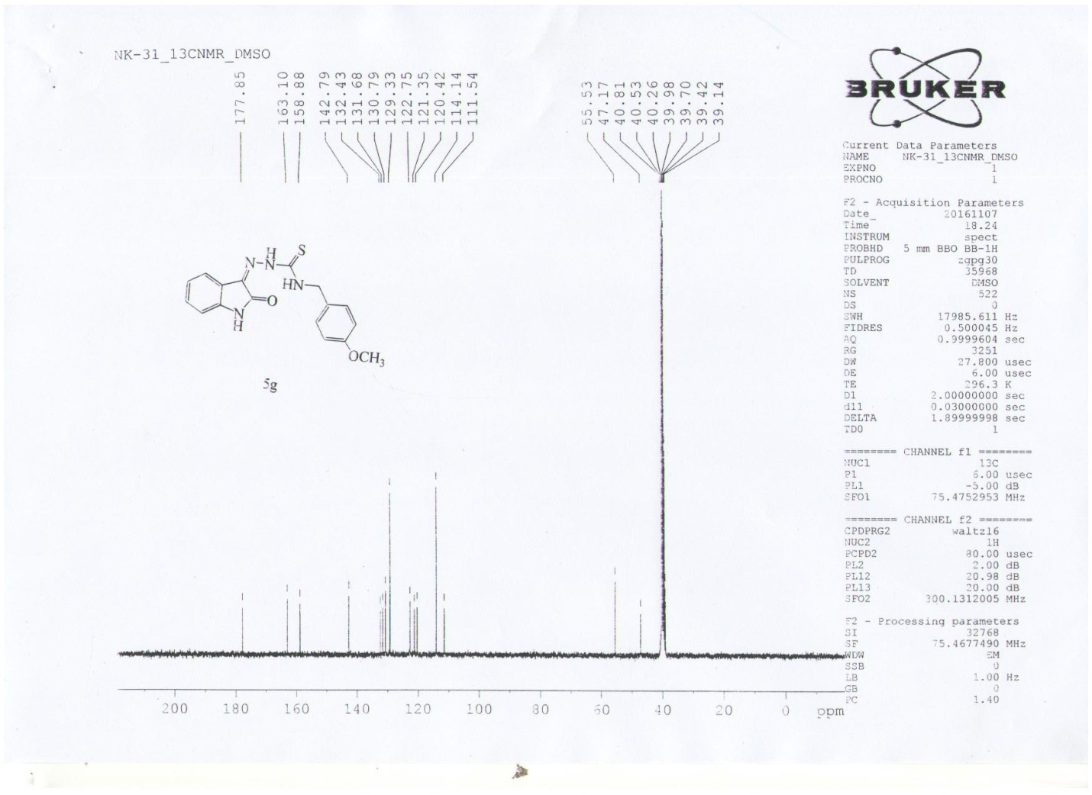

¹³C-NMR spectrum of 5h
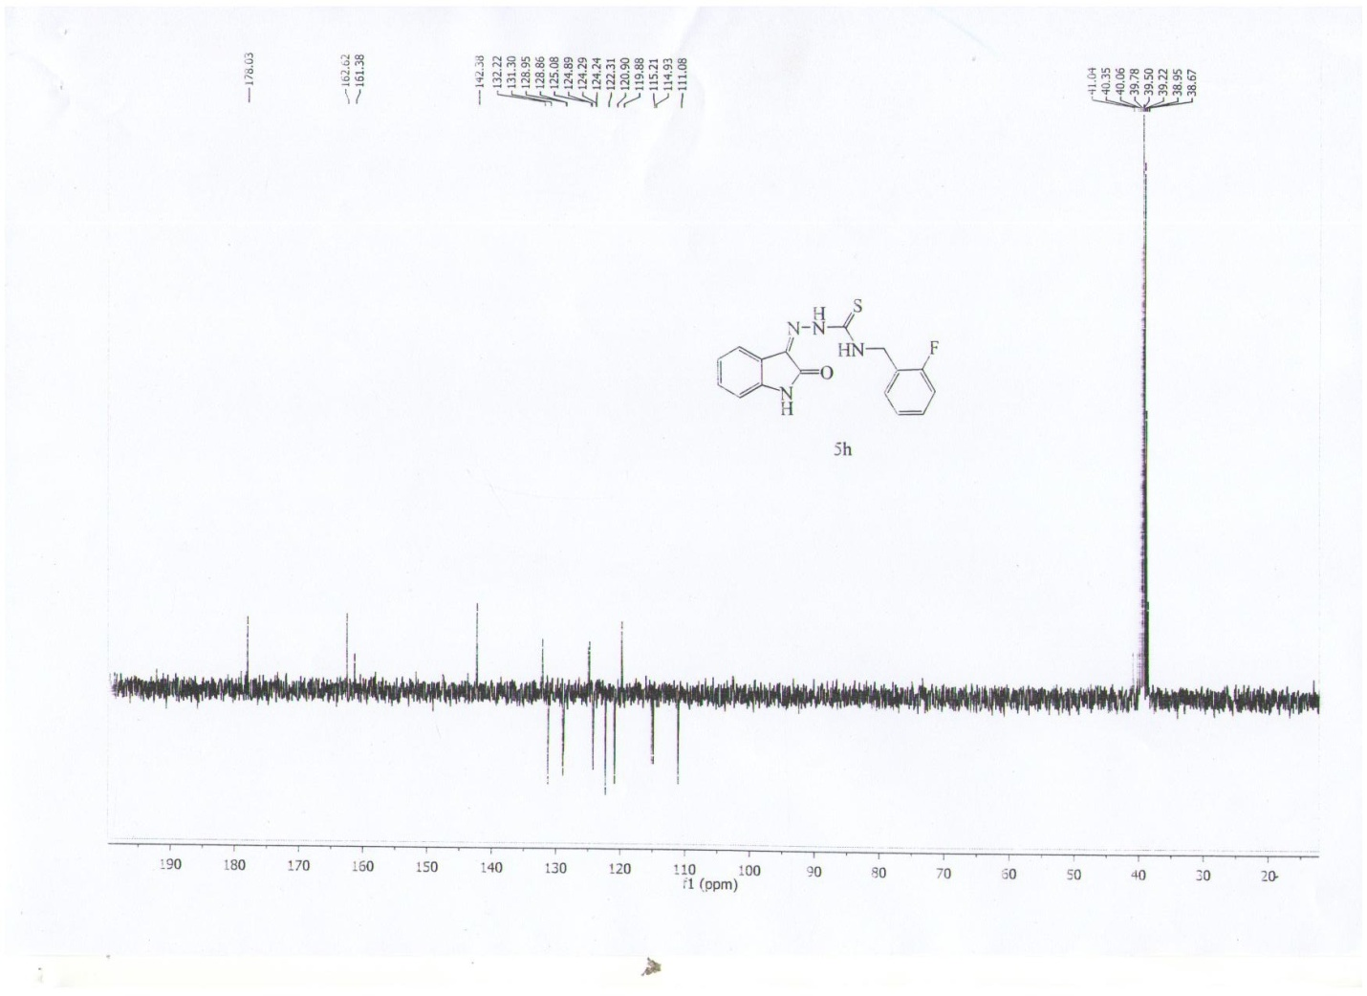

¹³C-NMR spectrum of 5k
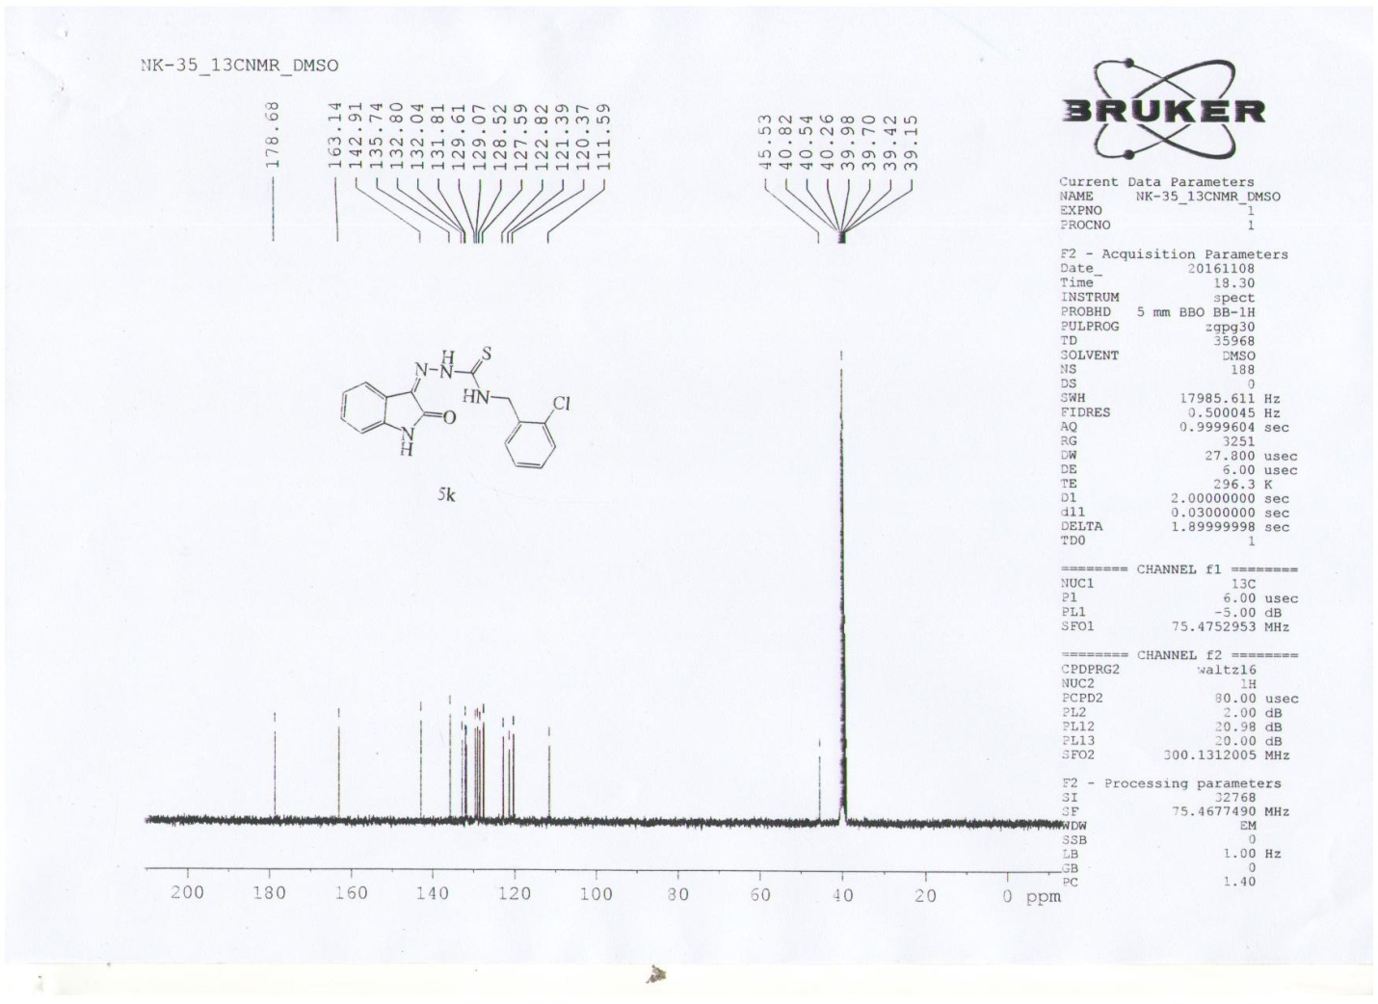

¹³C-NMR spectrum of 5l
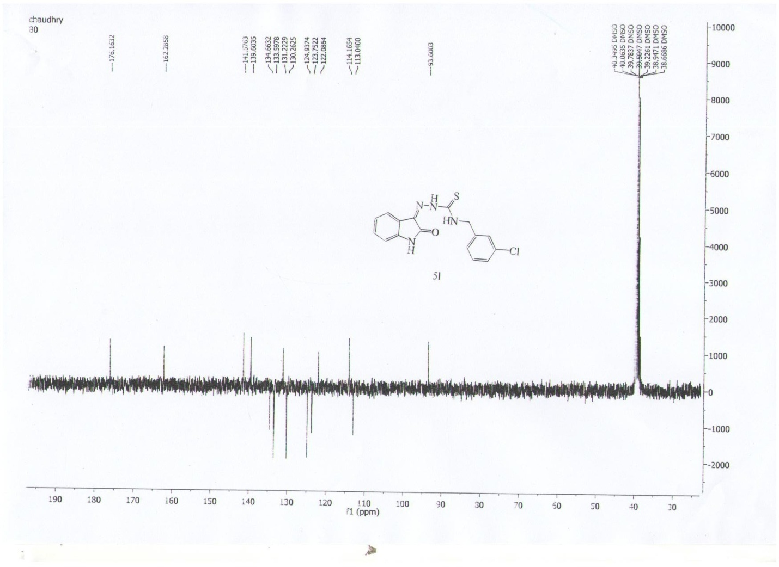

¹³C-NMR spectrum of 5o
