¹³C NMR Spectroscopy of heterocycles: 1-phenyl-3-aryl/t-butyl-5-arylpyrazoles
Amy N. Hockstedler, Beatrice A. Edjah, Saajid Z. Azhar, Hadrian Mendoza, Nicole A. Brown, Hayley B. Arrowood, Andrew C. Clay, Anand B. Shah, Glenda M. Duffek, Jianmei Cui and A.L. Baumstark*

Department of Chemistry, Center for Biotech and Drug Design, Georgia State University, Atlanta, Georgia 30302-4098, USA
*Corresponding author, email: abaumstark@gsu.edu

Supplementary material

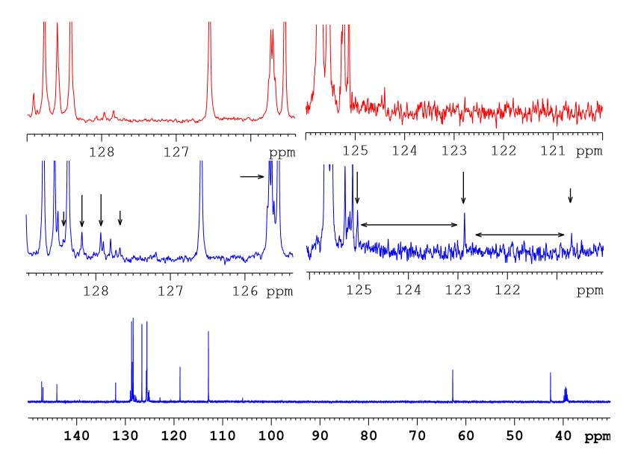
Figure S1 ¹³C decoupled spectra (blue, bottom spectrum) and ¹³C DEPT 135 (red, expanded inset) of 1,3-Diphenyl-5-(4-trifluorophenyl)pyrazoline (12Pi) used to located the CF₃ group and determine J values.

