New 8-substituted BODIPY-based chromophores: synthesis, optical and electrochemical properties
Nikolay Vologdin* Sylvain Achelle, Sébastien Gauthier, Bertrand Caro and Françoise Robin-le Guen

*Corresponding author: nvologdin@gmail.com

Supplementary material

Copy of ¹H and ¹³C NMR spectra of compounds 3-9 S2
UV/Vis and emission spectra of compounds 2-9 in DCM S9
Emission spectra of compound 7 in heptane, DCM and MeCN S17

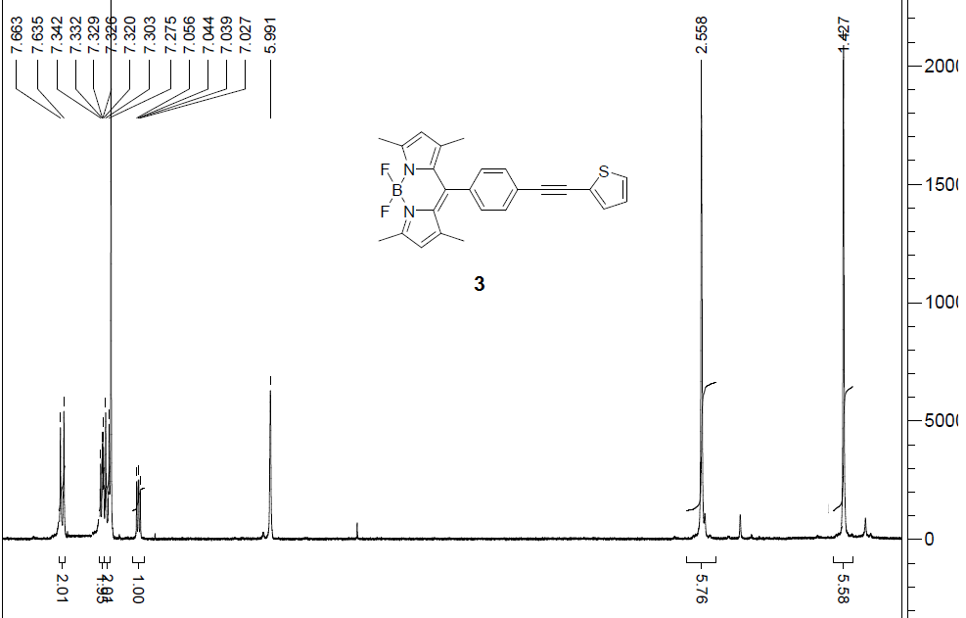
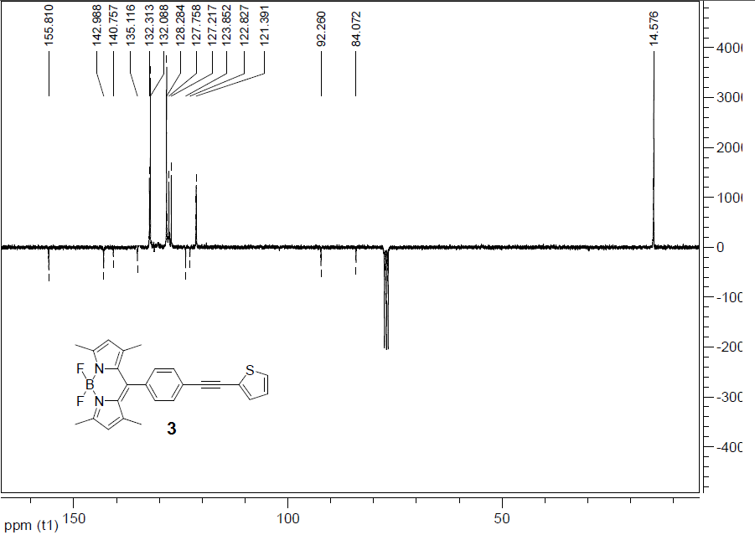
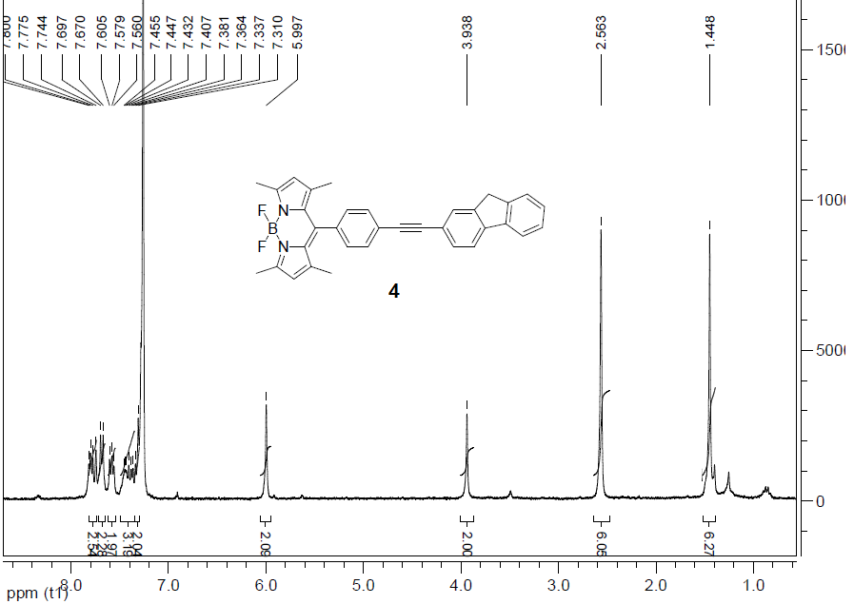
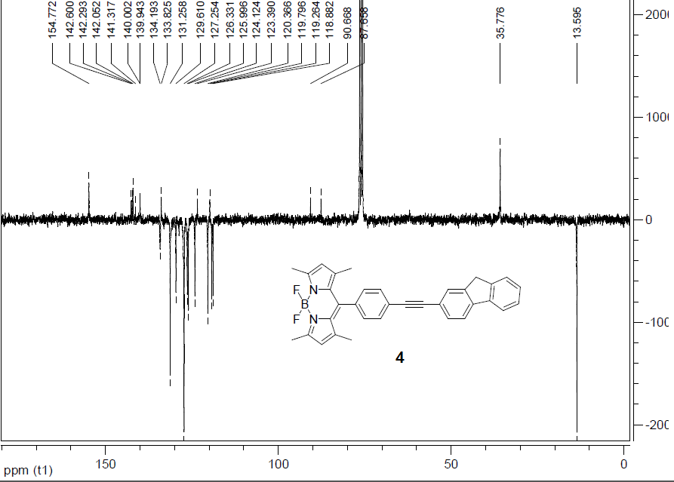
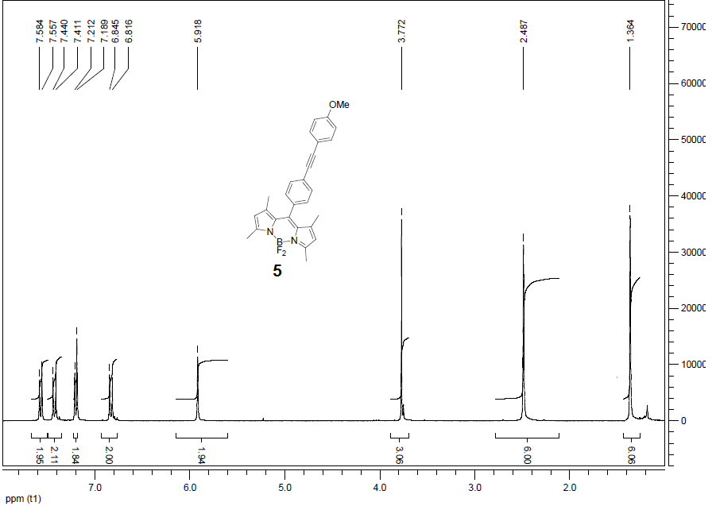
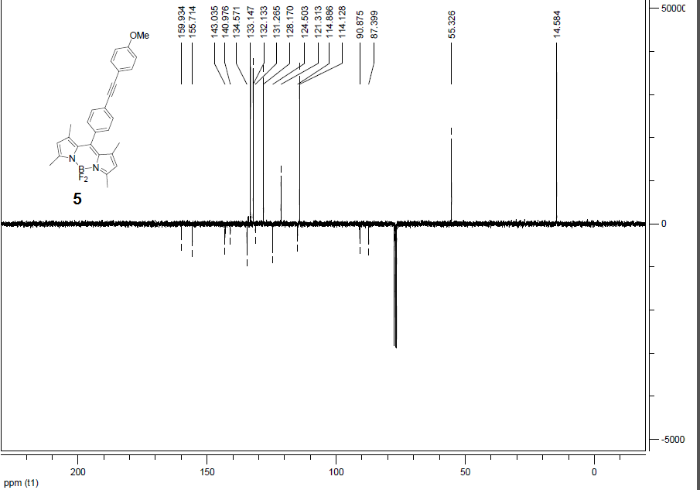
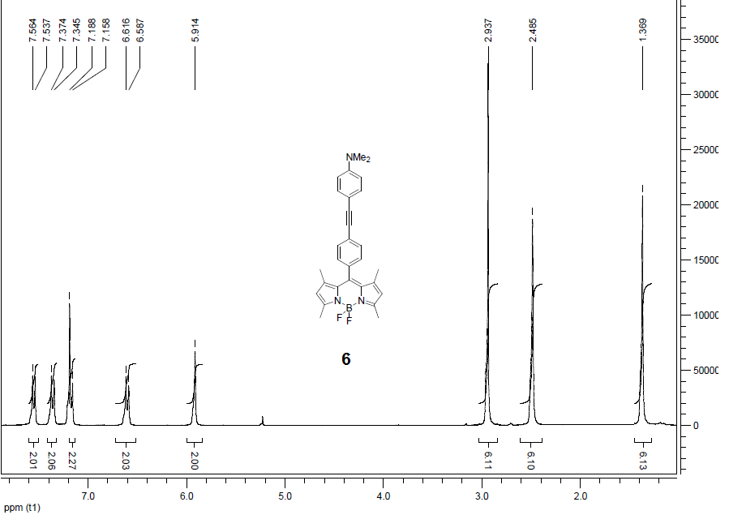
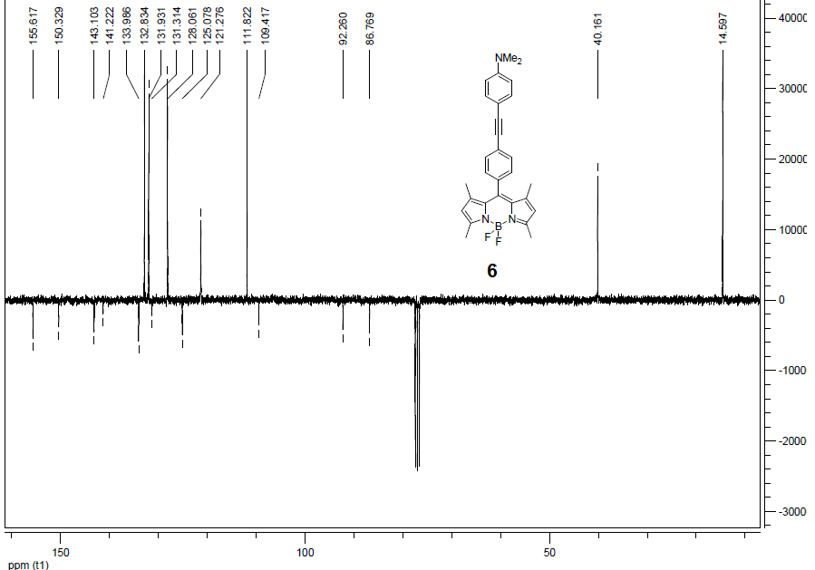
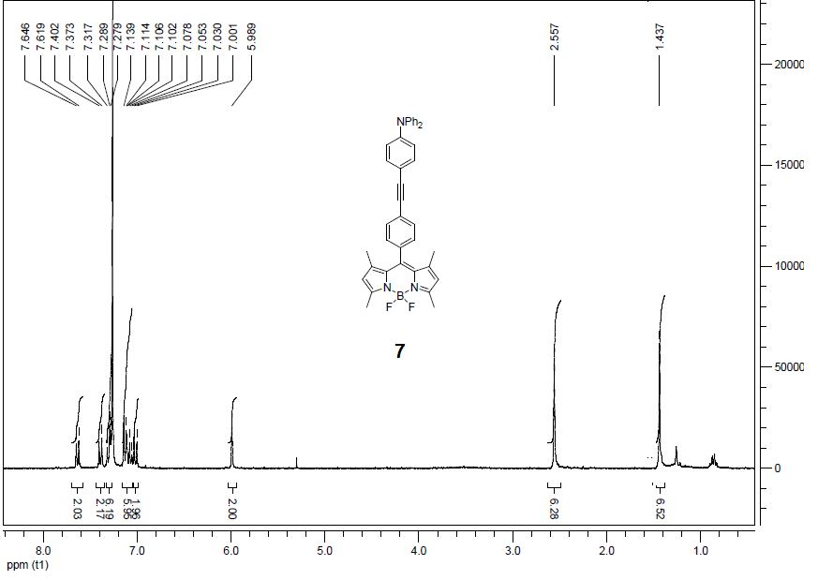
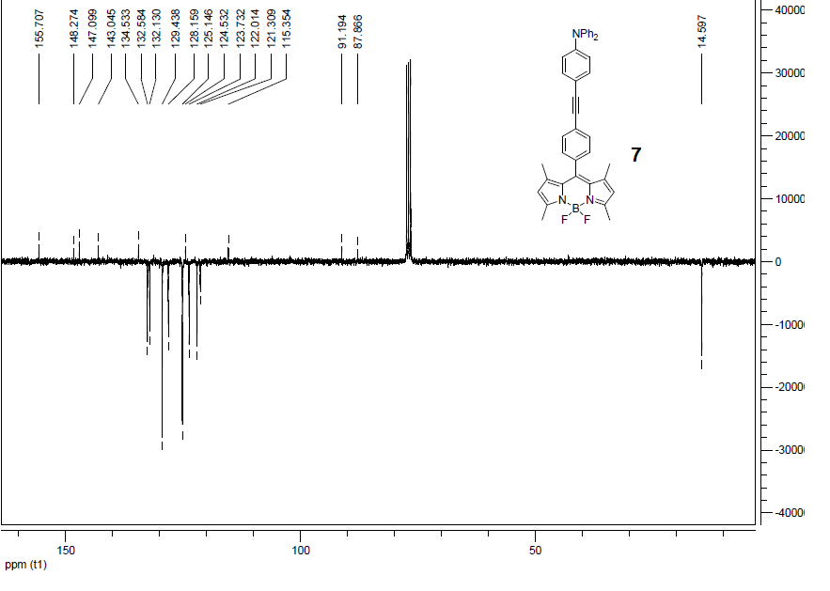
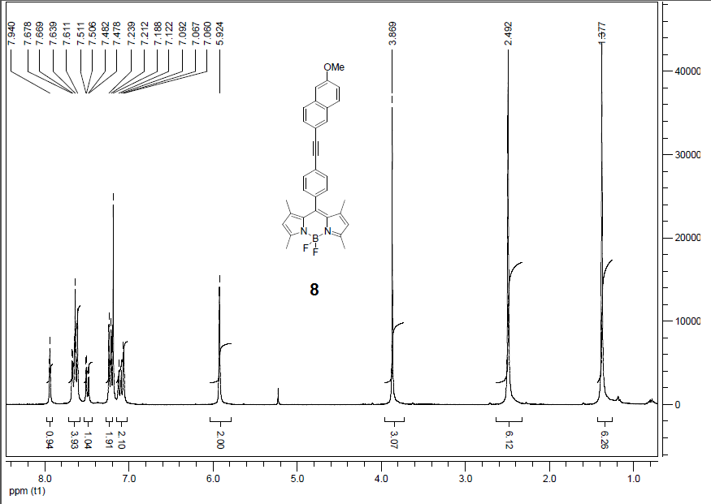
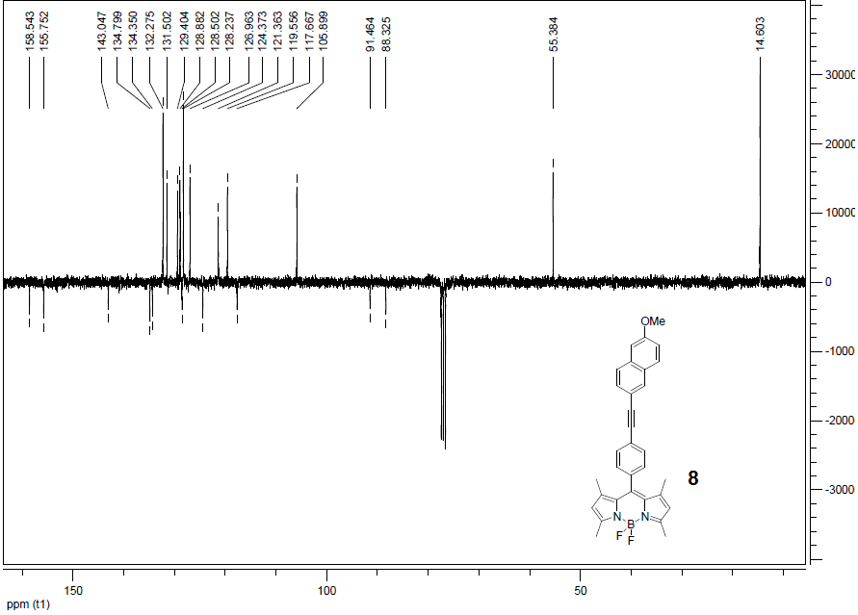

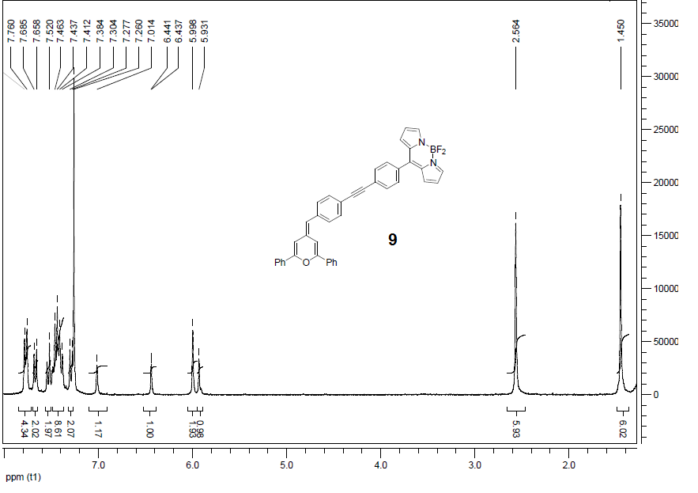
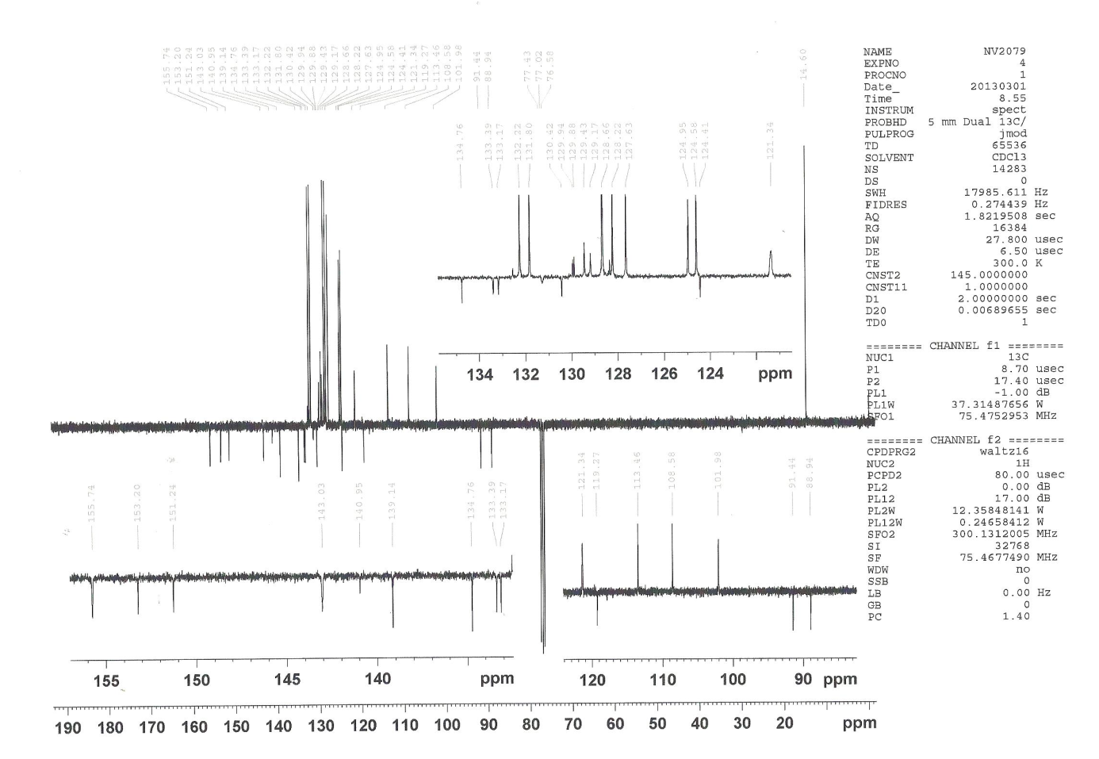

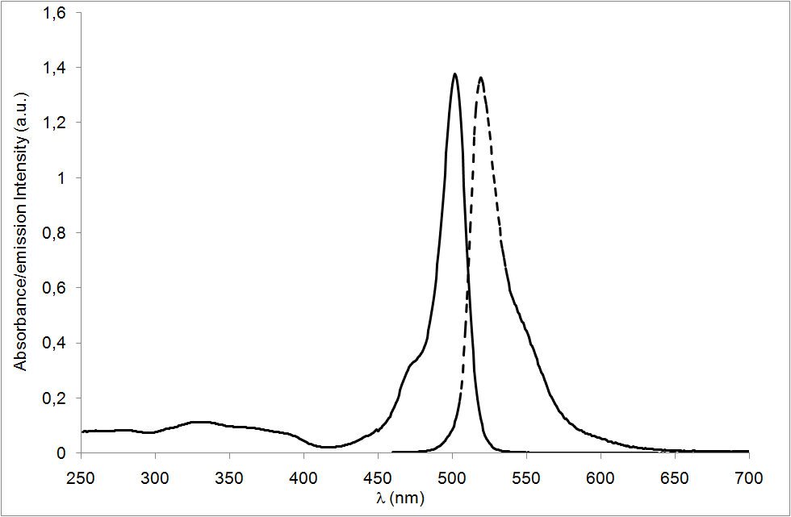
UV/Vis (solid line) and emission (dashed line) spectra of compound 2 in DCM (c = 8.4 × 10⁻⁶ M).

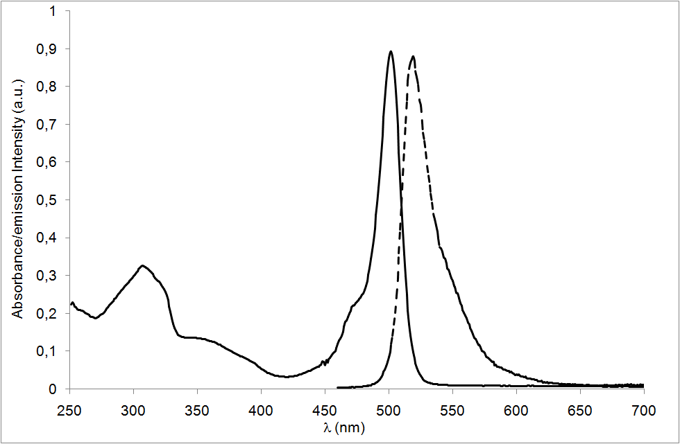
UV/Vis (solid line) and emission (dashed line) spectra of compound 3 in DCM (c = 1.36 × 10⁻⁵ M).

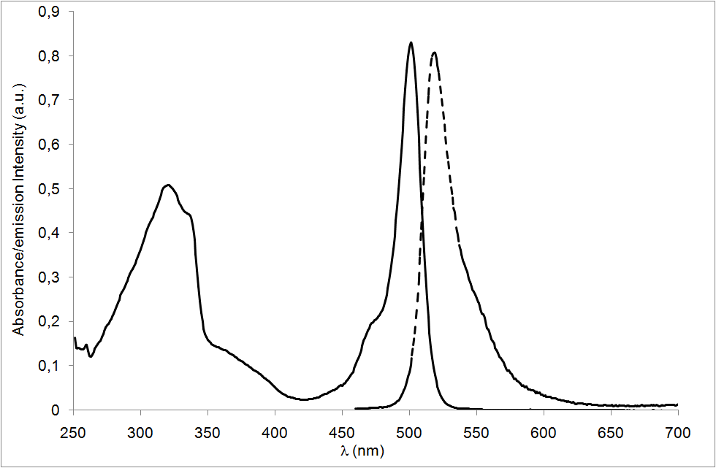
UV/Vis (solid line) and emission (dashed line) spectra of compound 4 in DCM (c = 8.82 × 10⁻⁶ M).

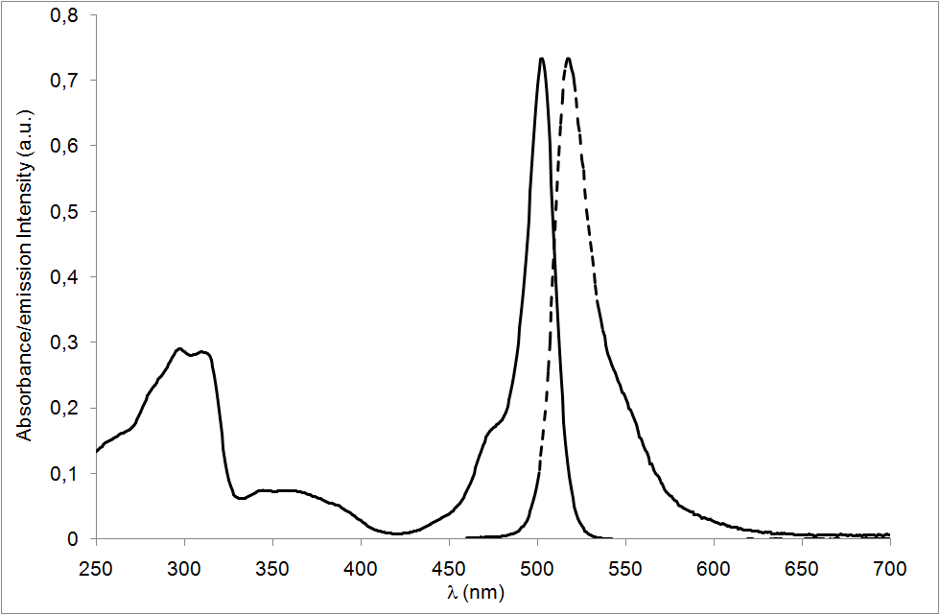
UV/Vis (solid line) and emission (dashed line) spectra of compound 5 in DCM (c = 8.17 × 10⁻⁶ M).

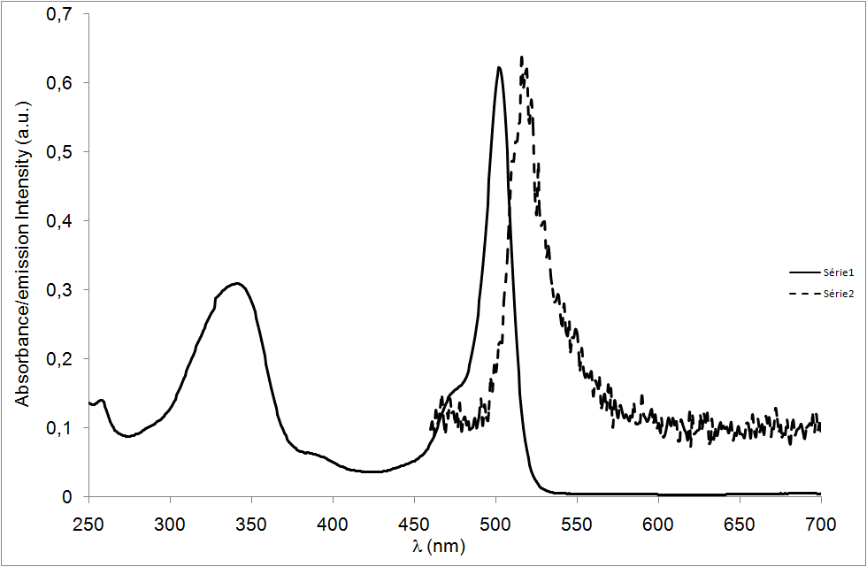
UV/Vis (solid line) and emission (dashed line) spectra of compound 6 in DCM (c = 6.35 × 10⁻⁶ M).

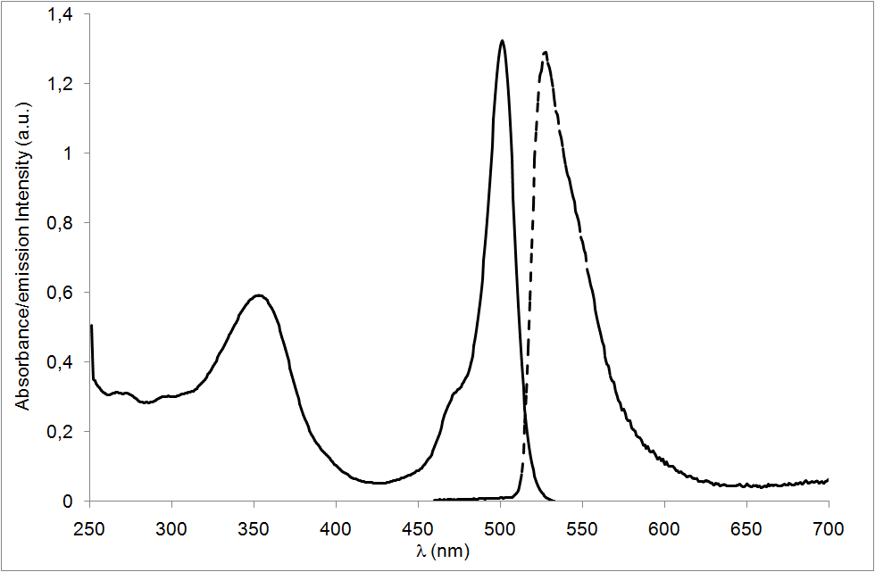
UV/Vis (solid line) and emission (dashed line) spectra of compound 7 in DCM (c = 6.35× 10⁻⁶ M).

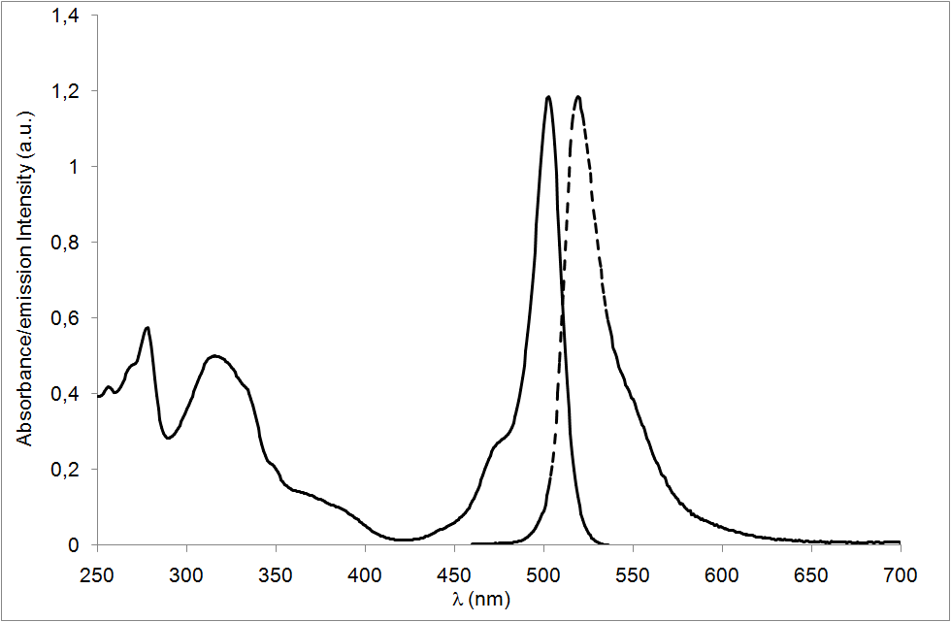
UV/Vis (solid line) and emission (dashed line) spectra of compound 8 in DCM (c = 1.15 × 10⁻⁵ M).

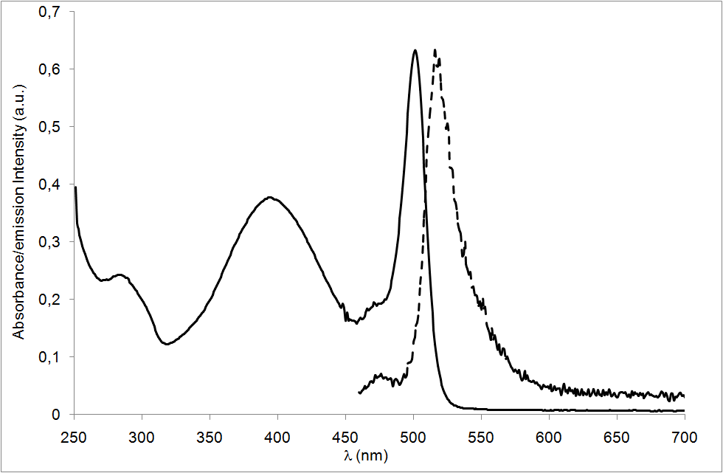
UV/Vis (solid line) and emission (dashed line) spectra of compound 9 in DCM (c = 5.60 × 10⁻⁶ M).

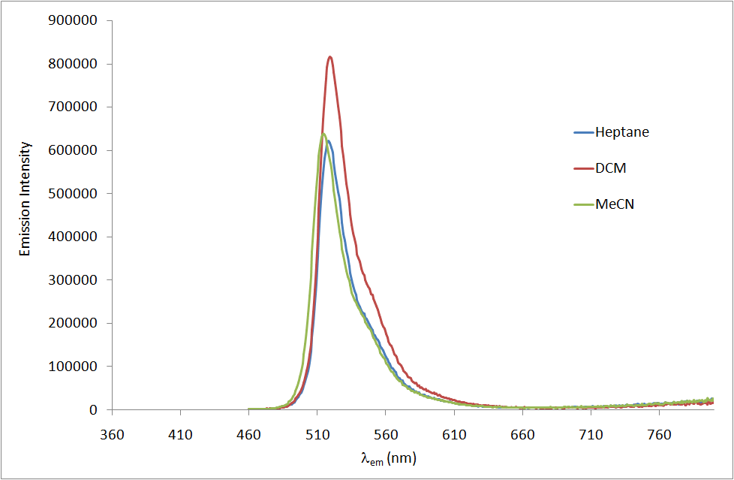
Emission spectra of compound 7 in heptane, DCM and MeCN (c = 6.35× 10⁻⁶ M).

