Supplemental material

Microwave-assisted one-pot syntheses of 4-aminoquinazoline
derivatives
Wenting Song, Shunli He, Zeli Yuan, Guangqing Yu, Di Wu, Qing Wu, Minqing Zhang,Yongzheng Chen and Qinghong Hu
DOI 10.1515/gps-2015-0121

Table of contents

Table of contents |  | Page
I. | General remarks | S1
II. | Synthesis procedure and characterization | S3-S7
III. | References | S7
IV. | Optimization of reaction conditions | S8-S9
V. | Cytotoxicity data(IC₅₀) for compounds 1-8 | S10
VI. | X-Ray data for compounds 3, 4 and 5 | S11-S15
VII. | Spectral copies of compounds 1-8 | S16-S29

I.General remarks

1. Materials.
All chemical reagents and solvents were purchased from J&K and used without further purification.

2. Instrumentation
NMR Spectroscopy: NMR spectra were recorded on Agilent-400MRDD2 spectrometers at 298 K; H RMS(ESI): Mass spectra were recorded on a Time-of-Flight Micromass LCT SolariX Spectrometer; FT-IR :Spectra were recorded on Vary-1000;Melting points were measured on a melting point apparatus and are uncorrected;The apparatus used for the condensation was an XH-100B microwave oven purchased from Beijing Xianggu Science and Technology Development Co., Ltd. (2450 MHz and 100–1000W, Beijing, China).
The crystal data were collected on CCD SMART APEX diffractometer with graphite-mono chromated Mo Ka radiation (l¼0.71073 Å) at 293 K, 9637 reflections for 3, 12,490 for 4 and 10,141 reflections for 5. Cell refinements and the data reductions were obtained from SAINT¹. Absorption corrections were applied by using multi-scan program SADABS¹. Structural solutions were performed by direct methods and full-matrix least-square refinement based on F² with the SHELXTL program packages.² Anisotropic thermal parameters were applied to all non-hydrogen. All atoms and all hydrogen atoms of carbon atoms were placed by geometric calculation. Hydrogen atoms on both nitrogen and oxygen atoms were located in a difference map and were restrained. The SHELXTL² and Mercury³ programs were used to prepare materials for publication and the molecular graphics. CCDC-1425686 for 3,CCDC-1425687 for 4 and CCDC-1425684 for 5 contain the supplementary crystallographic data for this paper. These data can be obtained free of charge fromThe Cambridge Crystallographic Data Center via http://www.ccdc. cam.ac.uk /Community/Requestastructure/Pages/DataRequest.aspx (or from the Cambridge Crystallographic Data Centre, 12Union Road, Cambridge CB21EZ, U.K.; fax: t44 1223 336 033 or email deposit@ccdc.cam.uk).

3. Cytotoxicity assays
3.1 Cell cultures and treatments
A549 cells (human lung carcinoma cell line) and HepG2 cells (human hepatoma cell line) were purchase from ATCC. A549 cells were grown in DMEM/HIGH GLUCOSE(1X) (Dulbecco's modified eagle's medium) and HepG2 cells were maintained in Modified Roswell
Park Memorial Institute 1640 (RPMI -1640) which were supplemented with 10% fetal bovine serum, and 1% penicillin streptomycin solution in a humidified atmosphere of 5% CO₂, 95% air at 37℃. The passage number range for both cell lines was maintained between 10 and 20. The cells were cultured in 25 cm² cell culture flasks. For experimental purposes, A549 and HepG2 cells were cultured in 96-well plates respectively (5×10⁴ cells/mL, 100mL/well). Cells were allowed to attach for 24 h before treatment with title compounds 1-8. The stock solution of compounds 1-8 was dissolved in DMSO and filtered with Minisart Filters (0.45 μm), then the solution was diluted with serum free medium to different concentration(0 to 120 μM). Cell monolayers were washed with PBS and then addition the compounds 1-8 within a range of concentrations from 0 to 120 μM for 24 h. The concentration range for the compounds 1-8 and the exposure times have been selected based on preliminary studies performed in our laboratory.
3.2 Growth of cells
A549 cells were maintained in Dulbecco's modified eagle's medium DMEM/HIGH GLUCOSE(1X) medium and HepG2 cells were maintained in Modified Roswell Park Memorial Institute 1640 (RPMI -1640) medium which were supplemented with 10% fetal bovine serum and culture medium, and were kept at 37℃ in a humidified atmosphere containing 5% CO₂.

3.3 MTT assay
The MTT assay is based on the protocol described for the first time by Mossmann. The assay was optimized for the cell lines used in this experiment. Briefly, at the end of the incubation time, cells were incubated for 4 h with 0.5mg/ml of MTT, dissolved in serum free medium (DMEM or RPMI -1640 for A459 and HepG2 cells respectively). Washing with PBS (100 μl) was followed by the addition of DMSO (200 μl), gentle shaking for 10 min and absorbance was recorded at 490nm using the Multiskan Spectrun. The cell viability ratio was calculated by the following formula: inhibitory ratio (%) =1-(ODtreated -ODblack)/ (ODcontrol -ODblack)×100%. Cytotoxicity was expressed as the concentration of the complex inhibiting cell growth by 50% (IC₅₀ value see Table S3).
II. Synthesis procedure and characterization
1.General Procedure: conventional heating(air bath) synthesis of product 1
1.63 g(10 mmol) 5-nitroanthranilonitrile and 1.43 g(12 mmol) N-Dimethylformamide Dimethylacetal (DMF-DMA) were placed in round-bottom flask. The resultant mixture was stirred at reflux for 2 h. Then, the acetic acid(5mL) solution of 1.70 g(12 mmol) m-bromoaniline was added into above solution, and the mixture was continue reaction at the same conditions for 6 h. The reaction was cooled to room temperature. The solid were filtered and purified by recrystallization using dimethyl sulphoxide(DMSO), washed with ether, and dried in vacuo (50 °C) to yield 1.45 g(42.42%) of product 1.

2.General Procedure: Microwave-assisted synthesis of products(1-8)
1.63 g(10 mmol) 5-nitroanthranilonitrile and 1.43 g(12 mmol) N-Dimethylformamide Dimethylacetal (DMF-DMA) were placed in a microwave vessel. The resultant mixture was heated in a microwave oven(XH-100B microwave oven, which is a monomode instrument) at 70°C with low stirring and 500 W for 5 min. Meanwhile, the system was run at constant temperature operation mode by using the circular water cooling feature of the apparatus. Then, acetic acid(5mL) solution of 12 mmol appropriate aniline was added into above solution, and the mixture was irradiated at the same conditions for 15 min. The reaction was cooled to room temperature. The solid were filtered and purified by recrystallization using dimethyl sulphoxide(DMSO), washed with ether, and dried in vacuo (50 °C) to products(1-8). (yield see Table 2 ).

3. Product Characterization
3.1 6-Nitro-4-(3-bromophenylamino)quinazoline 1

Yellow solid, 3.30 g, yield: 96.15%, m.p:262-264 ℃.¹H NMR (400 MHz,DMSO -d₆):δ(ppm): 10.54(s, 1H,NH), 9.64(s, 1H, Ar -H), 8.77 (s,1H,Ar-H), 8.57-8.60(m,1H, Ar-H), 8.17-8.18(d, J=6.6 Hz, Ar-H),7.95-7.98(d, J=9.1Hz,1H, Ar-H),7.83 -7.86(m,
1H, Ar-H),7.48-7.52(t, J=9.1 Hz, Ar-H); ¹³C NMR (100 MHz,DMSO-d₆) δ (ppm):
116.55,116.88,120.81,122.55,122.87,123.43,124.42,126.87,129.67,144.75,144.84,155.30,157.72; FT-IR(KBr,4 000 - 400 cm⁻¹): 3473,3412,3128,1624,1574, 1536,1510, 1485,1400, 1340,1263,1194, 1055,891, 854, 745. H RMS (ESI): Exact mass calcd for C₁₄H₉BrN₄O₂ [M+H]⁺ 344.99871, Found 344.99879.

3.2 6-Nitro-4-(2-hydroxyphenylamino)quinazoline 2

Brick red solid, 0.96 g, yield: 34.29%, m.p:286-288 ℃.¹H NMR (400 MHz,DMSO -d₆) δ(ppm): 8.70-8.71(d,J=2.7 Hz,1H),8.28(s,2H), 8.05-8.08(dd, J=9.3,2.7Hz, 1H), 7.76 -7.80 (m,2H),7.38-7.45(m,2H),6.97-6.99(d,J=9.3 Hz,1H);¹³C NMR (100 MHz, DMSO-d₆) δ (ppm) :105.41,110.83,115.93,119.40,124.99, 125.19,125.37,125.78, 127.54, 135.72, 140.68,148.59,153.37,160.64; FT-IR(KBr,4 000 - 400 cm⁻¹): 3430, 3282,3180, 1634,1573,1549,1490,1455,1400,1343,1262,1119,824,741;H RMS (ESI): Exact mass calcd for C₁₄H₁₀N₄O₃ [M+H]⁺ 283.08312, found 283.08342.

3.3 6-Nitro-4-(3-ethynylphenylamino)quinazoline 3

White solid, 1.93 g, yield: 66.63%, m.p:238-240 ℃;¹H NMR(400 MHz,DMSO-d₆) δ (ppm) : 10.48(s, 1H,NH), 9.66(s, 1H, Ar -H), 8.76(s, 1H,Ar-H),8.56-8.57(d, J=9.2 Hz,1H, Ar-H),8.03(s,1H,Ar-H),7.94-7.96(d, J=9.2 Hz,1H,Ar-H), 7.89 -7.91(d, J=8.3Hz, 1H,Ar-H),7.43-7.45(t, J=7.9 Hz,1H,Ar-H),7.28-7.30(d, J=7.2 Hz,1H, Ar -H), 4.23 (s,1H,CH); ¹³C NMR (100 MHz,DMSO-d₆) δ (ppm) : 80.39,83.39,104.07, 121.89,123.36, 125.49, 126.83, 129.14,129.60,144.62,153.09; FT-IR(KBr, 4 000-400 cm⁻¹):3437,3242,3125,3025,2918,1628,1580,1543,1495,1473,1447,1332,1247,1112,1032,845, 798. H RMS (ESI): Exact mass calcd for C₁₆H₁₀N₄O₂ [M+H]⁺ 291.08820, found 291.08873.
3.4 6-Nitro-4-(3-trifluoromethylphenylamino)quinazoline 4

Yellow solid, 2.13 g, yield: 63.60%, m.p:140-142 ℃;¹H NMR(400 MHz,DMSO-d₆) δ (ppm) :10.44(s, 1H,NH), 9.51(s, 1H, Ar -H),8.66(s, 1H, Ar-H),8.43-8.45(d, J=8.8 Hz,1H,Ar-H),8.15-8.18(d, J=9.5 Hz,1H,Ar-H),7.81-7.84(d, J=8.6 Hz,1H, Ar-H), 7.56 -7.60(t, J=7.8 Hz,1H,Ar-H),7.43-7.45(d, J=7.6 Hz,Ar-H); ¹³C NMR (100 MHz,DMSO-d₆) δ (ppm) : 114.36,118.56,120.50,120.83,122.86,125.57,125.98,126.76, 129.15, 129.47, 129.60,129.73,139.45,144.61,152.90,157.27,158.61; FT-IR(KBr, 4 000 -400 cm⁻¹): 3402,3304,3148,3121,3059,2924,2850, 1628,1582,1549,1518,1483, 1451,1414, 1393, 1334, 1287,1230,1191,1111,1073,1032,955,845,749; H RMS (ESI): Exact mass calcd for C₁₅H₉F₃N₄O₂ [M+H]⁺ 335.07559, found 355.07525.

3.5 6-Nitro-4-(4-methylphenylamino)quinazoline 5

Orange solid, 0.98 g, yield: 35.16%, m.p:213-215 ℃;¹H NMR(400 MHz,DMSO-d₆) δ (ppm) : 10.37(s,1H),9.60-9.61(d,J=2.3 Hz,1H),8.65(s,1H), 8.49-8.52(dd,J=9.2,2.3 Hz,1H),7.86-7.89(d, J=9.2 Hz,1H), 7.67-7.69(d,J=8.3 Hz,1H), 7.21-7.23 (d,J=8.3 Hz,1H),2.32(s,3H,-CH₃);¹³C NMR (1400 MHz,DMSO-d₆) δ(ppm) :20.62,114.36, 120.72, 120.96,122.98, 126.57,128.98,129.40,133.75,135.78,144.39,153.09, 157.70, 157.89,158.77; FT-IR(KBr, 4 000 -400 cm⁻¹):3454,3389,3284,3207,3119,3039,2851, 1626, 1586,1568,1534,1492,1454,1426,1362,1338,1226,1116,849,810; H RMS (ESI): Exact mass calcd for C₁₅H₁₂N₄O₂ [M+H]⁺ 281.10385, found 281.10386.

3.6 6-Nitro-4-(4-chlorophenylamino)quinazoline 6

Orange solid, 2.95 g, yield: 98.66%, m.p:200-203 ℃;¹H NMR(400 MHz,DMSO-d₆) δ (ppm) :10.46(s,1H),9.60-9.61(d,J= 2.2 Hz,1H),8.70(s,1H),8.52-8.54(dd,J= 9.2,2.4Hz, 1H),7.87-7.92(t,J=9.5 Hz,3H),7.45-7.49(m,2H);¹³C NMR (100 MHz,DMSO-d₆) δ (ppm) : 114.40,120.81,124.30,126.62, 128.18,128.47, 129.55, 137.26,144.56,153.02,157.64,159.28; FT-IR(KBr, 4 000 -400 cm⁻¹):3452,3243, 1625,1588, 1569,1541,1507,1488, 1399, 1341,1239,1092;H RMS (ESI): Exact mass calcd for C₁₄H₉ClN₄O₂ [M+H]⁺ 301.04905, found 301.04923.

3.7 6-Nitro-4-(4-fluoro-3-chlorophenylamino)quinazoline 7

Yellow solid, 3.14 g, yield: 98.86%, m.p:200-203 ℃;¹H NMR(400 MHz,DMSO-d₆) δ (ppm): 10.54(s, 1H,NH), 9.64(s, 1H, Ar -H), 8.77(s,1H, Ar-H),8.57-8.60 (m, 1H,Ar-H), 8.17 -8.18(d, J=6.6 Hz,Ar-H),7.95-7.98(d, J=9.1Hz,1H,Ar-H),7.83 -7.86 (m,1H, Ar-H), 7.48-7.52(t, J=9.1 Hz,Ar-H); ¹³C NMR (100 MHz,DMSO-d₆) δ (ppm) : 116.55,116.88, 120.81, 122.55,122.87,123.43,124.42, 126.87,129.67,144.75, 144.84,155.30,157.72; FT-IR(KBr, 4 000 -400 cm⁻¹): 3473,3412,3128,1624,1574, 1536,1510,1485,1400, 1340,1263, 1194, 1055,891, 854, 745. H RMS (ESI): Exact mass calcd for C₁₄H₈ClFN₄O₂ [M+H]⁺ 319.03981, found 319.03958.

3.8 6-Nitro-4-(2-fluoro-4-bromophenylamino)quinazoline 8

Yellow solid, 1.26 g, yield: 35.12%, m.p:212-214 ℃;¹H NMR(400 MHz,DMSO-d₆) δ
(ppm) :9.50-9.51(d, J=1.3 Hz,1H),8.57(s,1H),8.52-8.54(d, J= 9.1 Hz,1H),7.89-7.91(d, J= 9.2 Hz,1H), 7.65-7.68(d, J=9.8 Hz,1H),7.46-7.53(m,2H);¹³C NMR (100 MHz,DMSO-d₆) δ (ppm) :114.46,118.37,118.48,119.37,119.61,120.87, 121.08, 126.79,127.68,127.71,129.12,129.48,144.51,152.62,155.27,157.41,157.78,159.10; FT -IR(KBr,4 000 -400 cm⁻¹): 3461,3450,1623,1585, 1521,1401,1346,1230, 1185, 1112, 1018,872,844,745; H RMS (ESI): Exact mass calcd for C₁₄H₈BrFN₄O₂ [M+H]⁺ 362.98929, found 362.98878.
III. References
1. Bruker. SMART, SAINT and SADABS; Bruker AXS: Madison, WI, USA, 2003.
2. G. M. Sheldrick, Acta. Crystallogr., 2008, A64, 112.
3. C. F. Macrae, I. J. Bruno, J. A. Chisholm, P. R. Edgington, P. McCabe, E. Pidcock, L . Rodriguez-Monge, R. Taylor, J. Vande-Streek and P. A. Wood, J. Appl. Crystallogr.,
2008, 41, 466.

IV. Optimization of reaction conditions
- The effects of reactant molar ratio

Table S1 The effects of reactant molar ratio for one-pot synthesis 1-8 ^{a,b}
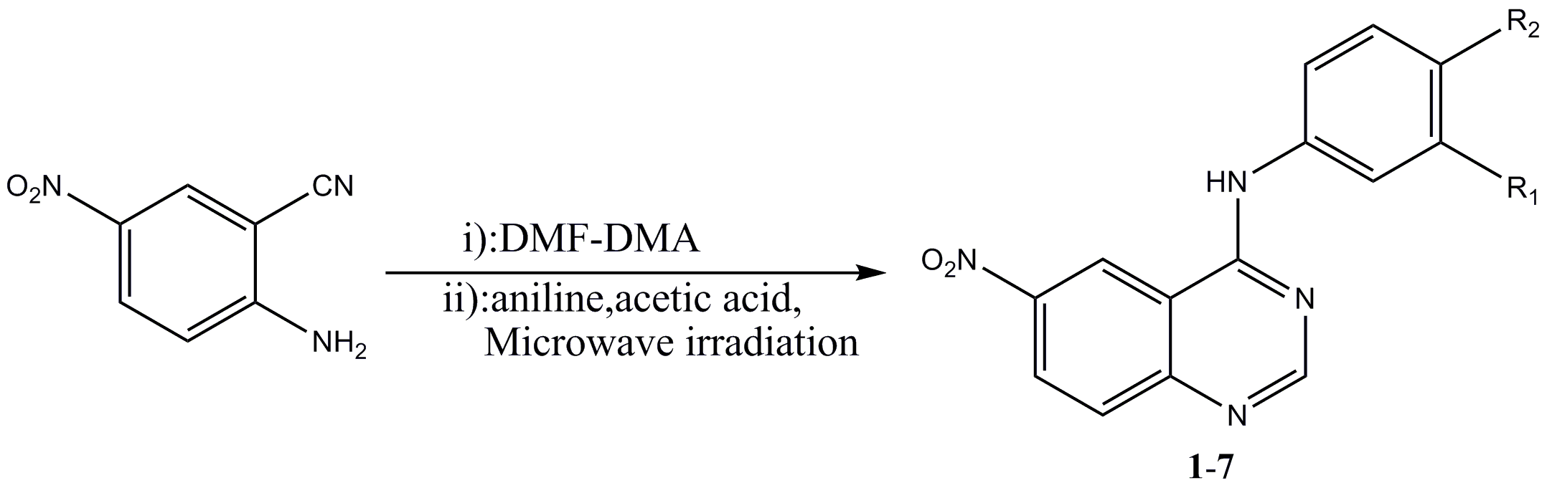

compounds | Time(min)  t₁,t₂ | Temp.(℃) | Power(W) | Yield(%)
1 | 5,15 | 70 | 500 | 76.41
2 | 5,15 | 70 | 500 | NR^{c}
3 | 5,15 | 70 | 500 | 51.65
4 | 5,15 | 70 | 500 | 48.55
5 | 5,15 | 70 | 500 | 33.95
6 | 5,15 | 70 | 500 | 94.81
7 | 5,15 | 70 | 500 | 65.12
8 | 5,15 | 70 | 500 | NR
ª Yield of isolated yields. ^{b} 2-Amino-5-nitrobenzonitrile (10 mmol), DMF-DMA(10 mmol),and aniline (10 mmol).^{c} No obtain

2.The effects of Reaction times

Table S2 Optimization of reaction times for one-pot synthesis 1 ^{a,b}
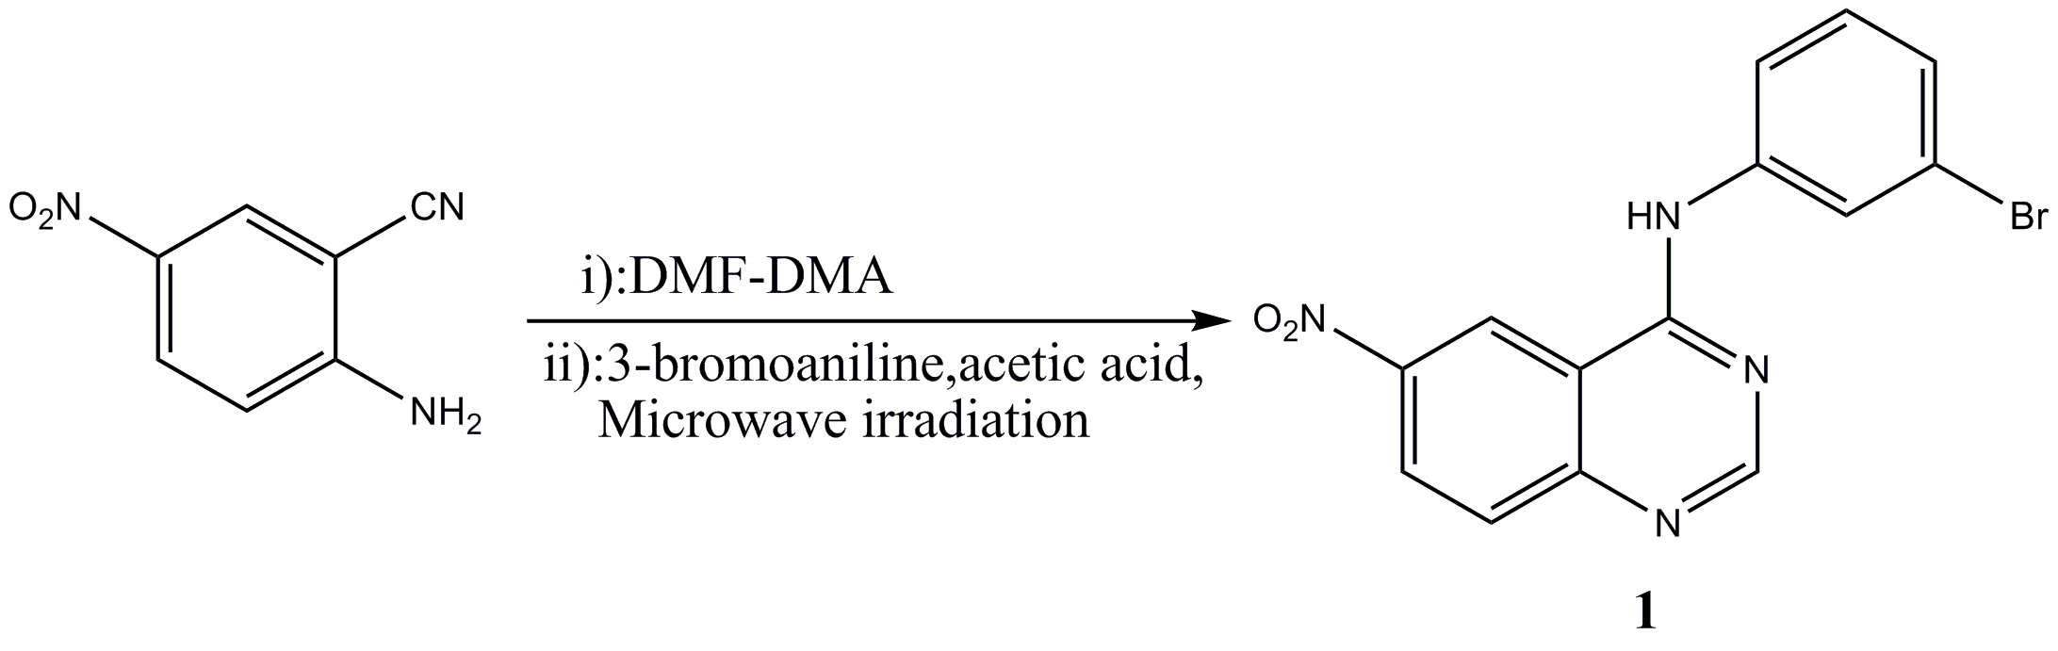

entry | Time(min)  t₁,t₂ | Temp.(℃) | Power(W) | Yield(%)
1 | 5,5 | 70 | 500 | 46.68
2 | 5,10 | 70 | 500 | 86.23
3 | 5,15 | 70 | 500 | 96.14
4 | 5,20 | 70 | 500 | 88.64
5 | 5,30 | 70 | 500 | 85.53
6 | 10,5 | 70 | 500 | 63.74
7 | 10,10 | 70 | 500 | 79.04
8 | 10,15 | 70 | 500 | 90.58
9 | 10,20 | 70 | 500 | 88.84
10 | 15,5 | 70 | 500 | 61.91
11 | 30,5 | 70 | 500 | 68.32
ª Yield of isolated yields. ^{b} 2-Amino-5-nitrobenzonitrile (10 mmol), DMF-DMA(12 mmol),and aniline (12 mmol).^{c}

V. Cytotoxicity data for compounds 1-8

Table S3 Cytotoxicity in vitro of compounds 1-8 (IC₅₀(μM))
Compounds | A549 | HepG2
1 | 99.65 | >100
2 | >100 | >100
3 | >100 | 83.70
4 | >100 | >100
5 | >100 | 73.76
6 | >100 | >100
7 | >100 | >100
8 | >100 | >100

VI.X-Ray data for compounds 3, 4 and 5
Table S4 Crystal data and structure refinement for 3, 4 and 5

Formula | C₁₈H₁₆N₄O₃S(3) | C₁₇H₁₅F₃N₄O₃S(4) | C₃₄H₃₅N₈O₆S₂(5)
Molecular weight | 368.41 | 412.39 | 715.82
space group | P2(1)/c | P2(1)/c | P-1
a (A, ) | 8.280(8) | 9.5559(8) | 10.0722(17)
b (A, ) | 21.36(2) | 1.8212(9) | 11.0062(17)
c (A, ) | 10.215(9) | 16.0968(14) | 17.689(3)
β (°) | 93.43(2) | 96.431(2) | 78.295(4)
V (Å³) | 1803(3) | 1806.9(3) | 1754.3(5)
Z | 4 | 4 | 2
D_{calc} (g cm⁻³) | 1.357 | 1.516 | 1.355
Absorption corr Ψ-scan max., min | 0.956,0.964 | 0.949,0.958 | 0.956,0.963
F(000) | 768.0 | 848.0 | 750.0
Crystal size (mm) | 0.23×0.20×0.21 | 0.26×0.20×0.19 | 0.22×0.23×0.19
θ range data collection | 1.00-24.930 | 1.00-25.200 | 1.00-25.170
h,k,lmax | 9,25,12 | 11,14,19 | 12,13,21
Goodness-of-fit on F² | 0.982 | 1.032 | 1.034
R [I>2δ(I)] | 0.0441 | 0.0420 | 0.0585
wR² (all data) | 0.1394 | 0.1179 | 0.1740

Table S5 Selected bonds lengths(Å) and angles (°) of 3, 4 and 5
3 |  | 4 |  | 5
Bond lengths
C1-C6 | 1.354(4) | C20A-S1A | 1.786(4) | C1-C2 | 1.201(3)
C1-C2 | 1.390(4) | S1A-O3 | 1.5110  (19) | C2-C3 | 1.456(3)
C1-N1 | 1.463(4) | S1A-C19 | 1.723(3) | C3-C4 | 1.403(3)
C4-N2 | 1.373(4) | C20B-S1B | 1.746(11) | C4-C5 | 1.394(3)
C7-N2 | 1.299(4) | S1B-O3 | 1.447(3) | C5-C6 | 1.398(3)
C7-N3 | 1.340(4) | S1B-C19 | 1.849(4) | C6-C7 | 1.414(3)
C8-N3 | 1.333(3) | C13-C12 | 1.385(3) | C7-C8 | 1.404(3)
C8-N4 | 1.352(3) | C13-C14 | 1.384(3) | C7-N1 | 1.437(3)
C9-N4 | 1.418(3) | C13-C15 | 1.484(3) | C9-N2 | 1.338(3)
C31-S2A | 1.763(4) | C15-F1B | 1.276(11) | C9-N1 | 1.369(3)
C32-S2B | 1.741(8) | C15-F2A | 1.305(10) | C9-C10 | 1.470(3)
C32-S2A | 1.753(4) | C15-F3B | 1.315(11) | C10-C11 | 1.416(3)
C33-S1 | 1.755(4) | C15-F2B | 1.318(9) | C10-C15 | 1.429(3)
C34-S1 | 1.762(3) | C15-F3A | 1.325(11) | C11-C12 | 1.387(3)
N1-O1 | 1.208(4) | C15-F1A | 1.356(11) | C12-C13 | 1.413(3)
N1-O2 | 1.218(4) | C1-C6 | 1.365(3) | C12-N4 | 1.476(3)
N5-O4 | 1.205(4) | C1-C2 | 1.390(3) | C13-C14 | 1.369(3)
N5-O3 | 1.215(3) | C1-N1 | 1.468(3) | C14-C15 | 1.433(3)
O5-S1 | 1.485(3) | C2-C3 | 1.351(3) | C15-N3 | 1.386(3)
O6-S2A | 1.505(2) | C3-C4 | 1.412(3) | C16-N3 | 1.322(3)
O6-S2B | 1.506(8) | C4-N2 | 1.371(3) | C16-N2 | 1.357(3)
C16-C17 | 1.407(4) | C4-C5 | 1.410(3) | C17-S1 | 1.777(3)

Bond angles
C(6)-C(1)-C(2) | 122.9  (3) | O(3)-S(1A)-C(19) | 105.27  (15) | C(1)-C(2)-C(3) | 178.8(2)
C(6)-C(1)-N(1) | 119.2  (3) | O(3)-S(1A)-C(20A) | 105.1(2) | C(4)-C(3)-C(8) | 120.5(2)
C(2)-C(1)-N(1) | 117.9  (3) | C(19)-S(1A)-C(20A) | 95.7  (3) | C(4)-C(3)-C(2) | 120.19  (19)
C(3)-C(2)-C(1) | 118.9  (3) | O(3)-S(1B)-C(20B) | 101.8(6) | C(8)-C(3)-C(2) | 119.28  (19)
C(2)-C(3)-C(4) | 120.6  (3) | O(3)-S(1B)-C(19) | 102.0(2) | C(5)-C(4)-C(3) | 119.0(2)
N(2)-C(4)-C(3) | 118.3  (3) | C(20B)-S(1B)-C(19) | 100.7(5) | C(4)-C(5)-C(6) | 121.2(2)
N(2)-C(4)-C(5) | 122.1  (3) | C(12)-C(13)-C(14) | 121.7(2) | C(5)-C(6)-C7) | 120.2(2)
C(3)-C(4)-C(5) | 119.6  (3) | C(12)-C(13)-C(15) | 119.07  (19) | C(8)-C(7)-C(6) | 119.07  (19)
C(4)-C(5)-C(6) | 119.1  (2) | C(14)-C(13)-C(15) | 119.2(2) | C(8)-C(7)-N(1) | 124.99  (18)
C(4)-C(5)-C(8) | 116.2  (2) | F(1B)-C(15)-F(2A) | 86.3(8) | C(6)-C(7)-N(1) | 115.9(2)
C(6)-C(5)-C(8) | 124.6  (3) | F(1B)-C(15)-F(3B) | 110.2(9) | C(7)-C(8)-C(3) | 119.98  (19)
C(1)-C(6)-C(5) | 118.8  (3) | F(2A)-C(15)-F(3B) | 120.5(8) | N(2)-C(9)-N(1) | 119.00  (18)
N(2)-C(7)-N(3) | 129.8  (3) | F(1B)-C(15)-F(2B) | 108.2(8) | N(2)-C(9)-C(10) | 120.65  (17)
N(3)-C(8)-N(4) | 118.1  (2) | F(2A)-C(15)-F(2B) | 23.7(9) | N(1)-C(9)-C(10) | 120.4(2)
N(3)-C(8)-C(5) | 120.3  (3) | F(3B)-C(15)-F(2B) | 103.2(8) | C(11)-C(10)-C(15) | 119.25  (18)
N(4)-C(8)-C(5) | 121.6  (2) | F(1B)-C(15)-F(3A) | 119.7(9) | C(11)-C(10)-C(9) | 125.09  (18)
C(10)-C(9)-C(14) | 119.3  (3) | F(2A)-C(15)-F(3A) | 105.8(8) | C(15)-C(10)-C(9) | 115.66  (19)
C(10)-C(9)-N(4) | 118.4  (3) | F(3B)-C(15)-F(3A) | 16.7(11) | C(12)-C(11)-C(10) | 118.87  (19)
C(14)-C(9)-N(4) | 122.3  (3) | F(2B)-C(15)-F(3A) | 86.9(9) | C(11)-C(12)-C(13) | 122.9(2)
C(9)-C(10)-C(11) | 120.9  (3) | F(1B)-C(15)-F(1A) | 23.9(9) | C(11)-C(12)-N(4) | 118.79  (19)

N(6)-C(22)-N(7) | 129.6  (3) | F(3B)-C(15)-F(1A) | 87.3(8) | C(14)-C(13)-C(12) | 118.7(2)
N(7)-C(23)-N(8) | 119.3  (3) | F(2B)-C(15)-F(1A) | 121.9(8) | C(13)-C(14)-C(15) | 120.9(2)
N(7)-C(23)-C(20) | 120.4  (3) | F(3A)-C(15)-F(1A) | 98.9(8) | N(3)-C(15)-C(10) | 122.55  (18)
N(8)-C(23)-C(20) | 120.4  (3) | F(1B)-C(15)-C(13) | 112.2(6) | N(3)-C(15)-C(14) | 118.08  (18)
S(2B)-C(31)-S(2A) | 46.4(4) | F(2A)-C(15)-C(13) | 115.2(6) | C(10)-C(15)-C(14) | 119.4(2)
S(2B)-C(32)-S(2A) | 46.7(4) | F(3B)-C(15)-C(13) | 110.1(6) | N(3)-C(16)-N(2) | 129.9(2)
O(1)-N(1)-O(2) | 123.2  (3) | F(2B)-C(15)-C(13) | 112.5(6) | C(9)-N(1)-C(7) | 129.7(2)
O(1)-N(1)-C(1) | 117.7  (3) | F(3A)-C(15)-C(13) | 114.3(7) | C(9)-N(2)-C(16) | 116.88  (17)
O(2)-N(1)-C(1) | 119.1  (3) | F(1A)-C(15)-C(13) | 116.7(6) | C(16)-N(3)-C(15) | 114.39  (17)
C(7)-N(2)-C(4) | 114.8  (3) | N(2)-C(4)-C(5) | 122.60  (19) | O(2)-N(4)-O(3) | 123.2(2)
C(8)-N(3)-C(7) | 116.7  (3) | N(2)-C(4)-C(3) | 118.1(2) | O(2)-N(4)-C(12) | 118.52  (18)
C(8)-N(4)-C(9) | 127.0  (2) | N(3)-C(7)-N(4) | 119.50  (17) | O(3)-N(4)-C(12) | 118.3(2)
O(4)-N(5)-O(3) | 122.0  (3) | S(1A)-C(19)-S(1B) | 37.90  (11) | O(1)-S(1)-C(17) | 105.86  (14)
O(5)-S(1)-C(33) | 105.8  (2) | O(2)-N(1)-O(1) | 122.8(2) | O(1)-S(1)-C(18) | 105.10  (13)
O(5)-S(1)-C(34) | 106.42  (18) | O(2)-N(1)-C(1) | 119.02  (19) | C(17)-S(1)-C(18) | 99.21  (16)
C(33)-S(1)-C(34) | 96.9(2) | O(1)-N(1)-C(1) | 118.2(2)
O(6)-S(2A)-C(32) | 106.20  (18) | C(8)-N(2)-C(4) | 114.40  (19)
O(6)-S(2A)-C(31) | 104.99  (19) | C(7)-N(3)-C(8) | 116.75  (18)
C(32)-S(2A)-C(31) | 98.8(3) | C(7)-N(4)-C(9) | 129.91  (18)
O(6)-S(2B)-C(32) | 106.7  (5) | S(1B)-O(3)-S(1A) | 46.38  (12)
O(6)-S(2B)-C(31) | 105.5  (5) | N(4)-C(7)-C(5) | 119.93  (17)

VII. Spectral copies of compounds 1-8
7.1 Spectral copies of ¹H NMR and ¹³C NMR for compounds 1-8
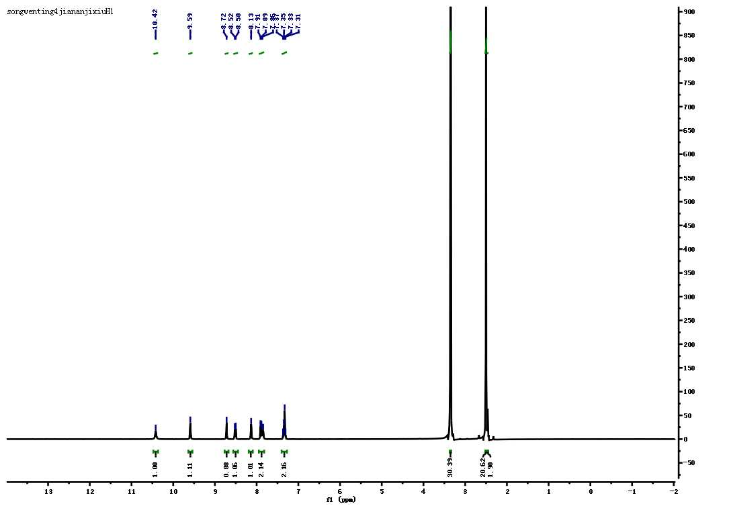
DMSO solvent
H₂O
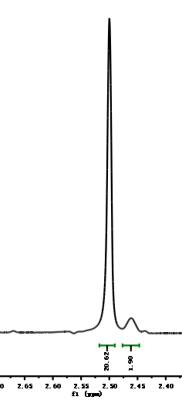

DMSO-d₆

Fig. S2 The ¹H NMR spectroscopy of 1 (Insert :magnify for DMSO-d₆ peak at 2.47 to 2.50 ppm. DMSO solvent peak was found at 2.52 ppm)
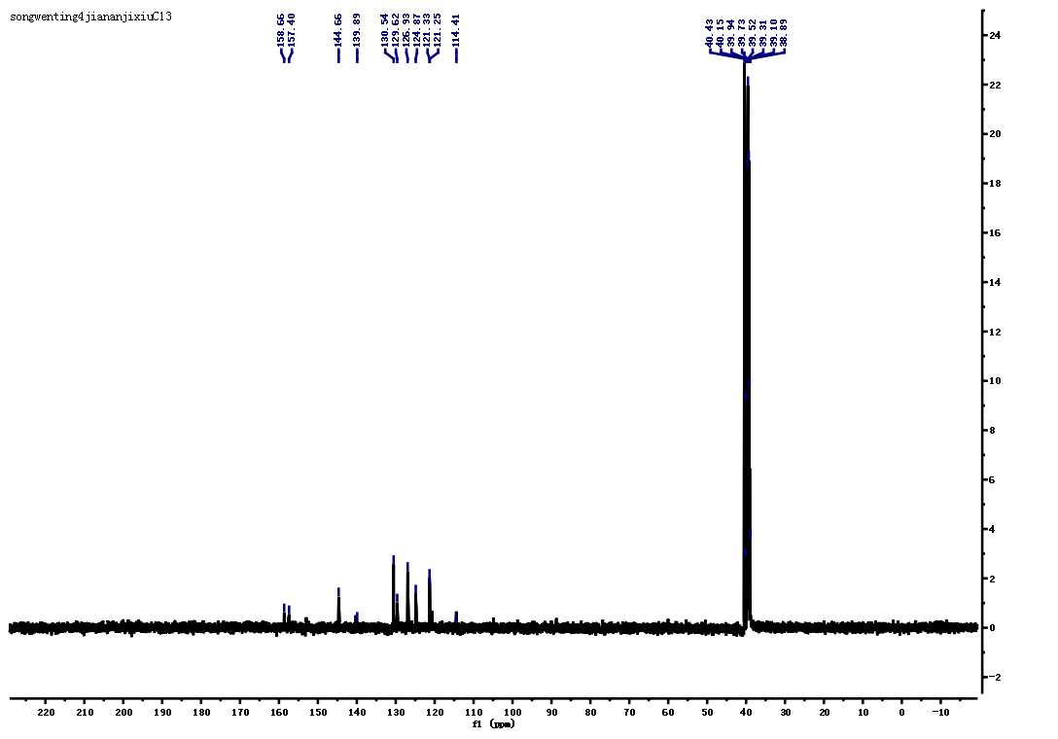
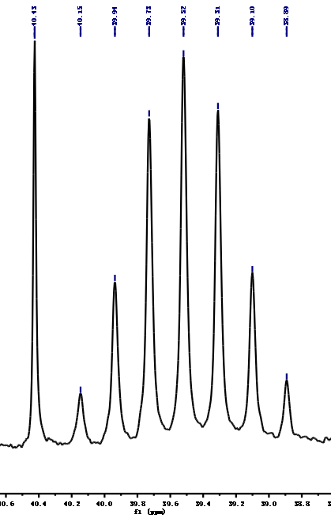

DMSO solvent

Fig. S3 The ¹³C NMR spectroscopy of 1(Insert :magnify for peak at 38.8 to 40.6 ppm. DMSO solvent peak was found at 40.43 ppm.
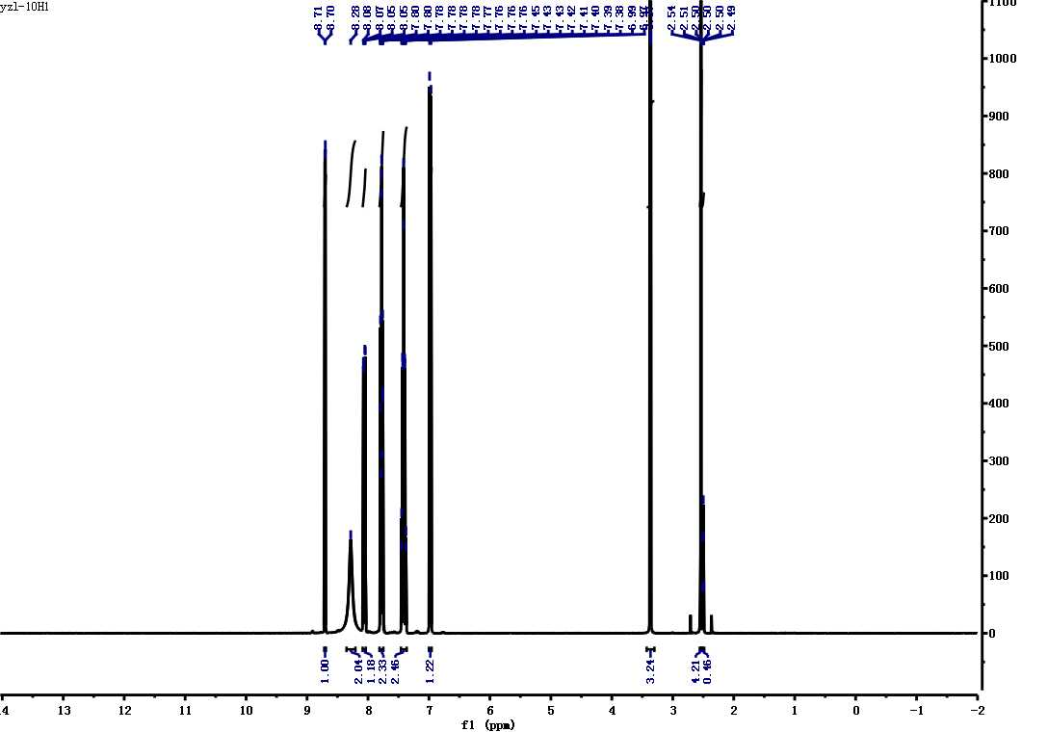

DMSO solvent
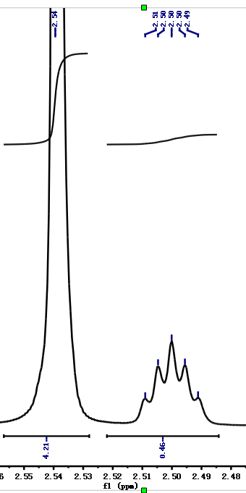

DMSO-d₆

Fig. S4 The ¹H NMR spectroscopy of 2 (Insert :magnify for DMSO-d₆ peak at 2.49 to 2.51 ppm. DMSO solvent peak was found at 2.54 ppm)
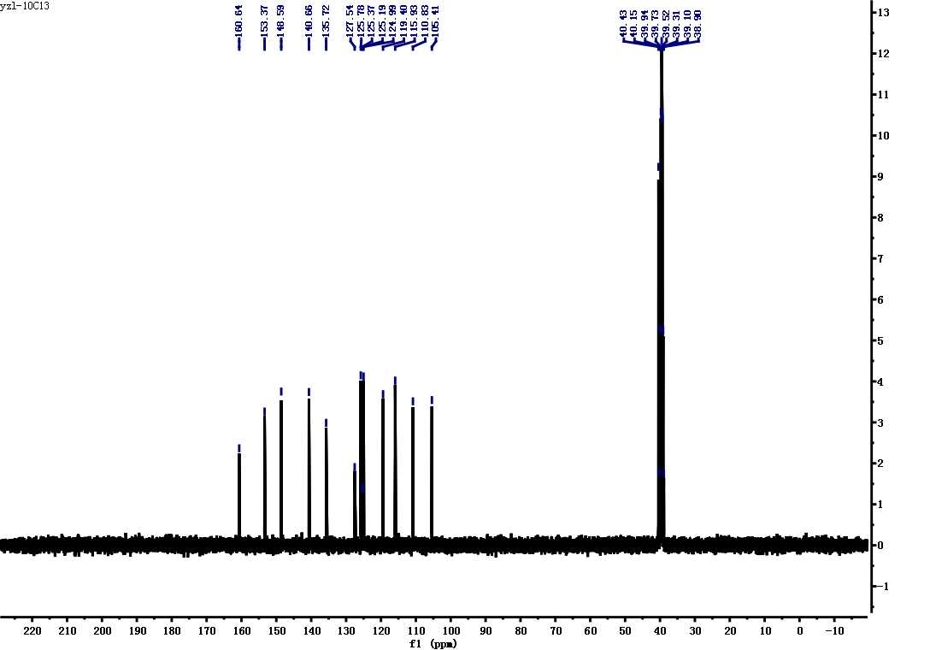
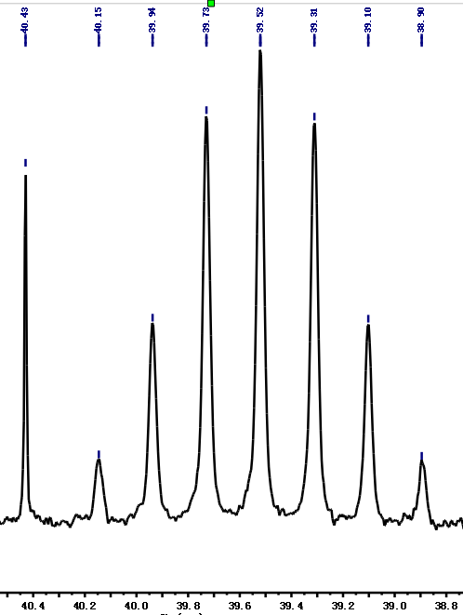
DMSO solvent

Fig. S5 The ¹³C NMR spectroscopy of 2(Insert :magnify for peak at 38.8 to 40.6 ppm. DMSO solvent peak was found at 40.43 ppm.)
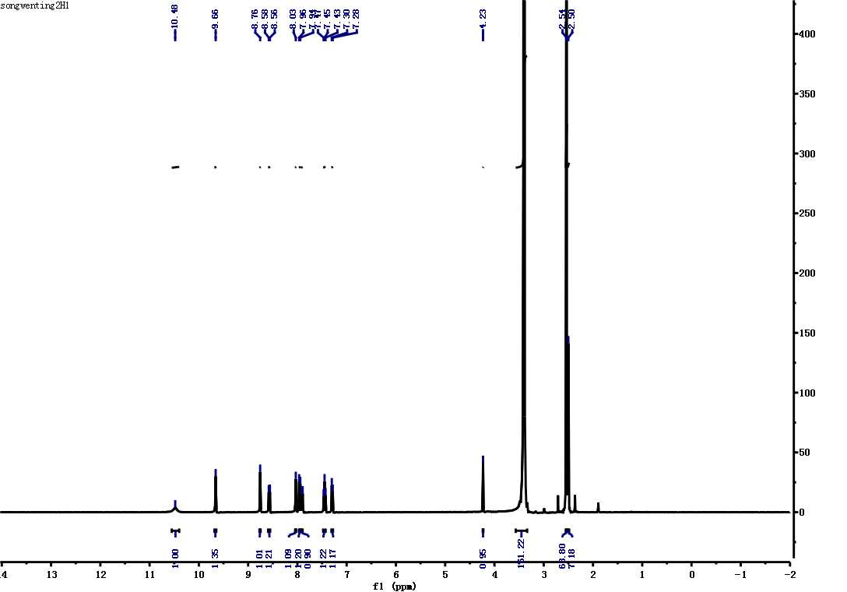

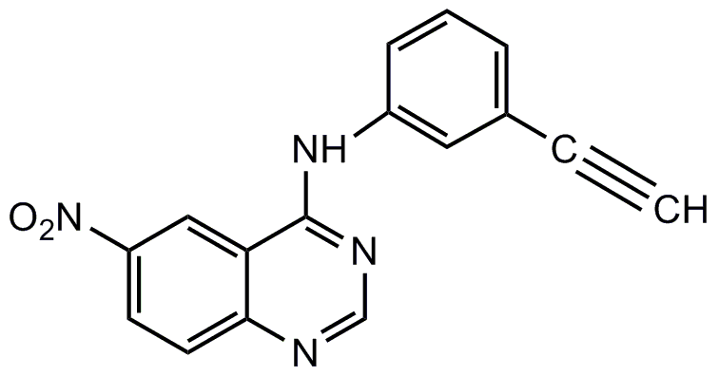

Fig. S6 The ¹H NMR spectroscopy of 3 (Insert :magnify for DMSO-d₆ peak at 2.49 to 2.51 ppm. DMSO solvent peak was found at 2.54 ppm)
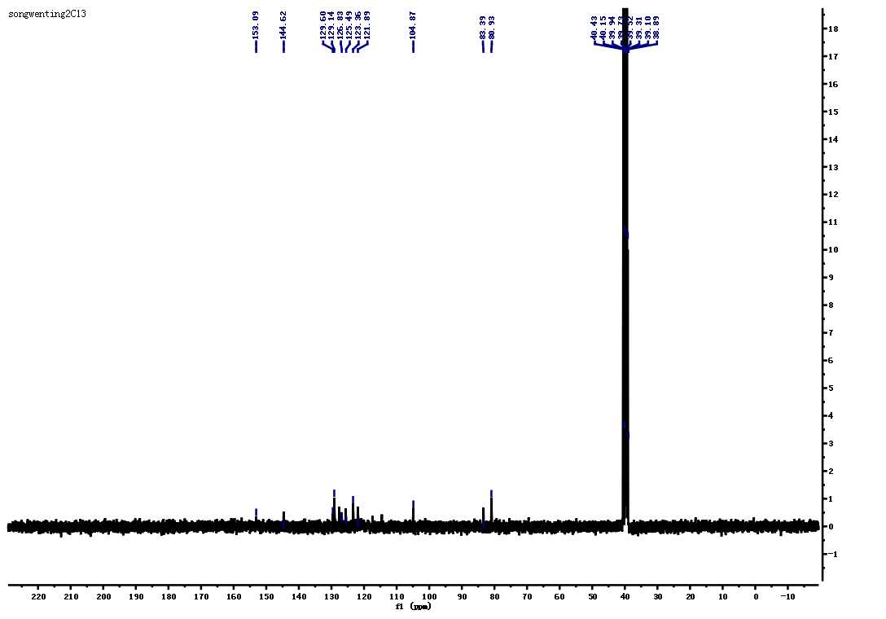

Fig. S7 The ¹³C NMR spectroscopy of 3
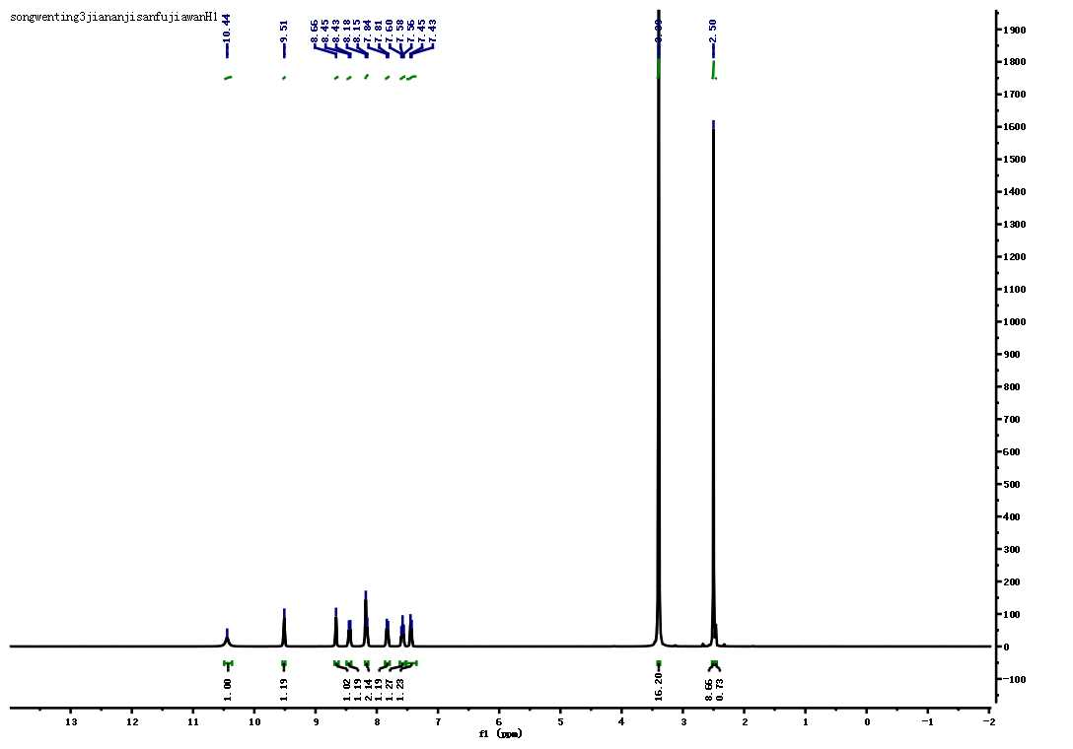

Fig. S8 The ¹H NMR spectroscopy of 4 (Insert :magnify for DMSO-d₆ peak at 2.49 to 2.51 ppm. DMSO solvent peak was found at 2.54 ppm)
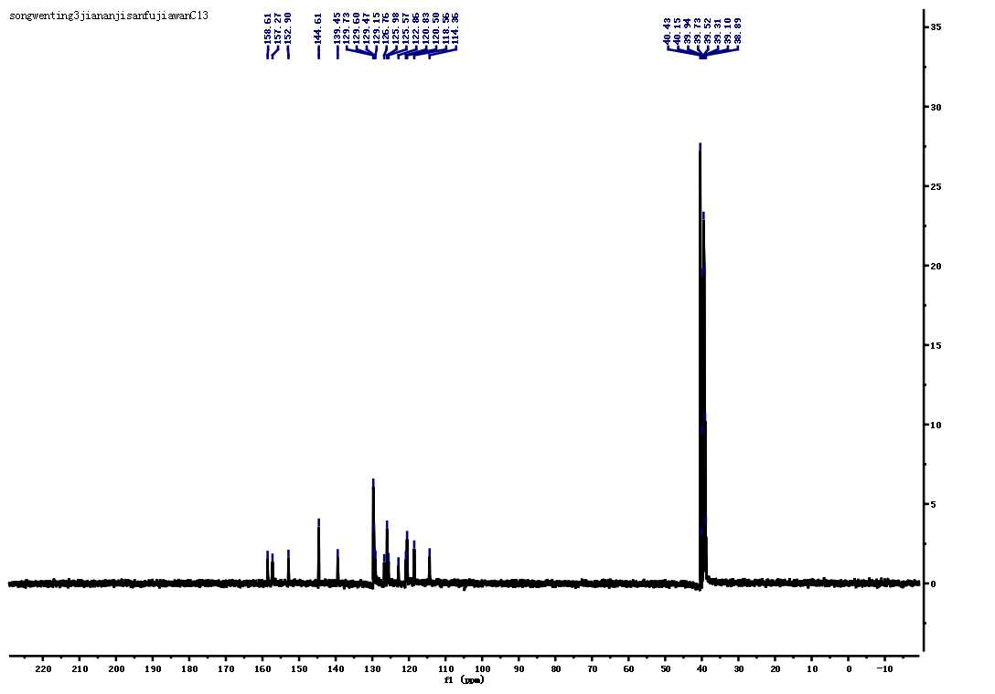

Fig. S9 The ¹³C NMR spectroscopy of 4

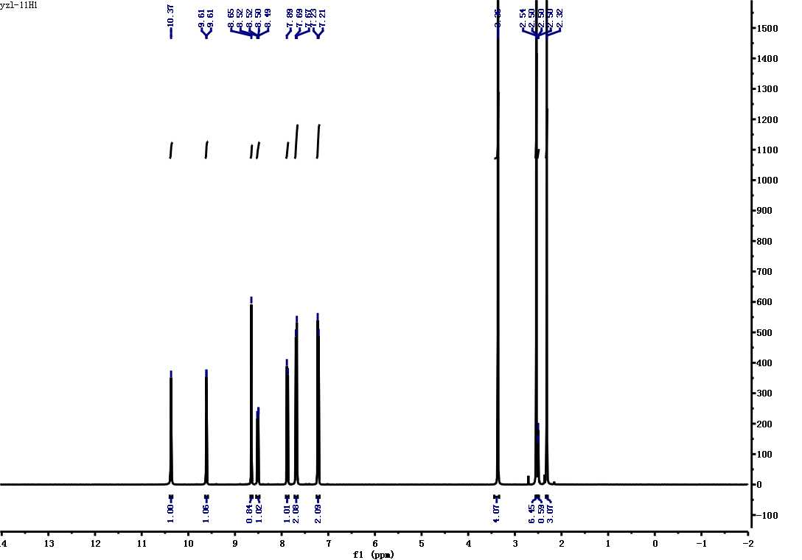

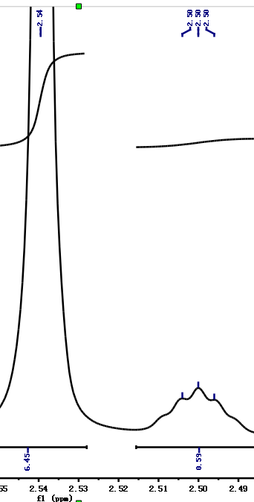

Fig. S10 The ¹H NMR spectroscopy of 5 (Insert :magnify for DMSO-d₆ peak at 2.49 to 2.51 ppm. DMSO solvent peak was found at 2.54 ppm)
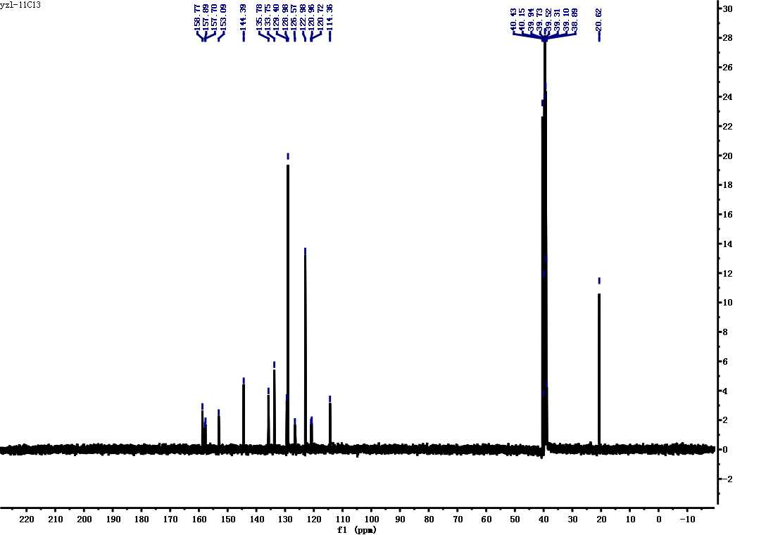

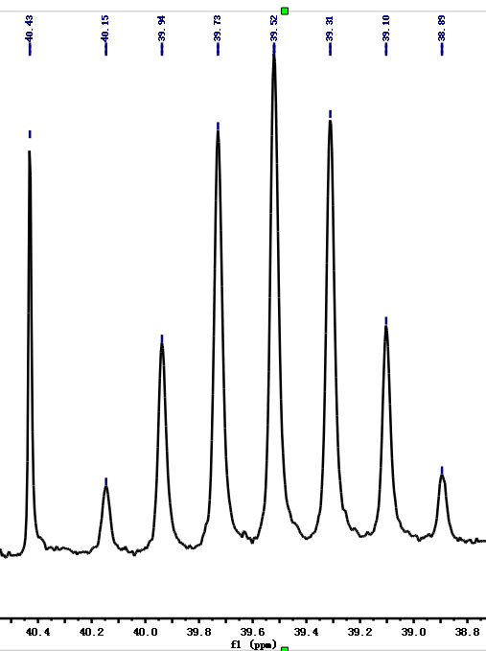

Fig. S11 The ¹³C NMR spectroscopy of 5(Insert :magnify for peak at 38.8 to 40.6 ppm. DMSO solvent peak was found at 40.43 ppm.)
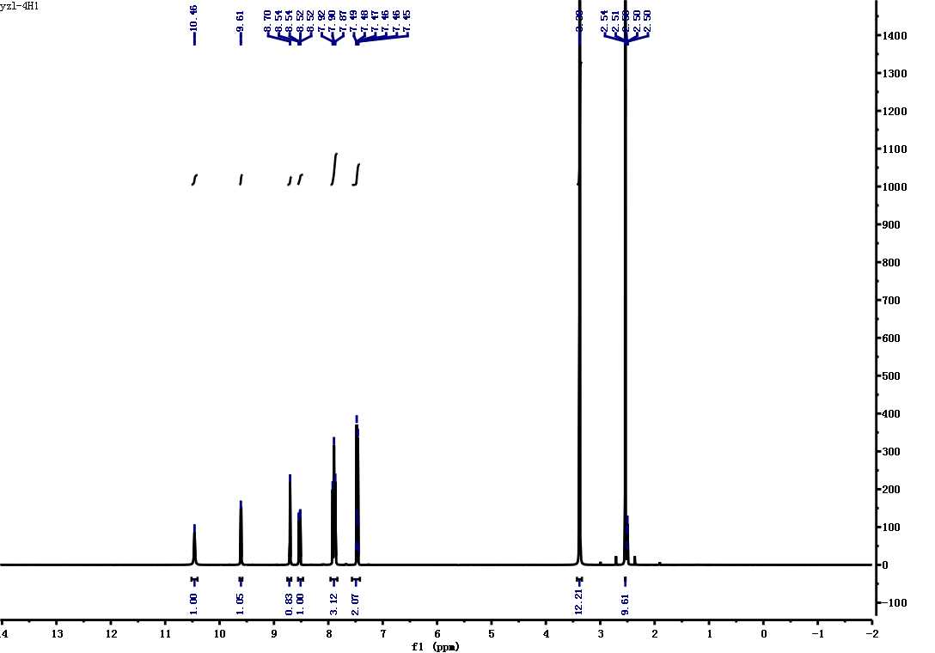

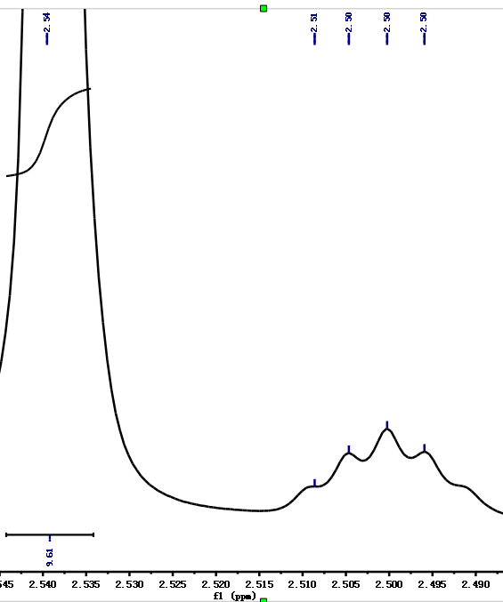

Fig. S12 The ¹H NMR spectroscopy of 6 (Insert :magnify for DMSO-d₆ peak at 2.49 to 2.51 ppm. DMSO solvent peak was found at 2.54 ppm)
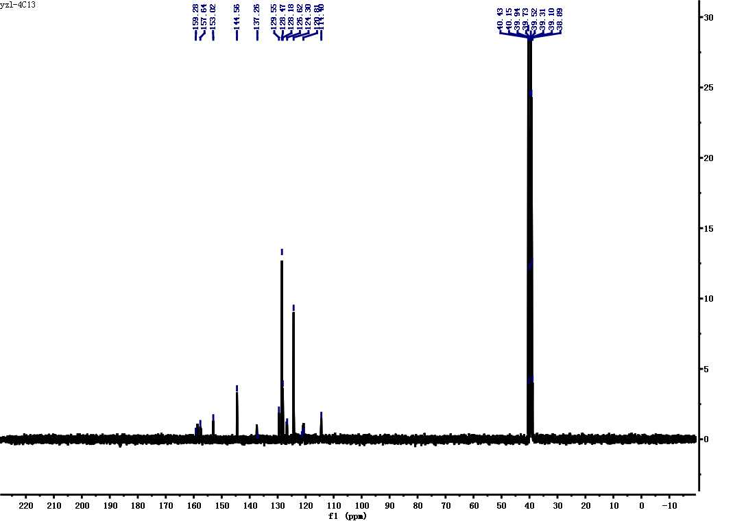

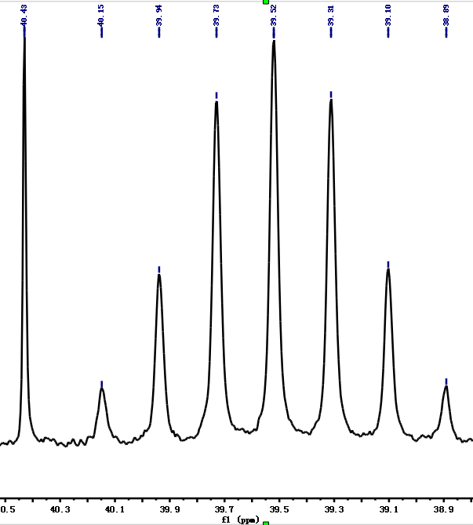

Fig. S13 The ¹³C NMR spectroscopy of 6(Insert :magnify for peak at 38.8 to 40.6 ppm. DMSO solvent peak was found at 40.43 ppm.)
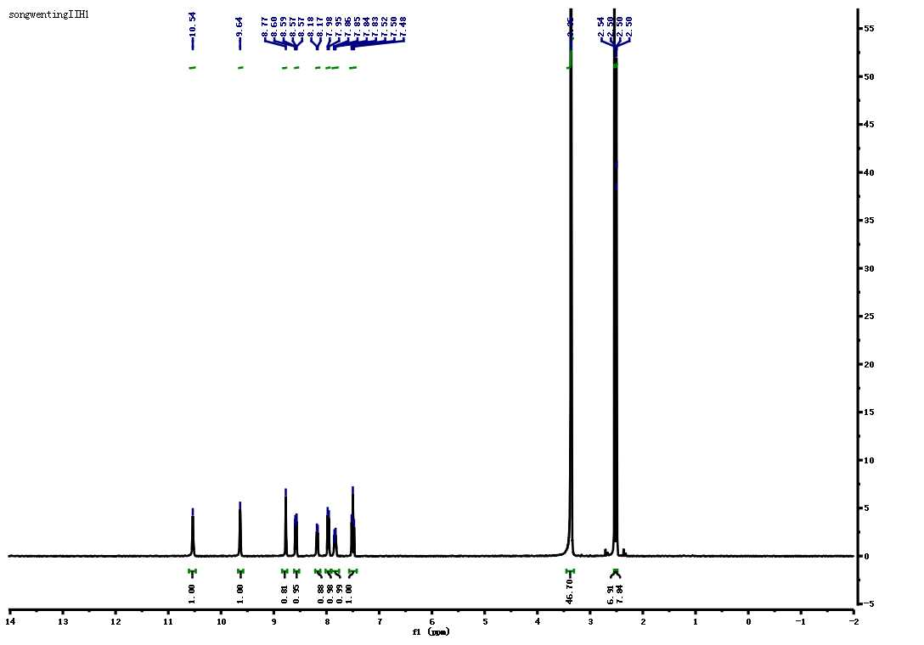

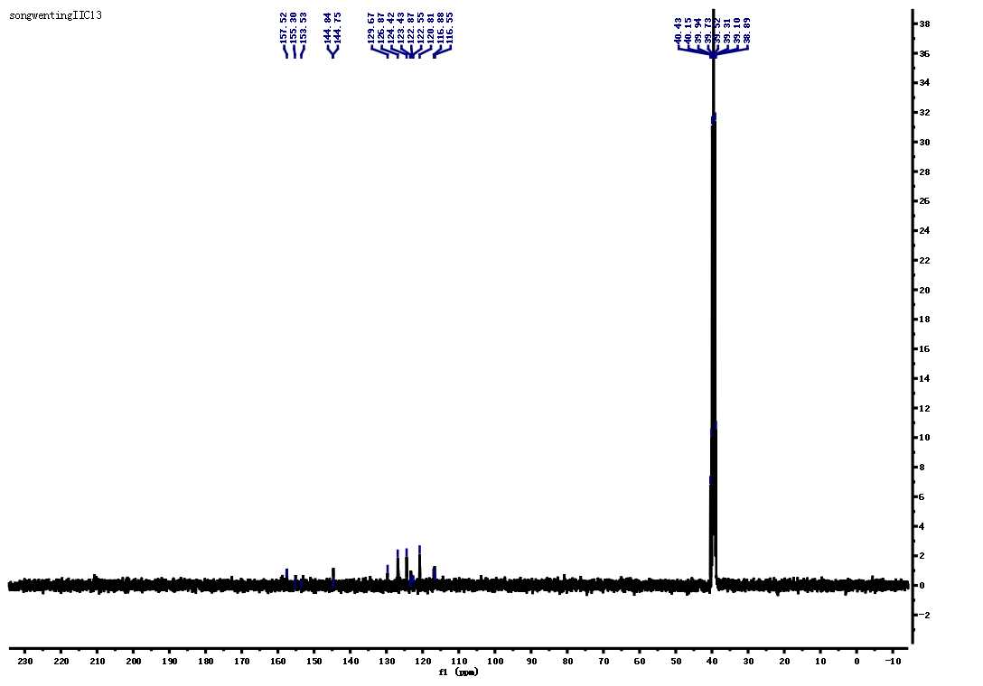
Fig. S14 The ¹H NMR spectroscopy of 7 (Insert :magnify for DMSO-d₆ peak at 2.49 to 2.51 ppm. DMSO solvent peak was found at 2.54 ppm)

Fig. S15 Fig S3 The ¹³C NMR spectroscopy of 7(Insert :magnify for peak at 38.8 to 40.6 ppm. DMSO solvent peak was found at 40.43 ppm.)
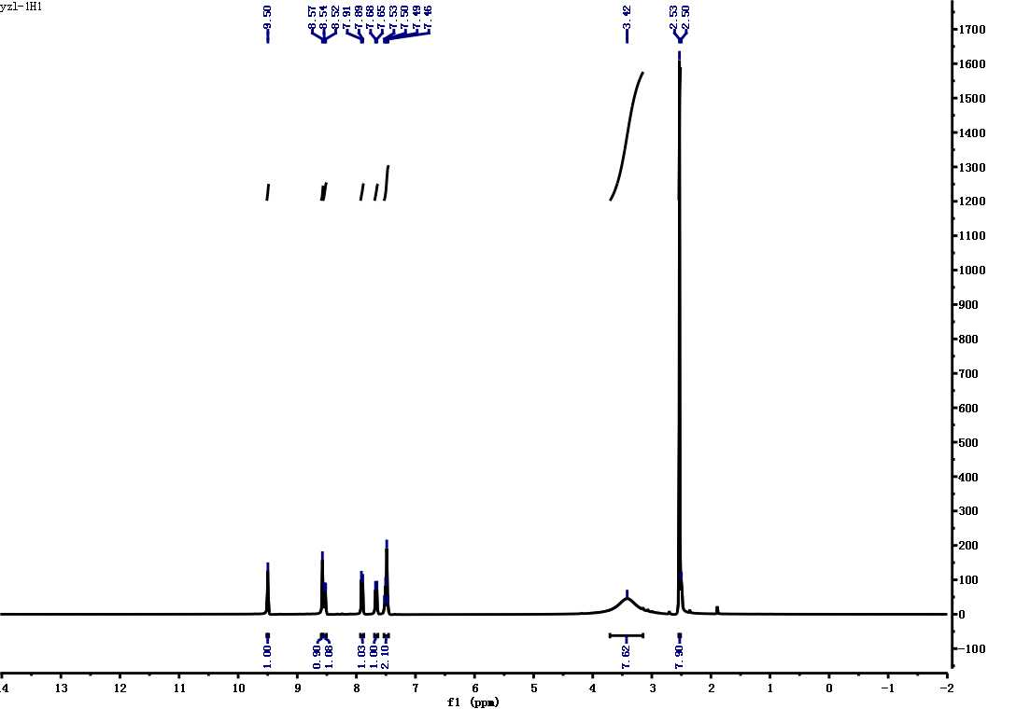

Fig. S16 The ¹H NMR spectroscopy of 8 (Insert :magnify for DMSO-d₆ peak at 2.49 to 2.51 ppm. DMSO solvent peak was found at 2.54 ppm)
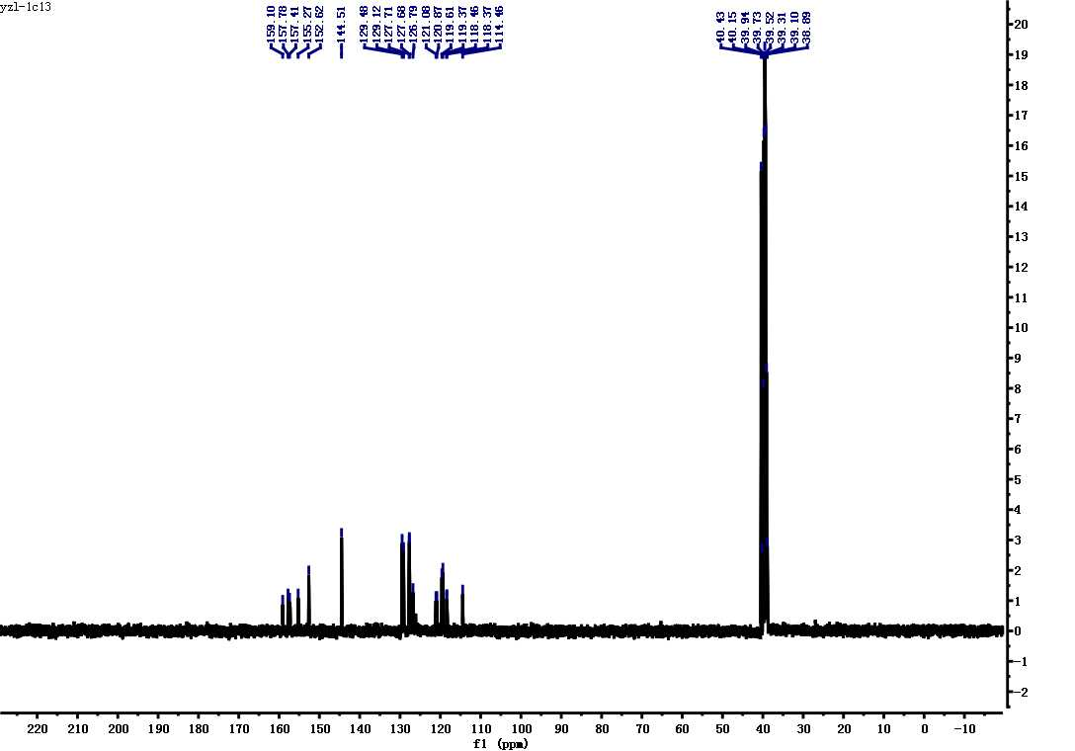
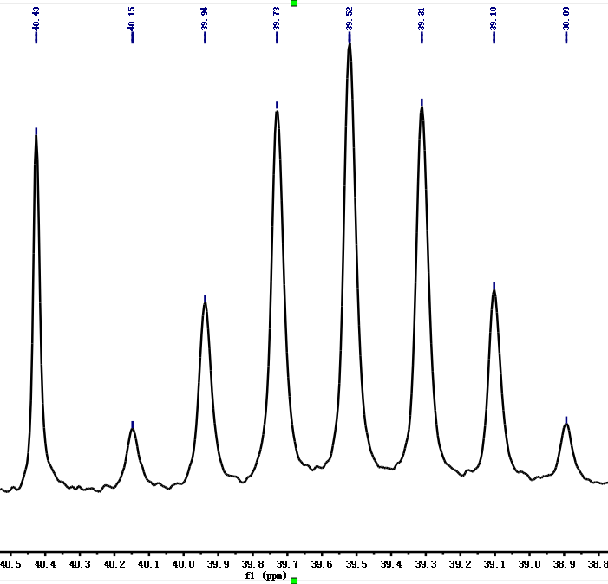

Fig. S17 The ¹³C NMR spectroscopy of 8(Insert :magnify for peak at 38.8 to 40.6 ppm. DMSO solvent peak was found at 40.43 ppm.)
7.2 Spectral copies of HR-MS(ESI) for compounds 1-8
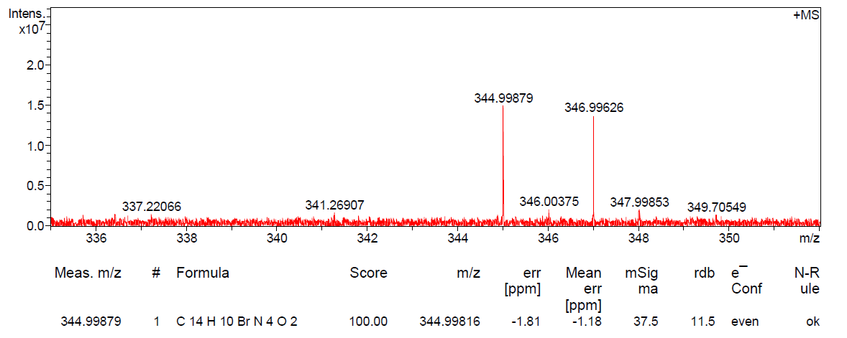
Fig. S18 The HR-MS spectroscopy of 1
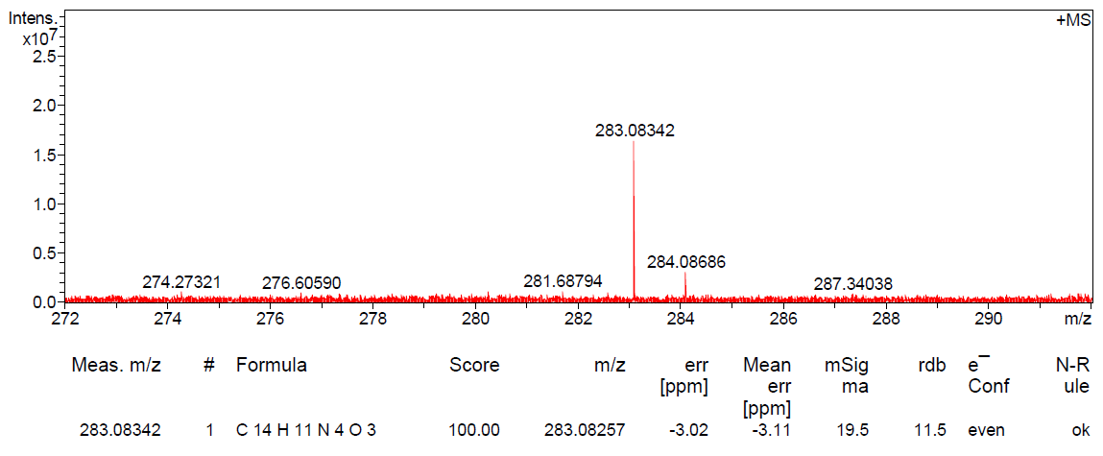
Fig. S19 The HR-MS spectroscopy of 2
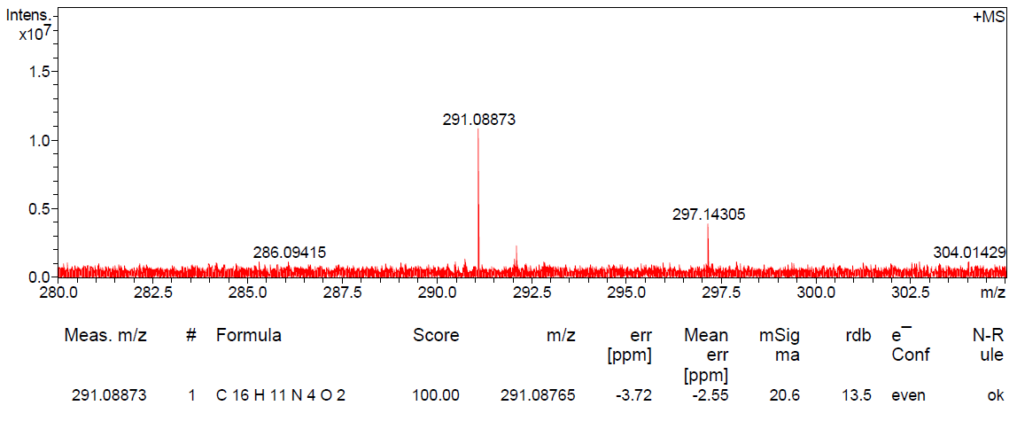
Fig. S20 The HR-MS spectroscopy of 3

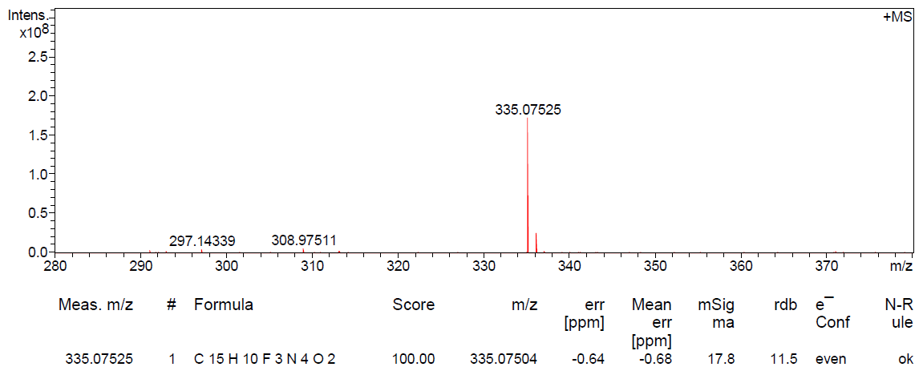
Fig. S21 The HR-MS spectroscopy of 4
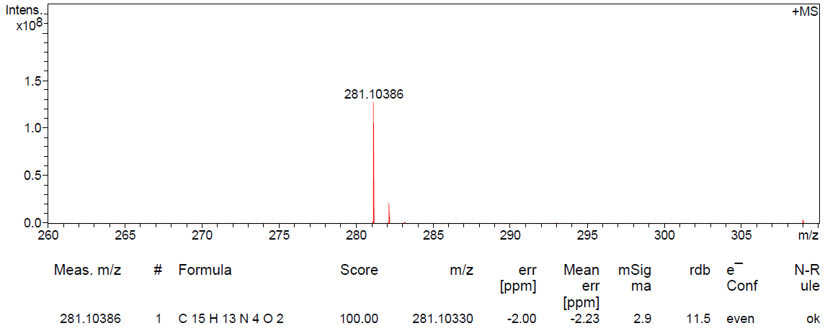
Fig. S22 The HR-MS spectroscopy of 5
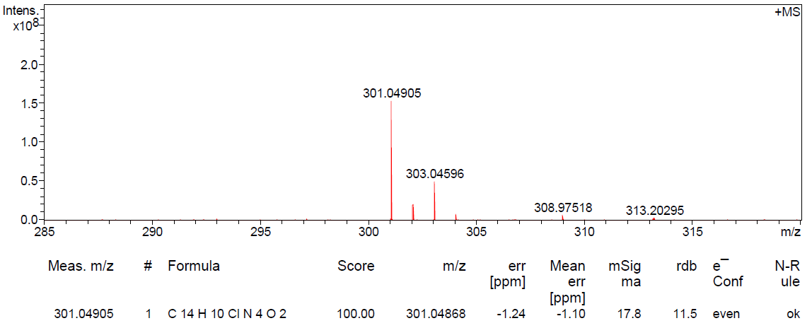
Fig. S23 The HR-MS spectroscopy of 6

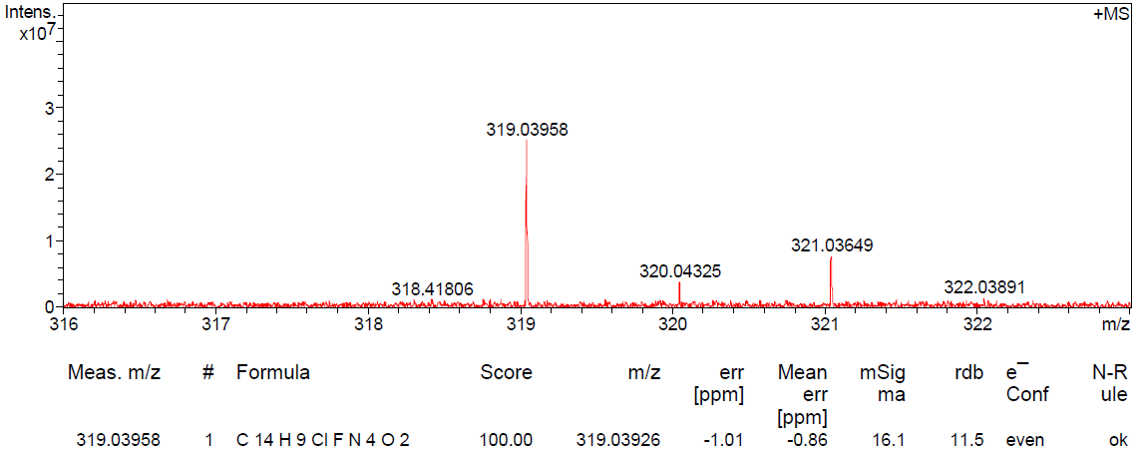
Fig. S24 The HR-MS spectroscopy of 7
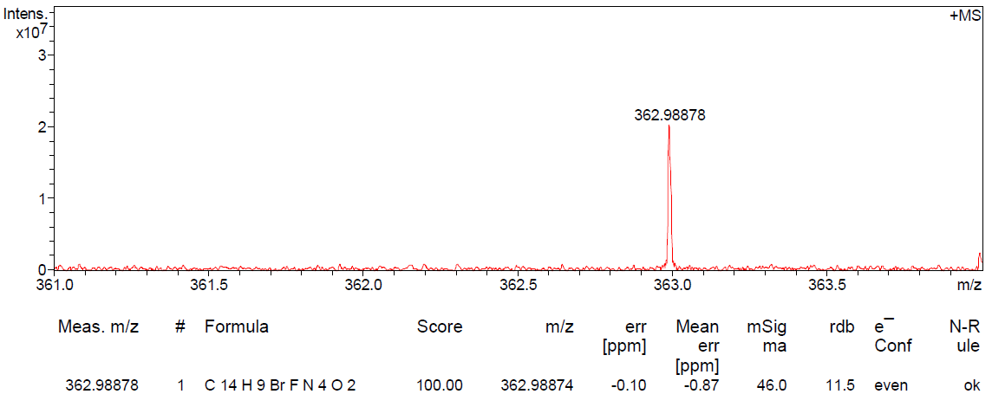
Fig. S25 The HR-MS spectroscopy of 8

7.3 Spectral copies of FT-IR for compounds 1-8
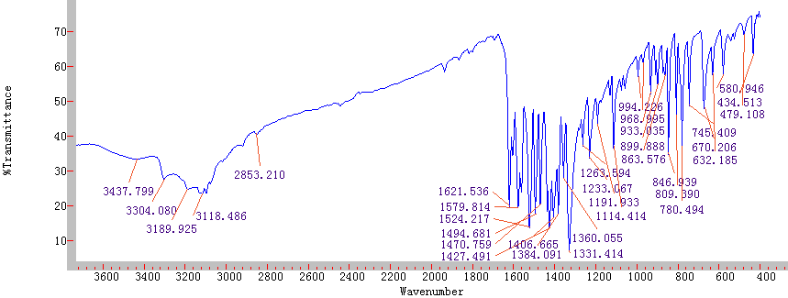

Fig.S26 The FT-IR spectroscopy of 1
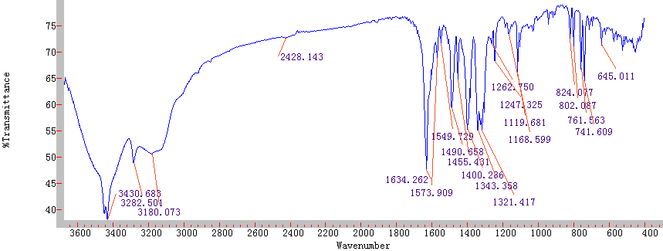

Fig.S27 The FT-IR spectroscopy of 2
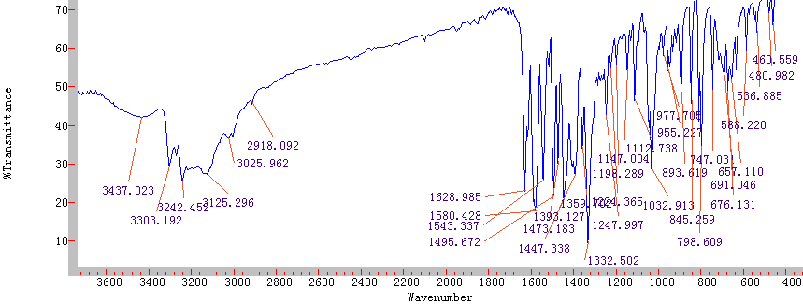

Fig.S28 The FT-IR spectroscopy of 3

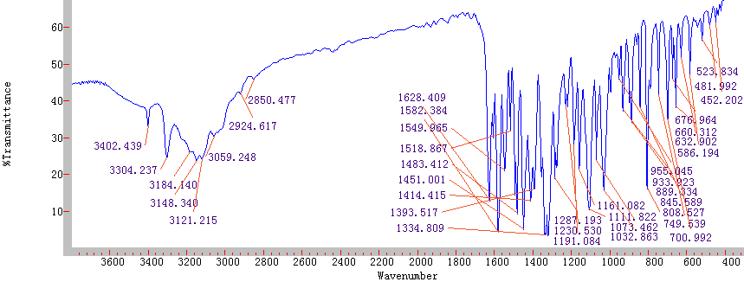

Fig.S29 The FT-IR spectroscopy of 4
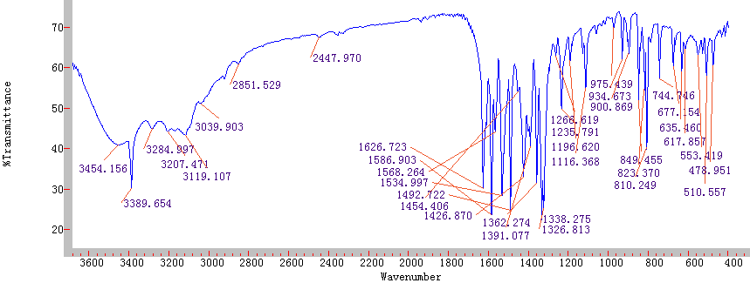

Fig.S30 The FT-IR spectroscopy of 5
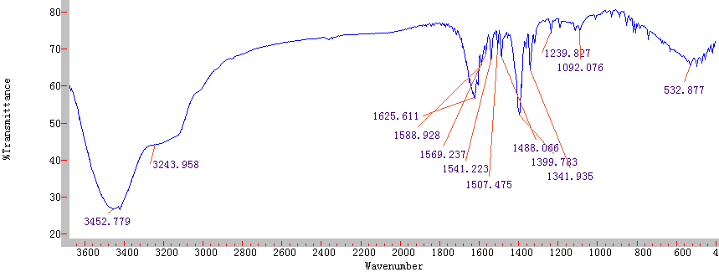

Fig.S31 The FT-IR spectroscopy of 6

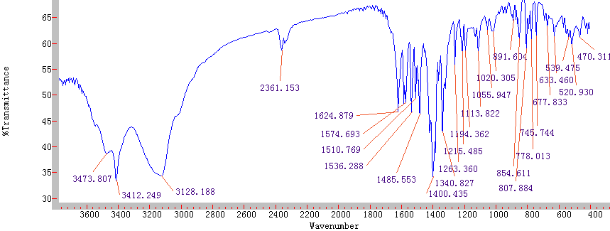

Fig.S32 The FT-IR spectroscopy of 7
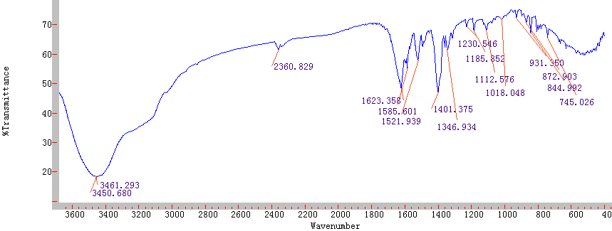

Fig.S33 The FT-IR spectroscopy of 8

