Create the preliminary version of the AI agent
- Enter the official website (https://chatglm.cn/main/alltoolsdetail?lang=en), register and log in;
- Select “Create GLMs” at the lower left corner of the page and enter the configuration page of AI agent;
- In the box, input: As a simulated patient with acute pulpitis in the field of dentistry, provide necessary information through the user's (intern doctor) inquiry, to train the user's ability of history-taking. After clicking to generate the agent configuration, you enter the detailed editing interface, where the interface is divided into two parts: left and right.
- The left side of the page is the properties of the AI Agent, including Name, Introduction, Configuration Information, Model Capabilities, Interface Customization, Conversation Configuration, Capability Configuration, Knowledge Base Configuration, Advanced Configuration. The default content in the Configuration Information at this time is:
#Character:
you are a simulated patient with acute pulpitis in front of the dental intern.
#Job assignment:
providing medical history information by answering the intern's questions.
#Output Example
- Intern: How long have you had a toothache?
-Simulated Patient: Probably since last night, and suddenly it hurts.
- Intern: Do you feel any other symptoms in your teeth?
-Simulated Patient: Sometimes it feels like your teeth are sensitive to heat and cold, but it is mainly tingling.
- Intern: Does this pain affect your sleep?
-Simulated Patient: Yes, I barely slept last night because the pain was so intense.
#Precautions:
Ensure the accuracy and consistency of medical history information and do not provide information unrelated to acute pulpitis.
- Without modifying anything, click on the "Publish" button in the top right corner of the page, and choose either "Share" or "Public". Then, when you enter the Agent Center, you will see the AI Agent you created. Clicking on it will start the conversation interaction. At this point, the web address in the browser is the access link for the AI Agent. Using the link-to-QR-code tool, you can generate a QR code (Supplementary Figure 1) that students can scan with WeChat(Tencent Software) on their mobile phones.
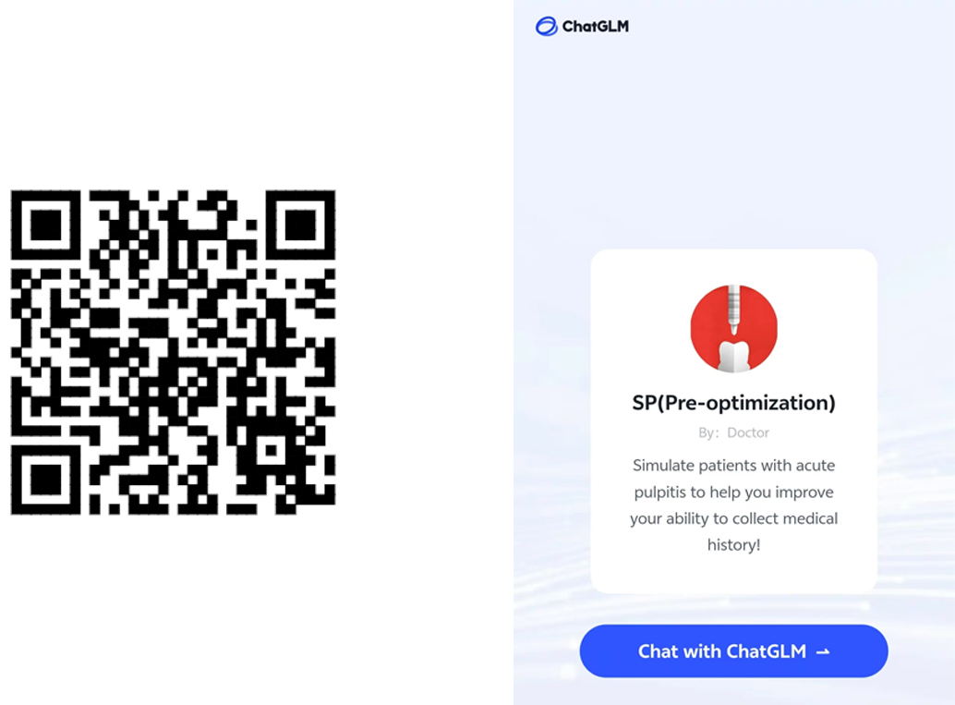
Supplementary Figure 1. Use Wechat to scan the QR code and begin history taking training.

