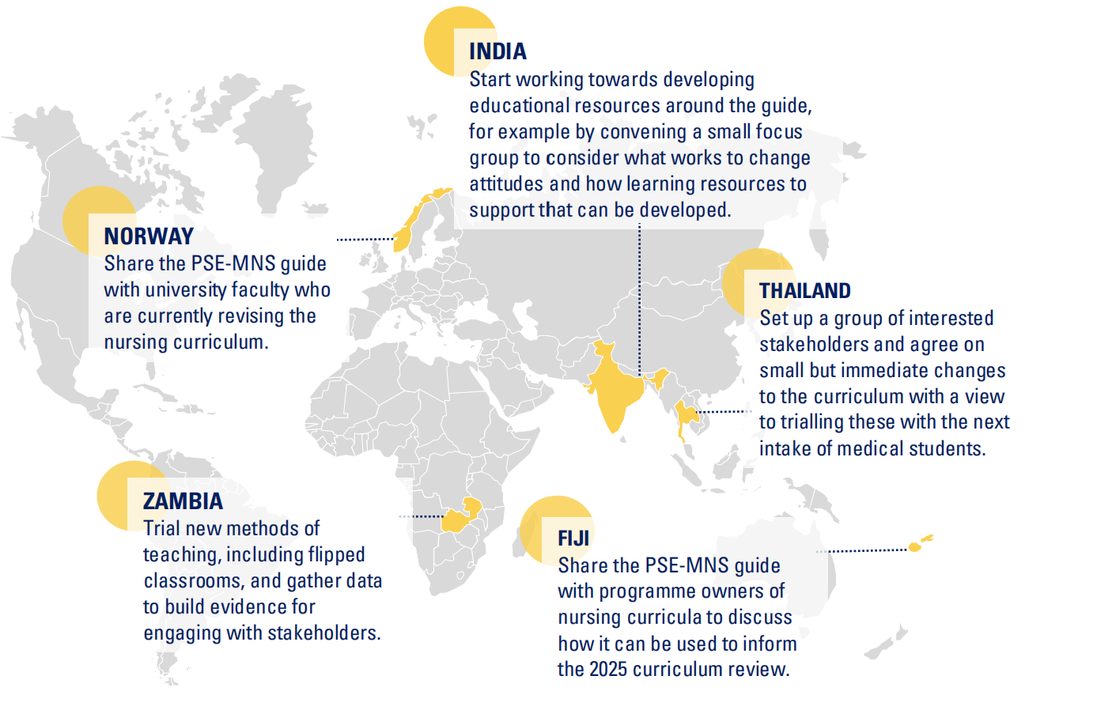
Note: This map was adopted from the “Pre-service education in mental, brain and behavioural health: scaling up implementation and dissemination workshop–WHO Collaborating Centre for Research and Training in Mental Health (Shanghai), 2024”.

