# **Appendix**

## **Mobility Impairment Health State Selection**

The first simplified health state, defined as “minimally impaired”, grouped Expanded Disability Status Scale (EDSS) health states 0.0–3.5 defining patients experiencing difficulty in one or more functional systems such as tremor, difficulty swallowing, or numbness but do not impair a patient’s mobility. The second simplified health state, defined as “able to walk with aid”, grouped EDSS health states 4.0–6.5 which are defined as the ability to walk with an aid, such as a cane or walker. The third simplified health state, defined as “confined to a wheelchair” correspond to EDSS states 7.0–8.0 where patients are restricted to both unassisted and motor assisted wheelchairs. The final health state was defined as “bedridden” and corresponded to EDSS states 8.5–9.5 where patients are restricted to their bed and, in later stages, totally dependent on caregivers for basic needs. However, because mobility impairments can broadly describe the progression of neurological conditions, these simplified mobility health states can be mapped to other clinical staging scales such as the Heohn & Yahr Scale for Parkinson’s disease and Myasthenia Gravis Foundation of America (MGFA) Classification.[7, 55, 56] Table 1 details on how these staging scales map to mobility impairment health states.

*Appendix Table 1: Mapping Clinical Staging to Mobility Impairment Health States*

|  |  |  |  |
| --- | --- | --- | --- |
| **Mobility Impairment Health States** | **EDSS**  **(Kurtzke 1983)** | **H&Y**  **(Hoehn and Yahr 1967)** | **Myasthenia Gravis Foundation of America (MGFA) Classification**  **(America 2024)** |
| Minimally Impaired | 0-3.5 | 1, 1.5, 2, 2.5, 3 | I, II |
| Able to Walk with Aid | 4.0-6.5 | 4 | III |
| Confined to Wheelchair | 7.0-8.0 | 5 | IV |
| Bedridden | 8.5-9.5 | 5 | V |

EDSS: Expanded Disability Status Scale, H&Y: Heohn and Yahr Scale

**[Placement of Appendix Figure 1: Example Question from Health State Quality of Life Ranking Module]**

*Appendix Table 2: Example Probability Sequence for RRA Module*

|  |  |  |  |  |  |  |  |  |  |  |  |
| --- | --- | --- | --- | --- | --- | --- | --- | --- | --- | --- | --- |
|  | **Option A** | | | | **Option B** | | | | **Utility / Risk Aversion** | | |
| Q# | Minimally Impaired | Able to walk with aid | Confined to wheelchair | Bedridden | Minimally Impaired | Able to walk with aid | Confined to wheelchair | Bedridden | EU(A)-EU(B) under risk neutrality | RRA if pick A | RRA if pick B |
|  | 0.797 | 0.639 | 0.399 | 0.136 | 0.797 | 0.639 | 0.399 | 0.136 |
| 1 | - | 0% | 100% | - | 0% | - | - | 100% | 0.2627 | A strictly dominates | |
| 2 | - | 10% | 90% | - | 10% | - | - | 90% | 0.22067 | > -2.95 | < -2.95 |
| 3 | - | 20% | 80% | - | 20% | - | - | 80% | 0.17864 | > -1.99 | < -1.99 |
| 4 | - | 30% | 70% | - | 30% | - | - | 70% | 0.13661 | > -1.39 | < -1.39 |
| 5 | - | 40% | 60% | - | 40% | - | - | 60% | 0.09458 | > -0.92 | < -0.92 |
| 6 | - | 50% | 50% | - | 50% | - | - | 50% | 0.05255 | > -0.50 | < -0.507 |
| 7 | - | 60% | 40% | - | 60% | - | - | 40% | 0.01052 | > -0.10 | < -0.10 |
| 8 | - | 70% | 30% | - | 70% | - | - | 30% | -0.03151 | > 0.32 | < 0.32 |
| 9 | - | 80% | 20% | - | 80% | - | - | 20% | -0.07354 | > 0.82 | < 0.82 |
| 10 | - | 90% | 10% | - | 90% | - | - | 10% | -0.11557 | > 1.53 | < 1.53 |
| 11 | - | 95% | 5% | - | 95% | - | - | 5% | -0.136585 | > 2.157 | < 2.157 |
| 12 | - | 100% | 0% | - | 100% | - | - | 0% | -0.1576 | B strictly dominates | |

EU: Expected Utility, RRA: Relative Risk Aversion, Q: Question

*Example:* For a respondent who switched treatments at question 2, their expected utility can be computed as the product of health state specific quality of life [0.797, 0.136] and the probability of being in each respective health state in question 2, by treatment [10%, 90%]. The difference in expected utility is defined as EU(A) – EU(B) and is = 0.221 in question 2. Assuming a constant relative risk aversion utility function, the relative risk aversion such that a respondent would be indifferent between the two treatments (expected utility = 0) is employed to adjust RRA by 0.001. If the respondent selected treatment B this recursion computes a minimum risk-aversion value of -1.99.

*Appendix Table 3: Full Table of Respondent Characteristics*

| **Metric** | **Cognitive** | | **Mobility** | |
| --- | --- | --- | --- | --- |
| **N/Mean** | **%/SD** | **N/Mean** | **%/SD** |
|  |
| **Age** | 51.1 | 16.0 | 49.3 | 16.1 |  |
| 18–24 | 18 | 6.1% | 8 | 3.1% |  |
| 25–34 | 38 | 12.9% | 51 | 19.7% |  |
| 35–44 | 51 | 17.3% | 47 | 18.1% |  |
| 45–54 | 53 | 18.0% | 52 | 20.1% |  |
| 55–64 | 69 | 23.4% | 44 | 17.0% |  |
| ≥ 65 | 66 | 22.4% | 57 | 22.0% |  |
| **Gender** |  |  |  |  |  |
| Male | 131 | 44.4% | 126 | 48.6% |  |
| Female | 160 | 54.2% | 132 | 51.0% |  |
| Non-Binary or Prefer not to answer | 4 | 1.4% | 1 | 0.4% |  |
| **Marital Status** |  |  |  |  |  |
| Married | 133 | 45.1% | 133 | 51.4% |  |
| Never married | 101 | 34.2% | 90 | 34.7% |  |
| Divorced | 43 | 14.6% | 24 | 9.3% |  |
| Widowed/Separated | 18 | 6.1% | 12 | 4.6% |  |
| **Race** |  |  |  |  |  |
| Native American | 5 | 1.7% | 10 | 3.9% |  |
| Asian/Pacific Islander | 25 | 8.5% | 9 | 3.5% |  |
| Black | 18 | 6.1% | 37 | 14.3% |  |
| White | 252 | 85.4% | 213 | 82.2% |  |
| Prefer not to answer | 6 | 2.0% | 4 | 1.5% |  |
| **Income** |  |  |  |  |  |
| ≤ $9,999 | 15 | 5.1% | 20 | 7.7% |  |
| $10,000–$49,999 | 92 | 31.2% | 81 | 31.3% |  |
| $50,000–$74,999 | 68 | 23.1% | 52 | 20.1% |  |
| $75,000–$99,999 | 42 | 14.2% | 45 | 17.4% |  |
| $100,000–$149,000 | 37 | 12.5% | 36 | 13.9% |  |
| ≥ $150,000 | 32 | 10.8% | 20 | 7.7% |  |
| Not Reported | 9 | 3.1% | 5 | 1.9% |  |
| **Education** |  |  |  |  |  |
| Less than high school | 2 | 0.7% | 3 | 1.2% |  |
| High school | 32 | 10.8% | 31 | 12.0% |  |
| Some college | 51 | 17.3% | 56 | 21.6% |  |
| Associates degree | 36 | 12.2% | 28 | 10.8% |  |
| College or more | 112 | 38.0% | 94 | 36.3% |  |
| **Employment** |  |  |  |  |  |
| Yes | 143 | 55.2% | 173 | 58.6% |  |
| No | 114 | 44.0% | 119 | 40.3% |  |
| Prefer not to answer | 2 | 0.8% | 3 | 1.0% |  |
| **Health Insurance** |  |  |  |  |  |
| Employer | 125 | 48.3% | 153 | 51.9% |  |
| Direct | 40 | 15.4% | 49 | 16.6% |  |
| Medicare | 66 | 25.5% | 72 | 24.4% |  |
| Medicaid | 38 | 14.7% | 36 | 12.2% |  |
| Tricare | 6 | 2.3% | 1 | 0.3% |  |
| Veterans Affairs | 9 | 3.5% | 8 | 2.7% |  |
| Indian Health Service | 2 | 0.8% | 0 | 0.0% |  |
| Other | 8 | 3.1% | 5 | 1.7% |  |
| Uninsured | 20 | 7.7% | 3 | 1.0% |  |
| **Risk Preferences** |  |  |  |  |  |
| Receipt of flu shot in last 12 months | |  |  |  |  |
| Flu shot | 114 | 44.0% | 160 | 54.2% |  |
| No flu shot | 142 | 54.8% | 134 | 45.4% |  |
| Ineligible | 0 | 0.0% | 0 | 0.0% |  |
| Prefer not to answer | 2 | 0.8% | 1 | 0.3% |  |
| Purchased a lottery ticket | 0 | 0.0% |  |  |  |
| Yes | 114 | 44.0% | 136 | 46.1% |  |
| No | 143 | 55.2% | 159 | 53.9% |  |
| Prefer not to answer | 2 | 0.8% | 0 | 0.0% |  |
| **Disease Experience** |  |  |  |  |  |
| No disease experience | 147 | 49.8% | 197 | 76.1% |  |
| Diagnosis |  |  |  |  |  |
| Alzheimer's disease | 1 | 0.4% | 0 | 0.0% |  |
| Amyotrophic lateral sclerosis | 1 | 0.4% | 0 | 0.0% |  |
| Mental health | 49 | 18.9% | 49 | 16.6% |  |
| Multiple Sclerosis | 1 | 0.4% | 1 | 0.3% |  |
| Parkinson's disease | 2 | 0.8% | 1 | 0.3% |  |
| Stroke | 4 | 1.5% | 4 | 1.4% |  |
| Other | 2 | 0.8% | 1 | 0.3% |  |
| None | 204 | 78.8% | 243 | 82.4% |  |
| Diagnosis of a loved one |  |  |  |  |  |
| Alzheimer's disease | 27 | 10.4% | 41 | 13.9% |  |
| Amyotrophic lateral sclerosis | 3 | 1.2% | 3 | 1.0% |  |
| Multiple Sclerosis | 7 | 2.7% | 9 | 3.1% |  |
| Parkinson's disease | 21 | 8.1% | 10 | 3.4% |  |
| Other | 25 | 9.7% | 41 | 13.9% |  |
| None | 197 | 76.1% | 210 | 71.2% |  |
| Experience Caregiving |  |  |  |  |  |
| Alzheimer's disease | 19 | 7.3% | 26 | 8.8% |  |
| Amyotrophic lateral sclerosis | 3 | 1.2% | 1 | 0.3% |  |
| Multiple Sclerosis | 3 | 1.2% | 3 | 1.0% |  |
| Parkinson's disease | 11 | 4.2% | 9 | 3.1% |  |
| Other | 23 | 8.9% | 24 | 8.1% |  |
| None | 214 | 82.6% | 244 | 82.7% |  |

*Appendix Table 4: Respondent-Reported Quality of Life Estimates*

|  |  |  |  |
| --- | --- | --- | --- |
| **Survey** | **Health State** | **Respondent** | |
| **Mean** | **Median** |
| Cognitive | No Cognitive Impairment | 0.998 | 1.000 |
| Mild Cognitive Impairment Without Dementia | 0.781 | 0.800 |
| Mild Dementia | 0.540 | 0.500 |
| Moderate Dementia | 0.299 | 0.300 |
| Severe Dementia | 0.055 | 0.000 |
| Mobility | Minimally Impaired | 0.803 | 0.850 |
| Able to Walk with Aid | 0.616 | 0.700 |
| Confined to a Wheelchair | 0.387 | 0.400 |
| Bedridden | 0.116 | 0.100 |

*Appendix Table 5: Cognitive Survey Insurance Value Stratification Results*

|  |  |  |  |  |  |  |  |  |  |
| --- | --- | --- | --- | --- | --- | --- | --- | --- | --- |
| **Category** | **Insurance Type** | **Expected Treatment Value** | | **Respondent WTP** | | **Insurance Value** | | **F-Statistic/T-Statistic** | **P-Value** |
| **Monthly** | **Annual** | **Monthly** | **Annual** |
| Insurance Type | Employer | $ 21.73 | $ 260.80 | $ 57.23 | $ 686.81 | 62.03% | 2.09 (df = 5) | | 0.07 |
| Medicaid | $ 21.73 | $ 260.80 | $ 50.92 | $ 611.04 | 57.32% |
| Medicare | $ 21.73 | $ 260.80 | $ 53.35 | $ 640.16 | 59.26% |
| Other | $ 21.73 | $ 260.80 | $ 53.64 | $ 643.64 | 59.48% |
| Veterans Affairs | $ 21.73 | $ 260.80 | $ 37.32 | $ 447.82 | 41.76% |
| Uninsured | $ 21.73 | $ 260.80 | $ 38.30 | $ 459.60 | 43.26% |
| Previous Risk Behavior | Received a flu shot | $ 21.73 | $ 260.80 | $ 56.77 | $ 681.19 | 61.71% | t = -1.27 | | 0.21 |
| Did not receive a flu shot | $ 21.73 | $ 260.80 | $ 50.16 | $ 601.89 | 56.67% |
| Purchased a lottery ticket | $ 21.73 | $ 260.80 | $ 54.48 | $ 653.70 | 60.10% | t = -0.19 | | 0.84 |
| Did not purchase a lottery ticket | $ 21.73 | $ 260.80 | $ 53.42 | $ 641.04 | 59.32% |
| Sex | Female | $ 21.73 | $ 260.80 | $ 55.34 | $ 664.07 | 60.73% | t = 0.51 | | 0.61 |
| Male | $ 21.73 | $ 260.80 | $ 52.76 | $ 633.10 | 58.81% |
| Age | 65+ | $ 21.73 | $ 260.80 | $ 53.06 | $ 636.73 | 59.04% | F = 0.51  (df = 5) | | 0.77 |
| 55–64 | $ 21.73 | $ 260.80 | $ 54.33 | $ 651.91 | 59.99% |
| 45–54 | $ 21.73 | $ 260.80 | $ 57.46 | $ 689.48 | 62.17% |
| 35–44 | $ 21.73 | $ 260.80 | $ 47.13 | $ 565.51 | 53.88% |
| 25–34 | $ 21.73 | $ 260.80 | $ 56.95 | $ 683.40 | 61.84% |
| 18–24 | $ 21.73 | $ 260.80 | $ 57.73 | $ 692.80 | 62.36% |

WTP: Willingness to pay

*Appendix Table 6: Mobility survey Insurance Value Stratification Result*

| **Category** | **Insurance Type** | **Expected** | | **Respondent WTP** | | **Insurance Value** | **F-Statistic/T-Statistic** | **P-Value** |
| --- | --- | --- | --- | --- | --- | --- | --- | --- |
| **Monthly** | **Annual** | **Monthly** | **Annual** |
| Insurance Type | Employer | $ 11.10 | $ 133.23 | $ 58.21 | $ 698.46 | 80.93% | 1.61 (df = 5) | 0.16 |
| Medicaid | $ 11.10 | $ 133.23 | $ 55.86 | $ 670.27 | 80.12% |
| Medicare | $ 11.10 | $ 133.23 | $ 52.38 | $ 628.50 | 78.80% |
| Other | $ 11.10 | $ 133.23 | $ 52.79 | $ 633.48 | 78.97% |
| Veterans Affairs | $ 11.10 | $ 133.23 | $ 46.23 | $ 554.73 | 75.98% |
| Uninsured | $ 11.10 | $ 133.23 | $ 44.91 | $ 538.92 | 75.28% |
| Previous Risk Behavior | Received a flu shot | $ 11.10 | $ 133.23 | $ 54.85 | $ 658.17 | 79.76% | t= 0.87 | 0.39 |
| Did not receive a flu shot | $ 11.10 | $ 133.23 | $ 55.93 | $ 671.12 | 80.15% |
| Purchased a lottery ticket | $ 11.10 | $ 133.23 | $ 53.73 | $ 644.74 | 79.34% | t = 0.31 | 0.76 |
| Did not purchase a lottery ticket | $ 11.10 | $ 133.23 | $ 57.81 | $ 693.67 | 80.79% |
| Sex | Female | $ 11.10 | $ 133.23 | $ 54.39 | $ 652.65 | 79.59% | t = -0.51 | 0.61 |
| Male | $ 11.10 | $ 133.23 | $ 57.24 | $ 686.88 | 80.60% |
| Age | 65+ | $ 11.10 | $ 133.23 | $ 52.65 | $ 631.83 | 78.91% | 1.83 (df = 5) | 0.11 |
| 55–64 | $ 11.10 | $ 133.23 | $ 48.67 | $ 584.07 | 77.19% |
| 45–54 | $ 11.10 | $ 133.23 | $ 50.95 | $ 611.45 | 78.21% |
| 35–44 | $ 11.10 | $ 133.23 | $ 64.18 | $ 770.17 | 82.70% |
| 25–34 | $ 11.10 | $ 133.23 | $ 59.82 | $ 717.84 | 81.44% |
| 18–24 | $ 11.10 | $ 133.23 | $ 78.79 | $ 945.45 | 85.91% |

WTP: Willingness to pay

*Appendix Table 7: Insurance Value Assessed When Re-Weighted and Treatment Does Not Confer a Survival Gain*

|  |  |  |
| --- | --- | --- |
| **Survey** | **Sensitivity Analysis** | **Insurance Value** |
| Cognitive | Weighted to match U.S. Census age and sex distribution | 54.32% |
| Weighted to match U.S Census age and income distribution | 59.07% |
| Treatment did not confer a survival gain | 70.84% |
| Mobility | Weighted to match U.S. Census age and sex distribution | 79.80% |
| Weighted to match U.S Census age and income distribution | 79.83% |
| Treatment did not confer a survival gain | 81.52% |

*Appendix Table 8: Insurance Value Assessed Under Different Ex-Ante Cost Effectiveness Thresholds*

|  |  |  |  |  |  |  |
| --- | --- | --- | --- | --- | --- | --- |
| **Survey** | **WTP, Monthly** *[A]* | **WTP, Annual** *[B] = [A] x 12* | **Cost Effectiveness Threshold** | **Expected Value, Annual** *[C]* | **Difference** *[D] = [B] - [C]* | **Insurance Value** *[E] = [D] ÷ [B]* |
| Cognitive | $ 53.91 | $ 646.88 | $ 50,000.00 | $ 130.40 | $ 516.48 | 79.84% |
| $ 53.91 | $ 646.88 | $ 100,000.00 | $ 260.80 | $ 386.08 | 59.68% |
| $ 53.91 | $ 646.88 | $ 150,000.00 | $ 391.20 | $ 255.68 | 39.53% |
| $ 53.91 | $ 646.88 | $ 200,000.00 | $ 521.60 | $ 125.28 | 19.37% |
| Mobility | $ 55.95 | $ 671.35 | $ 50,000.00 | $ 66.61 | $ 604.74 | 90.08% |
| $ 55.95 | $ 671.35 | $ 100,000.00 | $ 133.23 | $ 538.12 | 80.16% |
| $ 55.95 | $ 671.35 | $ 150,000.00 | $ 199.84 | $ 471.51 | 70.23% |
| $ 55.95 | $ 671.35 | $ 200,000.00 | $ 266.45 | $ 404.90 | 60.31% |

*Appendix Table 9: Insurance Value Assessed Using Cumulative Decision Weights*

|  |  |  |  |  |  |
| --- | --- | --- | --- | --- | --- |
| **Survey** | **Gamma** | **Weighted Incidence** | ***Ex-Ante WTP*** | **Respondent WTP** | **Insurance Value** |
| Cognitive | **-** | **0.0040** | **$ 260.80** | **$ 646.88** | **59.68%** |
| 0.80 | 0.0119 | $ 778.22 | $ 646.88 | < 0% |
| 0.85 | 0.0091 | $ 593.02 | $ 646.88 | 8.33% |
| 0.90 | 0.0069 | $ 451.32 | $ 646.88 | 30.23% |
| 0.95 | 0.0053 | $ 343.19 | $ 646.88 | 46.95% |
| Mobility | **-** | **0.0008** | **$ 133.23** | **$ 671.35** | **80.15%** |
| 0.80 | 0.0032 | $ 558.90 | $ 671.35 | 16.75% |
| 0.85 | 0.0022 | $ 390.75 | $ 671.35 | 41.80% |
| 0.90 | 0.0016 | $ 273.05 | $ 671.35 | 59.33% |
| 0.95 | 0.0011 | $ 190.75 | $ 671.35 | 71.59% |
| ***Bold*** *values represent baseline survey results.* | | |  |  |  |

WTP: Willingness to pay

*Appendix Table 10: Cognitive Survey RRA Stratified Results*

|  |  |  |  |  |  |  |  |
| --- | --- | --- | --- | --- | --- | --- | --- |
| **Category** | **Strata** | **Mean** | **SD** | **Median** | **95% Confidence Interval** | | **N** |
| **Low** | **High** |
| Disease Experience | Family Member | 1.737 | 1.901 | 1.402 | 1.176 | 2.299 | 44 |
| Caregiver | 1.502 | 1.530 | 1.402 | 1.161 | 1.844 | 77 |
| Patient | 1.638 | 1.508 | 1.402 | 1.193 | 2.084 | 44 |
| No Experience | 1.417 | 1.578 | 1.402 | 1.162 | 1.672 | 147 |
| Previous Risk Behavior | Received a flu shot | 1.467 | 1.651 | 1.402 | 1.188 | 1.747 | 134 |
| Did not receive a flu shot | 1.513 | 1.532 | 1.402 | 1.242 | 1.785 | 122 |
| Purchased a lottery ticket | 1.525 | 1.586 | 1.402 | 1.240 | 1.810 | 119 |
| Did not purchase a lottery ticket | 1.454 | 1.598 | 1.402 | 1.187 | 1.720 | 138 |
| Age | 65+ | 1.591 | 1.783 | 1.402 | 1.124 | 2.058 | 56 |
| 55–64 | 1.761 | 1.336 | 1.402 | 1.431 | 2.091 | 63 |
| 45–54 | 1.463 | 1.794 | 1.402 | 0.950 | 1.976 | 47 |
| 35–44 | 0.839 | 1.428 | 0.860 | 0.407 | 1.271 | 42 |
| 25–34 | 1.569 | 1.568 | 1.402 | 1.034 | 2.104 | 33 |
| 18–24 | 1.641 | 1.353 | 1.131 | 0.978 | 2.303 | 16 |

SD: Standard deviation

*Appendix Table 11: Mobility survey RRA Stratified Results*

|  |  |  |  |  |  |  |  |
| --- | --- | --- | --- | --- | --- | --- | --- |
| **Category** | **Strata** | **Mean** | **SD** | **Median** | **95% Confidence Interval** | | **N** |
| **Low** | **High** |
| Disease Experience | Family Member | 0.637 | 1.903 | 0.280 | 0.354 | 0.920 | 177 |
| Caregiver | 0.646 | 1.900 | 0.265 | 0.350 | 0.943 | 161 |
| Patient | 0.456 | 1.681 | 0.272 | -0.035 | 0.947 | 46 |
| No Experience | 0.706 | 2.026 | 0.250 | 0.341 | 1.071 | 121 |
| Previous Risk Behavior | Received a flu shot | 0.767 | 1.826 | 0.405 | 0.398 | 1.136 | 96 |
| Did not receive a flu shot | 0.559 | 1.861 | 0.195 | 0.218 | 0.899 | 117 |
| Purchased a lottery ticket | 0.494 | 1.754 | 0.190 | 0.136 | 0.852 | 94 |
| Did not purchase a lottery ticket | 0.743 | 1.881 | 0.447 | 0.403 | 1.083 | 120 |
| Age | 65+ | 0.803 | 2.093 | 0.480 | 0.199 | 1.408 | 47 |
| 55–64 | 0.586 | 1.746 | 0.332 | 0.010 | 1.162 | 36 |
| 44–54 | 0.919 | 2.060 | 0.375 | 0.317 | 1.520 | 46 |
| 34–45 | 0.020 | 1.572 | -0.113 | -0.484 | 0.525 | 38 |
| 25–34 | 0.813 | 1.686 | 0.470 | 0.304 | 1.322 | 43 |
| 18–24 | -0.012 | 0.542 | -0.185 | -0.450 | 0.427 | 6 |

SD: Standard deviation

*Appendix Table 12: Cognitive Survey RRA Relying on Alternative Health State Quality of Life and Indifference Points*

|  |  |  |  |  |  |  |  |
| --- | --- | --- | --- | --- | --- | --- | --- |
| **Quality of Life** | **Switch Used for RRA** | **Mean** | **Median** | **SD** | **95% Confidence Interval** | | **N** |
| **Low** | **High** |
| (Neumann, Kuntz et al. 1999) | Only Once | -0.802 | -0.889 | 3.120 | -1.183 | -0.421 | 257 |
| First | -1.151 | -0.889 | 3.252 | -1.522 | -0.780 | 295 |
| Last | -0.504 | -0.889 | 3.154 | -0.864 | -0.144 | 295 |
| Average | -0.828 | -0.889 | 3.042 | -1.175 | -0.481 | 295 |
| (Ekman, Berg et al. 2007) | Only Once | 1.487 | 1.402 | 1.590 | 1.292 | 1.681 | 257 |
| First | 1.311 | 1.402 | 1.647 | 1.123 | 1.499 | 295 |
| Last | 1.641 | 1.402 | 1.614 | 1.457 | 1.825 | 295 |
| Average | 1.476 | 1.402 | 1.549 | 1.299 | 1.653 | 295 |
| Average Respondent HRQoL | Only Once | 0.561 | 0.380 | 1.362 | 0.395 | 0.728 | 257 |
| First | 0.427 | 0.380 | 1.370 | 0.270 | 0.583 | 295 |
| Last | 0.724 | 0.380 | 1.467 | 0.557 | 0.891 | 295 |
| Average | 0.575 | 0.380 | 1.337 | 0.423 | 0.728 | 295 |
| Individual Respondent HRQoL | Only Once | 0.538 | 0.350 | 1.407 | 0.366 | 0.710 | 257 |
| First | 0.387 | 0.300 | 1.423 | 0.225 | 0.550 | 295 |
| Last | 0.688 | 0.400 | 1.514 | 0.515 | 0.861 | 295 |
| Average | 0.538 | 0.350 | 1.387 | 0.379 | 0.696 | 295 |

SD: Standard deviation, HRQoL: Health related quality of life, RRA: Relative Risk Aversion

*Appendix Table 13: Mobility survey RRA Relying on Alternative Health State Quality of Life and Indifference Points*

|  |  |  |  |  |  |  |  |
| --- | --- | --- | --- | --- | --- | --- | --- |
| **HRQoL** | **Switch Used for RRA** | **Mean** | **SD** | **Median** | **95% Confidence Interval** | | **N\*** |
| **Low** | **High** |
| Literature Average QoL | Only Once | 1.343 | 1.354 | 0.927 | 1.161 | 1.525 | 217 |
| First | 1.166 | 1.353 | 0.927 | 1.000 | 1.333 | 259 |
| Last | 1.546 | 1.433 | 1.286 | 1.370 | 1.723 | 259 |
| Average* | 1.356 | 1.301 | 0.927 | 1.196 | 1.516 | 259 |
| Average Respondent | Only Once | 0.709 | 1.732 | 0.250 | 0.476 | 0.942 | 217 |
| First | 0.478 | 1.740 | 0.250 | 0.264 | 0.692 | 259 |
| Last | 0.968 | 1.829 | 0.650 | 0.743 | 1.193 | 259 |
| Average* | 0.723 | 1.666 | 0.250 | 0.518 | 0.928 | 259 |
| Individual Respondent | Only Once | 0.680 | 1.843 | 0.350 | 0.433 | 0.928 | 217 |
| First | 0.412 | 1.859 | 0.200 | 0.184 | 0.641 | 259 |
| Last | 0.901 | 1.921 | 0.450 | 0.665 | 1.137 | 259 |
| Average* | 0.657 | 1.768 | 0.350 | 0.439 | 0.874 | 259 |

SD: Standard deviation, HRQoL: Health related quality of life, RRA: Relative Risk Aversion  
* Sample size differs as some respondents switched multiple times. +217 respondents switched once. Note: Literature Average=Average state utility values of mobility health states based on Expanded Disability Status Scale (EDSS) for Multiple Sclerosis(Kurtzke 1983), Heohn & Yahr Scale (H&Y) for Parkinson’s disease(Hoehn and Yahr 1967), and Myasthenia Gravis Foundation of America (MGFA)(America 2024).

*Appendix Table 14: Cognitive Survey Rescaled Respondent-Provided Quality of Life Estimates*

|  |  |  |  |  |  |
| --- | --- | --- | --- | --- | --- |
| **Health State** | **Rescale Value** | **Rescaled HRQoL** | | | |
| **5%** | **10%** | **20%** | **30%** |
| **No Cognitive Impairment** | 0.999 |  |  |  |  |
| **Mild Cognitive Impairment Without Dementia** | 0.780 | 0.791 | 0.802 | 0.824 | 0.845 |
| **Mild Dementia** | 0.536 | 0.559 | 0.582 | 0.628 | 0.675 |
| **Moderate Dementia** | 0.291 | 0.326 | 0.362 | 0.433 | 0.503 |
| **Severe Dementia** | 0.056 | 0.104 | 0.151 | 0.245 | 0.339 |

HRQoL: Health related quality of life

*Appendix Table 15: Cognitive Survey RRA Computed with Rescaled Respondent-Provided Quality of Life*

| **Rescale** | **Switch used for RRA** | **Mean** | **SD** | **Median** | **95% Confidence Interval** | | **N** |
| --- | --- | --- | --- | --- | --- | --- | --- |
| **Low** | **High** |
| 5% | Only Once | 0.669 | 1.441 | 0.485 | 0.493 | 0.845 | 257 |
| First | 0.524 | 1.454 | 0.485 | 0.358 | 0.690 | 295 |
| Last | 0.839 | 1.543 | 0.485 | 0.663 | 1.015 | 295 |
| Average | 0.681 | 1.413 | 0.485 | 0.520 | 0.843 | 295 |
| 10% | Only Once | 0.742 | 1.533 | 0.560 | 0.554 | 0.929 | 257 |
| First | 0.585 | 1.550 | 0.560 | 0.408 | 0.762 | 295 |
| Last | 0.920 | 1.631 | 0.560 | 0.734 | 1.106 | 295 |
| Average | 0.753 | 1.502 | 0.560 | 0.581 | 0.924 | 295 |
| 20% | Only Once | 0.902 | 1.744 | 0.730 | 0.689 | 1.115 | 257 |
| First | 0.719 | 1.772 | 0.730 | 0.517 | 0.922 | 295 |
| Last | 1.099 | 1.835 | 0.730 | 0.890 | 1.309 | 295 |
| Average | 0.909 | 1.707 | 0.730 | 0.715 | 1.104 | 295 |
| 30% | Only Once | 1.099 | 1.998 | 0.920 | 0.855 | 1.344 | 257 |
| First | 0.889 | 2.032 | 0.920 | 0.657 | 1.120 | 295 |
| Last | 1.319 | 2.084 | 0.920 | 1.081 | 1.557 | 295 |
| Average | 1.104 | 1.952 | 0.920 | 0.881 | 1.326 | 295 |

SD: Standard deviation, RRA: Relative Risk Aversion

*Appendix Table 16: Cognitive Survey RRA Results when Re-Weighted to Match U.S. Census*

|  |  |  |  |  |  |  |  |
| --- | --- | --- | --- | --- | --- | --- | --- |
| **Weighting** | **Switch used for RRA** | **Mean** | **SD** | **Median** | **95% Confidence Interval** | | **N\*** |
| **Low** | **High** |
| Unweighted | Only Once | 1.487 | 1.590 | 1.402 | 1.292 | 1.681 | 257 |
| First | 1.311 | 1.647 | 1.402 | 1.123 | 1.499 | 295 |
| Last | 1.641 | 1.614 | 1.402 | 1.457 | 1.825 | 295 |
| Average | 1.476 | 1.549 | 1.402 | 1.299 | 1.653 | 295 |
| Age and Income | Only Once | 1.208 | 1.806 | 1.085 | 0.986 | 1.431 | 253 |
| First | 1.034 | 1.826 | 1.085 | 0.824 | 1.243 | 291 |
| Last | 1.437 | 1.896 | 1.085 | 1.219 | 1.655 | 291 |
| Average | 1.255 | 1.758 | 1.085 | 1.052 | 1.457 | 291 |
| Age and Sex | Only Once | 1.275 | 1.741 | 1.085 | 1.059 | 1.490 | 250 |
| First | 1.098 | 1.781 | 1.085 | 0.892 | 1.305 | 286 |
| Last | 1.424 | 1.789 | 1.085 | 1.217 | 1.632 | 286 |
| Average | 1.265 | 1.761 | 1.085 | 1.061 | 1.469 | 286 |

* Sample size differs as some respondents switched multiple times or preferred not to answer questions on respondent characteristics.

SD: Standard deviation, RRA: Relative Risk Aversion

*Appendix Table 17: Mobility Survey RRA Results when Re-Weighted to Match U.S. Census*

|  |  |  |  |  |  |  |  |
| --- | --- | --- | --- | --- | --- | --- | --- |
| **Weighting** | **Switch used for RRA** | **Mean** | **SD** | **Median** | **95% Confidence Interval** | | **N\*** |
| **Low** | **High** |
| Unweighted | Only Once | 0.680 | 1.843 | 0.350 | 0.433 | 0.928 | 217 |
| First | 0.412 | 1.859 | 0.200 | 0.184 | 0.641 | 259 |
| Last | 0.901 | 1.921 | 0.450 | 0.655 | 1.137 | 259 |
| Average | 0.657 | 1.768 | 0.350 | 0.439 | 0.874 | 259 |
| Age and Income | Only Once | 0.601 | 1.842 | 0.210 | 0.353 | 0.850 | 215 |
| First | 0.322 | 1.850 | 0.120 | 0.093 | 0.550 | 257 |
| Last | 0.855 | 1.943 | 0.360 | 0.615 | 1.095 | 257 |
| Average | 0.615 | 1.777 | 0.295 | 0.396 | 0.835 | 257 |
| Age and Sex | Only Once | 0.706 | 1.898 | 0.360 | 0.448 | 0.963 | 213 |
| First | 0.454 | 1.901 | 0.195 | 0.218 | 0.689 | 255 |
| Last | 0.862 | 1.934 | 0.420 | 0.622 | 1.102 | 255 |
| Average | 0.623 | 1.775 | 0.280 | 0.403 | 0.846 | 255 |

* Sample size differs as some respondents switched multiple times or preferred not to answer questions on respondent characteristics.  
SD: Standard deviation, RRA: Relative risk aversion

## **Cognitive Impairment Survey Instrument**

December 21, 2023

DATE \@ "MMMM d, yyyy" \* MERGEFORMAT March 29, 2023

**Informed Consent Form**

You are invited to participate in a study being conducted by FTI Consulting. The purpose of the study is to measure how you perceive different health status, your preference over hypothetical treatments for cognitive impairment due to a brain disorder, and health insurance options. In the United States, more than 9 million patients are affected by at least one brain disorder with a total estimated cost of care of $765 billion for the most common conditions. Although you may not presently have a brain disorder, this study aims to understand your thought process in the hypothetical case where you may be at risk for cognitive impairment in the future due to a brain disorder. Participation in this survey should take approximately 30 minutes to complete.

PARTICIPATION  
Your participation in this survey is voluntary. You may refuse to take part in the research or exit the survey at any time without penalty.

BENEFITS & RISKS  
You will receive no direct benefits from participating in this research study. However, your responses may help us learn more about the value of brain-related treatments. Foreseeable risks involved in participating in this study are minimal, and include:

* There is the risk that you may find some of the questions to be sensitive; or
* There is the risk that some questions may cause emotional discomfort.

CONFIDENTIALITY

Your survey answers will be stored initially with the Schlesinger Group, a global research firm, in a password protected electronic format. The survey will be administered using the following privacy policies in order to protect respondent confidentiality.

1. All personally identifiable information (PII) obtained shall be lawfully collected, compiled, stored, allowed access to, processed and utilized by Schlesinger Group companies.
2. Participation in all research projects is voluntary and you may opt out of any research project, at any time.
3. All PII obtained will be treated confidentially, shall be used for research purposes only and shall not be disclosed to any person not employed by Schlesinger Group companies, except with consent, as required by law or by court order.
4. All PII such as your name, email or telephone number will **NOT** be disclosed to any entities outside of Schlesinger.
5. Schlesinger Group companies comply with all pertinent Federal and State laws governing privacy, including but not limited to the recently enacted California Consumer Privacy Act (CCPA).

CONTACT

If you have further questions or concerns about your rights as a participant in this study, contact Jason Shafrin. If you have questions concerning the study, contact Jason Shafrin by phone at 213-452-6483 or by email at jason.shafrin@FTIconsulting.com

ELECTRONIC CONSENT: Please select your choice below. You may print a copy of this consent form for your records. Clicking on the “Agree” button indicates that

* You have read the above information
* You voluntarily agree to participate
* You are 21 years of age or older

◻ Agree

◻ Disagree

Overview

Thank you for participating in this survey. Your responses will be kept anonymous and confidential. The purpose of this survey is to measure how you perceive different health status and your preferences over different types of health insurance options and medical treatments. The survey will be administered electronically online with a personal computer (PC), laptop or tablet.

Module 1: Inclusion/Exclusion Criteria

To start things off, we have a few questions to assess your eligibility for the survey.

1. Are you fluent in reading and writing in English?
   1. Yes
   2. No
2. Do you live in the United States?
   1. Yes
   2. No
3. What is your age?
   1. [Code as integer]

Module 2: Health Status Perception and Valuation

For these next set of questions, we would like to know how you **perceive different health conditions using a numerical (number-based) scale**. These questions will relate to diseases impacting your cognition or thinking.

**Background**

In the United States, about 9 million people suffer from brain disorders such as Alzheimer’s disease, Parkinson’s Disease, Multiple Sclerosis, Amyotrophic Lateral Sclerosis (ALS or Lou Gehrig’s disease), stroke, and various mental health conditions. These diseases are progressive, or in other words, **get worse over time and offer a significant burden** for both patients and their caregivers.

Cognitive impairments are common symptoms of brain disorders. Patients who are diagnosed with cognitive impairment have a high likelihood of progressing to dementia. The symptoms of dementia include confusion, forgetfulness, memory loss, and disorientation. Dementia is progressive. **Once diagnosed, patients progress through stages of mild cognitive impairment without dementia, mild dementia, moderate dementia, severe dementia, and early death.**

[Next Screen]

The current care for cognitive impairment or dementia is made up of supportive care, provided by caregivers who become essential for even the most basic tasks as the disease progresses. **The effects of dementia are described by six activities in most research studies: memory, orientation, judgement & problem solving, community affairs, home & hobbies, and personal care.**

**A combination of these six activities can describe five levels, or health statuses, of dementia severity as patients’ disease progresses.** Click “Continue” to read how progression of dementia impacts various aspects of a patient’s abilities and life.

[Next screen]

Each activity description is listed on the left, and as you move across the columns, you can see how that activity is affected due to disease progression (going from no cognitive impairment to severe dementia). The color gradient **from green to red** represents the best possible health to the worst possible health.

**

|  |  |  |  |  |  |  |
| --- | --- | --- | --- | --- | --- | --- |
| **Category** | **Description** | **No Cognitive Impairment** | **Mild Cognitive Impairment Without Dementia** | **Mild Dementia** | **Moderate Dementia** | **Severe Dementia** |
| **Memory** | Remember recent, distant, and important events and people (i.e. family). |  | **Disease Progression** |  |  |  |
| **Orientation** | Know the date, time, location, and order of events | **Disease Progression** |  |  |  |  |
| **Judgement & Problem Solving** | Solve problems at work or upkeep personal finances. | **Disease Progression** |  |  |  |  |
| **Community Affairs** | Shopping, dining, and attending events. |  |  | **Disease Progression** |  |  |
| **Home & Hobbies** | Enjoy hobbies and complete household chores. |  |  | **Disease Progression** |  |  |
| **Personal Care** | Maintain hygiene and dress oneself. |  |  | **Disease Progression** |  |  |

**Detailed descriptions of these health statuses are given in the table on the next screen.** While symptoms may vary for an individual patient, each column of the table describes the **typical patient in each stage**.

[Next Screen]

|  |  |  |  |  |  |  |
| --- | --- | --- | --- | --- | --- | --- |
| **Category** | **Description** | **No Cognitive Impairment** | **Mild Cognitive Impairment Without Dementia** | **Mild Dementia** | **Moderate Dementia** | **Severe Dementia** |
| **Memory** | Remember recent, distant, and important events and people (i.e., family). | Always | Sometimes | Regularly forget | Rarely | Only fragments |
| **Orientation** | Know the date, time, location, and order of events. | Always | Sometimes | Very difficult | Only know location | No knowledge |
| **Judgement & Problem Solving** | Solve problems at work or upkeep personal finances. | Always | Sometimes | Difficult | Very difficult | Cannot solve problems |
| **Community Affairs** | Shopping, dining, and attending events. | Always | Sometimes difficult | Require assistance | Require assistance | Cannot leave home |
| **Home & Hobbies** | Enjoy hobbies and complete household chores. | Always | Some are difficult | Cannot complete difficult tasks | Rarely complete tasks | Bedridden |
| **Personal Care** | Maintain hygiene and dress oneself. | Always | Always | Need reminding | Require assistance | Cannot perform self-care |

**

*[Next screen]*

**Instructions**

Imagine that you were a patient with a brain disorder that causes cognitive impairment.

**We would like you to evaluate numerically how good or bad a health status is on a scale from 0 to 100.** To help you visualize the scale before entering the numerical value in the following screens, we have drawn a scale (rather like a thermometer) numbered from 0 to 100 (example below). **A score of 100 means the best possible health you can imagine, and a score of 0 means the worst possible health you can imagine.**

**You will be ranking each of the five cognitive impairment and dementia health status separately, meaning that you will provide five (5) separate rankings in this module**. On the following screens, you will write the number you would rate the listed health status.

***[Screen 1]***

First, we would like to ask two questions to ensure that you are comfortable with interpreting the survey.

***Q2-1:* Of the five cognitive impairment levels listed below, which is the least severe (best) health status?**

1. No cognitive impairment
2. Mild cognitive impairment without dementia
3. Mild dementia
4. Moderate dementia
5. Severe dementia

***[Screen 2]***

**Q2-2: Of the five health cognitive impairment levels listed below, which is the most severe (worst) health status?**

1. No cognitive impairment
2. Mild cognitive impairment without dementia
3. Mild dementia
4. Moderate dementia
5. Severe dementia

***[Screen 3]***

*The table below describes how* ***no cognitive impairment*** *affects six activities. The scale on the right is to help you visualize the possible number value for the health status shown below. On the* ***next screen*** *you will be asked to enter a number that reflects how good or bad a health status is from 0 (worst) to 100 (best).*

***[Screen 4 – Q2-3]***

***[Screen 5]***

*The table below describes how* ***mild cognitive impairment without dementia*** *affects six activities. The scale on the right is to help you visualize the possible number value for the health status shown below. On the* ***next screen*** *you will be asked to enter a number that reflects how good or bad a health status is from 0 (worst) to 100 (best).*

***[Screen 6 – Q2-4]***

***[Screen 7]***

*The table below describes how* ***mild dementia*** *affects six activities. The scale on the right is to help you visualize the possible number value for the health status shown below. On the* ***next screen*** *you will be asked to enter a number that reflects how good or bad a health status is from 0 (worst) to 100 (best).*

***[Screen 8 – Q2-5]***

***[Screen 9]***

*The table below describes how* ***moderate dementia*** *affects six activities. The scale on the right is to help you visualize the possible number value for the health status shown below. On the* ***next screen*** *you will be asked to enter a number that reflects how good or bad a health status is 0 (worst) to 100 (best).*

***[Screen 10 – Q2-6]***

***[Screen 10]***

*The table below describes how* ***severe dementia*** *affects six activities. The scale on the right is to help you visualize the possible number value for the health status shown below. On the* ***next screen*** *you will be asked to enter a number that reflects how good or bad a health status is from 0 (worst) to 100 (best).*

***[Screen 11 – Q2-7]***

Module 3: Treatment preferences

***[Screen 1]***

Now consider the hypothetical case where **you are a patient with cognitive impairment** and need treatment for your brain disorder. Your physician recommends that you take one of the following two treatments: Treatment A or Treatment B. These treatments will determine your health for the **next year**.

**Neither Treatment A nor Treatment B has any side effects**. The treatments are identical except for the fact that **each treatment will give you a different probability, or chance, of the outcome or experiencing different health status in the following year**.

***[Next screen]***

***This is an example table – no selection is necessary.***

***[Next screen]***

***This is an example table – no selection is necessary*.**

***[Next screen]***

***This is an example table – no selection is necessary*.**

***[Next screen]***

***This is an example table – no selection is necessary*.**

***[Next screen]***

**Both treatments offer patients uncertain health outcomes.** Remember that each treatment is identical and have no side effects. The treatments differ in the likelihood of being in each health status or outcome **in the next year**.

***This is an example table – no selection is necessary*.**

***[Next Screen]***

In a sense, you will be making “tradeoffs” between the likelihood of different health status and select a treatment that you prefer. The questions may seem repetitive, but the answers will help us to understand which types of treatment would be best for patients with cognitive impairment.

***This is an example table – no selection is necessary*.**

***[Next Screen]***

**Q3-1.** **Please choose whether you would prefer Treatment A or Treatment B if you had cognitive impairment.**

*The left two columns show the health statuses and the ratings you provided in the previous module. Please select one treatment.*

“Treatment A and Treatment B are identical except for likelihood of being in each health status or outcome in the next year. The figures in each row of the table show you how many patients (or what proportion) end up with each health outcome as a result of taking the treatment.”

***[Next screen]***

**Q3-2. Please choose whether you would prefer treatment A or Treatment B if you had cognitive impairment.**

*The left two columns show the health statuses and the ratings you provided in the previous module. Please select one treatment.*

“Treatment A and Treatment B are identical except for likelihood of being in each health status or outcome in the next year. The figures in each row of the table show you how many patients (or what proportion) end up with each health outcome as a result of taking the treatment. Select one treatment.”

***[Next screen]***

**Q3-3. Please choose whether you would prefer treatment A or Treatment B if you had cognitive impairment.**

*The left two columns show the health statuses and the ratings you provided in the previous module. Please select one treatment.*

“Treatment A and Treatment B are identical except for likelihood of being in each health status or outcome in the next year. The figures in each row of the table show you how many patients (or what proportion) end up with each health outcome as a result of taking the treatment. Select one treatment.”

***[Next screen]***

**Q3-4. Please choose whether you would prefer treatment A or Treatment B if you had cognitive impairment.**

*The left two columns show the health statuses and the ratings you provided in the previous module. Please select one treatment.*

“Treatment A and Treatment B are identical except for likelihood of being in each health status or outcome in the next year. The figures in each row of the table show you how many patients (or what proportion) end up with each health outcome as a result of taking the treatment. Select one treatment.”

***[Next screen]***

**Q3-5. Please choose whether you would prefer treatment A or Treatment B if you had cognitive impairment.**

*The left two columns show the health statuses and the ratings you provided in the previous module. Please select one treatment.*

“Treatment A and Treatment B are identical except for likelihood of being in each health status or outcome in the next year. The figures in each row of the table show you how many patients (or what proportion) end up with each health outcome as a result of taking the treatment. Select one treatment.”

***[Next screen]***

**Q3-6. Please choose whether you would prefer treatment A or Treatment B if you had cognitive impairment.**

*The left two columns show the health statuses and the ratings you provided in the previous module. Please select one treatment.*

*[SAGO to add pop-up titled “Click here for instructions.” with below text]*

“Treatment A and Treatment B are identical except for likelihood of being in each health status or outcome in the next year. The figures in each row of the table show you how many patients (or what proportion) end up with each health outcome as a result of taking the treatment. Select one treatment.”

***[Next screen]***

**Q3-7. Please choose whether you would prefer treatment A or Treatment B if you had cognitive impairment.**

*The left two columns show the health statuses and the ratings you provided in the previous module. Please select one treatment.*

*[SAGO to add pop-up titled “Click here for instructions.” with below text]*

“Treatment A and Treatment B are identical except for likelihood of being in each health status or outcome in the next year. The figures in each row of the table show you how many patients (or what proportion) end up with each health outcome as a result of taking the treatment. Select one treatment.”

***[Next screen]***

**Q3-8. Please choose whether you would prefer treatment A or Treatment B if you had cognitive impairment.**

*The left two columns show the health statuses and the ratings you provided in the previous module. Please select one treatment.*

*[SAGO to add pop-up titled “Click here for instructions.” with below text]*

“Treatment A and Treatment B are identical except for likelihood of being in each health status or outcome in the next year. The figures in each row of the table show you how many patients (or what proportion) end up with each health outcome as a result of taking the treatment. Select one treatment.”

***[Next screen]***

**Q3-9. Please choose whether you would prefer treatment A or Treatment B if you had cognitive impairment.**

*The left two columns show the health statuses and the ratings you provided in the previous module. Please select one treatment.*

*[SAGO to add pop-up titled “Click here for instructions.” with below text]*

“Treatment A and Treatment B are identical except for likelihood of being in each health status or outcome in the next year. The figures in each row of the table show you how many patients (or what proportion) end up with each health outcome as a result of taking the treatment. Select one treatment.”

***[Next screen]***

**Q3-10. Please choose whether you would prefer treatment A or Treatment B if you had cognitive impairment.**

*The left two columns show the health statuses and the ratings you provided in the previous module. Please select one treatment.*

*[SAGO to add pop-up titled “Click here for instructions.” with below text]*

“Treatment A and Treatment B are identical except for likelihood of being in each health status or outcome in the next year. The figures in each row of the table show you how many patients (or what proportion) end up with each health outcome as a result of taking the treatment. Select one treatment.”

***[Next screen]***

**Q3-11. Please choose whether you would prefer treatment A or Treatment B if you had cognitive impairment.**

*The left two columns show the health statuses and the ratings you provided in the previous module. Please select one treatment.*

*[SAGO to add pop-up titled “Click here for instructions.” with below text]*

“Treatment A and Treatment B are identical except for likelihood of being in each health status or outcome in the next year. The figures in each row of the table show you how many patients (or what proportion) end up with each health outcome as a result of taking the treatment. Select one treatment.”

***[Next screen]***

**Q3-12. Please choose whether you would prefer treatment A or Treatment B if you had cognitive impairment.**

*The left two columns show the health statuses and the ratings you provided in the previous module. Please select one treatment.*

*[SAGO to add pop-up titled “Click here for instructions.” with below text]*

“Treatment A and Treatment B are identical except for likelihood of being in each health status or outcome in the next year. The figures in each row of the table show you how many patients (or what proportion) end up with each health outcome as a result of taking the treatment. Select one treatment.”

***[Next screen]***

Module 4: Insurance Value

***[Screen 1]***

Now we wish to measure your preferences over different health insurance plan choices. **Assume you are 70 years old and currently do not have any type of cognitive impairment.** The health insurance plans that you will choose from provide different types of coverage of treatments for the cognitive impairment caused by common brain disorders.

Currently, there is no cure for cognitive impairment or dementia. **Once diagnosed, patients progress through stages of mild cognitive impairment without dementia, mild dementia, moderate dementia, severe dementia, and early death.**

***[Next Screen]***

**Recent pharmaceutical innovations for those with mild cognitive impairment without dementia delay their disease progression to dementia by one year.**

Once a patient progresses to dementia, however, the treatments are no longer effective, and symptoms worsen at the same speed experienced by patients who only received supportive care and did not take the new treatment.

Recall that **mild cognitive impairment without dementia** is described as:

*You sometimes forget things, including the date or day of the week. This makes problem solving at work or attending social events with friends difficult on occasion. While hobbies and chores are less enjoyable than they worse were, you still have no difficulties dressing yourself or maintaining personal hygiene.*

While **dementia** is described as:

*You cannot remember any recent events or learn new things, nor do you know the date, time of day, or year. It is difficult to remember where you are as well as solve any type of problem. You have no independence outside of your home, can only complete the simplest chores and hobbies, and require help to maintain personal hygiene and get dressed.*

About 4 in every 1,000 (0.4%) of individuals aged 70 will develop dementia or cognitive impairment in the coming year. **This means your risk of developing cognitive impairment is 0.4%.** The average age of diagnosis of cognitive impairment is 70 years old, but patients have been known to be diagnosed as early as age 30.

***[Next screen]***

On the following screens, you will be presented with two health insurance plan choices. The first column indicates whether the health plan covers the conventional cognitive impairment therapy (supportive care) only or whether it covers both the conventional and new cognitive impairment therapies.

***[Next Screen]***

*This is an example table.*

***[Next Screen]***

*This is an example table.*

***[Next screen]***

***[Next Screen]***

*This is an example table.*

***[Next screen]***

*This is an example table.*

***[Next screen]***

*This is an example table.*

***[Next screen]***

*This is an example table.*

***[Next screen]***

*Please imagine you are* ***70 years old*** *and do not have cognitive impairment. Each insurance plan is identical except* ***Plan 2 provides coverage for the treatment of cognitive impairment and dementia*** *for an additional monthly cost.*

*You can use the back arrow at the bottom of the screen to revisit health status descriptions.*

**[Graphic]**

**Q4-1. Please choose whether you would prefer plan 1 or plan 2 for your health insurance plan.**

*Please imagine you are* ***70 years old*** *and do not have cognitive impairment. Each insurance plan is identical except* ***Plan 2 provides coverage for the treatment of cognitive impairment and dementia*** *for an additional monthly cost.*

*You can use the back arrow at the bottom of the screen to revisit health status descriptions.*

**[Graphic]**

**Q4-2. Please choose whether you would prefer plan 1 or plan 2 for your health insurance plan.**

*Please imagine you are* ***70 years old*** *and do not have cognitive impairment. Each insurance plan is identical except* ***Plan 2 provides coverage for the treatment of cognitive impairment and dementia*** *for an additional monthly cost.*

*You can use the back arrow at the bottom of the screen to revisit health status descriptions.*

**[Graphic]**

**Q4-3. Please choose whether you would prefer plan 1 or plan 2 for your health insurance plan.**

*Please imagine you are* ***70 years old*** *and do not have cognitive impairment. Each insurance plan is identical except* ***Plan 2 provides coverage for the treatment of cognitive impairment and dementia*** *for an additional monthly cost.*

*You can use the back arrow at the bottom of the screen to revisit health status descriptions.*

**[Graphic]**

**Q4-4. Please choose whether you would prefer plan 1 or plan 2 for your health insurance plan.**

*Please imagine you are* ***70 years old*** *and do not have cognitive impairment. Each insurance plan is identical except* ***Plan 2 provides coverage for the treatment of cognitive impairment and dementia*** *for an additional monthly cost.*

*You can use the back arrow at the bottom of the screen to revisit health status descriptions.*

**[Graphic]**

**Q4-5. Please choose whether you would prefer plan 1 or plan 2 for your health insurance plan.**

*Please imagine you are* ***70 years old*** *and do not have cognitive impairment. Each insurance plan is identical except* ***Plan 2 provides coverage for the treatment of cognitive impairment and dementia*** *for an additional monthly cost.*

*You can use the back arrow at the bottom of the screen to revisit health status descriptions.*

*Please imagine you are* ***70 years old*** *without cognitive impairment. Each insurance plan is identical except* ***Plan 2 provides coverage for the treatment of cognitive impairment and dementia*** *for an additional monthly cost.*

**[Graphic]**

**Q4-6. Please choose whether you would prefer plan 1 or plan 2 for your health insurance plan.**

*Please imagine you are* ***70 years old*** *and do not have cognitive impairment. Each insurance plan is identical except* ***Plan 2 provides coverage for the treatment of cognitive impairment and dementia*** *for an additional monthly cost.*

*You can use the back arrow at the bottom of the screen to revisit health status descriptions.*

*Please imagine you are* ***70 years old*** *without cognitive impairment. Each insurance plan is identical except* ***Plan 2 provides coverage for the treatment of cognitive impairment and dementia*** *for an additional monthly cost.*

**[Graphic]**

Module 5: Background characteristics

This section is to collect some demographic information to ensure we have a representative sample.

**Q5-1.** What gender do you identify as?

* 1. Male
  2. Female
  3. Nonbinary
  4. Prefer not to answer

**Q5-2.** Do you consider yourself to be Hispanic or Latino?

* 1. Yes
  2. No
  3. Prefer not to answer

**Q5-3.** With what racial group(s) do youidentify? (Mark more than one if applicable)

* 1. American Indian or Alaska native
  2. Asian
  3. Black or African American
  4. Native Hawaiian or Other Pacific Islander
  5. White
  6. Prefer not to answer

**Q5-4.** What is your marital status?

* 1. Married
  2. Widowed
  3. Divorced
  4. Separated
  5. Never married

**Q5-5.** What is the highest degree or level of school you have completed?

* 1. Less than high school or secondary degree
  2. High school diploma, GED, or secondary degree
  3. Some college credit, but no degree
  4. Associate’s degree (e.g., AA, AS)
  5. Bachelor’s degree (e.g., BA BS)
  6. Professional or doctoral degree beyond bachelor’s degree (e.g., PhD, MD, JD, MBA, MS, MA, Med, DDS)

**Q5-6.** Last week, did you work for pay at a job or business?

* 1. Yes
  2. No
  3. Prefer not to answer

**Q5-7.** Which of these best describes your personal income last year?

* 1. <$10,000
  2. $10,000-$49,999
  3. $50,000-$74,999
  4. $75,000-$99,999
  5. $100,000-$149,999
  6. $150,000 and greater
  7. Prefer not to answer

**Q5-8.** Are you CURRENTLY covered by any of the following types of health insurance or health coverage plans? (Mark “Yes” or “No” for each type of coverage. If a-h are marked as “No”, code respondent as “Uninsured”)

|  |  |  |
| --- | --- | --- |
|  | Yes | No |
| 1. Insurance through a current or former employer or union (of this person or another family member) |  |  |
| 1. Insurance purchased directly from an insurance company |  |  |
| 1. Medicare, for people 65 and older, or people with certain disabilities |  |  |
| 1. Medicaid, Medical Assistance, or any kind of government-assistance plan for those with low incomes or a disability |  |  |
| 1. TRICARE or other military health care |  |  |
| 1. VA (enrolled for VA healthcare) |  |  |
| 1. Indian Health Service |  |  |
| 1. Other |  |  |
| 1. Not currently covered by health insurance or a health coverage plan |  |  |

**Q5-9.** During the last 12 months, have you had either a flu shot that was sprayed in your nose or a flu shot injected into your arm?

* 1. Yes
  2. No
  3. Ineligible to receive a flu shot
  4. Prefer not to answer

**Q5-10.** During the last 12 months, have you purchased a lottery ticket?

* 1. Yes
  2. No
  3. Prefer not to answer

**Q5-11.** Please select any of the following conditions that *you* have been diagnosed with.

* 1. Alzheimer’s disease
  2. Parkinson’s disease
  3. Multiple Sclerosis
  4. Amyotrophic lateral sclerosis (ALS) or Lou Gehrig’s disease
  5. Other types of dementia
  6. Stroke
  7. Mental Health
  8. None of the above

**Q5-12.** Please select any of the following conditions that *a loved one* has been diagnosed with.

* 1. Alzheimer’s disease
  2. Parkinson’s disease
  3. Multiple Sclerosis
  4. Amyotrophic lateral sclerosis (ALS) or Lou Gehrig’s disease
  5. Other types of dementia
  6. None of the above

**Q5-13.** Check the box if you have been a caregiver to a family member who has any of the following conditions:

* 1. Alzheimer’s disease
  2. Parkinson’s disease
  3. Multiple Sclerosis
  4. Amyotrophic lateral sclerosis (ALS) or Lou Gehrig’s disease
  5. Other types of dementia
  6. None of the above

## **Mobility Impairment Survey Instrument**

**Informed Consent Form**

You are invited to participate in a study being conducted by FTI Consulting. The purpose of the study is to measure how you perceive different health status and your preference over hypothetical treatments for future mobility problems caused by brain-related medical conditions and health insurance options. In the United States, more than 9 million patients are affected by at least one brain disorder with a total estimated cost of care of $765 billion for the most common conditions. Examples of these conditions include Parkinson’s disease, multiple sclerosis, and stroke. Although you may not presently have a brain disorder, this study aims to understand your thought process in the hypothetical case where you may be at risk for mobility impairment in the future due to a brain disorder. Participation in this survey should take approximately 30 minutes to complete.

PARTICIPATION  
Your participation in this survey is voluntary. You may refuse to take part in the research or exit the survey at any time without penalty.

BENEFITS & RISKS  
You will receive no direct benefits from participating in this research study. However, your responses may help researchers learn more about the value of brain-related treatments. Foreseeable risks involved in participating in this study are minimal, and include:

* There is the risk that you may find some of the questions to be sensitive; or
* There is the risk that some questions may cause emotional discomfort.

CONFIDENTIALITY

Your survey answers will be stored initially with the Schlesinger Group, a global research firm, in a password protected electronic format. The survey will be administered using the following privacy policies in order to protect respondent confidentiality.

1. All personally identifiable information (PII) obtained shall be lawfully collected, compiled, stored, allowed access to, processed and utilized by Schlesinger Group companies.
2. Participation in all research projects is voluntary and you may opt out of any research project, at any time.
3. All PII obtained will be treated confidentially, shall be used for research purposes only and shall not be disclosed to any person not employed by Schlesinger Group companies, except with consent, as required by law or by court order.
4. All PII such as your name, email or telephone number will **NOT** be disclosed to any entities outside of Schlesinger.
5. Schlesinger Group companies comply with all pertinent Federal and State laws governing privacy, including but not limited to the recently enacted California Consumer Privacy Act (CCPA).

CONTACT

If you have further questions or concerns about your rights as a participant in this study, contact Jason Shafrin. If you have questions concerning the study, contact Jason Shafrin by phone at 213-452-6483 or by email at jason.shafrin@FTIconsulting.com

ELECTRONIC CONSENT: Please select your choice below. You may print a copy of this consent form for your records. Clicking on the “Agree” button indicates that

* You have read the above information
* You voluntarily agree to participate
* You are 21 years of age or older

◻ Agree

◻ Disagree

Overview

Thank you for participating in this survey. Your responses will be kept anonymous and confidential. The purpose of this survey is to measure how you perceive different health status and your preferences over different types of health insurance options and medical treatments. The survey will be administered electronically online with a personal computer (PC), laptop or tablet.

Module 1: Inclusion/Exclusion Criteria

To start things off, we have a few questions to assess your eligibility for the survey.

Q1-1: Are you fluent in reading and writing in English?

Yes

No

Q1-2: Do you live in the United States?

* 1. Yes
  2. No

Q1-3: What is your age?

* 1. [Code as integer]

Module 2: Health Status Perception and Valuation

For these next set of questions, we would like to know how you perceive different health conditions using a numerical (number-based) scale. These questions will relate to diseases impacting your mobility or the ability to walk.

**Background**

Difficulty walking is a form of mobility impairment and is a common symptom of brain disorders, such as Alzheimer’s disease, Parkinson’s disease, multiple sclerosis, amyotrophic lateral sclerosis (ALS or Lou Gehrig’s disease), stroke, and other brain disorders. In the United States, about 9 million people suffer from brain disorders. These diseases are progressive and offer a significant burden for both patients and their caregivers.

**In many common brain disorders mobility impairments are progressive** **or, in other words, the disease gets worse over time.** Once diagnosed with a brain disorder, patients’ walking ability (previously impaired or not) is made worse by the disease. Patients who experience difficulty walking due to a brain disorder may have the disease progress where they may lose all physical mobility.

***[Next Screen]***

**Difficulty walking or mobility impairment can be described by four major milestones or health status: (1) minimally impaired, (2) able to walk with aid, (3) confined to a wheelchair, and (4) bedridden.**

*[Next screen]*

1. **Minimally impaired** patients experience no impairment to walking but might experience other complications to daily activities, such as difficulty swallowing, bladder and bowel control issues, and higher levels of fatigue.
2. Patients who are **able to walk with aid** require a cane, walker, crutches, or other device to safely walk a distance of more than a few feet but retain relative autonomy both inside and outside of their home.
3. Once **confined to a wheelchair**, patients are relegated to being either seated or lying down, but in most cases can move in their wheelchair autonomously and perform transfers to and from their wheelchair without assistance.
4. Patients who are **bedridden** cannot leave bed without the assistance of a caregiver and only retain the ability to eat and speak.

***[Next Screen]***

**Instructions**

We would like you to imagine that you were a patient with a brain disorder that causes difficulty walking. **To help you visualize the scale before entering the numerical value in the following screens, we have drawn a scale (rather like a thermometer) numbered from 0 to 100 (example below). A score of 100 means the best possible health you can imagine, and a score of 0 means the worst possible health you can imagine.** We will ask your opinions on four (4) different levels of mobility impairment health status: minimally impaired, able to walk with aid, confined to wheelchair, and bedridden. For each health status listed on the following screens, please provide the number you would rate the listed health status.

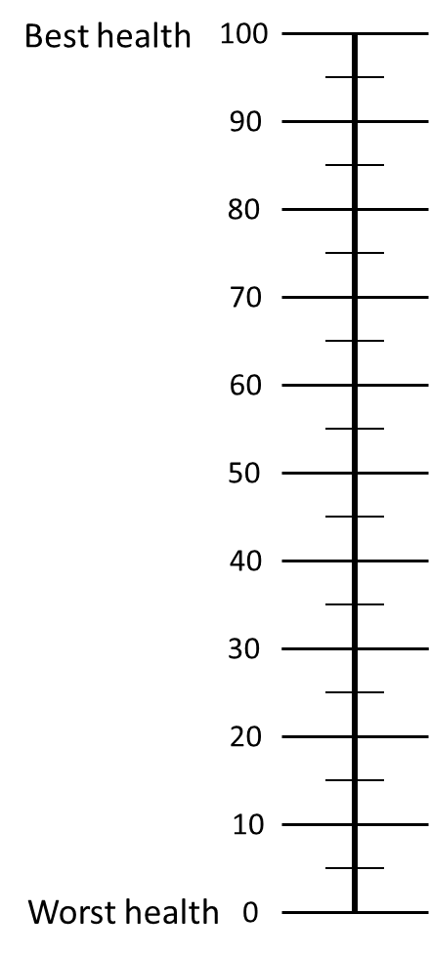

***[Screen 1]***

First, we would like to ask two questions to ensure that you are comfortable with interpreting the survey.

***Q2-1:* Of the four mobility impairment levels listed below, which is the least severe (best) health status?**

1. Minimally impaired
2. Able to walk with aid
3. Confined to a wheelchair
4. Bedridden

***[Screen 2]***

**Q2-2: Of the four mobility impairment levels listed below, which is the most severe (worst) health status?**

1. Minimally impaired
2. Able to walk with aid
3. Confined to a wheelchair
4. Bedridden

***[Screen 3]***

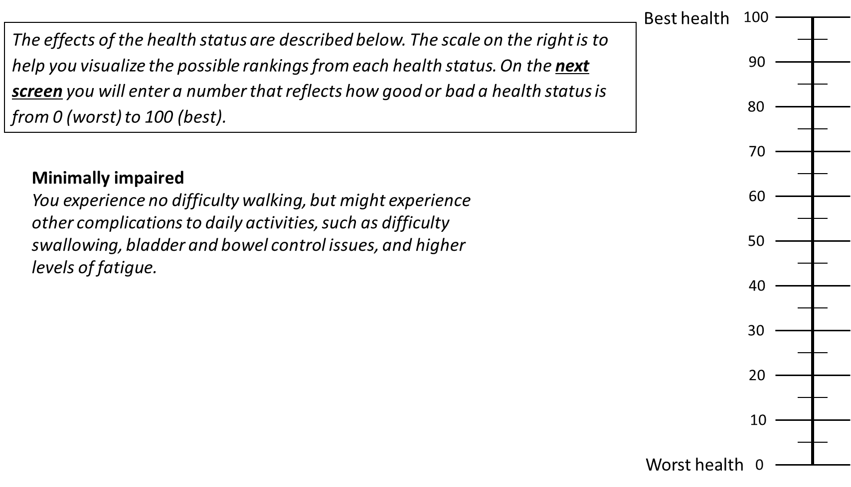

***[Screen 4 – Q2-3]***

***[Screen 5]***

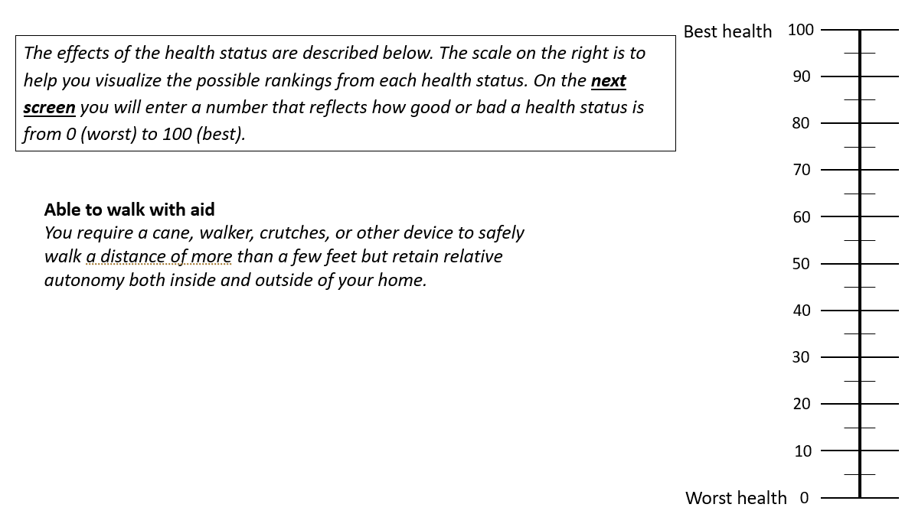

***[Screen 6 – Q2-4]***

***[Screen 7]***

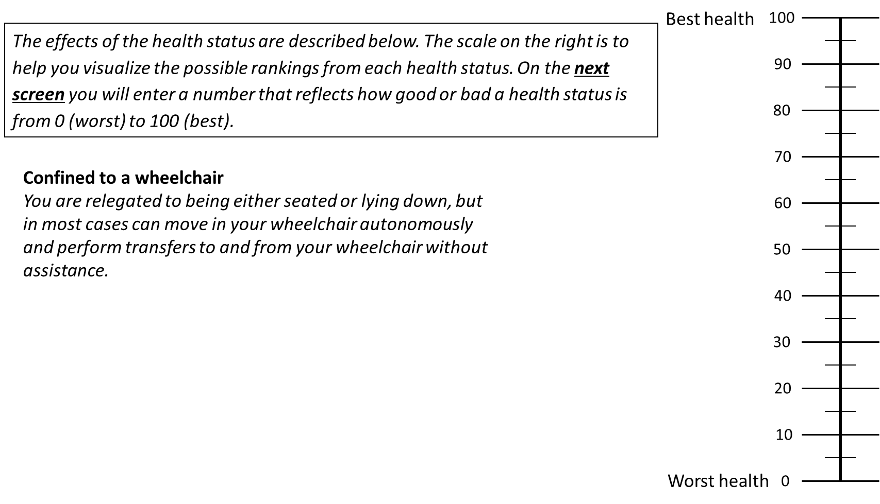

***[Screen 8 – Q2-5]***

***[Screen 9]***

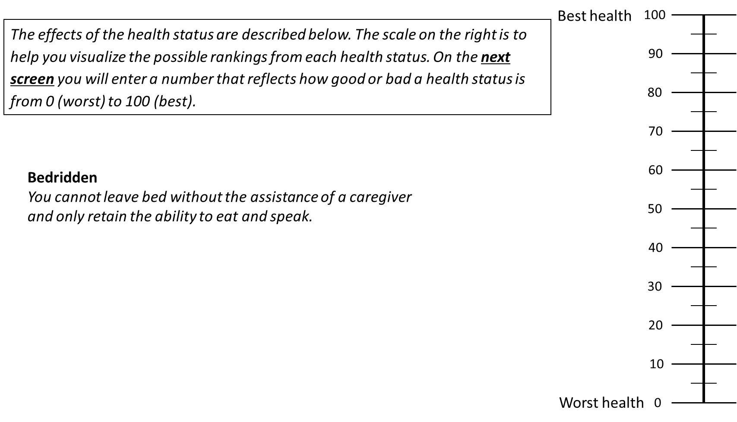

***[Screen 10 – Q2-6]***

Module 3: Treatment preferences

***[Screen 1]***

Now consider the hypothetical case where you are a patient who is diagnosed with a brain disorder and have mobility impairment. Your physician recommends that you take one of the following two hypothetical treatments: Treatment A or Treatment B.

**Neither Treatment A nor Treatment B has any side effects**. The treatments are identical except for the fact that **each treatment will give you a different probability, or chance, of the outcome or experiencing different health status in the following year.**

***[Next screen]***

***This is an example table – no selection is necessary*.**

***[Next screen]***

***This is an example table – no selection is necessary*.**

*****[Next screen]***

***This is an example table – no selection is necessary*.**

*****[Next screen]***

***This is an example table – no selection is necessary*.**

*****[Next screen]***

**Both treatments offer patients uncertain health outcomes.** Remember that each treatment is identical and have no side effects. The treatments differ in the likelihood of being in each health status or outcome **in the next year**.

***This is an example table – no selection is necessary*.**

In a sense, you will be making “tradeoffs” between the likelihood of different health status and select a treatment that you prefer. The questions may seem repetitive, but the answers will help us to understand which types of treatment would be best for patients with mobility impairment.

***[Next Screen]***

**Q3-1. Please choose whether you would prefer Treatment A or Treatment B if you had mobility impairment.**

*The left two columns show the health statuses and the ratings you provided in the previous module.* *Please select one treatment.*

“Treatment A and Treatment B are identical except for likelihood of being in each health status or outcome in the next year. The figures in each row of the table show you how many patients (or what proportion) end up with each health outcome as a result of taking the treatment. Select one treatment.”

***[Next screen]***

**Q3-2. Please choose whether you would prefer Treatment A or Treatment B if you had mobility impairment.**

*The left two columns show the health statuses and the ratings you provided in the previous module. Please select one treatment.*

“Treatment A and Treatment B are identical except for likelihood of being in each health status or outcome in the next year. The figures in each row of the table show you how many patients (or what proportion) end up with each health outcome as a result of taking the treatment. Select one treatment.”

***[Next screen]***

**Q3-3. Please choose whether you would prefer Treatment A or Treatment B if you had mobility impairment.**

*The left two columns show the health statuses and the ratings you provided in the previous module. Please select one treatment.*

“Treatment A and Treatment B are identical except for likelihood of being in each health status or outcome in the next year. The figures in each row of the table show you how many patients (or what proportion) end up with each health outcome as a result of taking the treatment. Select one treatment.”

***[Next screen]***

**Q3-4. Please choose whether you would prefer Treatment A or Treatment B if you had mobility impairment.**

*The left two columns show the health statuses and the ratings you provided in the previous module. Please select one treatment.*

“Treatment A and Treatment B are identical except for likelihood of being in each health status or outcome in the next year. The figures in each row of the table show you how many patients (or what proportion) end up with each health outcome as a result of taking the treatment. Select one treatment.”

***[Next screen]***

**Q3-5. Please choose whether you would prefer Treatment A or Treatment B if you had mobility impairment.**

*The left two columns show the health statuses and the ratings you provided in the previous module. Please select one treatment.*

“Treatment A and Treatment B are identical except for likelihood of being in each health status or outcome in the next year. The figures in each row of the table show you how many patients (or what proportion) end up with each health outcome as a result of taking the treatment. Select one treatment.”

***[Next screen]***

**Q3-6. Please choose whether you would prefer Treatment A or Treatment B if you had mobility impairment.**

*The left two columns show the health statuses and the ratings you provided in the previous module. Please select one treatment.*

“Treatment A and Treatment B are identical except for likelihood of being in each health status or outcome in the next year. The figures in each row of the table show you how many patients (or what proportion) end up with each health outcome as a result of taking the treatment. Select one treatment.”

***[Next screen]***

**Q3-7. Please choose whether you would prefer Treatment A or Treatment B if you had mobility impairment.**

*The left two columns show the health statuses and the ratings you provided in the previous module. Please select one treatment.*

“Treatment A and Treatment B are identical except for likelihood of being in each health status or outcome in the next year. The figures in each row of the table show you how many patients (or what proportion) end up with each health outcome as a result of taking the treatment. Select one treatment.”

***[Next screen]***

**Q3-8. Please choose whether you would prefer Treatment A or Treatment B if you had mobility impairment.**

*The left two columns show the health statuses and the ratings you provided in the previous module. Please select one treatment.*

“Treatment A and Treatment B are identical except for likelihood of being in each health status or outcome in the next year. The figures in each row of the table show you how many patients (or what proportion) end up with each health outcome as a result of taking the treatment. Select one treatment.”

***[Next screen]***

**Q3-9. Please choose whether you would prefer Treatment A or Treatment B if you had mobility impairment.**

*The left two columns show the health statuses and the ratings you provided in the previous module. Please select one treatment.*

“Treatment A and Treatment B are identical except for likelihood of being in each health status or outcome in the next year. The figures in each row of the table show you how many patients (or what proportion) end up with each health outcome as a result of taking the treatment. Select one treatment.”

***[Next screen]***

**Q3-10. Please choose whether you would prefer Treatment A or Treatment B if you had mobility impairment.**

*The left two columns show the health statuses and the ratings you provided in the previous module. Please select one treatment.*

“Treatment A and Treatment B are identical except for likelihood of being in each health status or outcome in the next year. The figures in each row of the table show you how many patients (or what proportion) end up with each health outcome as a result of taking the treatment. Select one treatment.”

***[Next screen]***

**Q3-11. Please choose whether you would prefer Treatment A or Treatment B if you had mobility impairment.**

*The left two columns show the health statuses and the ratings you provided in the previous module. Please select one treatment.*

“Treatment A and Treatment B are identical except for likelihood of being in each health status or outcome in the next year. The figures in each row of the table show you how many patients (or what proportion) end up with each health outcome as a result of taking the treatment. Select one treatment.”

***[Next screen]***

**Q3-12. Please choose whether you would prefer Treatment A or Treatment B if you had mobility impairment.**

*The left two columns show the health statuses and the ratings you provided in the previous module. Please select one treatment.*

“Treatment A and Treatment B are identical except for likelihood of being in each health status or outcome in the next year. The figures in each row of the table show you how many patients (or what proportion) end up with each health outcome as a result of taking the treatment. Select one treatment.”

***[Next screen]***

Module 4: Insurance Value

***[Screen 1]***

Now we wish to measure your preferences over different health insurance plan choices. Assume that **you are forty (40) years old** and currently do not have any type of mobility impairment. The health insurance plans that you will choose from provide different types of coverage of treatments for the mobility impairment caused by common brain disorders.

While there is no cure for brain disorders that cause mobility impairment, some conventional treatments are available that can lessen and delay symptoms. However, **once diagnosed, patients progress through stages of minimally impaired, able to walk with aid, confined to wheelchair, bedridden, and ultimately die**.

***[Next Screen]***

The current care for mobility impairment is made up of pain relief, reduction in tremor, and supportive care mostly provided by caregivers who become essential for even the most basic tasks as the disease progresses. **However, recent pharmaceutical innovations have developed treatments that delay disease progression.** Specifically, these drugs can alter the course of disease progression, **delaying worsening mobility by 25%, or an average of four (4) months for every additional (1) year lived**.

***[Next Screen]***

About 76 in every 100,000 individuals will be diagnosed with a brain disorder that impairs their movement this year. **This means you have a 0.076% chance of becoming mobility impaired due to a brain disorder.** The average age at which patients are diagnosed with brain disorders is 40 years old.

***[Next screen]***

On the following screens, you will be presented with two health insurance plan choices. The first column indicates whether the health plan covers the conventional mobility impairment therapy (supportive care) only or whether it covers both the conventional and new mobility impairment therapies.

***[Next Screen]***

*This is an example table.*

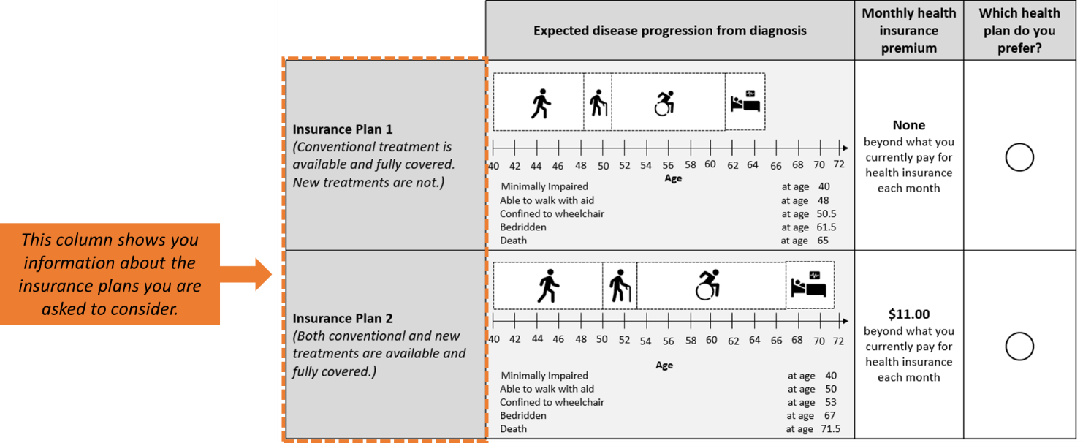

***[Next Screen]***

*This is an example table.*

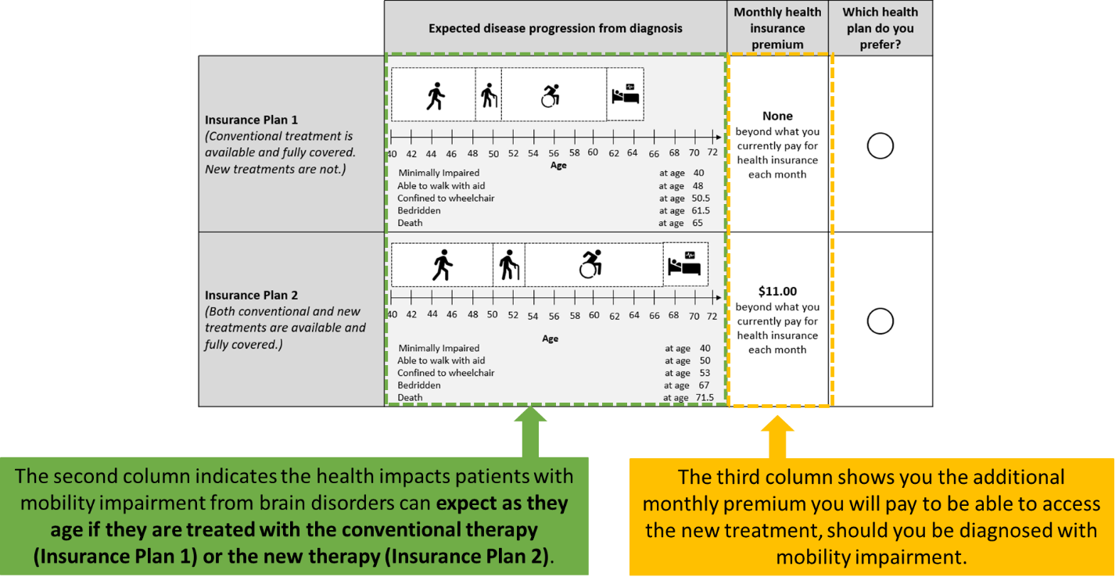

***[Next Screen]***

*This is an example table.*

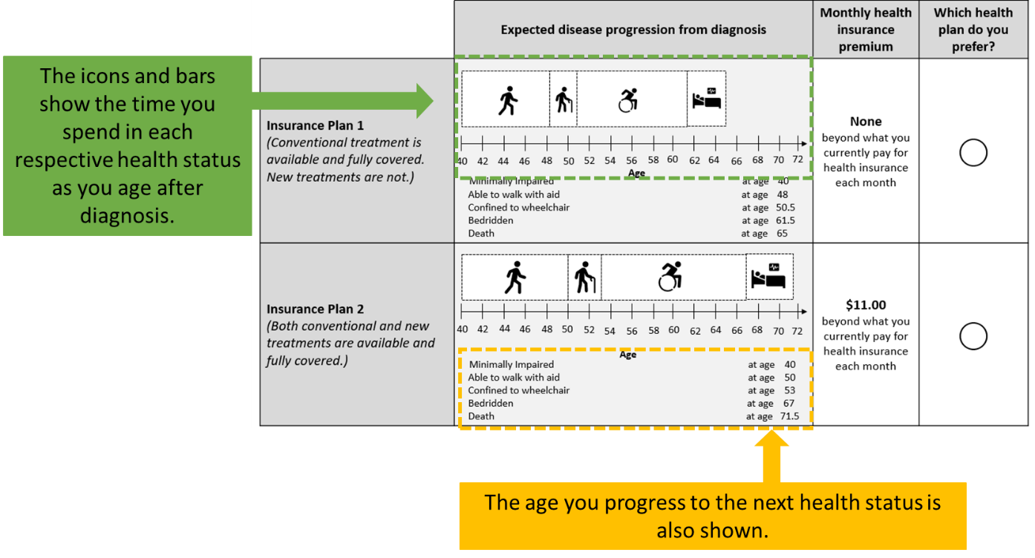

***[Next Screen]***

*This is an example table.*

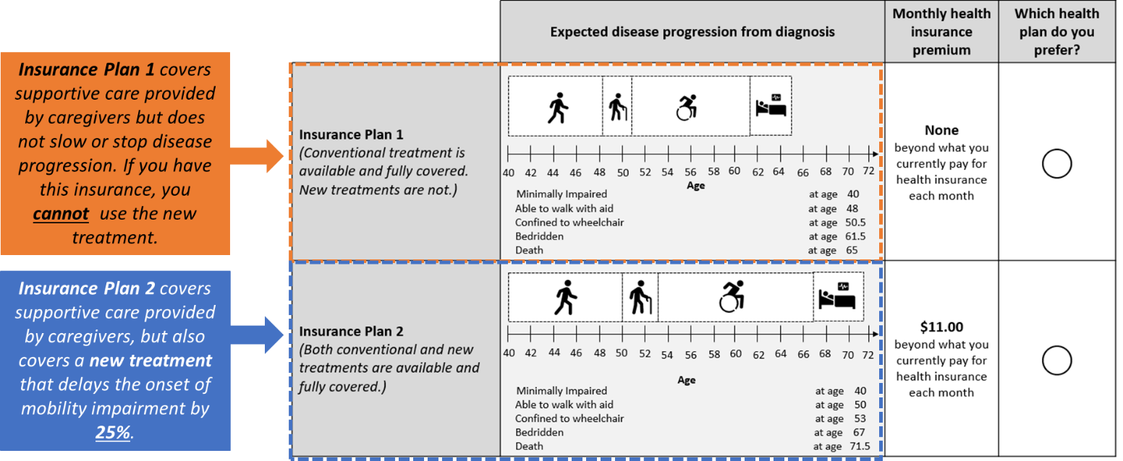

***[Next screen]***

*This is an example table.*

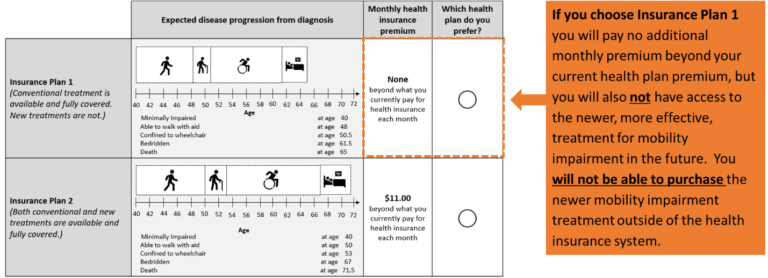

***[Next screen]***

*This is an example table.*

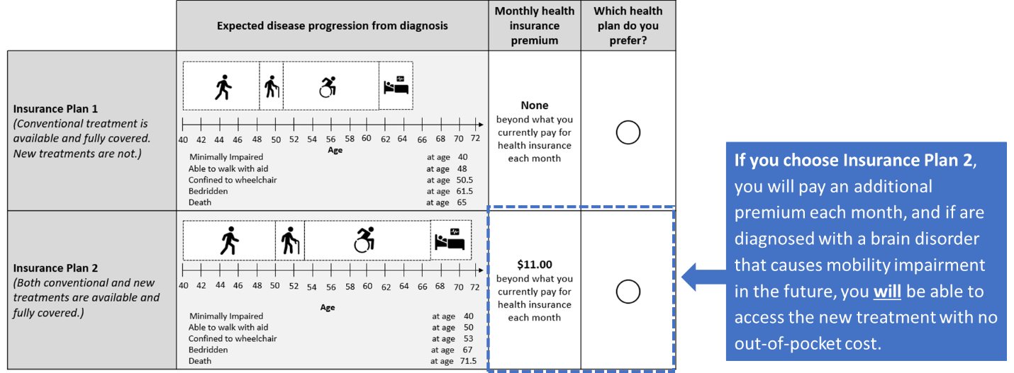

***[Next screen]***

*This is an example table.*

***[Next screen]***

**[Graphic]**

**Q4-1. Please choose whether you would prefer plan 1 or plan 2 for your health insurance plan.**

*Please imagine you are* ***40 years old*** *and do not have mobility impairment. Each insurance plan is identical except* ***Plan 2 provides coverage for the treatment of mobility impairment*** *for an additional monthly cost.*

*You can use the back button at the bottom of the screen to review health status descriptions.*

*Please imagine you are* ***40 years old*** *and do not have mobility impairment. Each insurance plan is identical except* ***Plan 2 provides coverage for the treatment of mobility impairment*** *for an additional monthly cost.*

*You can use the back button at the bottom of the screen to review health status descriptions.*

**[Graphic]**

**[Graphic]**

**Q4-2. Please choose whether you would prefer plan 1 or plan 2 for your health insurance plan.**

*Please imagine you are* ***40 years old*** *without mobility impairment. Each insurance plan is identical except* ***Plan 2 provides coverage for the treatment of mobility impairment*** *for an additional monthly cost.*

*Please imagine you are* ***40 years old*** *without mobility impairment. Each insurance plan is identical except* ***Plan 2 provides coverage for the treatment of mobility impairment*** *for an additional monthly cost.*

**[Graphic]**

**Q4-3. Please choose whether you would prefer plan 1 or plan 2 for your health insurance plan.**

*Please imagine you are* ***40 years old*** *and do not have mobility impairment. Each insurance plan is identical except* ***Plan 2 provides coverage for the treatment of mobility impairment*** *for an additional monthly cost.*

*You can use the back button at the bottom of the screen to review health status descriptions.*

**[Graphic]**

**Q4-4. Please choose whether you would prefer plan 1 or plan 2 for your health insurance plan.**

*Please imagine you are* ***40 years old*** *and do not have mobility impairment. Each insurance plan is identical except* ***Plan 2 provides coverage for the treatment of mobility impairment*** *for an additional monthly cost.*

*You can use the back button at the bottom of the screen to review health status descriptions.*

*Please imagine you are* ***40 years old*** *without mobility impairment. Each insurance plan is identical except* ***Plan 2 provides coverage for the treatment of mobility impairment*** *for an additional monthly cost.*

**[Graphic]**

**Q4-5. Please choose whether you would prefer plan 1 or plan 2 for your health insurance plan.**

*Please imagine you are* ***40 years old*** *and do not have mobility impairment. Each insurance plan is identical except* ***Plan 2 provides coverage for the treatment of mobility impairment*** *for an additional monthly cost.*

*You can use the back button at the bottom of the screen to review health status descriptions.*

*Please imagine you are* ***40 years old*** *without mobility impairment. Each insurance plan is identical except* ***Plan 2 provides coverage for the treatment of mobility impairment*** *for an additional monthly cost.*

**[Graphic]**

**Q4-6. Please choose whether you would prefer plan 1 or plan 2 for your health insurance plan.**

*Please imagine you are* ***40 years old*** *and do not have mobility impairment. Each insurance plan is identical except* ***Plan 2 provides coverage for the treatment of mobility impairment*** *for an additional monthly cost.*

*You can use the back button at the bottom of the screen to review health status descriptions.*

*Please imagine you are* ***40 years old*** *without mobility impairment. Each insurance plan is identical except* ***Plan 2 provides coverage for the treatment of mobility impairment*** *for an additional monthly cost.*

**[Graphic]**

Module 5: Background characteristics

This section is to collect some demographic information to ensure we have a representative sample.

**Q5-1.** What gender do you identify as?

* 1. Male
  2. Female
  3. Nonbinary
  4. Prefer not to answer

**Q5-2.** Do you consider yourself to be Hispanic or Latino?

* 1. Yes
  2. No
  3. Prefer not to answer

**Q5-3.**  With what racial group(s) do youidentify? (Mark more than one if applicable)

* 1. American Indian or Alaska native
  2. Asian
  3. Black or African American
  4. Native Hawaiian or Other Pacific Islander
  5. White
  6. Prefer not to answer

**Q5-4.** What is your marital status?

* 1. Married
  2. Widowed
  3. Divorced
  4. Separated
  5. Never married

**Q5-5.** What is the highest degree or level of school you have completed?

* 1. Less than high school or secondary degree
  2. High school diploma, GED, or secondary degree
  3. Some college credit, but no degree
  4. Associate’s degree (e.g., AA, AS)
  5. Bachelor’s degree (e.g., BA, BS)
  6. Professional or doctoral degree beyond bachelor’s degree (e.g., PhD, MD, JD, MBA, MS, MA, Med, DDS)

**Q5-6.** Last week, did you work for pay at a job or business?

* 1. Yes
  2. No
  3. Prefer not to answer

**Q5-7.** Which of these best describes your personal income last year?

* 1. <$10,000
  2. $10,000-$49,000
  3. $50,000-$74,999
  4. $75,000-$99,999
  5. $100,000-$149,999
  6. $150,000 and greater
  7. Prefer not to answer

**Q5-8.** Are you CURRENTLY covered by any of the following types of health insurance or health coverage plans? (Mark “Yes” or “No” for each type of coverage.)

|  |  |  |
| --- | --- | --- |
|  | Yes | No |
| 1. Insurance through a current or former employer or union (of this person or another family member) |  |  |
| 1. Insurance purchased directly from an insurance company |  |  |
| 1. Medicare, for people 65 and older, or people with certain disabilities |  |  |
| 1. Medicaid, Medical Assistance, or any kind of government-assistance plan for those with low incomes or a disability |  |  |
| 1. TRICARE or other military health care |  |  |
| 1. VA (enrolled for VA healthcare) |  |  |
| 1. Indian Health Service |  |  |
| 1. Other |  |  |
| 1. Not currently covered by health insurance or a health coverage plan |  |  |

**Q5-9.** During the last 12 months, have you had either a flu shot that was sprayed in your nose or a flu shot injected into your arm?

* 1. Yes
  2. No
  3. Ineligible to receive a flu shot
  4. Prefer not to answer

**Q5-10.** During the last 12 months, have you purchased a lottery ticket?

Yes

No

Prefer not to answer

**Q5-11.** Please select any of the following conditions that *you* have been diagnosed with.

* 1. Alzheimer’s disease
  2. Parkinson’s disease
  3. Multiple Sclerosis
  4. Amyotrophic lateral sclerosis (ALS) or Lou Gehrig’s disease
  5. Other types of dementia
  6. Stroke
  7. Mental Health
  8. None of the above

**Q5-12.** Please select any of the following conditions that *a loved one* has been diagnosed with.

* 1. Alzheimer’s disease
  2. Parkinson’s disease
  3. Multiple Sclerosis
  4. Amyotrophic lateral sclerosis (ALS) or Lou Gehrig’s disease
  5. Other types of dementia
  6. None of the above

**Q5-13.** Check the box if you have been a caregiver to a family member who has any of the following conditions:

* 1. Alzheimer’s disease
  2. Parkinson’s disease
  3. Multiple Sclerosis
  4. Amyotrophic lateral sclerosis (ALS) or Lou Gehrig’s disease
  5. Other types of dementia
  6. None of the above