Supplementary Material
Twitter/X and LinkedIn Recruitment Post

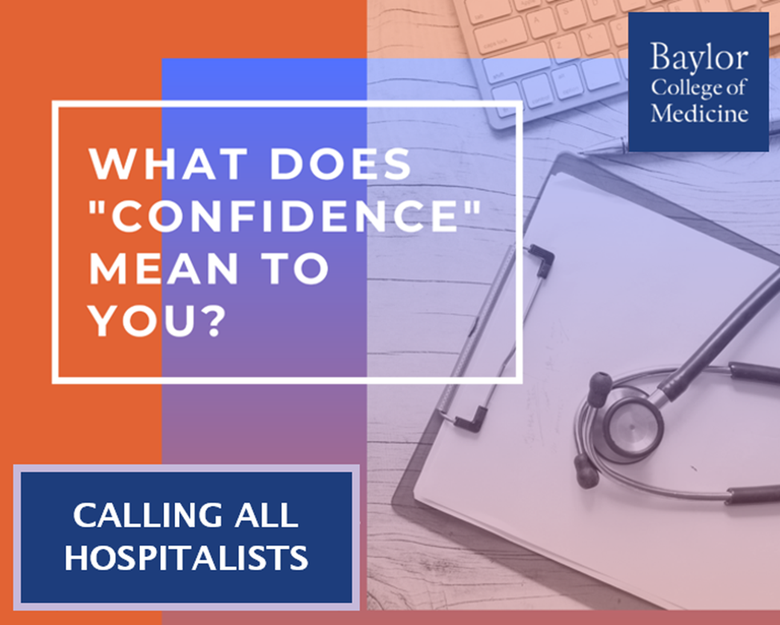

Calling Hospitalists:

Our research team at BCM is conducting a short online interview to gain a better understanding of how clinicians conceptualize their own confidence levels during diagnosis. For more info, please email Dr. Sloane jennifer.sloane@bcm.edu.

Interview Guide
Questions related to conceptualization of confidence:
- Let us begin with an event / case (within the past month or so) when you felt really confident in your final diagnosis. Without going into too much detail, can you briefly summarize the case in a few sentences.
Probes: to discuss the case further with the following questions:
  - Think back to when you arrived at your final diagnosis, if I showed you this scale:
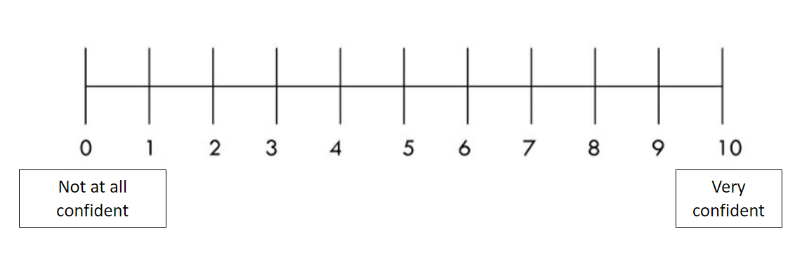
- How confident did you feel that you had made the correct diagnosis? Why did you choose that number, what did you consider?
- How confident were you, that your diagnostic approach was correct or reasonable? Why did you choose that number, what did you consider?
  - Did you ever receive any follow up on this case on whether or not the diagnosis was confirmed to be correct?
  - Discuss your working diagnosis
    - Do you remember if you were considering other diagnoses?
    - Was there a key piece of evidence that gave you the necessary confidence to move forward with your final diagnosis?
  - Did you seek out second opinions, such as curbside consultations or use any decision aids or online tools like UpToDate or Google?
  - Were you working with others on this case? If yes, do you feel as if their confidence levels impacted your confidence?

- Please take a moment to think about a case (within the past month or so) when you felt NOT so confident (or uncertain) in your final diagnosis. Without going into too much detail, can you briefly summarize the case in a few sentences.
Probes: to discuss the case further with the following questions:
  - Think back to when you arrived at your final diagnosis, if I showed you this scale:
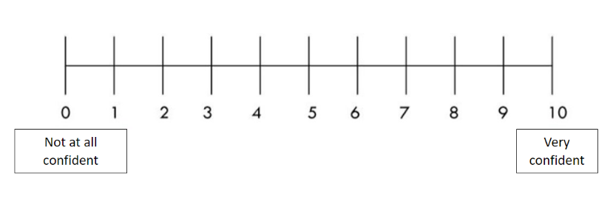
- How confident did you feel that you had made the correct diagnosis? Why did you choose that number, what did you consider?
- How confident were you, that your diagnostic approach was correct or reasonable? Why did you choose that number, what did you consider?
  - Did you ever receive any follow up on this case on whether or not the diagnosis was confirmed to be correct?
  - Discuss your working diagnosis
- Do you remember if you were considering other diagnoses?
- Was there a key piece of evidence that gave you the necessary confidence to move forward with your final diagnosis?
  - Did you seek out a second opinion or use any decision aids or online tools (like google or Uptodate)?
  - Were you working with others on this case? If yes, do you feel as if their confidence levels impacted your confidence?
  - What other actions (if any) did you take to try to increase your confidence in the diagnosis?
- Out of your last 10 patients that you evaluated for a diagnosis, estimate the number of patients you felt very confident in your final diagnosis?
  - Probe – What are you making your confidence estimate based on? Do you receive any sort of feedback or do some sort of an evaluation to “check” or is it just your own gut feeling?
- Up until this point, we’ve been talking about confidence in specific cases and contexts. More generally, how confident are you in your ability to diagnose patients? In other words, what is your self-efficacy in diagnosing patients?
  - Maybe follow up – are there physicians you know that you believe overestimate their confidence and self-efficacy levels? Do you think this is a problem?
Questions related to confidence and clinician well-being
- How do you think your confidence in diagnosing and treating your patients affects your well-being? (example: if you feel less confident in a case, does it impact other aspects of your daily life?)
  - Do you remember feeling more stressed or anxious earlier in your career when you were likely less confident in your abilities?
    - If YES – did you have (or do you still have) any strategies to help manage the stress and anxiety that comes with confidently diagnosing patients?
    - If NO - skip
- Can you recall a time when you found out about a misdiagnosis when you were highly confident (like a 10/10 on the confidence scale) you had originally made the right diagnosis? Without going into detail about the specifics of the case, do you remember how you felt?
  - Probe – ask about if they went over the case details again or if they felt as if it affected their diagnostic decision making shortly afterwards? Did it affect stress/anxiety levels in general (outside of work)?
Qualitative theme counts by case type
 | Case 1 | Case 2 | Total Participant Count*
Confidence in Final Diagnosis
Patient history | 10 | 8 | 14
Conclusiveness of workup | 17 | 11 | 19
Team Consensus | 9 | 17 | 19
Confidence in Diagnostic Approach
Utilizing diagnostic schemas | 7 | 4 | 8
Being as thorough as possible | 4 | 13 | 15

*Note: Each participant may be counted for both Case 1 and Case 2, which is why Case 1 plus Case 2 does not equal the total participant count

A.3 Qualitative theme counts by case type
 | Case 1 | Case 2 | Total Participant Count*
Confidence in Final Diagnosis
Patient history | 10 | 8 | 14
Conclusiveness of workup | 17 | 11 | 19
Team Consensus | 9 | 17 | 19
Confidence in Diagnostic Approach
Utilizing diagnostic schemas | 7 | 4 | 8
Being as thorough as possible | 4 | 13 | 15

*Note: Each participant may be counted for both Case 1 and Case 2, which is why Case 1 plus Case 2 does not equal the total participant count

