**Supplementary Material**

**Supplementary workflow 1:** Prenatal diagnosis by amniocentesis-Steps involved



**Supplementary workflow 2:** Workflow recommended for prenatal diagnosis (Screening

algorithm)

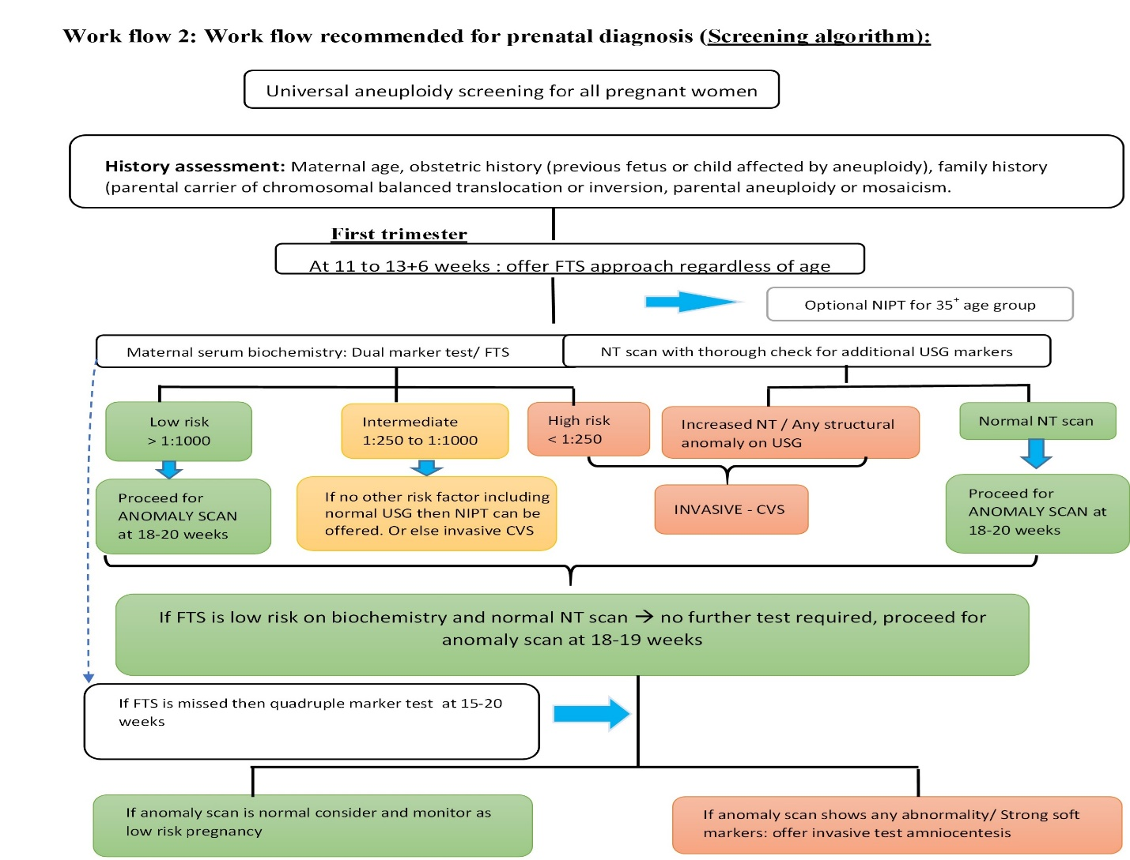

**Supplementary** **Figure 1:** Integrated test (Timing and technique)

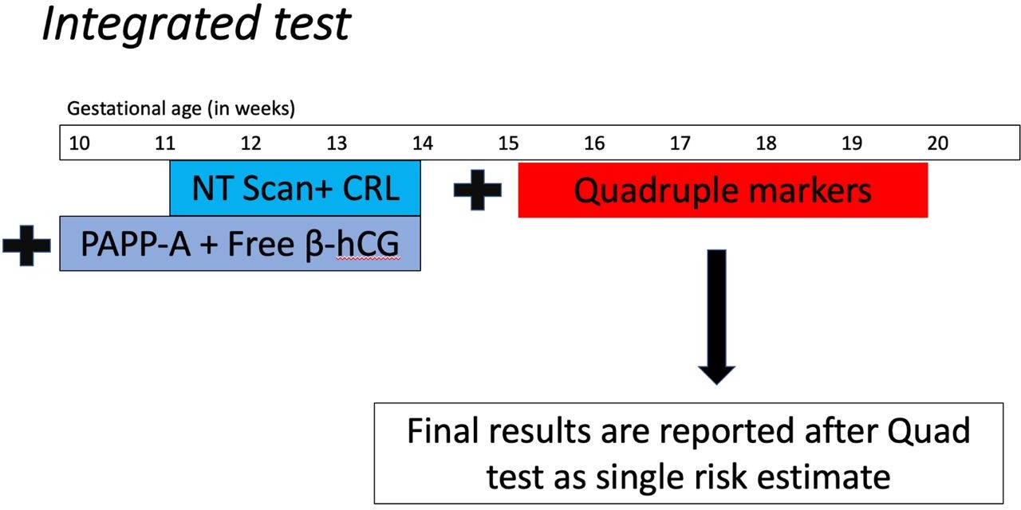

**Supplementary Figure 2: Structured, phase-by-phase approach incorporated for timing and technique**

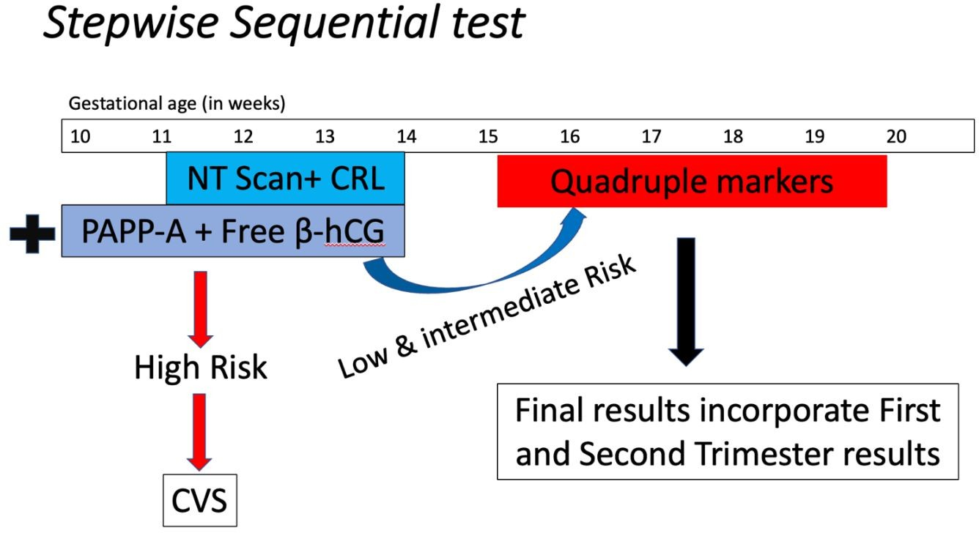

**Supplementary Figure 3: Strategic test optimization:** Timing and Technique

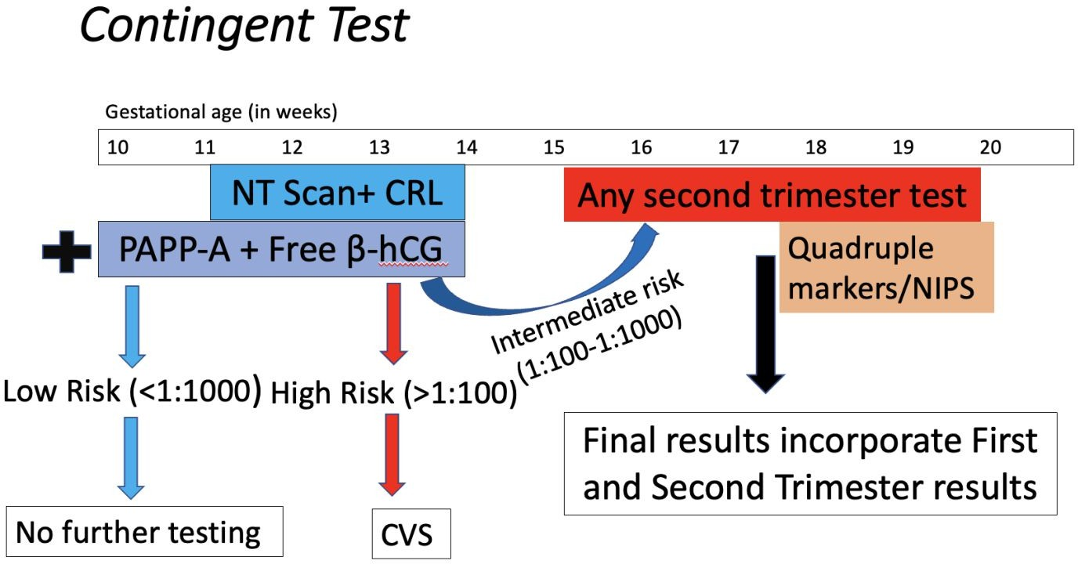

For

**Supplementary Figure 4**: Nuchal translucency scan

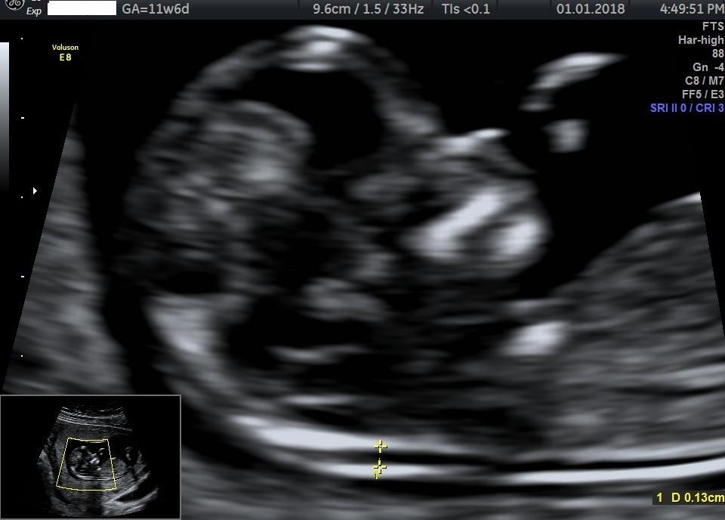

For Review

**Supplementary Figure 5**: Increased nuchal translucency

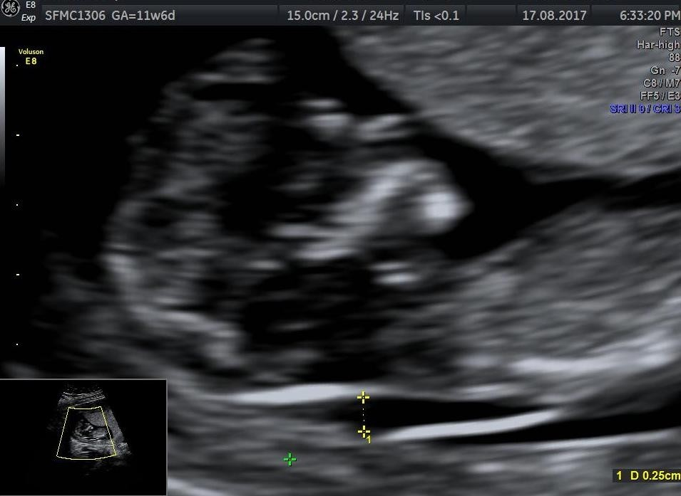

**Supplementary Figure 6**: Absent Nasal Bone (Nasal bone is evaluated in the same standard

plane as for Nuchal Translucency during the same 11 to 13 +6 weeks. Transducer should be such

that it is parallel to the long axis of Nasal bone. Nasal Bone is located in the substance of the nasal bridge beneath the skin of the nasal bridge. So it is seen as two echogenic lines roughly parallel to each other (equal sign). Nasal bone should be at least as echogenic as the skin. Less echogenic line may be seen representing the cartilage, if the nasal bone is absent.

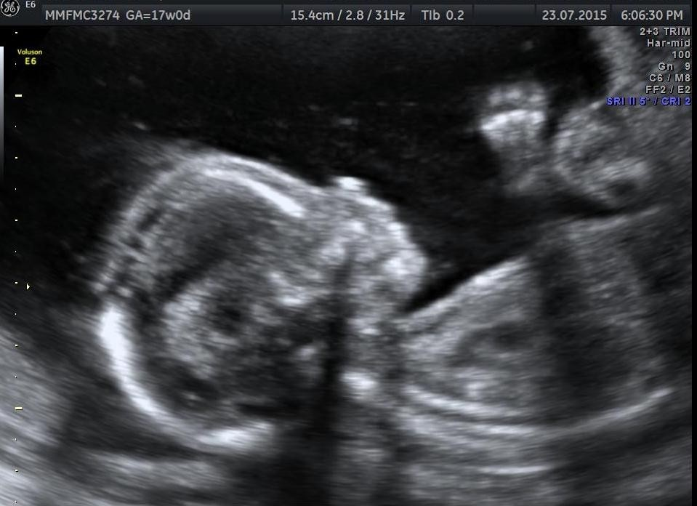

**Supplementary Figure 7a:** Normal Ductus Venosus waveform

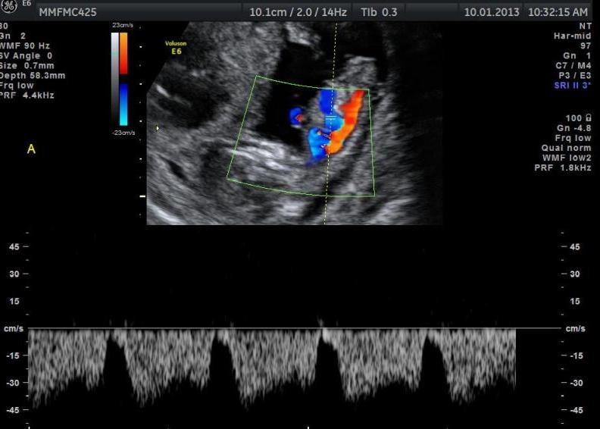

**Supplementary Figure 7b:** Reversed a wave in Ductus Venosus

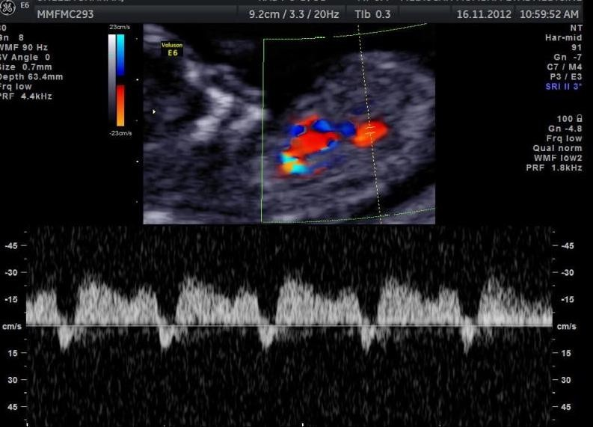

**Supplementary Figure 8a:** Normal Tricuspid valve flow

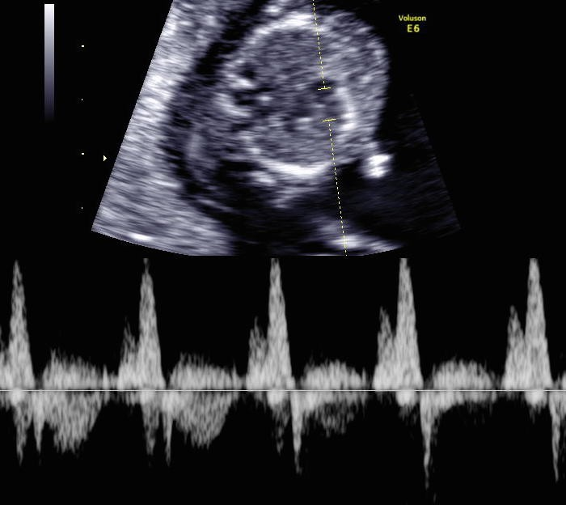

**Supplementary Figure 8b:** Tricuspid regurgitation

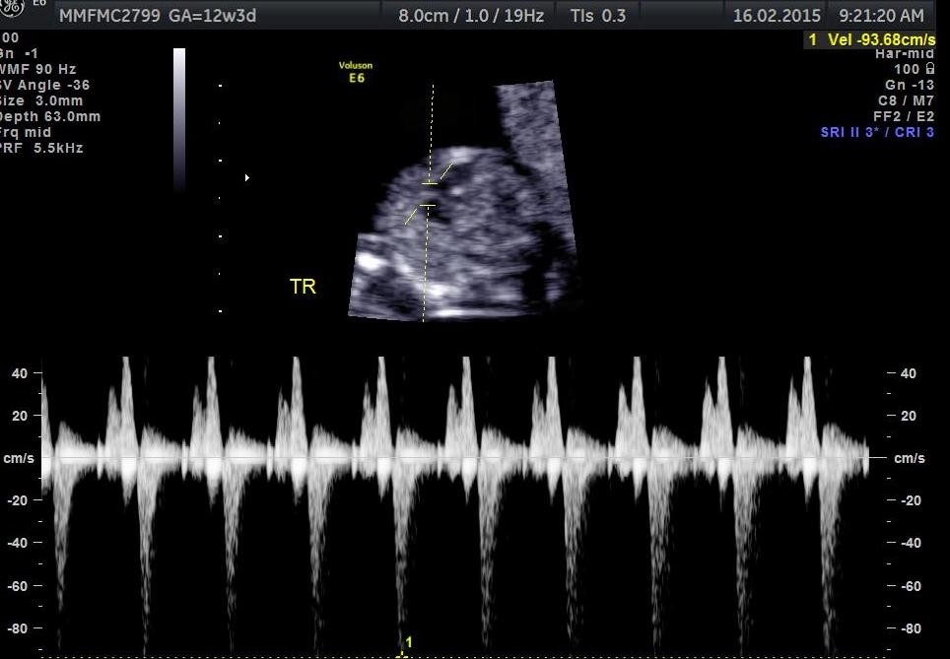

**Supplementary Figure 9a:** Increased Nuchal fold thickness

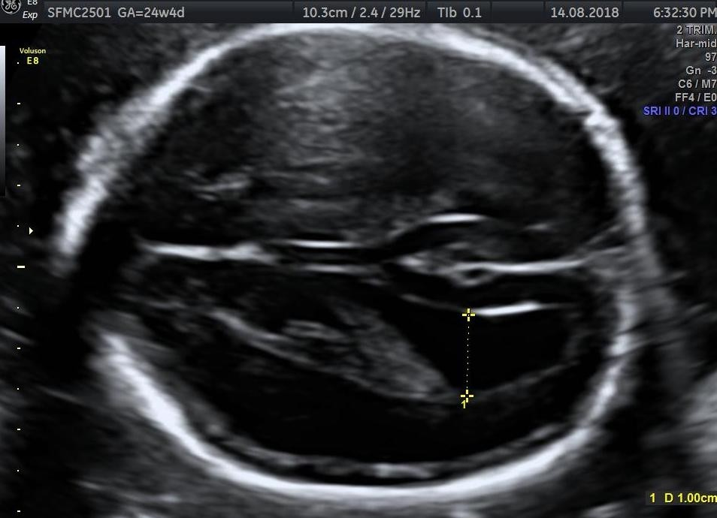

**Supplementary Figure 9b:** Ventriculomegaly

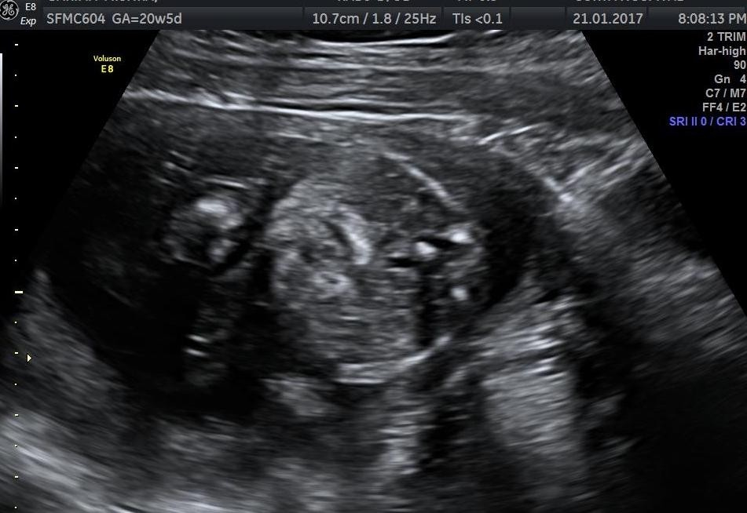

**Supplementary Figure 9c:** Echogenic small bowel

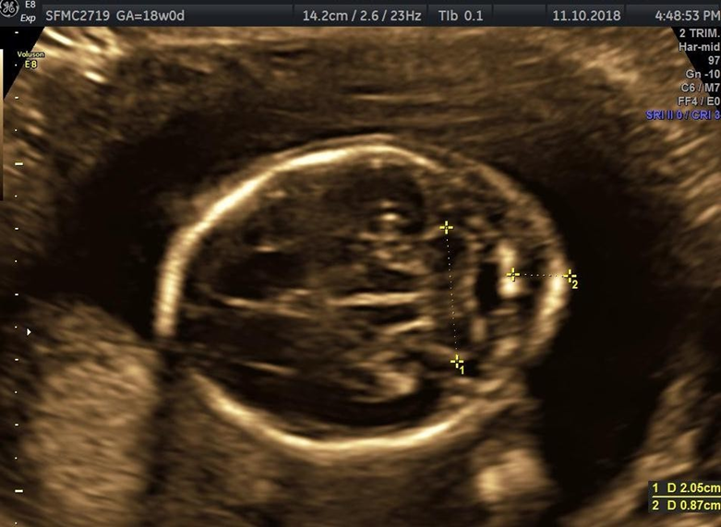

**Supplementary Figure 9d:** Aberrant right subclavian artery

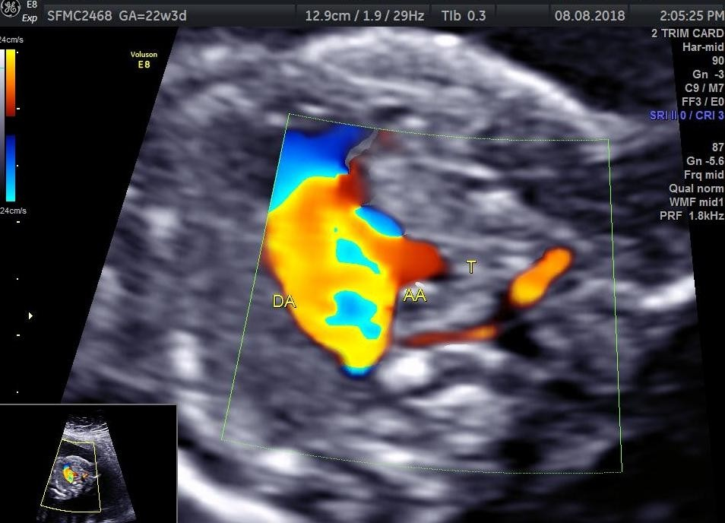

**Supplementary Table 1:** Dual Marker Test aneuploidy screening

|  |  |  |
| --- | --- | --- |
| **Dual marker parameters** | **PAPP-A** | **Free** β **-HCG** |
| TRISOMY 21 | Decreased ≤ 0.5 multiple of the median (MOM) | Increased ≥ 2.0 MOM |
| TRISOMY 18 | Decreased | Decreased |
| TRSIOMY 13 | Decreased | Decreased |
| SEX CHROMOSOME ABNORMALITY | Decreased | Normal |

**Supplementary Table 2:** Hormonal levels and risk associated in QMT of particular condition

|  |  |  |  |
| --- | --- | --- | --- |
| Parameter | Open Neural Tube Defect | Risk of Trisomy 21 | Risk of Trisomy 18 |
| MSAFP |  |  |  |
| ß-hCG |  |  |  |
| uE3 |  |  |  |
| Inhibin |  |  |  |

**Supplementary Table 3:** Criteria for Nuchal Translucency

|  |  |
| --- | --- |
| **USG machine** | **High resolution with a video-loop and caliper that provides measurement to one decimal point** |
| Gestational age | 11+0 weeks to 13+6 weeks |
| Crown rump length | 45 – 84 mm |
| Magnification | Fetal head and Torso occupy 75% of image |
| Position | Midsagittal view of fetus with fetus facing towards transducer Neutral position, neither hyper extended nor hyper flexed |
| Anatomical landmarks | Tip of the nose  Hard palate is trapezoid in shape  Absence of frontal process of maxilla (Zygoma)  Rounded hypoechoic structure within the centre of the intracranial cavity representing the thalamus  Amniotic membrane to be differentiated from nuchal skin by waiting for spontaneous fetal movement or by tapping the mothers abdomen or coughing to make the fetus jump. |
| Caliper placement | Horizontal cross-hatch of the caliper should be flushed with the inner aspect of the line bordering the NT |
| Measurement | Perform three measurements and the largest measurement is taken for risk assessment. If nuchal cord is present NT is measured below and above the cord and average of the two is taken. Reduce gain before measurement to reduce fuzzy edge of the line |
| Appearance | It is the amount of fluid accumulation (NT thickness) and not its appearance (presence or absence of septation/ fluid accumulation confined to neck or enveloping the whole fetus) that determines the risk |

**Supplementary Table 4 :** Technique for Ductus venosus waveform

**Position**

Right parasagittal view of fetal upper abdomen

**Magnification** Abdomen and thorax occupying majority of the image

**Identifying DV** On colour doppler aliasing seen in vessel connecting hepatic portion of

umbilical vein with inferior vena cava is the ductus venosus

**Sample gate**

Small sample gate (0.5-1 mm) in order to avoid contamination with

hepatic veins and artery

**Angle of insonation**

**Supplementary Table 5:** Technique for Tricuspid regurgitation

**Position**

Transverse 4 chamber heart

**Magnification** Chest occupies 75% of the image

**Doppler sample** Doppler gate placed across tricuspid valve

Large sample size used (2-3 mm)

**Angle of insonation** < 30%

**Normal Waveform** Biphasic waveform with first wave due to forward flow during diastole

and second larger wave due to atrial systole

**Tricuspid regurgitation** During ventricular systole any backward flow across Tricuspid valve is considered regurgitation if the peak velocity of the regurgitant jet is more than 60 cm/s and should remain for at least 30% of ventricular systole

**Supplementary Table 6:** Likelihood ratios of all soft markers

|  |  |  |  |
| --- | --- | --- | --- |
| Marker | LR+ | LR- | Isolated marker LR |
| Intracardiac echogenic focus | 5.83 | 0.8 | 0.95 |
| Mild pyelectasis | 7.63 | 0.92 | 1.08 |
| Short femur | 3.72 | 0.8 | 0.61 |
| Echogenic bowel | 11.44 | 0.9 | 1.65 |
| Increased nuchal fold | 23.3 | 0.8 | 3.79 |
| Aberrant right subclavian artery | 21.48 | 0.71 | 3.94 |
| Absent or hypoplastic nasal bone | 23.27 | 0.46 | 6.58 |
| Ventriculomegaly | 27.52 | 0.94 | 3.81 |