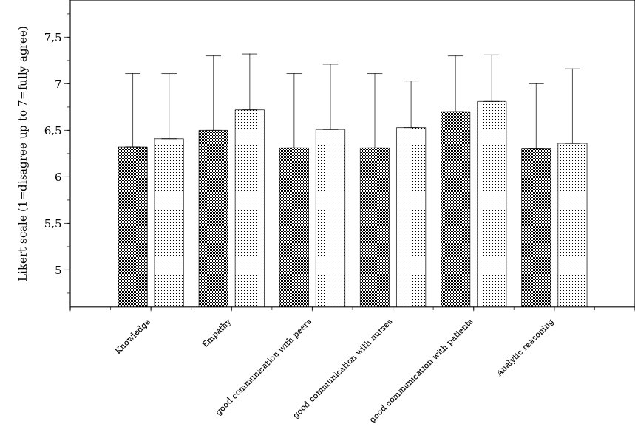

0 -

m

f

p=0.462

p=0.001

p<0.001

p=0.006

p<0.001

p=0.059

**Figure 1s:** Answers of the quantitative (second) study part to the questions: “What makes a doctor a good physician ?” # Likert scale (mean+STD) responses. 1 = strong disagreement, 7 = full agreement. f = female, m = male students. Statistical group comparison using the unpaired two-tailed Wilcoxon rank-sum test.