Supplementary Materials:

Supplementary material 1: Examples of radiological cases developed for use in this study.

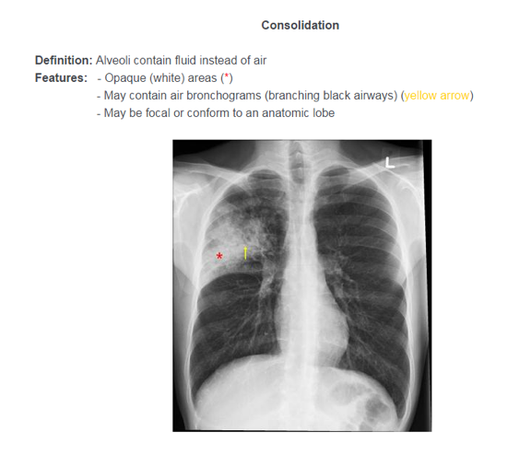

Appendix 2
Supplementary material 2: Example of case presentation during the learning phase with randomised answer options.

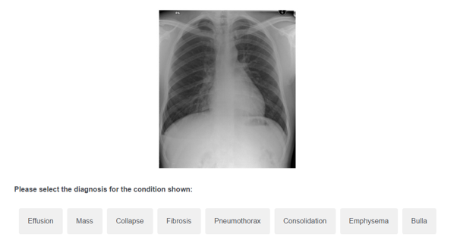

Supplementary material 3: Overview of all cases used; trained, near-transfer, far-transfer, and untrained cases

Notes:
- When presented to participants, images had been standardized so labels such as ‘portable’ and ‘L’ were not seen.
- These images were selected from a hospital image bank and the key features seen and level of transfer needed was agreed upon by at least 2 radiologists of consultant level or above.

Supplementary material 4: Overview of the positions of the sources and detectors of the fNIRS cap

Supplementary material 5: Contrast analysis and difference scores of oxy-Hb data for each channel between start and end of learning phase.
Contrast analysis between start and end of learning phase oxy-Hb:

Delta oxy-Hb start and end of learning phase:
Note: x-axis denotes channels, y-axis denotes amplitude in millimolar mM

Supplementary material 6: Contrast analysis and comparison of oxy-Hb data for each channel between the trained and untrained cases in the test phase.

Contrast analysis between untrained and trained cases of test phase oxy-Hb:

Delta oxy-Hb untainted and trained cases of test phase:

Note: x-axis denotes channels, y-axis denotes amplitude in millimolar mM

