a | 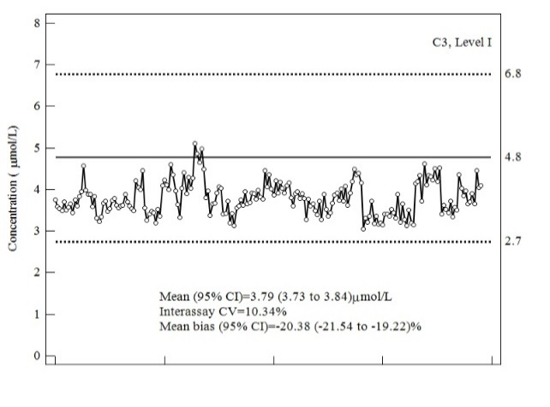 | b | 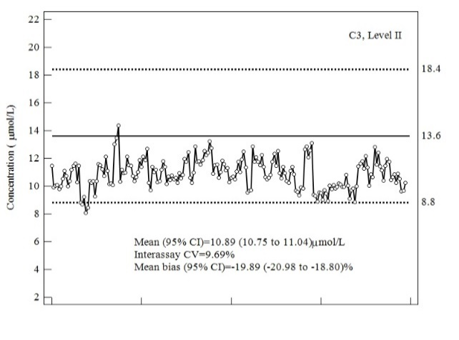
c | 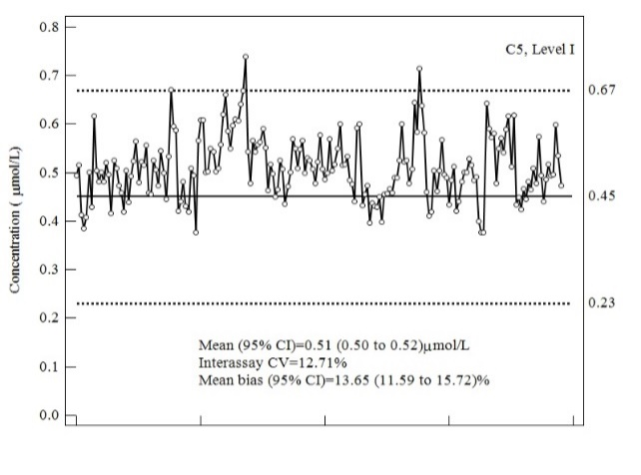 | d | 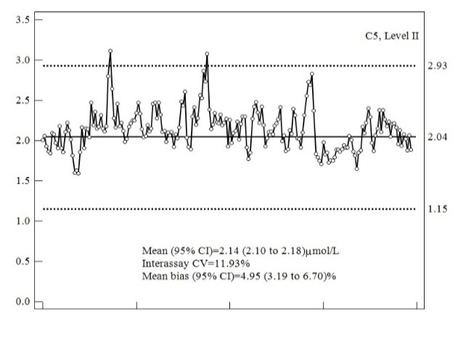
e | 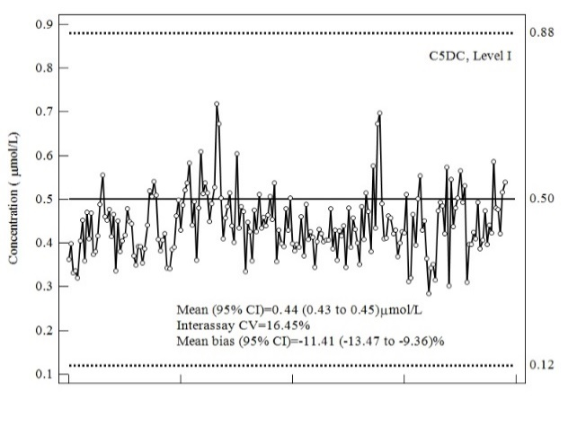 | f | 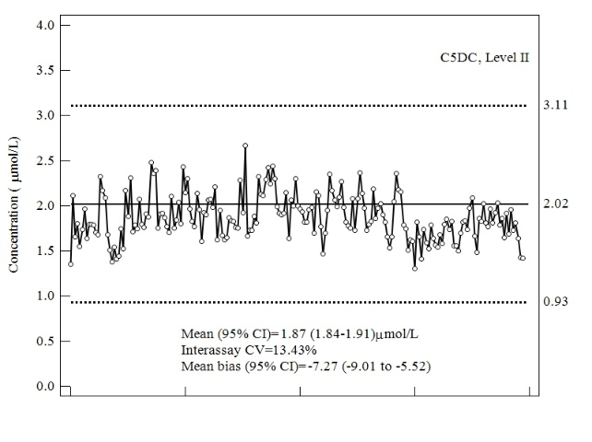
Supplementary Figure: QC charts with the mean of measured values (represented by circles) with the 95% confidence interval (CI), coefficient of variation (CV), and mean bias with the 95% (CI) for: (a, b) propionylcarnitine (C3), (c, d) isovalerylcarnitine (C5), and (e, f) glutarylcarnitine (C5DC). On the right of the y-axis there are the target value (line) and the acceptable range of values (dotted line), as declared by the Manufacturer.

