Nonparametric Tests

Notes
Output Created |  | 22-FEB-2022 17:27:45
Comments
Input | Data | C:\Users\harirfor.ETSU\Desktop\V2\Statistics\Diabetes data_042219.sav
Input | Active Dataset | DataSet1
Input | Filter | <none>
Input | Weight | <none>
Input | Split File | <none>
Input | N of Rows in Working Data File | 63
Syntax |  | NPTESTS  /INDEPENDENT TEST (KIM1_ngml ADMA_CON_umolL) GROUP (DiseaseState)  /MISSING SCOPE=ANALYSIS USERMISSING=EXCLUDE  /CRITERIA ALPHA=0.05 CILEVEL=95.
Resources | Processor Time | 00:00:01.00
Resources | Elapsed Time | 00:00:01.03
[DataSet1] C:\Users\harirfor.ETSU\Desktop\V2\Statistics\Diabetes data_042219.sav

Hypothesis Test Summary
 | Null Hypothesis | Test | Sig.^{a,b}
1 | The distribution of KIM-1 is the same across categories of Disease State. | Independent-Samples Mann-Whitney U Test | .160^{c}
2 | The distribution of ADMA_CON_umolL is the same across categories of Disease State. | Independent-Samples Mann-Whitney U Test | .735

Hypothesis Test Summary
 | Decision
1 | Retain the null hypothesis.
2 | Retain the null hypothesis.

a. The significance level is .050.
b. Asymptotic significance is displayed.
c. Exact significance is displayed for this test.

Independent-Samples Mann-Whitney U Test

KIM-1 across Disease State

Independent-Samples Mann-Whitney U Test Summary
Total N | 36
Mann-Whitney U | 198.000
Wilcoxon W | 303.000
Test Statistic | 198.000
Standard Error | 30.815
Standardized Test Statistic | 1.428
Asymptotic Sig.(2-sided test) | .153
Exact Sig.(2-sided test) | .160

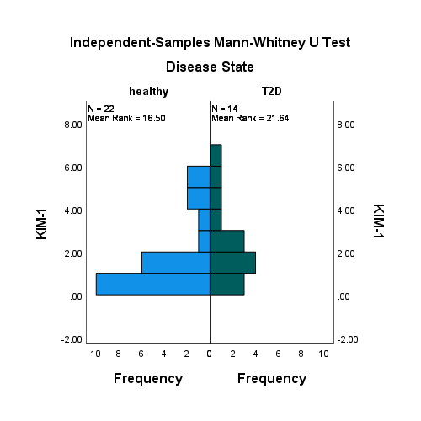

ADMA_CON_umolL across Disease State

Independent-Samples Mann-Whitney U Test Summary
Total N | 61
Mann-Whitney U | 441.500
Wilcoxon W | 906.500
Test Statistic | 441.500
Standard Error | 69.308
Standardized Test Statistic | -.339
Asymptotic Sig.(2-sided test) | .735

