T-Test

Notes
Output Created |  | 22-FEB-2022 12:17:19
Comments
Input | Data | C:\Users\harirfor.ETSU\Desktop\Diabetes data_042219.sav
Input | Active Dataset | DataSet1
Input | Filter | <none>
Input | Weight | <none>
Input | Split File | <none>
Input | N of Rows in Working Data File | 63
Missing Value Handling | Definition of Missing | User defined missing values are treated as missing.
Missing Value Handling | Cases Used | Statistics for each analysis are based on the cases with no missing or out-of-range data for any variable in the analysis.
Syntax |  | T-TEST GROUPS=DiseaseState(1 2)  /MISSING=ANALYSIS  /VARIABLES=ADMA_CON_umolL KIM1_ngml  /ES DISPLAY(TRUE)  /CRITERIA=CI(.95).
Resources | Processor Time | 00:00:00.00
Resources | Elapsed Time | 00:00:00.01

Group Statistics
 | Disease State | N | Mean | Std. Deviation | Std. Error Mean
ADMA_CON_umolL | healthy | 31 | 1.8287 | 1.40827 | .25293
ADMA_CON_umolL | T2D | 30 | 1.8972 | 1.81938 | .33217
KIM-1 | healthy | 22 | 1.8179 | 1.79295 | .38226
KIM-1 | T2D | 14 | 2.5306 | 1.86857 | .49940

Independent Samples Test
 |  | Levene's Test for Equality of Variances |  | t-test for Equality of Means
 |  | F | Sig. | t | df
ADMA_CON_umolL | Equal variances assumed | .522 | .473 | -.165 | 59
ADMA_CON_umolL | Equal variances not assumed |  |  | -.164 | 54.626
KIM-1 | Equal variances assumed | .002 | .964 | -1.144 | 34
KIM-1 | Equal variances not assumed |  |  | -1.133 | 26.966

Independent Samples Test
 |  | t-test for Equality of Means
 |  | Significance |  | Mean Difference
 |  | One-Sided p | Two-Sided p | Mean Difference
ADMA_CON_umolL | Equal variances assumed | .435 | .870 | -.06855
ADMA_CON_umolL | Equal variances not assumed | .435 | .870 | -.06855
KIM-1 | Equal variances assumed | .130 | .261 | -.71273
KIM-1 | Equal variances not assumed | .134 | .267 | -.71273

Independent Samples Test
 |  | t-test for Equality of Means
 |  | Std. Error Difference | 95% Confidence Interval of the Difference
 |  | Std. Error Difference | Lower | Upper
ADMA_CON_umolL | Equal variances assumed | .41577 | -.90050 | .76340
ADMA_CON_umolL | Equal variances not assumed | .41751 | -.90538 | .76828
KIM-1 | Equal variances assumed | .62299 | -1.97880 | .55334
KIM-1 | Equal variances not assumed | .62890 | -2.00321 | .57775

Independent Samples Effect Sizes
 |  | Standardizerª | Point Estimate | 95% Confidence Interval
 |  | Standardizerª | Point Estimate | Lower | Upper
ADMA_CON_umolL | Cohen's d | 1.62340 | -.042 | -.544 | .460
ADMA_CON_umolL | Hedges' correction | 1.64441 | -.042 | -.537 | .454
ADMA_CON_umolL | Glass's delta | 1.81938 | -.038 | -.539 | .465
KIM-1 | Cohen's d | 1.82224 | -.391 | -1.065 | .288
KIM-1 | Hedges' correction | 1.86370 | -.382 | -1.041 | .282
KIM-1 | Glass's delta | 1.86857 | -.381 | -1.060 | .311
a. The denominator used in estimating the effect sizes.
Cohen's d uses the pooled standard deviation.
Hedges' correction uses the pooled standard deviation, plus a correction factor.
Glass's delta uses the sample standard deviation of the control group.

Regression

Notes
Output Created |  | 22-FEB-2022 12:40:05
Comments
Input | Data | C:\Users\harirfor.ETSU\Desktop\Diabetes data_042219.sav
Input | Active Dataset | DataSet1
Input | Filter | <none>
Input | Weight | <none>
Input | Split File | <none>
Input | N of Rows in Working Data File | 63
Missing Value Handling | Definition of Missing | User-defined missing values are treated as missing.
Missing Value Handling | Cases Used | Statistics are based on cases with no missing values for any variable used.
Syntax |  | REGRESSION  /MISSING LISTWISE  /STATISTICS COEFF OUTS CI(95) R ANOVA COLLIN TOL CHANGE  /CRITERIA=PIN(.05) POUT(.10)  /NOORIGIN  /DEPENDENT KIM1_ngml  /METHOD=ENTER Gender Age DiseaseState Race  /SCATTERPLOT=(KIM1_ngml ,*ZPRED) (*ZRESID ,KIM1_ngml) (*ZRESID ,*ZPRED)  /RESIDUALS DURBIN HISTOGRAM(ZRESID) NORMPROB(ZRESID).
Resources | Processor Time | 00:00:03.95
Resources | Elapsed Time | 00:00:01.57
Resources | Memory Required | 4192 bytes
Resources | Additional Memory Required for Residual Plots | 1360 bytes

Variables Entered/Removedª
Model | Variables Entered | Variables Removed | Method
1 | Race , Age , Disease State, Gender^{b} | . | Enter
a. Dependent Variable: KIM-1
b. All requested variables entered.

Model Summary^{b}
Model | R | R Square | Adjusted R Square | Std. Error of the Estimate | Change Statistics
 |  |  |  |  | R Square Change | F Change | df1
1 | .413ª | .171 | .063 | 1.77122 | .171 | 1.593 | 4

Model Summary^{b}
Model | Change Statistics |  |  | Durbin-Watson
Model | df2 | Sig. F Change
1 | 31 | .201 |  | 1.521

a. Predictors: (Constant), Race , Age , Disease State, Gender
b. Dependent Variable: KIM-1

ANOVAª
Model |  | Sum of Squares | df | Mean Square | F | Sig.
1 | Regression | 19.991 | 4 | 4.998 | 1.593 | .201^{b}
1 | Residual | 97.254 | 31 | 3.137
1 | Total | 117.245 | 35
a. Dependent Variable: KIM-1
b. Predictors: (Constant), Race , Age , Disease State, Gender

Coefficientsª
Model |  | Unstandardized Coefficients |  | Standardized Coefficients | t | Sig.
 |  | B | Std. Error | Beta | t | Sig.
1 | (Constant) | -.461 | 2.958 |  | -.156 | .877
1 | Gender | 1.476 | .709 | .409 | 2.081 | .046
1 | Age | .021 | .028 | .137 | .749 | .460
1 | Disease State | .164 | .654 | .044 | .250 | .804
1 | Race | -.812 | 1.838 | -.074 | -.442 | .662

Coefficientsª
Model |  | 95.0% Confidence Interval for B |  |  |  | Collinearity Statistics
 |  | Lower Bound |  | Upper Bound |  | Tolerance | VIF
1 | (Constant) | -6.494 |  | 5.573
1 | Gender | .030 |  | 2.922 |  | .693 | 1.442
1 | Age | -.036 |  | .077 |  | .798 | 1.253
1 | Disease State | -1.170 |  | 1.497 |  | .858 | 1.165
1 | Race | -4.560 |  | 2.936 |  | .955 | 1.047

a. Dependent Variable: KIM-1

Collinearity Diagnosticsª
Model | Dimension | Eigenvalue | Condition Index | Variance Proportions
 |  |  |  | (Constant) | Gender | Age | Disease State
1 | 1 | 4.754 | 1.000 | .00 | .00 | .00 | .00
1 | 2 | .129 | 6.080 | .00 | .22 | .15 | .11
1 | 3 | .075 | 7.981 | .00 | .20 | .02 | .78
1 | 4 | .036 | 11.534 | .00 | .30 | .51 | .09
1 | 5 | .007 | 25.593 | .99 | .27 | .32 | .01

Collinearity Diagnosticsª
Model | Dimension | Variance Proportions
Model | Dimension | Race
1 | 1 | .00
1 | 2 | .01
1 | 3 | .03
1 | 4 | .29
1 | 5 | .67

a. Dependent Variable: KIM-1

Residuals Statisticsª
 | Minimum | Maximum | Mean | Std. Deviation | N
Predicted Value | .4642 | 3.3491 | 2.0951 | .75576 | 36
Residual | -2.76850 | 3.49815 | .00000 | 1.66694 | 36
Std. Predicted Value | -2.158 | 1.659 | .000 | 1.000 | 36
Std. Residual | -1.563 | 1.975 | .000 | .941 | 36
a. Dependent Variable: KIM-1

Charts

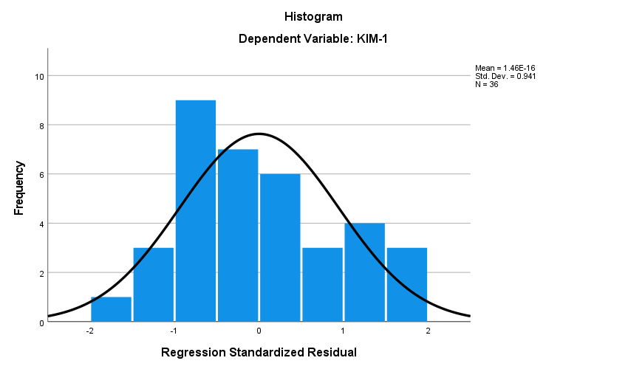

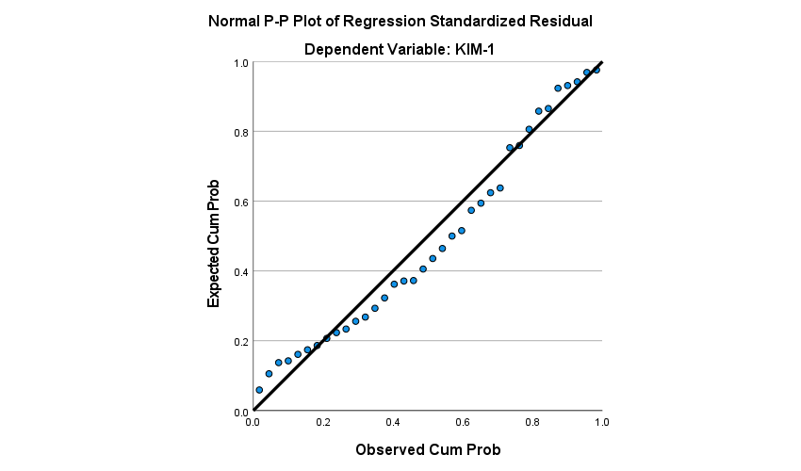

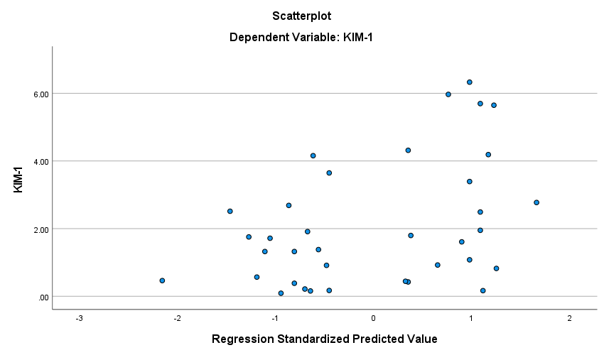

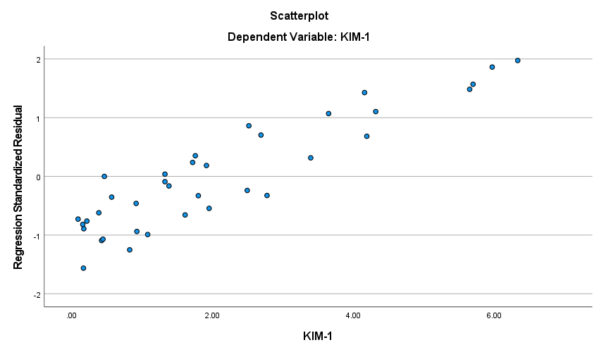

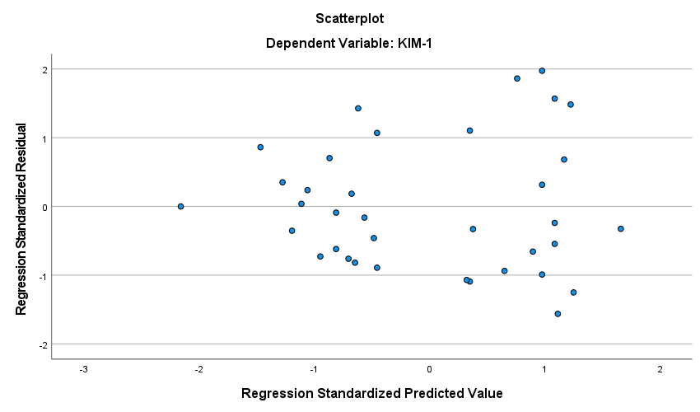

Regression

Notes
Output Created |  | 22-FEB-2022 12:43:40
Comments
Input | Data | C:\Users\harirfor.ETSU\Desktop\Diabetes data_042219.sav
Input | Active Dataset | DataSet1
Input | Filter | <none>
Input | Weight | <none>
Input | Split File | <none>
Input | N of Rows in Working Data File | 63
Missing Value Handling | Definition of Missing | User-defined missing values are treated as missing.
Missing Value Handling | Cases Used | Statistics are based on cases with no missing values for any variable used.
Syntax |  | REGRESSION  /MISSING LISTWISE  /STATISTICS COEFF OUTS CI(95) R ANOVA COLLIN TOL CHANGE  /CRITERIA=PIN(.05) POUT(.10)  /NOORIGIN  /DEPENDENT ADMA_CON_umolL  /METHOD=ENTER Gender Age DiseaseState Race  /SCATTERPLOT=(ADMA_CON_umolL ,*ZPRED) (*ZRESID ,ADMA_CON_umolL) (*ZRESID ,*ZPRED)  /RESIDUALS DURBIN HISTOGRAM(ZRESID) NORMPROB(ZRESID).
Resources | Processor Time | 00:00:01.84
Resources | Elapsed Time | 00:00:00.60
Resources | Memory Required | 4192 bytes
Resources | Additional Memory Required for Residual Plots | 1360 bytes

Variables Entered/Removedª
Model | Variables Entered | Variables Removed | Method
1 | Race , Age , Disease State, Gender^{b} | . | Enter
a. Dependent Variable: ADMA_CON_umolL
b. All requested variables entered.

Model Summary^{b}
Model | R | R Square | Adjusted R Square | Std. Error of the Estimate | Change Statistics
 |  |  |  |  | R Square Change | F Change | df1
1 | .405ª | .164 | .104 | 1.52402 | .164 | 2.744 | 4

Model Summary^{b}
Model | Change Statistics |  |  | Durbin-Watson
Model | df2 | Sig. F Change
1 | 56 | .037 |  | 1.732

a. Predictors: (Constant), Race , Age , Disease State, Gender
b. Dependent Variable: ADMA_CON_umolL

ANOVAª
Model |  | Sum of Squares | df | Mean Square | F | Sig.
1 | Regression | 25.495 | 4 | 6.374 | 2.744 | .037^{b}
1 | Residual | 130.067 | 56 | 2.323
1 | Total | 155.562 | 60
a. Dependent Variable: ADMA_CON_umolL
b. Predictors: (Constant), Race , Age , Disease State, Gender

Coefficientsª
Model |  | Unstandardized Coefficients |  | Standardized Coefficients | t | Sig.
 |  | B | Std. Error | Beta | t | Sig.
1 | (Constant) | 5.060 | 2.064 |  | 2.452 | .017
1 | Gender | -.147 | .433 | -.045 | -.340 | .735
1 | Age | -.055 | .017 | -.412 | -3.190 | .002
1 | Disease State | .145 | .405 | .045 | .359 | .721
1 | Race | -.768 | 1.554 | -.061 | -.494 | .623

Coefficientsª
Model |  | 95.0% Confidence Interval for B |  |  |  | Collinearity Statistics
 |  | Lower Bound |  | Upper Bound |  | Tolerance | VIF
1 | (Constant) | .926 |  | 9.193
1 | Gender | -1.015 |  | .721 |  | .849 | 1.177
1 | Age | -.090 |  | -.021 |  | .893 | 1.120
1 | Disease State | -.666 |  | .957 |  | .928 | 1.077
1 | Race | -3.881 |  | 2.346 |  | .977 | 1.023

a. Dependent Variable: ADMA_CON_umolL

Collinearity Diagnosticsª
Model | Dimension | Eigenvalue | Condition Index | Variance Proportions
 |  |  |  | (Constant) | Gender | Age | Disease State
1 | 1 | 4.759 | 1.000 | .00 | .00 | .00 | .00
1 | 2 | .120 | 6.301 | .00 | .44 | .19 | .02
1 | 3 | .078 | 7.790 | .00 | .13 | .01 | .93
1 | 4 | .036 | 11.462 | .02 | .32 | .69 | .01
1 | 5 | .006 | 28.217 | .97 | .11 | .11 | .05

Collinearity Diagnosticsª
Model | Dimension | Variance Proportions
Model | Dimension | Race
1 | 1 | .00
1 | 2 | .00
1 | 3 | .01
1 | 4 | .15
1 | 5 | .83

a. Dependent Variable: ADMA_CON_umolL

Residuals Statisticsª
 | Minimum | Maximum | Mean | Std. Deviation | N
Predicted Value | .5906 | 3.3310 | 1.8624 | .65186 | 61
Residual | -1.83551 | 6.69140 | .00000 | 1.47234 | 61
Std. Predicted Value | -1.951 | 2.253 | .000 | 1.000 | 61
Std. Residual | -1.204 | 4.391 | .000 | .966 | 61
a. Dependent Variable: ADMA_CON_umolL

Charts

