**Supplementary File**

**Figure-S1:** Calibration curve created with known standards in normalization to the internal standard

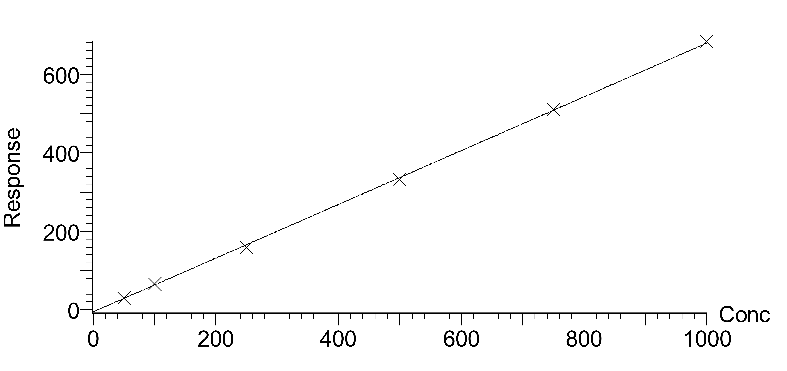

Compound name: 5-FU

Correlation coefficient: r = 0.999815, r2 = 0.999630

Slope value: 0.7

Response type: Internal Standard

Curve type: Linear, Origin: Exclude.

**Figure-S2:** Mass chromatogram showing the peak areas of 5-FU and 5-BU with reference to control 7 (250 ng/ml) and patients samples s6 and s10

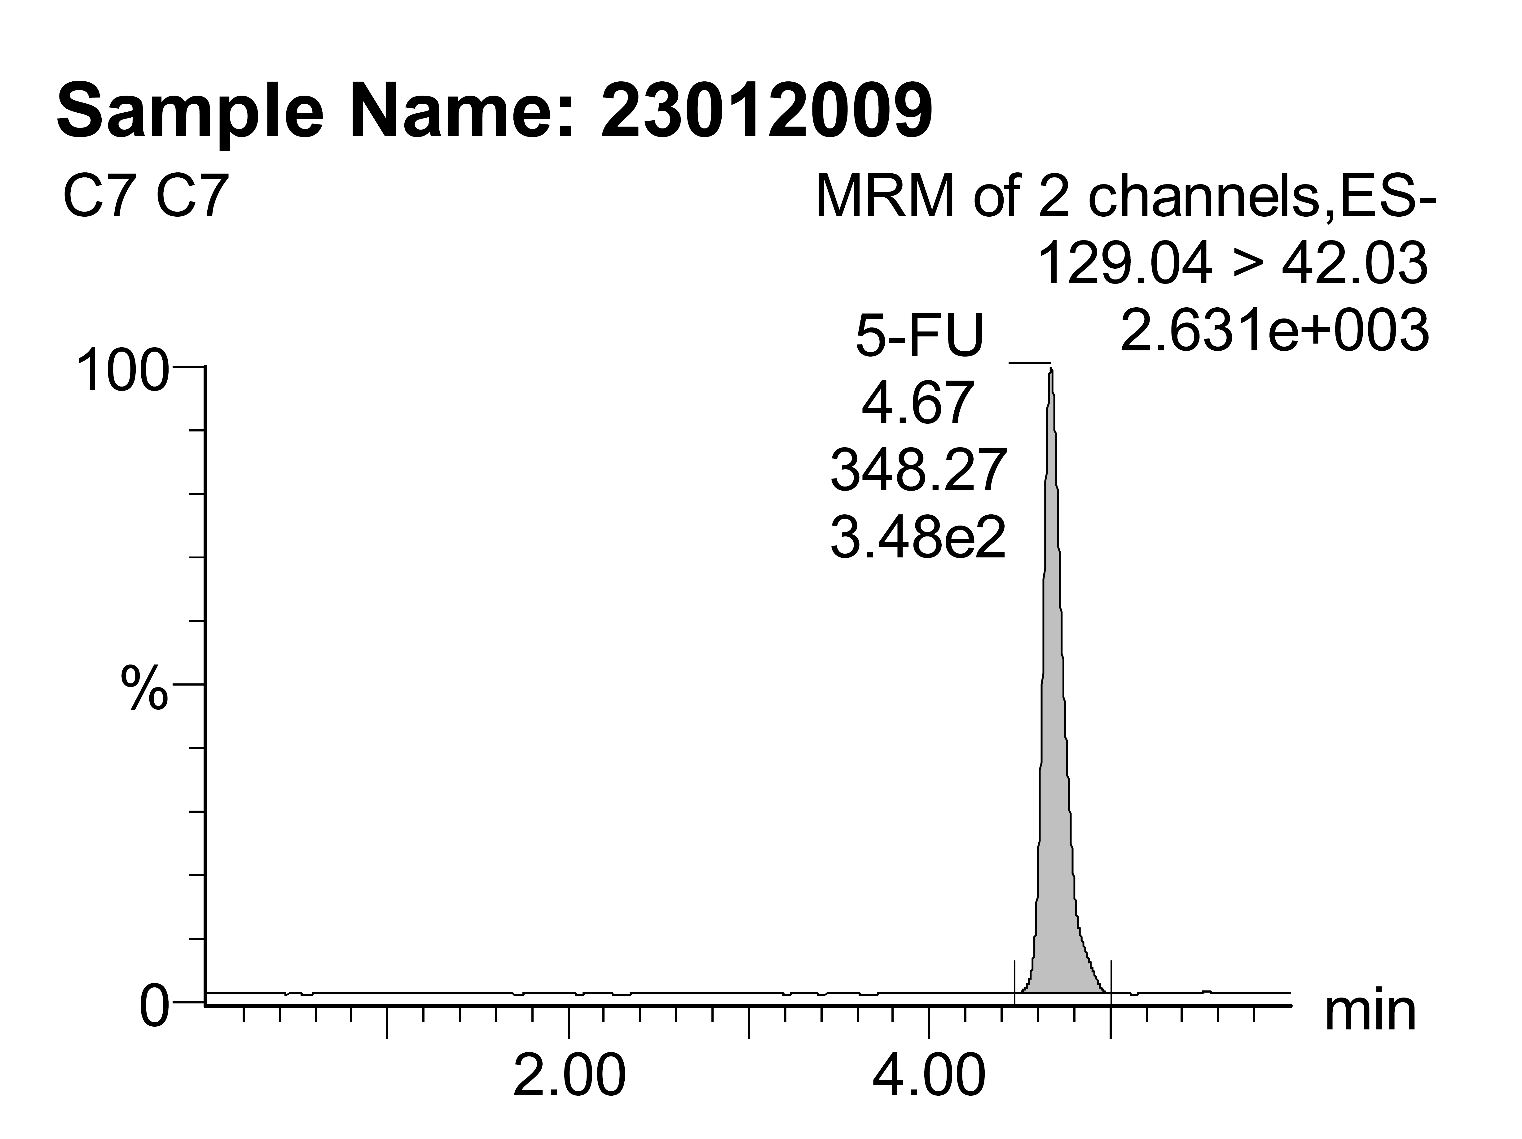 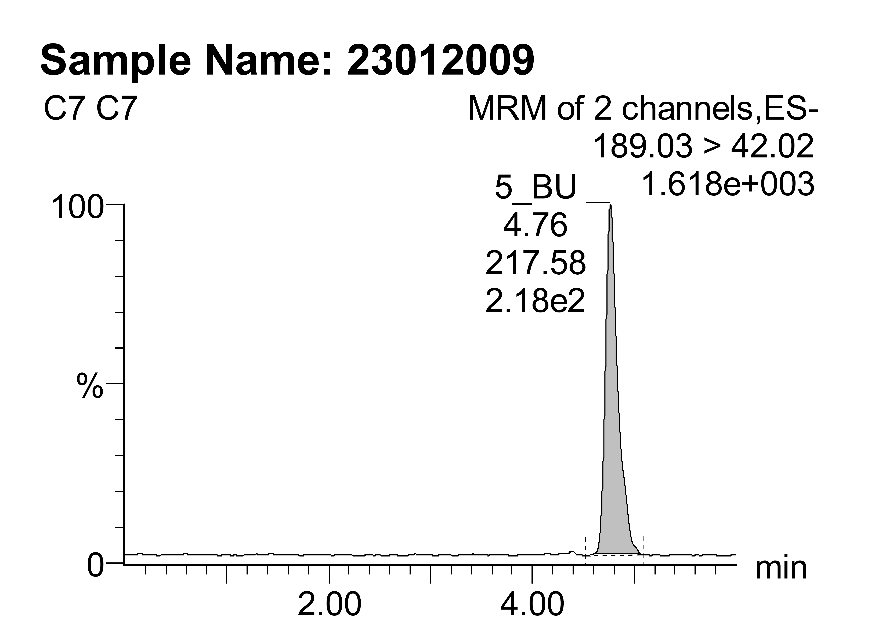

**2a 2b**

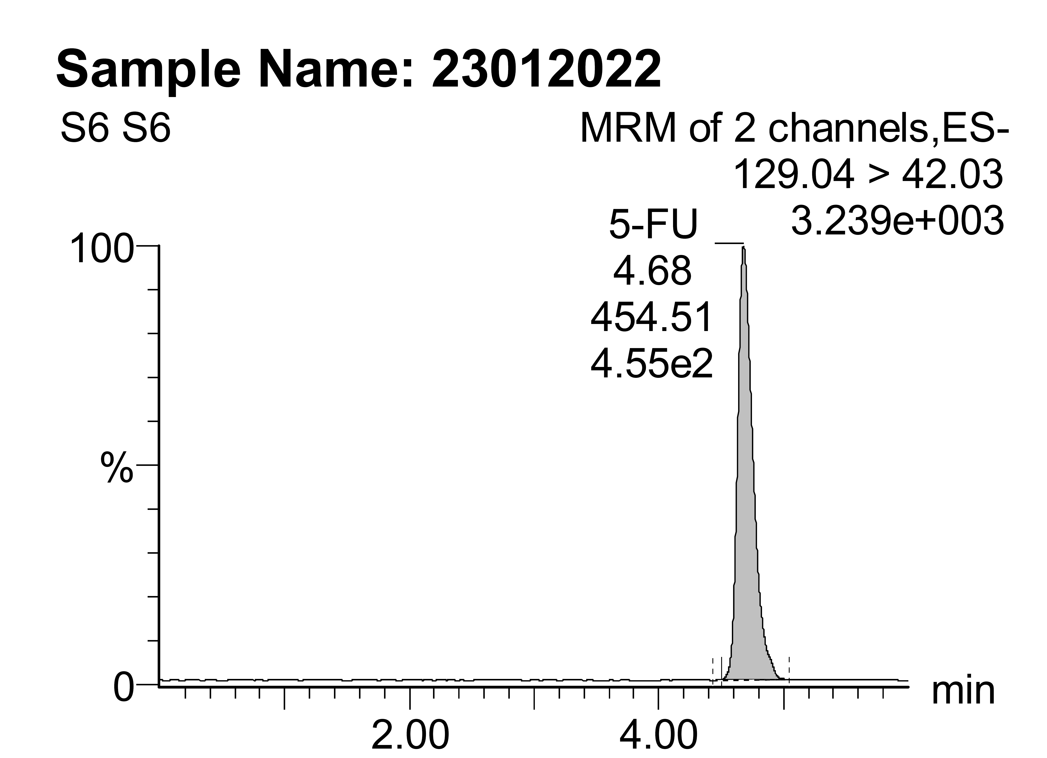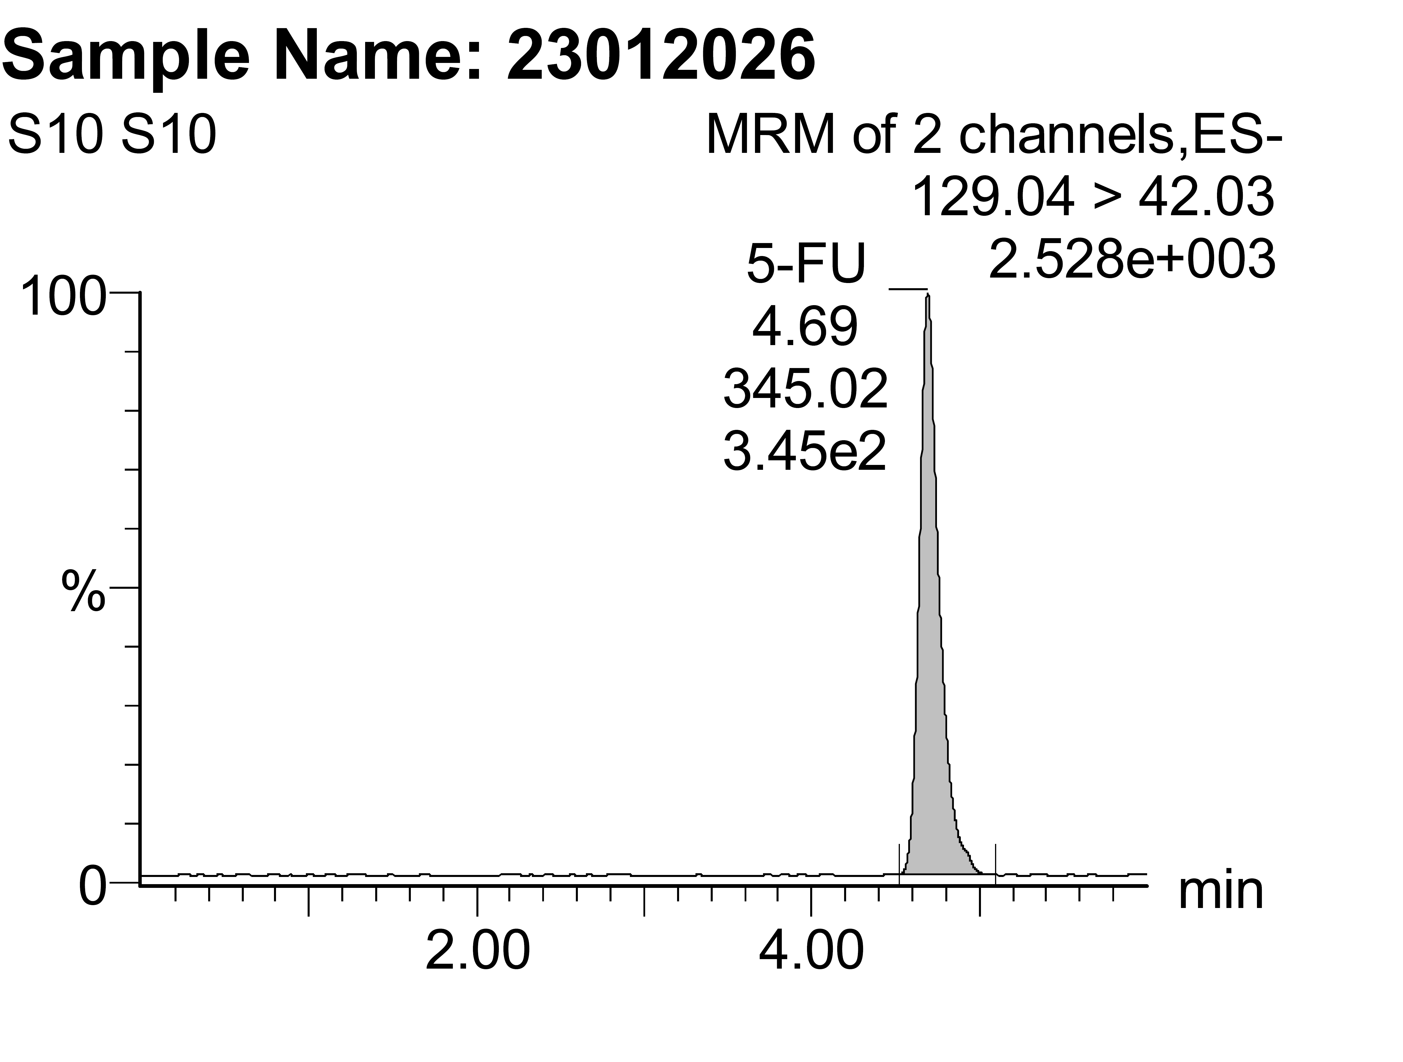

**2c 2d**

MRM= Multiple reaction monitoring.

ES - = Negative mode

**2a:** 5 FU Transition = 129.04 > 42.03, Peak area = 348, retention time = 4.67.

**2b:** 5-BU Transition = 189.03 > 42.02, Peak area = 217, retention time =4.76.

**2c:** 5-FU Transition (Patient sample) =129.03 > 42.02, Peak area = 454, retention time 4.68.

**2d:** 5-FU Transition (Patient sample) = 129.03 > 42.02, Peak area = 345, retention time 4.68.

**Table S1:** Quantification report of reference (5-FU) and internal standards (5-BU) by LC-

MS/MS analysis

|  |  |  |  |  |  |  |  |
| --- | --- | --- | --- | --- | --- | --- | --- |
| S.no | Standards | Concentration  (ng/ml) | RT | S.Area | IS.Area | R | R (%) |
| 1 | C1 | 1 | 4.63 | 2 | 212 | 1.32 | 132 |
| 2 | C2 | 5 | 4.67 | 8 | 210 | 5.08 | 101.6 |
| 3 | C3 | 10 | 4.69 | 10 | 217 | 8.82 | 88.3 |
| 4 | C4 | 25 | 4.70 | 36 | 194 | 26 | 104 |
| 5 | C5 | 50 | 4.68 | 65 | 215 | 48.79 | 97.58 |
| 6 | C6 | 100 | 4.67 | 131 | 192 | 104.3 | 104.3 |
| 7 | C7 | 250 | 4.67 | 348 | 217 | 241.5 | 96.6 |
| 8 | C8 | 500 | 4.67 | 693 | 210 | 493 | 98.7 |
| 9 | C9 | 750 | 4.67 | 1086 | 212 | 754 | 100.5 |
| 10 | C10 | 1000 | 4.67 | 1424 | 202 | 1007 | 100.7 |
| 11 | QC1 | 75 | 4.67 | 97 | 206 | 75.2 | 100.2 |
| 12 | QC2 | 300 | 4.68 | 450 | 211 | 309 | 103.1 |
| 13 | QC3 | 600 | 4.68 | 913 | 216 | 610 | 101.8 |

QC= quality control.

RT= retention time.

S.area = Standard area.

IS area= Internal standard area.

R= recovery.

R % = recovery percentage.

**Table – S2:** Chromatography conditions

|  |  |  |
| --- | --- | --- |
| S.no | Conditions | Results |
| 1 | Flow rate | 0.6ml/min |
| 2 | Run time | 6 minutes |
| 3 | Column temperature | 30oC |
| 4 | Sample volume | 20µl |

**Table –S3:** Multiple reactions monitoring (MRM) conditions

|  |  |  |  |  |  |  |
| --- | --- | --- | --- | --- | --- | --- |
| S.no | Compound | Parent Ion Mass (M/Z) | Daughter Ion Mass (M/Z) | Cone voltage (V) | Collision energy (eV) | Retention Time (min) |
| 1 | 5-BU | 189.03 | 42.02 | 28 | 14 | 4.67 |
| 2 | 5-FU | 129.03 | 42.03 | 26 | 12 | 4.76 |

M/Z=Mass to charge ratio

**Formulas for calculating response of standards and concentration of unknown in normalization to internal standard**

Area of standard (Ax) / Area of internal standard (AIS)

Response (R) =

Concentration of standard (Cx)/ Concentration of internal standard (CIS)

Area of unkown (AU) / Area IS

R

× CIS

Concentration unkown (CU) =