Supplementary Material #1
21-item Multiple-choice Conceptual Chemistry Questionnaire

Research Article
“Enhancing Chemistry Understanding and Attitudes through an Outreach Education Program on Circular Plastic Economy: A Case Study with Thai Twelfth-Grade Students”

Authors
Banjong Prasongsap¹, Pawat Chaipidech^{1,2}, & Niwat Srisawasdi^{1,2*}
¹Faculty of Education, Khon Kaen University, Khon Kaen 40002, Thailand
²Digital Education and Learning Engineering Association, Nonthaburi 11110, Thailand
*Corresponding Author

Chemistry Conceptual Test on Plastic and Sustainability
(Translated into English version)

Instruction: This test consists of 21 multiple-choice questions, each with five answer choices (A–E). Please read each question carefully and select the most appropriate answer by marking it on the provided answer sheet.

1. Refer to the following image. Based on the properties of the substance shown, which of the following is correct?
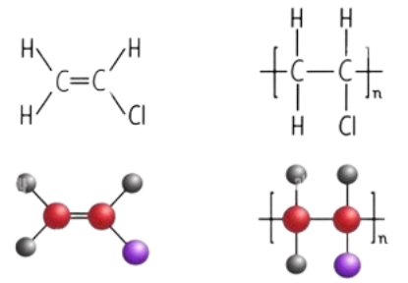

A. Lightweight, durable, low-cost, and easy to process (Correct Answer)
B. Lightweight, durable, low-cost, and easy to process
C. Lightweight, low-cost, and easy to process
D. Lightweight, durable, high-cost, and easy to process
E. Lightweight, durable, low-cost, and easy to process
2. Refer to the image of the following monomer. After polymerization, this monomer becomes a compound of which type?
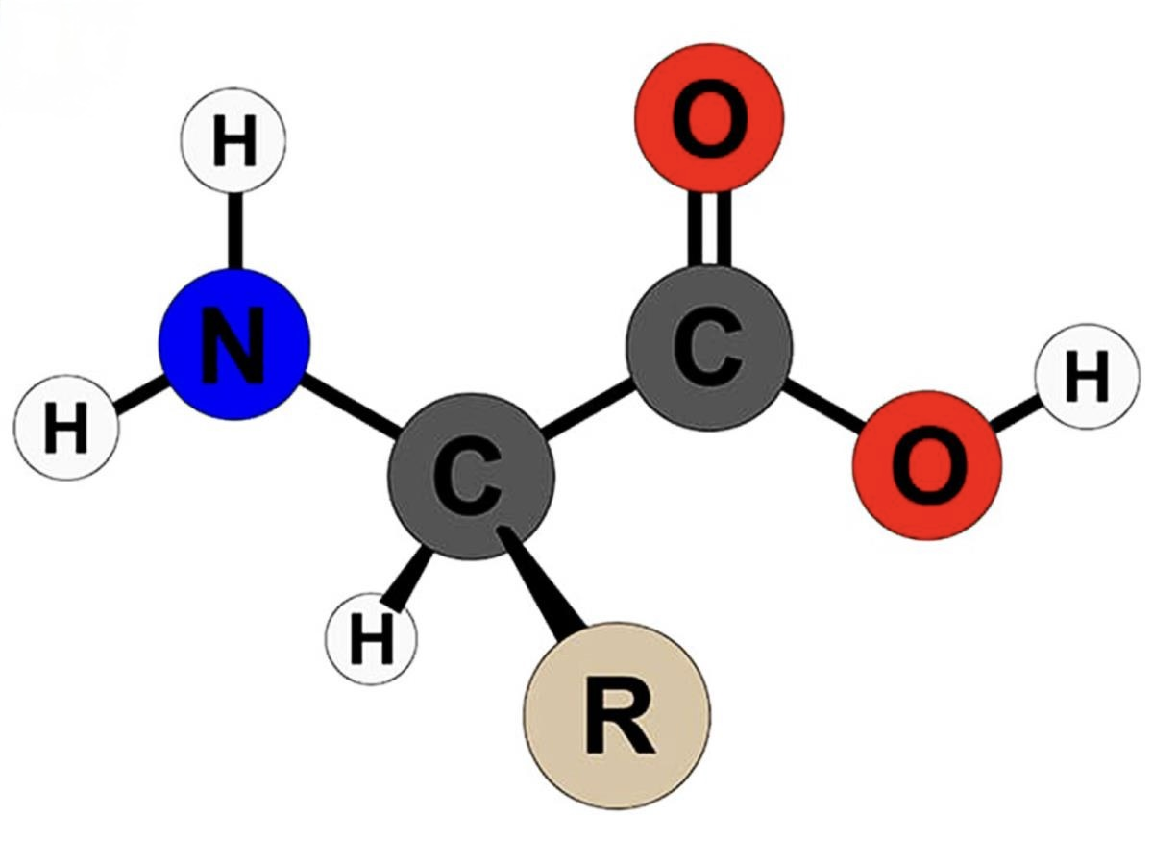

A. Carbohydrate
B. Lipid
C. Amino acid
D. Protein (Correct Answer)
E. Nucleic acid
3. Refer to the following image of A and B. Which statement is correct?
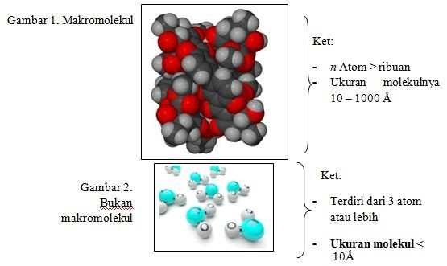
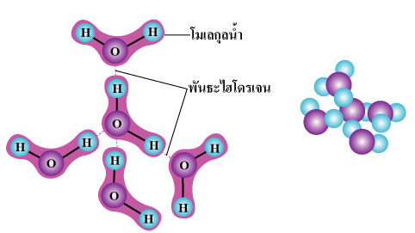
A
B

A. A and B are natural polymers
B. A and B are synthetic polymers
C. A is a polymer, B is not (Correct Answer)
D. Neither A nor B are polymers
E. A and B are monomers
4. Based on the image shown, what type of substance will this become?
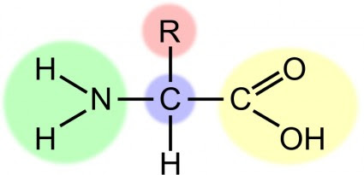

A. PET
B. LDPE
C. HDPE
D. Synthetic polymer
E. Natural polymer (Correct Answer)
5. How is energy transferred in the pyrolysis process?
A. Exothermic
B. Endothermic (Correct Answer)
C. Adiabatic
D. Exothermic–Endothermic
E. High-temperature condition

6. What is the key characteristic of the pyrolysis reaction?
A. Decomposition of inorganic matter without oxygen
B. Synthesis of inorganic matter without oxygen
C. Decomposition of organic matter without oxygen (Correct Answer)
D. Synthesis of organic matter without oxygen
E. Combustion of organic matter without oxygen
7. Why can plastic waste be converted into oil during pyrolysis?
A. It decomposes without combustion (Correct Answer)
B. It is burned without decomposition
C. It undergoes both combustion and decomposition
D. It is only burned
E. It undergoes breakdown and molecular modification
8. What chemical transformation occurs during pyrolysis?
A. Organic matter → water only
B. Organic matter → solids and gases only
C. Organic matter → gases only
D. Organic matter → solid, liquids, and uncondensed gases (Correct Answer)
E. Organic matter → solid, liquid, gas, and water
9. Which factor determines the quality of bioplastics?
A. Molding
B. Disposal
C. Usage
D. Production
E. Biodegradability (Correct Answer)
10. Given the table showing degradation times of bioplastics A, B, and C, which statement is incorrect?
Number | Bioplastic | Decomposition time (days)
1 | A | 7
2 | B | 6
3 | C | 10

A. B is the best bioplastic
B. C is the least effective bioplastic
C. Quality ranking is B > A > C
D. B degrades the fastest
E. A degrades the slowest (Correct Answer)
11. Which polymer is the most environmentally friendly?
A. Poly lactic acid (Correct Answer)
B. Polypropylene
C. Polyvinylchloride
D. Polyethylene terephthalate
E. Polystyrene
12. Which of the following is not a valid model to explain bioplastic degradation time?
A. Graphic
B. Bar chart
C. Pie chart
D. Scale (Correct Answer)
E. Equation
13. Which format best illustrates the degradation timeline of various bioplastics?
A. Pie chart
B. Equation
C. Scale
D. Formula
E. Infographic (Correct Answer)
14. What is the most suitable approach to promoting responsible plastic use in the community?
A. Ban all plastic use completely
B. Propose more plastic waste bins to community leaders
C. Use alternative materials
D. Avoid single-use plastics (Correct Answer)
E. Campaign for proper plastic incineration
15. To determine daily plastic use, which method is most appropriate?
A. Survey (Correct Answer)
B. Experiment
C. Design and development research
D. Literature review
E. Meta-analysis

16. Given a summary of plastic usage by individuals A, B, and C, which presentation format is most appropriate?
A. Table (Correct Answer)
B. Pie chart
C. Scale
D. Equation
E. Symbols
17. A plastic waste survey shows no PET usage, which seems unreasonable. What is the best explanation and response?
A. Respondents didn’t care, so stop the survey
B. Respondents didn’t care, change the method
C. Respondents didn’t care, provided simple ID training (Correct Answer)
D. Respondents didn’t care, exclude them
E. Respondents didn’t care, disqualify their participation
18. What is the main benefit of the plastic reuse principle?
A. Maximizing resource longevity (Correct Answer)
B. Preserving plastic for long-term use
C. Maintaining plastic quality
D. Sustaining plastic availability
E. Promoting continuous plastic use
19. Which process reduces plastic waste by transforming it into valuable products?
A. Reduce
B. Reuse
C. Re-purpose
D. Recycling (Correct Answer)
E. Reconsuming
20. Which method is commonly used to convert plastic waste into valuable products?
A. Gasification
B. Filtration
C. Chromatography
D. Pyrolysis (Correct Answer)
E. Hydrolysis

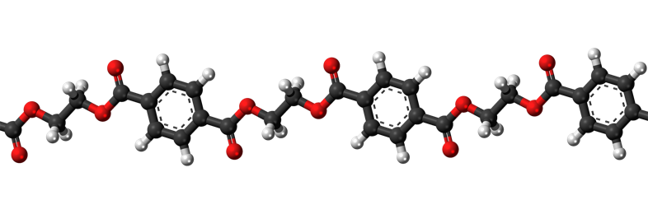
21. Refer to the molecular structure and polymerization process shown in the images. What material is being described, commonly used in daily life for various purposes?

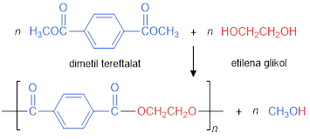

A. (Correct Answer)
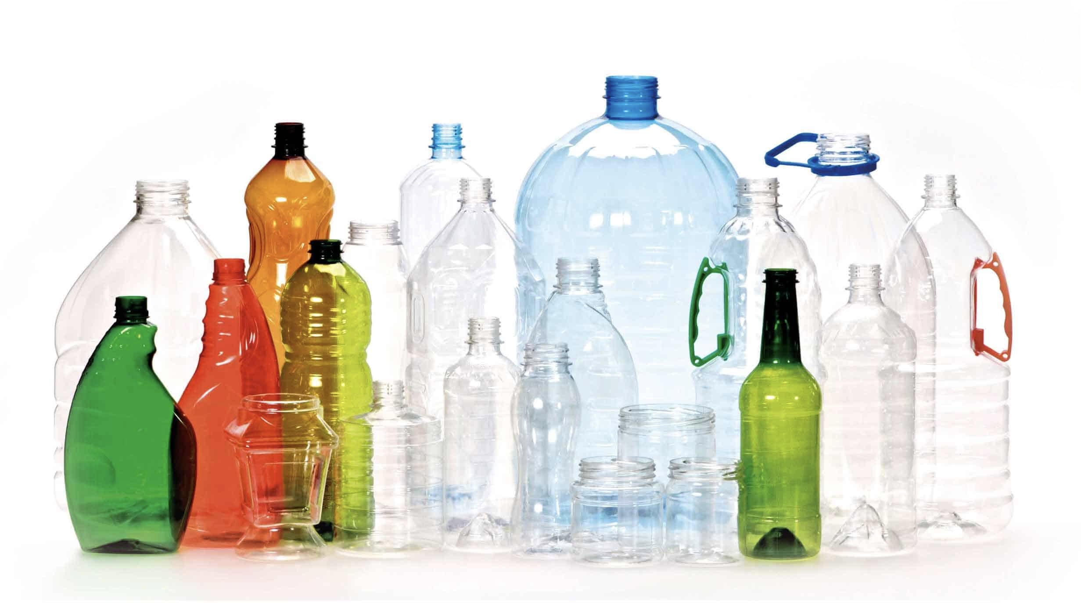

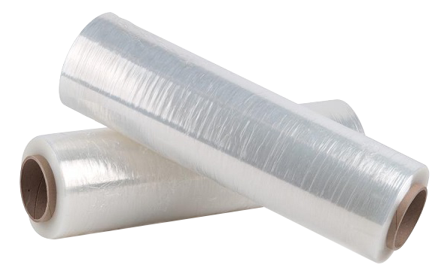
B.

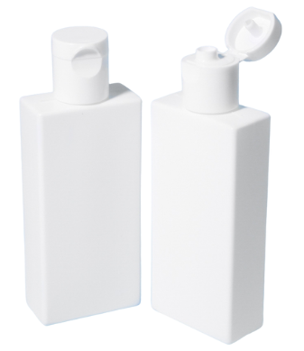
C.

D.
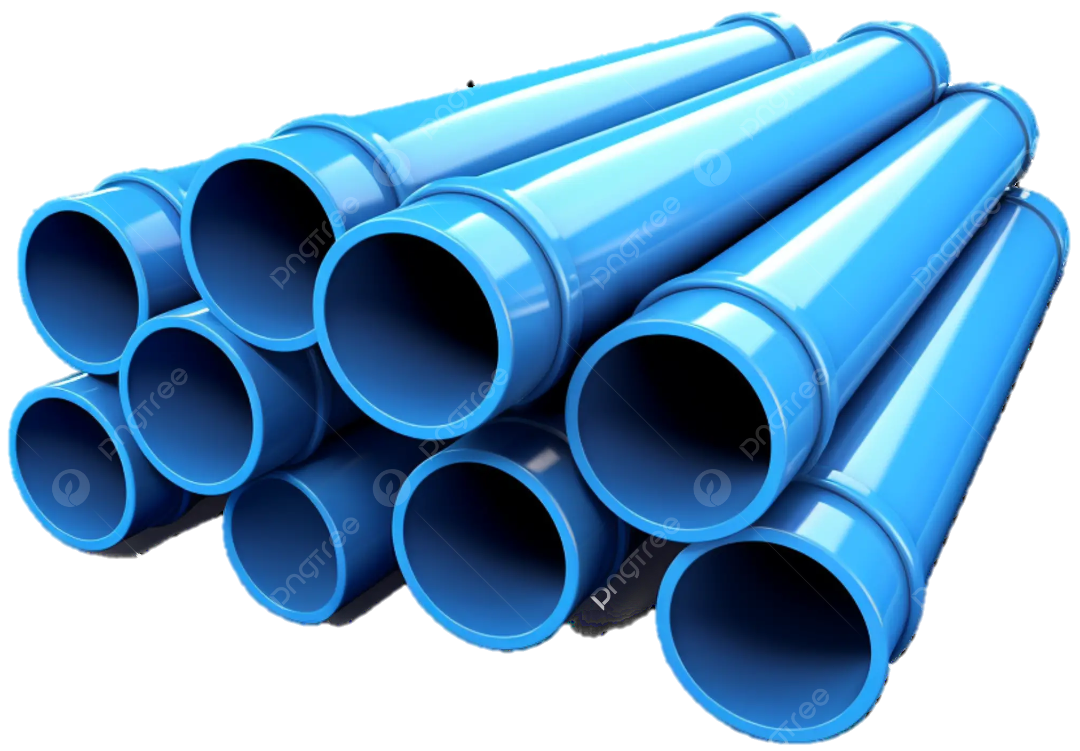

E.
