Box 1 Nitration of nitrobenzene
Pre-lab Questions:
- Draw the resonance structures of nitrobenzene.
- The –NO₂ group in nitrobenzene is an electron ____________ group and is ___________ directing in the electrophilic aromatic substitution reaction.
- Mark the possible side product(s) of the nitration reaction of nitrobenzene from below:
  - 1-nitro-3-nitrosobenzene, (b) 1,2-dinitrobenzene, (c) 1-nitro-4-nitrosobenzene, (d) 1,4-dinitrobenzene, (e) 1,3-dinitrobenzene.
- Conc. H₂SO₄ has an important role in the nitration reaction of nitrobenzene.
  - Complete and balance the following equilibrium reaction,
(b) More than one equivalent of H₂SO₄ (with respect to HNO₃) is used in the nitration reaction. Explain how the excess use of H₂SO₄ helps to increase the concentration of the electrophile.
- For the nitration reaction of benzene to nitrobenzene and nitrobenzene to m-dinitrobenzene, the reaction mixture needs to be heated at 50 ˚C and 80 ˚C respectively. Why is a lower temperature needed for the nitration of benzene?
- Calculate the theoretical yield of m-dinitrobenzene (using the given formula) if 0.5 mL of nitrobenzene is taken. The density of nitrobenzene is 1.2 g mL^{‒1}.
_______________________
Organic synthesis- The experiment involves comparison between two methods of synthesis, one traditional and another green method.

Box 2 Nitration of nitrobenzene
Post-lab Questions:
- In this synthesis, on heating the reaction flask, brown-colored fumes evolved. What is the gas evolved?
- In procedure – A, when NaNO₃ was added to conc. H₂SO₄, a white-colored solid salt was formed.
  - Write the reaction(s) for formation of this solid.
  - Will the white salt be present in the final product after washing with water? Justify your answer.
- Why was the conc. H₂SO₄ added slowly (or dropwise) to the conc. HNO₃ with shaking in procedure – B?
- One student decided to skip the recrystallization and recorded the melting point of the crude product directly. The student got a range of melting point from 81 ˚C to 88 ˚C, while the students who recorded the melting point of the recrystallized product, got a sharp melting point around 90 ˚C (melting point of o-, m- and p-dinitrobenzene are 118 ˚C, 90 ˚C, 174 ˚C respectively). Explain the observations.
- One student obtained a much lower yield of the product compared to the rest of the students. This could be due to:
(a) use of a 100 mL round bottomed flask for the reaction
(b) use of gglasswares which were not dried properly
(c) air condenser not being used
(d) performing the reaction for lesser time than instructed
(e) performing the reaction at room temperature
(f) use of lesser amount of nitrobenzene than specified
(g) use of greater amount of nitrobenzene than specified
- Two different procedures have been used to prepare m-dinitrobenzene from nitrobenzene. The reagents used and the reaction time are different.
(a) In terms of the safety of reagents used according to you which is the less hazardous
one?
(b) From the data of the yield obtained by all students, which procedure (A or B) gives better yield?
  - If you had to select a procedure for nitration of nitrobenzene which procedure A or B, would you select and why?
7. Complete the following table matching the substrate with the appropriate reaction conditions for nitration reaction.
Substrate | Reaction conditions
Phenol | mixture of conc. HNO₃ and conc. H₂SO₄ at 50 ˚C
Toluene | mixture of fuming HNO₃ and conc. H₂SO₄ at 40 ˚C
Benzaldehyde | dil. HNO₃ below 20 ˚C
Bromobenzene | mixture of conc. HNO₃ and conc. H₂SO₄ at 30 ˚C

Since 2013, fifteen teacher workshops have been conducted with around 400 participants.

Box 3 Determination of concentration of acetic acid in a commercial vinegar sample
Pre-lab Questions:
- Write all possible equilibria prevailing in a vinegar solution (dilute acetic acid solution).
- The list of conjugate acids and conjugate bases in the equilibria/(s) written by you in 1 are-
Conjugate acids-
Conjugate bases-
- The different species that will exist in a supplied vinegar sample is/are-
    - pKa of acetic acid is 4.76 whereas that of water is 14 at 25 °C. Using this information, mark the statement/(s) that is/are incorrect -
- Acetic acid is a weaker acid compared to water.
- The conjugate base of the acetic acid is stronger than the conjugate base of water.
- In aqueous solution, equilibria (i) will predominate over equilibria (ii)
(i) 2H₂O (l) H₃O⁺ (aq) + OH⁻(aq)
(ii) CH₃COOH (aq) + H₂O (l) H₃O⁺ (aq) + CH₃COO⁻ (aq)
- Acetic acid is a Bronsted acid, but water cannot act as a Bronsted acid
- Write the balanced chemical equation for the reaction happening during titration of vinegar with standard sodium hydroxide solution.
6. For this titration, we will be using phenolphthalein as an acid-base indicator. Phenolphthalein changes from colourless to pink between pH 8.5-10. The statements that are incorrect for the above titration is/are-
a) At the equivalence point, number of moles of NaOH and CH₃COOH are the same i.e., complete neutralization of the acid takes place.
b) There are more number of moles of NaOH compared to acetic acid at the end point.
c) Phenolphthalein itself undergoes acid-base reaction at the equivalence point to show a color change.
d) The equivalence point can be reached before or occur simultaneously at the endpoint but can never occur after the endpoint of the titration solution.
__________________________
Analytical chemistry - Acid-base titration

Box 4 Determination of concentration of acetic acid in a commercial vinegar sample
Post-lab Questions:
The structure of potassium hydrogen phthalate (KHP) is given below -
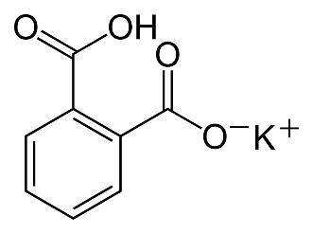
- Write the reaction between potassium hydrogen phthalate and NaOH. Indicate KHP by its molecular formula (C₈H₅O₄K) for writing the equation.
- Determine the molarity of NaOH solution. Show all the steps in the calculations.
- Calculate the number of moles of NaOH required to neutralize the acid.
- Show the steps involved in calculation for percent concentration of acetic acid in the given vinegar sample.
- Taking the density (check if it is sp. Gravity) of vinegar as 1.01 g/mL, find the volume/volume percent concentration of acetic acid (C₂H₄O₂; 60.06 g/mol) in the given vinegar sample.
- The structure of phenolphthalein is shown-
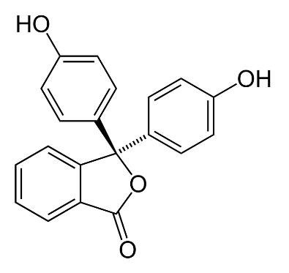
It is a pH indicator which is colourless in acidic medium and pink in alkaline medium. Mark the box corresponding to the species responsible for the colour change and write the appropriate reasoning for the answer.
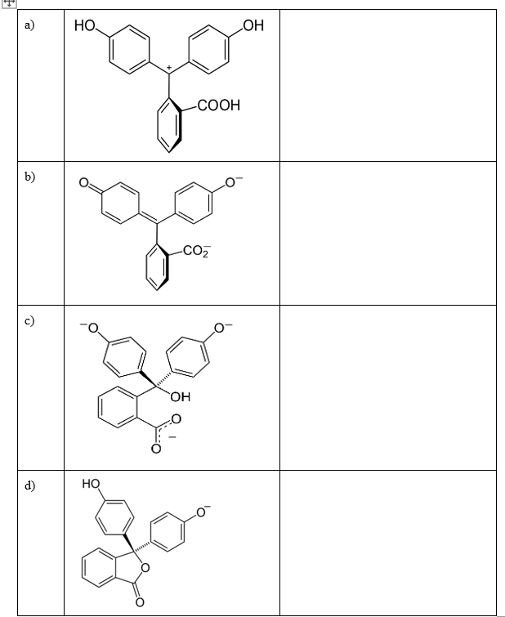

Box 4 Continued- Determination of concentration of acetic acid in a commercial vinegar sample
Post-lab Questions:
- If excess amount of NaOH is added accidentally, the pink colored solution turns colourless again. This change in color could be due to
a) ring closure resulting into lactone form b) decrease in conjugation
c) hydroxylation of highly conjugated species d) break in conjugation beyond pH 10
- List different species present in the solution:
a) Before the titration
b) At equivalence point- what will be the structure of indicator
c) At the end point- which structure predominates at end point
- Which species you feel may interfere in the estimation of acetic acid in the given vinegar sample? How can we eliminate those matrix interferences in the vinegar sample?
The following is a depiction of titration of 10 mL of 0.10 M aqueous acetic acid and 0.05 M sodium hydroxide solution.
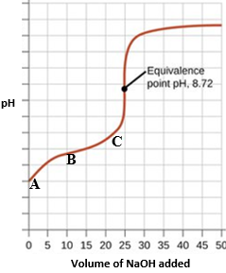
- Calculate the resultant pH at different points (marked as A, B, C) in the curve above. Show all relevant calculations.
- At point A, we have 10 mL of 0.10 M acetic acid solution in the conical flask.
- At point B, we have added 10 mL of 0.05 M NaOH solution to the same conical flask in 10i).
- At point C, we have added a total of 20 mL of NaOH solution to the same conical flask in 10i).

Box 6
Planning of an Experiment
Vinegar is often used in enhancing the taste of certain foods. It is also used as a preservative. It is produced from fermentation of sugars which produces ethanol which further undergoes fermentation to acetic acid. FDA requires that any product that is called vinegar have at least 4.0% acetic acid. Depending on the source, acetic acid concentrations vary from 4.0% to 8.0% in vinegar.
Devise a process to determine the concentration of acetic acid in a market sample of vinegar, the label of which says that it has 5.5% acetic acid.
Materials provided
10 mL pipette 1 Plastic dropper, 2 1 mL syringe, no needle, 3
25 mL beaker, 2 10 mL graduated cylinder, 1 Small spatula 1
Distilled water
Along with above, you have paper tissues and running water
Chemicals available
• 10 mL vinegar sample, 30 mL of 0.100 M NaOH
• Indicators:
  - Phenolphthalein (pH range - 8.2 – 10.0)
  - Methyl red (pH range - 4.4 – 6.2)
Notes:
The indicators can be added using plastic droppers.

Give a brief description of your experimental plan.

Box 8 lists the representative feedback received from students who have carried out i) the comparative study on nitration of dinitrobenzene by traditional method and the green route using the pre/post-lab approach and ii) investigatory project based on exploring estimation of Ca (II) using disodium ethylenediaminetetraacetic acid spectrophotometrically in presence and absence of Mg (II). The responses are for the question- a) whether the workshop changed the perception about the way the experiment was designed and performed and b) listing of two learning outcomes in the camp (experimental domain).
Box 8 Representative feedback from student participants
- whether the workshop changed the perception about the way the experiment was designed and performed

- “The workshop changed my perception about experiment. In general, we carry out our experiments as per the given lab module but in this workshop, we came to know that how all those things get derived.”
- “It helped me to develop the scientific view about the given conditions to find the reason behind the things happening in the reaction”
- “Honestly saying, yes as we got a innovative way to perform. Due to pre & post lab sessions, we were able to understand the process before experiment & also it helped after the practical which helped in gaining more info.”
- “Yes, initially my perception was that by following protocol given to us we get our result accurately, but here, I found that everything is not perfect there is changes at every step, thing is that we have to analyse what is happening and why it is happening.”
- “Yes, I now know how the values of concentrations, time, pH, etc. are decided, why only certain range of values yield results, how errors can be minimized, how to interpret data. I also learnt how to correlate different information/data to finally achieve the goal of the experiment.”

b) listing of two learning outcomes in the camp (experimental domain)
- “Investigate the behavior of your reagent (how they react wrt temperature, time, pH, etc., working range of your instruments, their constraints, how to correlate different data to get end goal’s result.”
- “Various soft skills technique, various interpretation of data in a logical and least lengthy way.”
- “Helped me to understand the way to correlate different variables in the given experiment, teamwork and coordination.”
- “In general, how to analyze the observed data and conclude them using theory.”
- “We should find out the reasons for the failure of experiments, performing the experiment is not the sole criteria.”
- “It has made me to connect the dots between the observation and the theory behind it by visualization, it has made me realize how important for one to choose the chemical and its concentration, amount to be used while planning an experiment.”

