Supplementary Materials

Portable Syringe Kit Demonstration of Gas Generating Reactions for Upper Secondary School Chemistry

Table of Contents Page
Instructor Notes 2
Safety Information 2
Equipment needed 3
Student Notes 4
• Objectives 4
• Lab Instruction 4
• Experimental Procedure 5
Experiment Results from the Investigation of CO₂ Volume with Time 7
• The conventional scale reaction with water displacement method 7
• The small-scale reaction with syringe kit method 8
Selected references 10

Instructor Notes
Safety Information
Hazards and Cautions
When preparing acid solutions from concentrated hydrogen chloric acid (HCl), sulfuric acid (H₂SO₄), and glacial acetic acid (CH₃COOH), please do so under a fume hood and wear gloves, goggles, and a lab coat. These acids can cause corrosion of skin, eyes, nose, mucous membranes, and respiratory and gastrointestinal tract. Inhaling hydrogen chloride may result in pulmonary edema, while ingestion can severely damage the mouth, throat, esophagus, and stomach.
Exercise caution when conducting experiments with sodium metal (Na). It reacts vigorously with water, releasing highly flammable hydrogen gas. Contact with Na metal on skin, eyes, or mucous membranes can result in severe burns. Be sure to store Na in oil when not in use.
When conducting a gas-generating reaction in a syringe kit, use only the recommended amount of reactant to prevent excessive pressure buildup. In addition, students received a safety briefing covering essential laboratory procedures before beginning the experiment. The experimental setup was carefully assembled and tested beforehand to reduce the chance of leaks and spills (Ng et al., 2020).
Safety considerations include using minimal amounts of reactive materials, avoiding strong light exposure for light-sensitive reactions, and using explosion screens for protection. Equipment primarily involves syringes, needles, rubber bungs, and small amounts of chemicals, with syringes acting as reaction vessels and collection devices.
Protection
• Protective goggles and gloves (and mask, if applicable) must be worn when preparing acid solutions and performing the experiment.
• Glass vials are fragile; please handle them with care.
Note: Laboratory coats and protective goggles are always desirable. Without chemical-resistant gloves, avoid direct contact with all chemicals. Please follow the laboratory safety guidelines.

Equipment Needed
All equipment needed to investigate CO₂ gas generated from conventional and syringe reactions is listed in Table S1.

Table S1. Equipment needed for the investigation of CO₂ gas generated from conventional and syringe kit reactions
Water Displacement Method (Conventional Scale) | Syringe kit method (Small-Scale)
• 120-mL Erlenmeyer flask  • Erlenmeyer flask stopper connected with rubber tube  • 50-mL Burette  • 20-mL Pipette  • Stopwatch or alternative  • Forceps  • Stand and burette clamp  • 0.5-L Beaker or alternative water container | • 50-mL (or 25-mL) syringes (Syringe A and C)  • 10-mL Luer-lock syringe (Syringe B)  • 3-way connector  • Stopwatch or alternative  • Forceps

Chemicals
All reagents were of analytical grade and used as follows.
• Sodium bicarbonate (NaHCO₃)
• Concentrated hydrochloric acid (HCl)
• Concentrated sulfuric acid (H₂SO₄)
• Concentrated acetic acid (CH₃COOH)
• Sodium carbonate (Na₂CO₃), primary standard
• Distilled water

Student Notes
Objectives
The objectives of this activity are:
• To investigate the rate of the reaction between sodium bicarbonate and hydrochloric acid by measuring the volume of the produced carbon dioxide gas,
• To compare the effects of the concentration of acids on the rate of the reaction of sodium carbonate and hydrochloric acids and
• To compare the effects of acid species (hydrochloric, acetic, and sulfuric acids) on the reaction rate of sodium carbonate and acids.

Lab Instruction
The chemical reaction rate is the change in the concentration of a reactant or a product with time (Chang & Overby, 2019). Some reactions or processes, such as the initial steps in nuclear chain reactions, take place on a time scale as short as 10⁻¹² s to 10⁻⁶ s. Others, like cement curing, take years or millions of years to complete.
Consider the reaction in which A molecules (reactant) are converted to B molecules (product):
A B (1)
The number of A molecules will decrease, and the number of B molecules will increase with time. It is more convenient to express the reaction rate in terms of the change in concentration with time. Thus, the rate of the reaction A B can be expressed as
rate =$\text{ -}\frac{\text{∆}\left[\text{A}\right]}{\text{∆t}}$ = $\frac{\text{∆}\left[\text{B}\right]}{\text{∆t}}$ (2)
To determine the reaction rate, we have to monitor the concentration or volume of the reactant (or product) as a function of time. For reactions in solution, the concentration of a species can often be measured by spectroscopic means. Reactions involving gases are most conveniently followed by pressure or volume measurements.
Gas-generated reactions are frequently used in experiments to investigate reaction rates by observing the change in gas volume over time. One of the most popular reactions in chemistry labs is generating CO₂ gas from various reactions between carbonate compounds and acids. Below are some examples of these reactions.
NaHCO₃(s) + H⁺(aq) → CO₂(g) + Na⁺(aq) + H₂O(l) (3)
The theoretical mole of CO₂ produced from these reactions can be calculated from the mole of a limiting reactant of the reaction. If a solid carbonate compound is the limiting reagent of equation (3), the mole of CO₂ equals that of the carbonate compound used. At STP, one mole of CO₂ (or any gas) has a volume of 22.4 dm³. The theoretical volume of CO₂ at the experimental condition can be calculated using equation (4), while the experimental volume can be converted to volume at STP using equation (5).
(4)
(5)
Where V, P, and T are values at ambient or experimental conditions.

Experimental Procedure

Table S2. The volume of CO₂ gas generated from conventional scale reaction between NaHCO₃ (0.084 g, 1.00 mmol) and acids (20.00 mL, 0.025-0.10 mol/L)
Rxn. | Solid A |  | Solution B |  | Remark
Rxn. | Chemical | Amount | Chemical | Amount | Remark
1 | NaHCO₃ | 0.50 mmol  (42 mg) | HCl | 0.50 mmol  (0.10 M, 5 mL) | Rxn. 1&2: Effect of type of carbonate compounds
2 | Na₂CO₃ | 0.50 mmol  (53 mg) | HCl | 0.50 mmol  (0.10 M, 5 mL) | Rxn. 1&2: Effect of type of carbonate compounds
3 | Na₂CO₃ | 1.00 mmol  (106 mg) | HCl | 0.50 mmol  (0.10 M, 5 mL) | Rxn. 2&3: Effect of limiting HCl
4 | Na₂CO₃ | 0.50 mmol  (53 mg) | HCl | 1.00 mmol  (0.20 M, 5 mL) | Rxn. 2&4: Effect of doubling concentration of HCl
5 | Na₂CO₃ | 0.50 mmol  (53 mg) | H₂SO₄ | 0.50 mmol  (0.10 M, 5 mL) | Rxn. 2&5: Effect of monoprotic HCl and diprotic H₂SO₄ acids
6 | Na₂CO₃ | 0.50 mmol  (53 mg) | CH₃COOH | 0.50 mmol  (0.10 M, 5 mL) | Rxn. 2&6: Effect of strong HCl and weak CH₃COOH acids

Here’s the procedure for investigating the volume of CO₂ gas generated in reactions using the syringe kit method.
Reaction 1:
- Preparation: Set up Syringes A, B, and C, along with a 3-way connector (refer to Figure S1a).
- Solution Transfer: Transfer 0.50 mmol of HCl (5.00 mL of 0.10 M solution) into Syringe B (Figure S1b).
- Solid Reactant Preparation: Weigh approximately 0.50 mmol of the carbonate compound (e.g., 0.042 g of NaHCO₃), recording the sample mass to 0.0001 g. Place the sample in a small plastic container, such as a plastic coffee spoon bowl. Carefully transfer this container into Syringe A using forceps (Figure S1b).
- Assembly: Connect Syringes A, B, and C with the 3-way connector, ensuring all connections are secure (Figure S1c).
- Initiating the Reaction:
- Set the stopcock to allow flow between Syringes A and B.
- Inject the HCl solution from Syringe B into Syringe A and start the timer.
- Once the solution is fully injected, adjust the stopcock to permit flow only between Syringes A and C, ensuring the syringe kit is held securely.
- Gas Volume Recording: Measure and record the gas volume in the syringe every 10 or 20 seconds until there is no volume change for over 120 seconds.
- Repetition: Repeat the procedure for Reaction 1 at least twice to calculate the average CO₂ gas volume.
- Data Plot: Plot a graph with gas volume on the y-axis and time on the x-axis to illustrate the reaction’s progression.
Reaction 2 – 6:
- Repeat the experimental procedure outlined for Reaction 1 for each of the other reactions (Reactions 2–6) listed in Table S2 to investigate the effects of different factors:
- Types of carbonate compounds (Reactions 1 & 2)
- Limiting acid (Reactions 2 & 3)
- Acid concentration (Reactions 2 & 4)
- Monoprotic vs. diprotic acids (Reactions 2 & 5)
- Weak vs. strong acids (Reactions 1 & 6)
- Discuss the experimental data from all reactions within your group, and then have the class analyze and explain how factors such as the nature of the reactant and acid concentration influence the rate of chemical reactions.
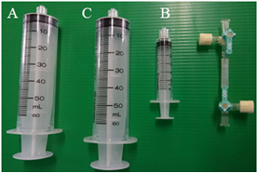 | 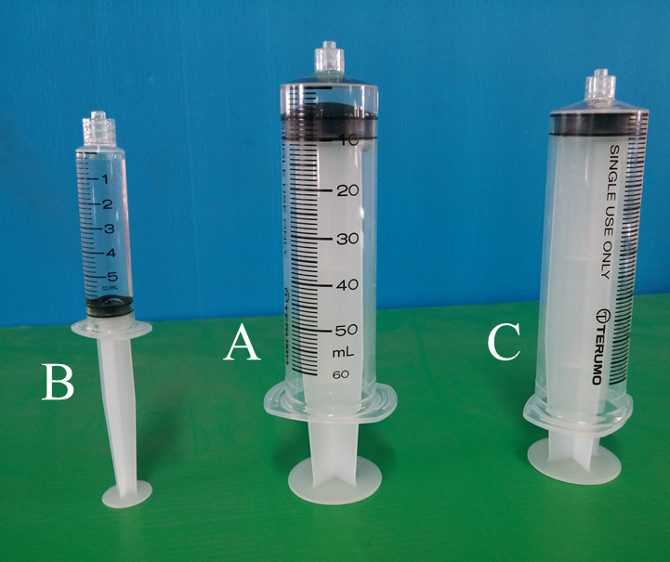 | 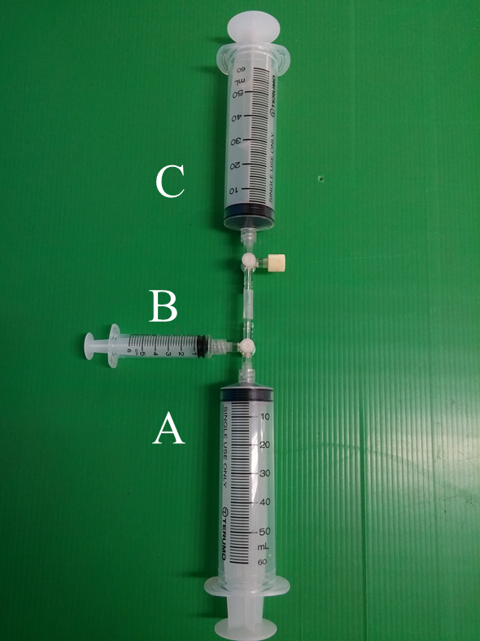
a) Set of syringe kit equipment | b) Syringes containing chemicals. | c) Connecting syringe kit using 3-way stopcock
Figure S1. Set up of the syringe kit demonstration for chemical reaction rate investigation

Experimental Results from the Investigation of CO₂ Volume with Time by Conventional Scale Water Displacement and Small-Scale Syringe Kit Methods

The Small-Scale Reaction with Syringe Kit Method
Table S3 presents the experimental results from the small-scale reactions using the syringe kit method, and Figure S2 illustrates the volume of CO₂ gas versus time. These small-scale reactions can be completed in under 3,600 seconds or 6 minutes.

Table S3. The volume of CO₂ gas generated from a small-scale reaction between NaHCO₃ (0.042 g, 0.50 mmol) and acids (10.00 mL, 0.25 – 1.00 mmol)
Time  (×10² s) | Volume of CO₂ (mL)
Time  (×10² s) | HCl |  |  | CH₃COOH | H₂SO₄
Time  (×10² s) | 0.25 mmol | 0.50 mmol | 1.00 mmol | 1.00 mmol | 1.00 mmol
0.00 | 0.00 | 0.00 | 0.00 | 0.00 | 0.00
0.20 | 3.40 | 6.33 | 7.27 | 6.87 | 8.60
0.40 | 3.81 | 8.40 | 8.93 | 8.66 | 9.68
0.60 | 3.96 | 8.93 | 9.65 | 9.15 | 10.13
0.80 | 4.18 | 9.07 | 9.78 | 9.30 | 10.33
1.00 | 4.28 | 9.07 | 9.88 | 9.38 | 10.40
1.20 | 4.35 | 9.07 | 9.91 | 9.46 | 10.53
1.40 | 4.40 | 9.07 | 9.93 | 9.54 | 10.53
1.60 | 4.45 | 9.07 | 9.93 | 9.60 | 10.53
1.80 | 4.50 | 9.07 | 9.93 | 9.60 | 10.53
2.00 | 4.55 | 9.07 | 9.93 | 9.60 | 10.53
2.20 | 4.60 | 9.07 | 9.93 | 9.60 | 10.53
2.40 | 4.67 | 9.07 | 9.93 | 9.60 | 10.53
2.60 | 4.72 | 9.07 | 9.93 | 9.60 | 10.53
2.80 | 4.74 | 9.07 | 9.93 | 9.60 | 10.53
3.00 | 4.75 | 9.07 | 9.93 | 9.60 | 10.53
3.20 | 4.77 | 9.07 | 9.93 | 9.60 | 10.53
3.40 | 4.77 | 9.07 | 9.93 | 9.60 | 10.53
3.60 | 4.77 | 9.07 | 9.93 | 9.60 | 10.53
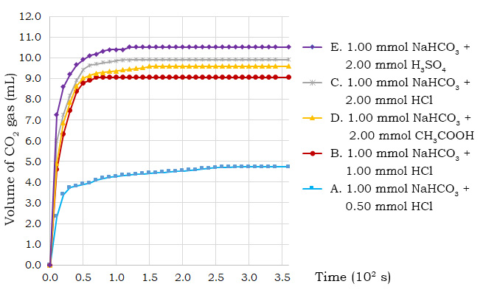
Figure S2. The volume of CO₂ gas versus time from small-scale reactions measured by the syringe kit method

The Conventional Scale Reaction with Water Displacement Method
Table S4 presents the experimental results from the conventional-scale reactions using the water displacement method, and Figure S3 illustrates the volume of CO₂ gas versus time. These conventional-scale reactions are completed within 1,000 to 1,500 seconds (about 16 to 25 minutes).

Table S4. The volume of CO₂ gas generated from conventional scale reaction between NaHCO₃ (0.084 g, 1.00 mmol) and acids (20 mL, 0.50 – 2.00 mmol)
Time  (×10² s) | Volume of CO₂ (mL)
Time  (×10² s) | HCl |  |  | CH₃COOH | H₂SO₄
Time  (×10² s) | 0.50 mmol | 1.00 mmol | 2.00 mmol | 2.00 mmol | 1.00 mmol
0.00 | 0.00 | 0.00 | 0.00 | 0.00 | 0.00
0.30 | 2.60 | 4.50 | 7.00 | 5.20 | 10.20
0.60 | 4.17 | 7.83 | 10.43 | 8.63 | 14.53
0.90 | 5.43 | 9.77 | 12.87 | 11.00 | 16.23
1.20 | 6.60 | 11.20 | 14.73 | 12.93 | 18.00
1.50 | 7.57 | 12.53 | 16.13 | 14.50 | 19.07
1.80 | 8.23 | 13.73 | 17.23 | 15.70 | 19.97
2.10 | 8.70 | 14.67 | 18.07 | 16.77 | 20.57
2.40 | 9.10 | 15.47 | 19.36 | 17.53 | 20.97
2.70 | 9.47 | 16.07 | 19.82 | 18.20 | 21.30
3.00 | 9.70 | 16.57 | 20.26 | 18.70 | 21.47
3.30 | 9.83 | 17.17 | 20.40 | 19.13 | 21.63
3.60 | 10.00 | 17.53 | 20.54 | 19.47 | 21.80
3.90 | 10.03 | 18.10 | 20.62 | 19.77 | 21.87
4.20 | 10.10 | 18.40 | 20.82 | 20.10 | 21.93
4.50 | 10.20 | 18.63 | 21.02 | 20.27 | 22.07
4.80 | 10.23 | 18.97 | 21.36 | 20.63 | 22.13
5.10 | 10.27 | 19.20 | 21.45 | 20.80 | 22.13
5.40 | 10.30 | 19.43 | 21.54 | 20.90 | 22.30
6.00 | 10.33 | 19.60 | 21.64 | 21.10 | 22.50
6.60 | 10.43 | 19.97 | 21.71 | 21.17 | 22.70
7.20 | 10.47 | 20.13 | 21.76 | 21.23 | 22.77
7.80 | 10.57 | 20.20 | 21.86 | 21.30 | 22.93
8.40 | 10.57 | 20.23 | 21.95 | 21.33 | 23.00
9.00 | 10.67 | 20.30 | 22.05 | 21.50 | 23.17
9.60 | 10.67 | 20.33 | 22.10 | 21.50 | 23.20
10.20 | 10.83 | 20.37 | 22.28 | 21.53 | 23.23
10.80 | 10.90 | 20.37 | 22.35 | 21.63 | 23.27
11.40 | 11.00 | 20.47 | 22.40 | 21.83 | 23.33
12.00 | 11.10 | 20.50 | 22.40 | 21.83 | 23.40
12.60 | 11.10 | 20.50 | 22.40 | 21.83 | 23.40
13.20 | 11.10 | 20.53 | 22.40 | 21.83 | 23.40
13.80 | 11.10 | 20.53 | 22.40 | 21.83 | 23.40
14.40 | 11.10 | 20.53 | 22.40 | 21.83 | 23.40
15.00 | 11.10 | 20.53 | 22.40 | 21.83 | 23.40

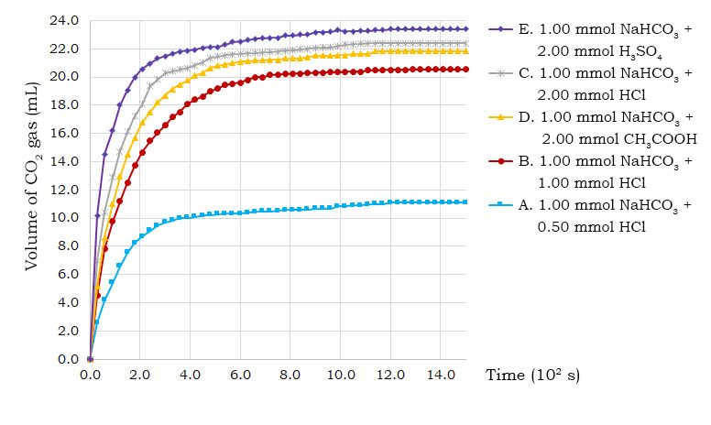
Figure S3. The volume of CO₂ gas versus time from normal reactions measured by the WD water displacement method

SELECTED REFERENCES
(1) Ng, E. M. W., Song, Z., Yau, C. D., Liew, O. W., & Ng, T. W. (2020). Safe handling of gas generating experiments using disposable plastic syringes. Journal of Chemical Education, 98(1), 237-242.
(2) Chang, R., & Overby, J. (2019). Chemistry (ISE) (13th ed.). Mcgraw-hill Education.

