Supplementary Information
Figure S1. Sample element cards.
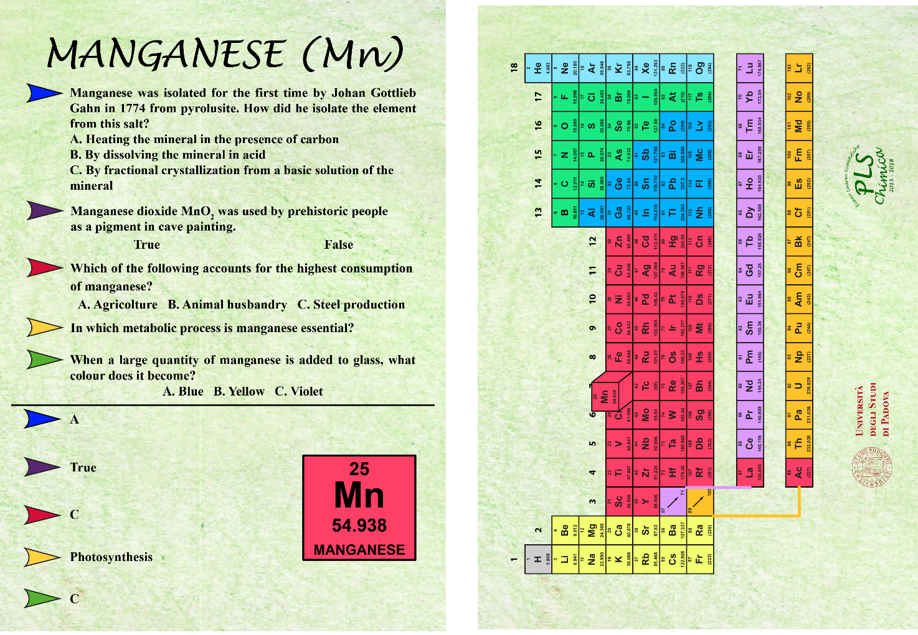
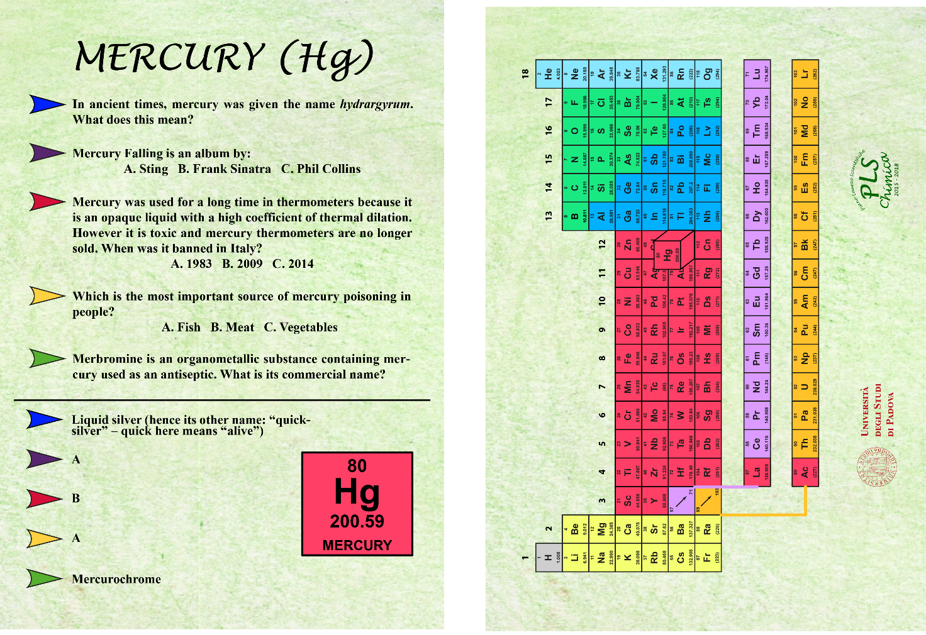
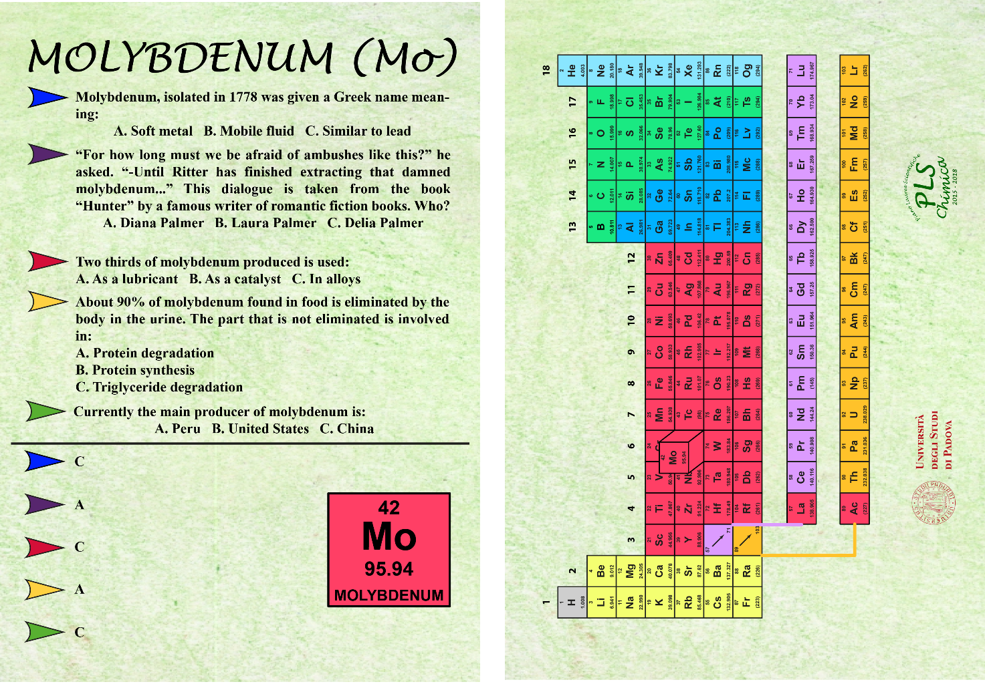
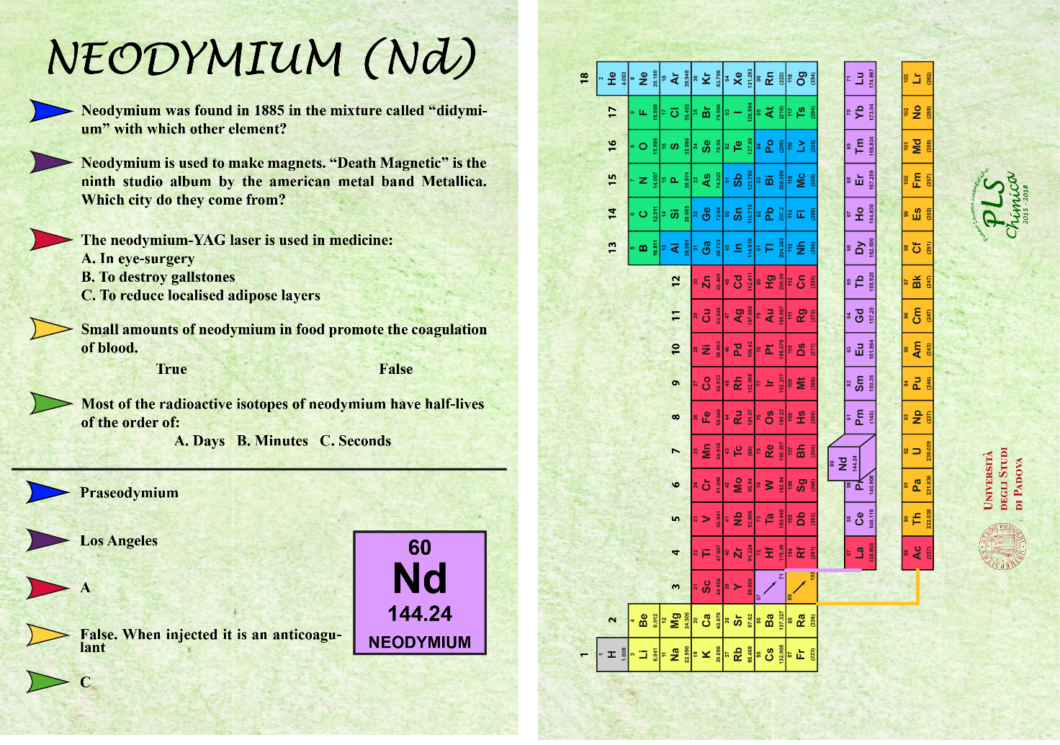

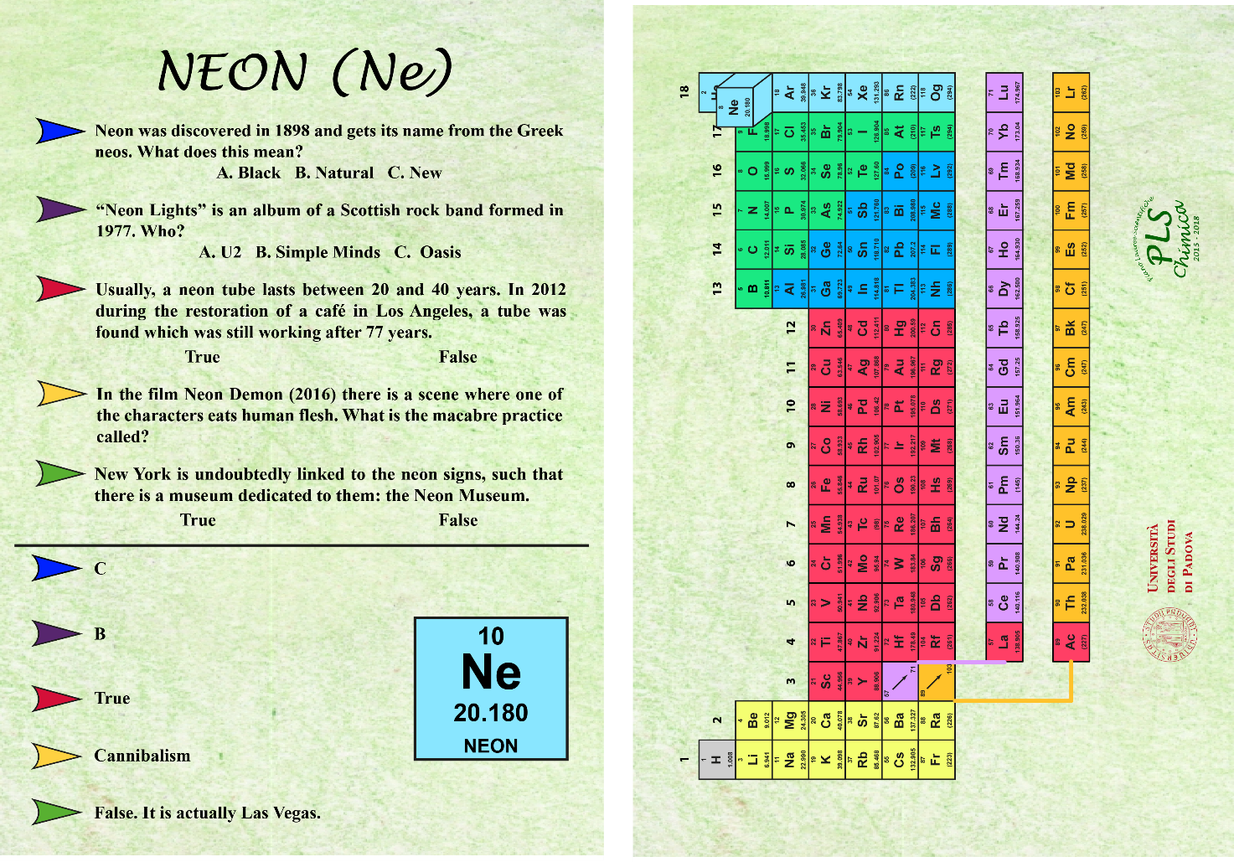

Guide to the software
The game is provided as a zip package and can be downloaded free of charge at https://pls.scienze.unipd.it/chimica/chemical-quest/. There is no installation needed and after decompressing the package the contents of the main folder that are useful for the end-user are:
README.txt: a readme file containing this guide to the usage of the software
Element_cards.pdf: a PDF file containing the 102 element cards in alphabetical order that can be printed (A5 format) or used to play the virtual version of the game.
Game_rules.pdf: a PDF file explaining briefly the rules of the game.
cq.sh: the main file to execute under Linux or macOS
cq.bat: the main file to execute under Windows.
The only requirement is that a java virtual machine is present on the system. To run the game in Linux or macOS systems the file cq.sh must be launched, whereas for Windows computers the file cq.bat starts the game. At the initial screen, with the game logo, the yellow button starts the game. In the board screen, the glassware pieces are moved with the mouse. A right click on one of the pieces allows to select a color that will add the corresponding bead to keep track of the correct answers.

