Supplementary Material
Table S1. Coding of Interaction Levels
Interaction Level | Code Description
Low | - One student initiates all ideas.  - Others accept without discussing /expanding.  - Yes/No type questions. No why/how questions.  - No addition to the discussion  - No clarifying other students’ statements.  - Generic agreement.  - One student wrote. Others contribute none or little.
Medium | - One student is proposing ideas mostly. Others shallow contribution.  - Other students are not expanding/opposing.  - Restate/repeat.  - Active engagement rather than passive.  - Add some critical information.  - Statements are discontinuous.  - Few why/how questions.
High | - Why /How questions.  - Equal amount of responses/statements  - Each statement is built upon each other.  - Expanding/elaborating/restating/rebuttal  - Conclusions are jointly made.

- Define the anti conformation.

- Draw a template to illustrate anti conformation of an alkane.

- Compare the most stable anti and least stable eclipsed conformations of heptane for the rotation around the C3-C4 axis.

- Draw the most stable anti-conformation of heptane for the rotation around the C3-C4 axis.

- Explain the stability of the least stable eclipsed conformations of butane defined for the rotation around the C2-C3 axis in comparison to that of octane defined for the rotation around the C4-C5 axis.

- Develop an analogy explaining why a molecule's stability will change as substituent size increases.
Figure S1. All prompts for group quiz 2

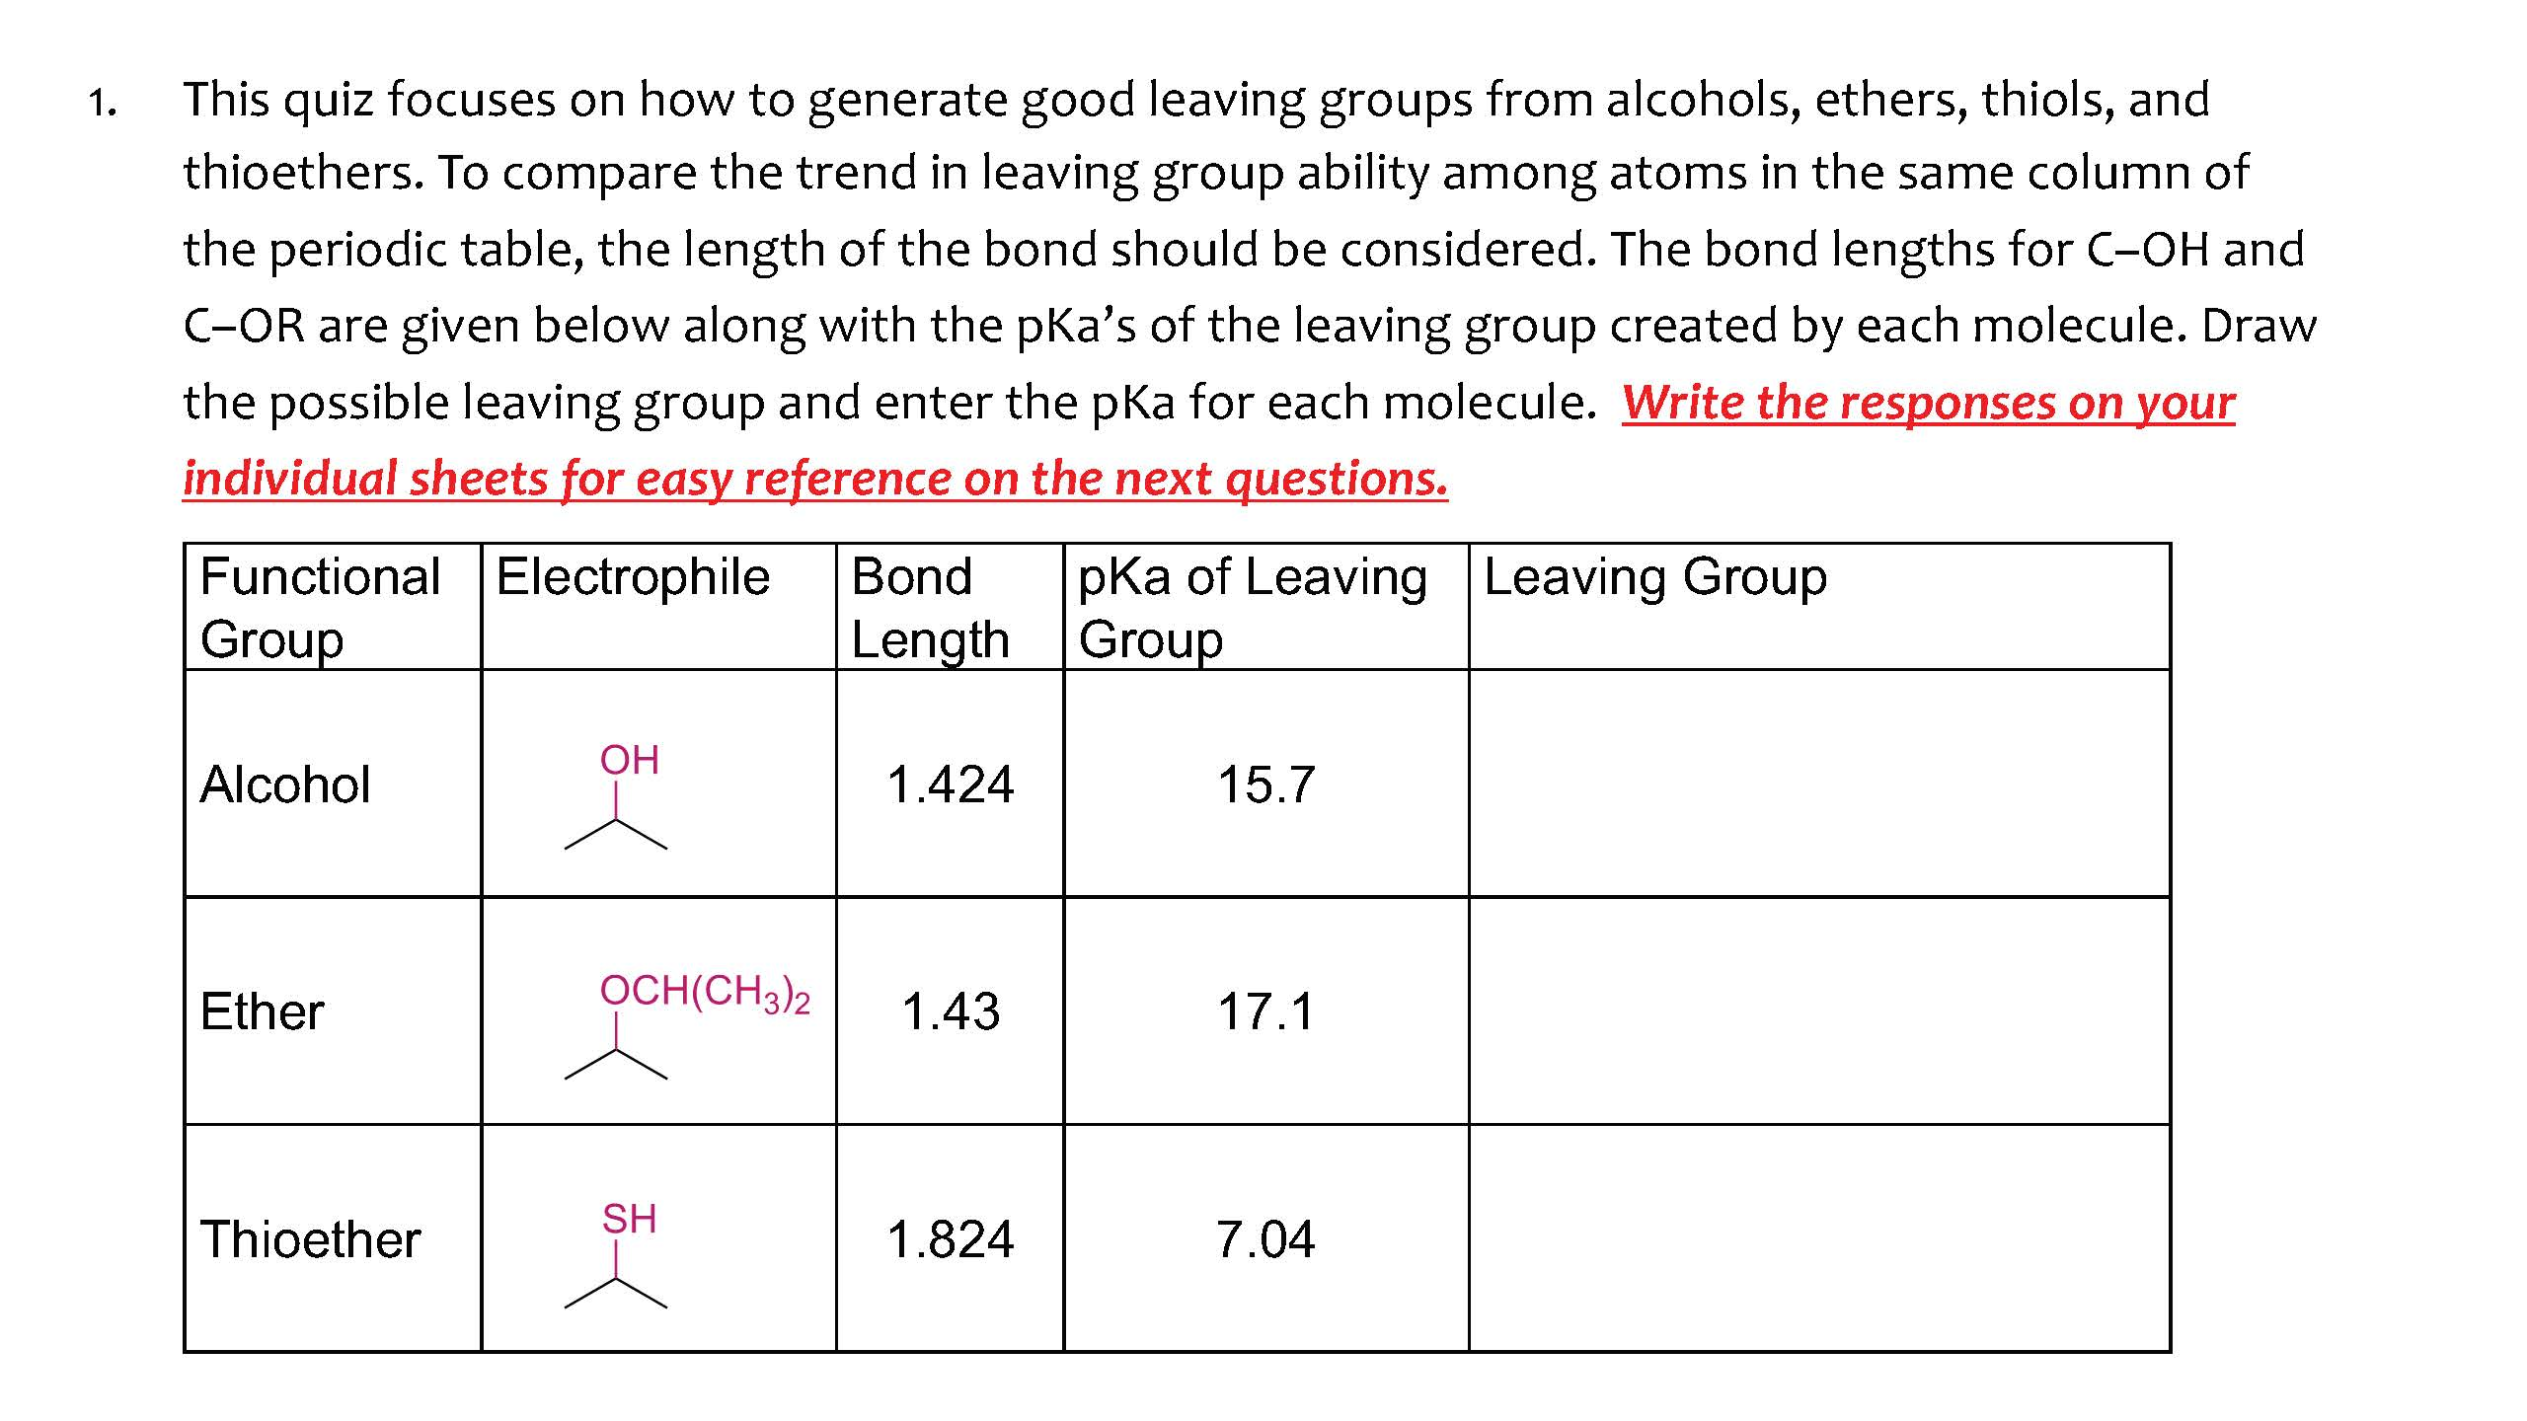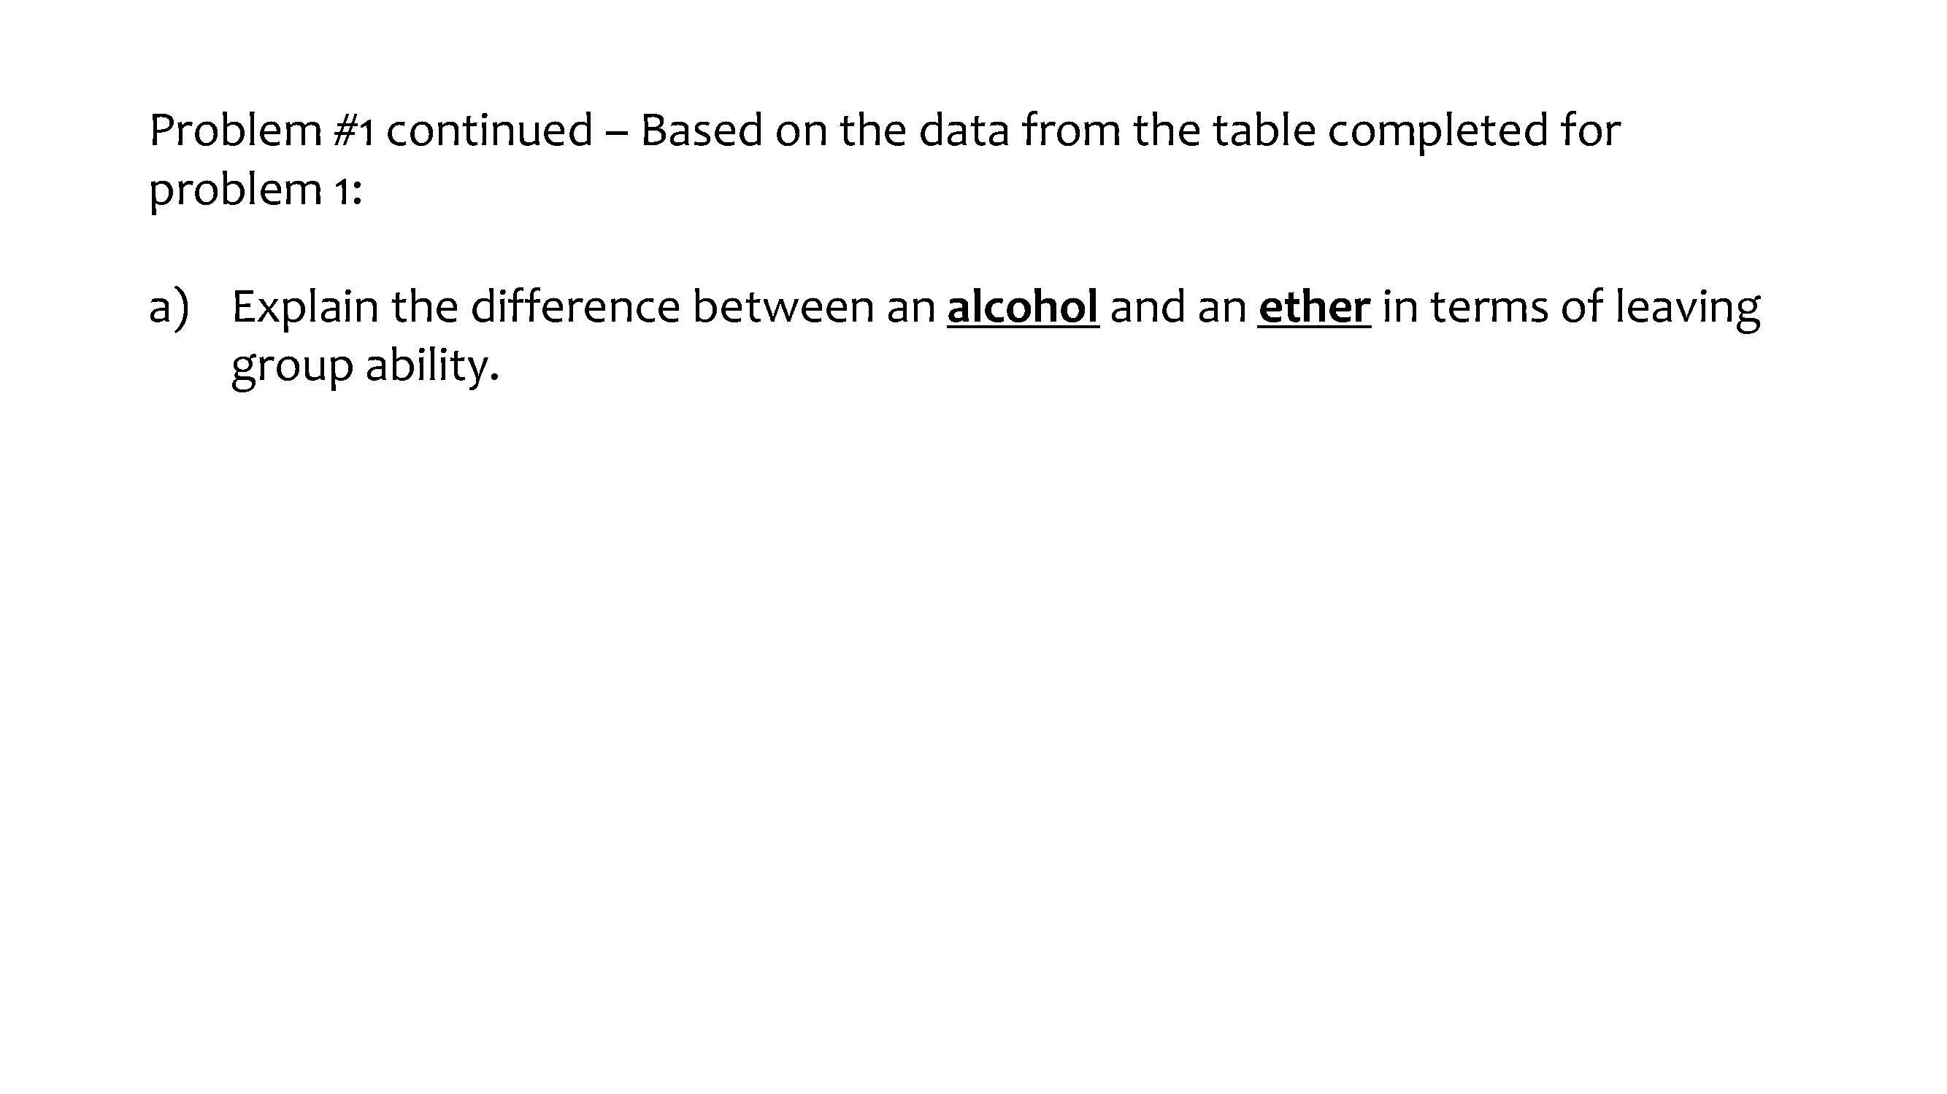
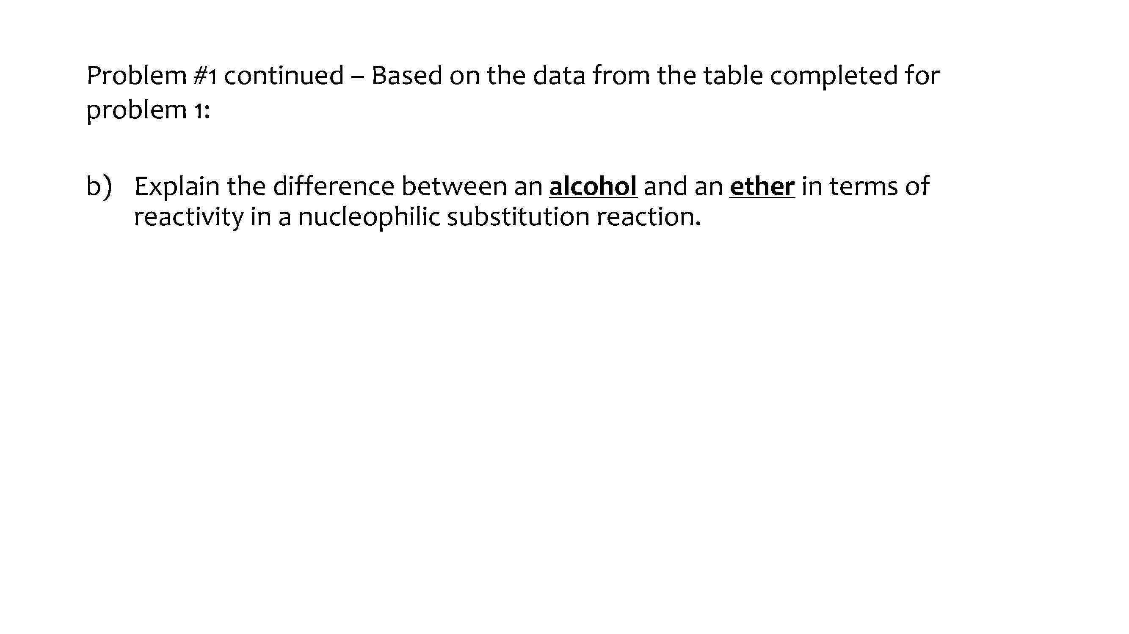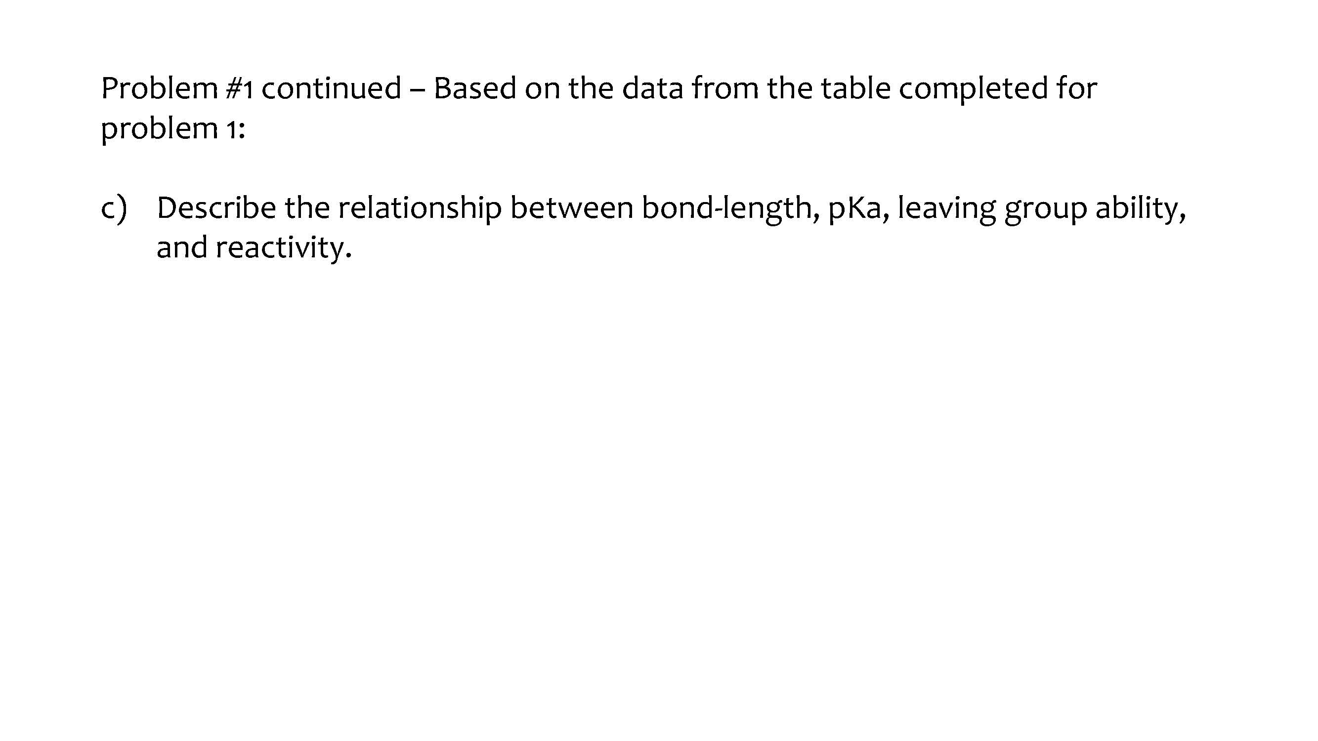
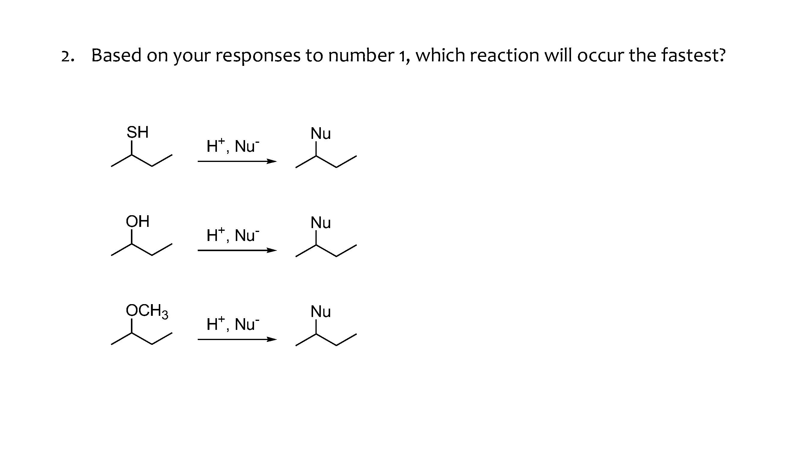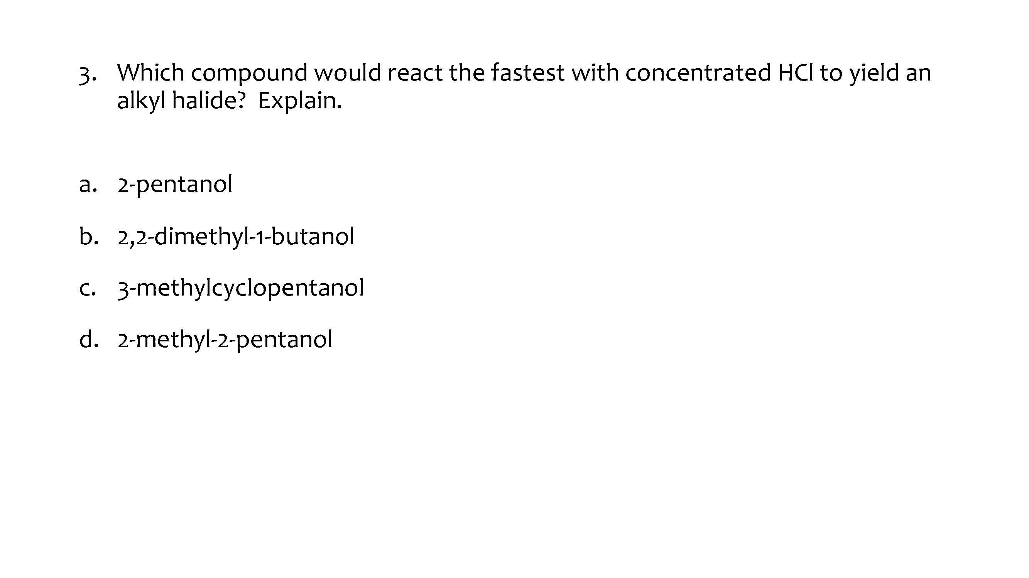
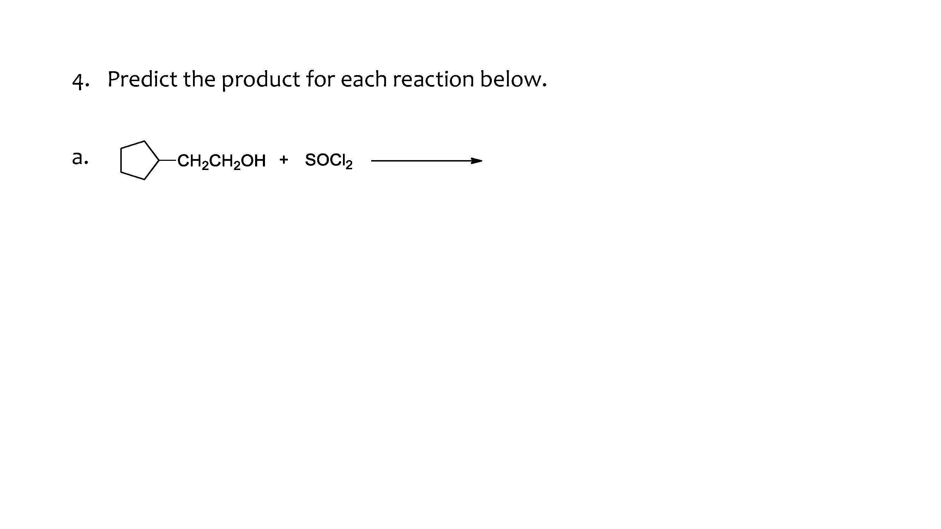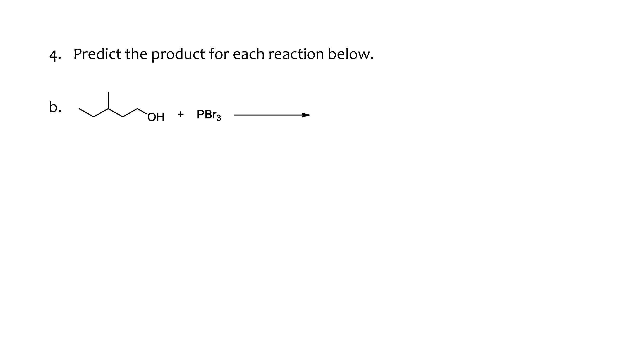
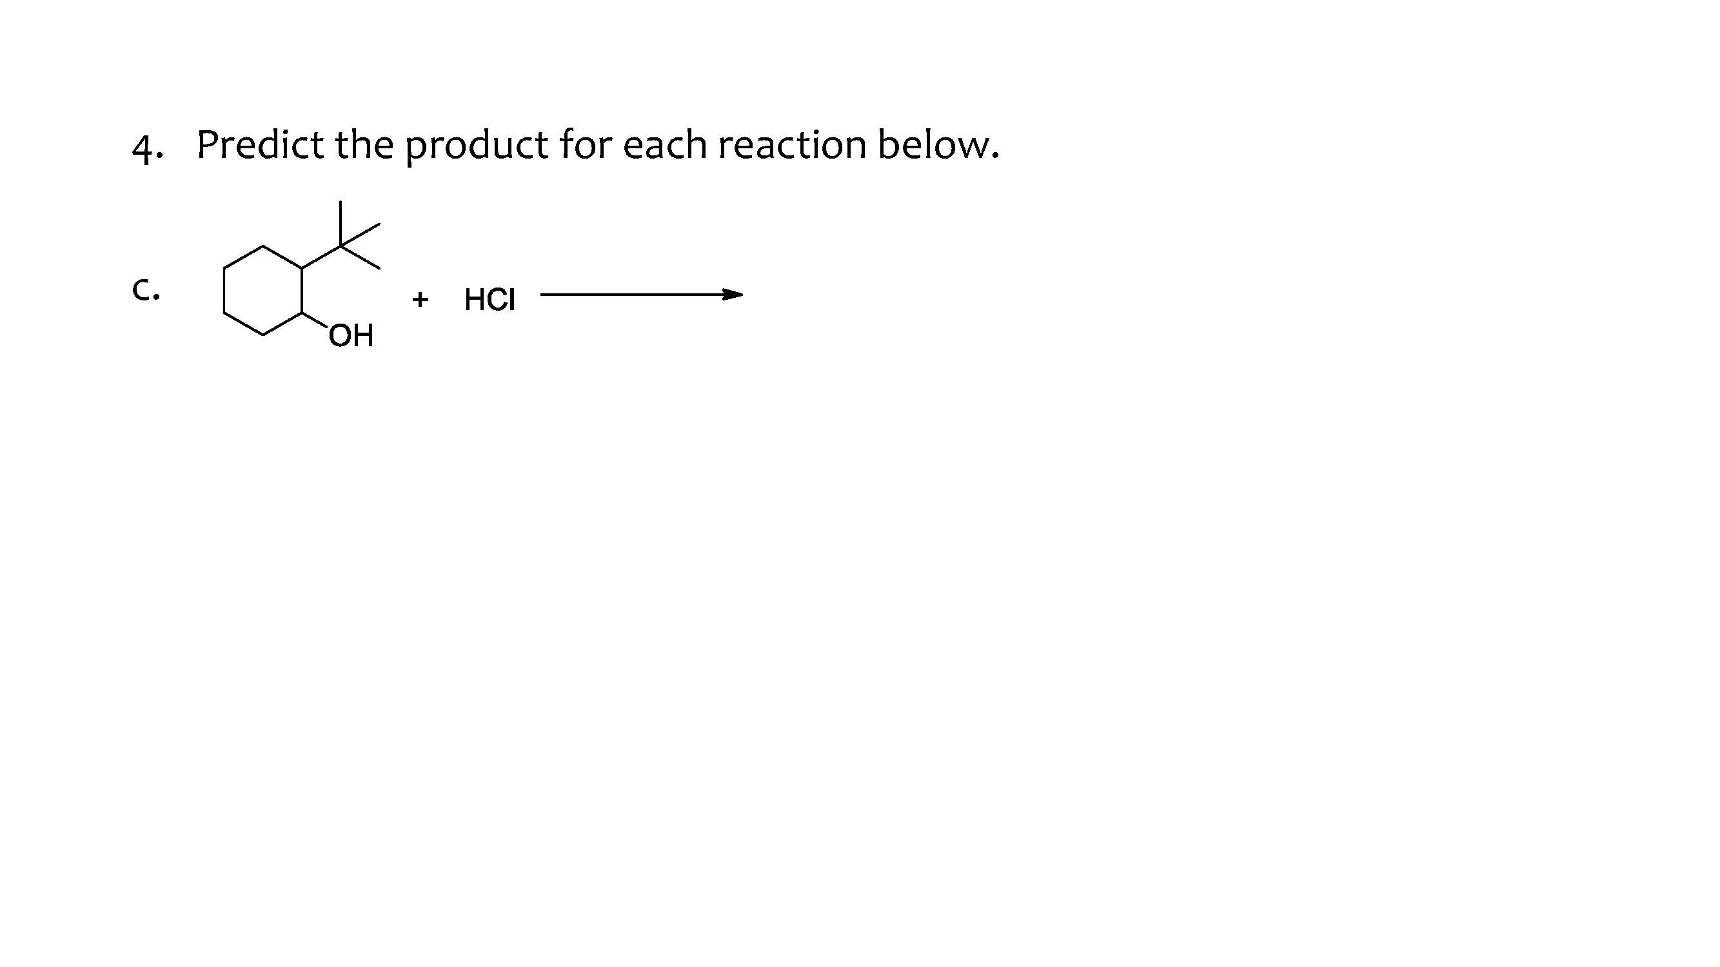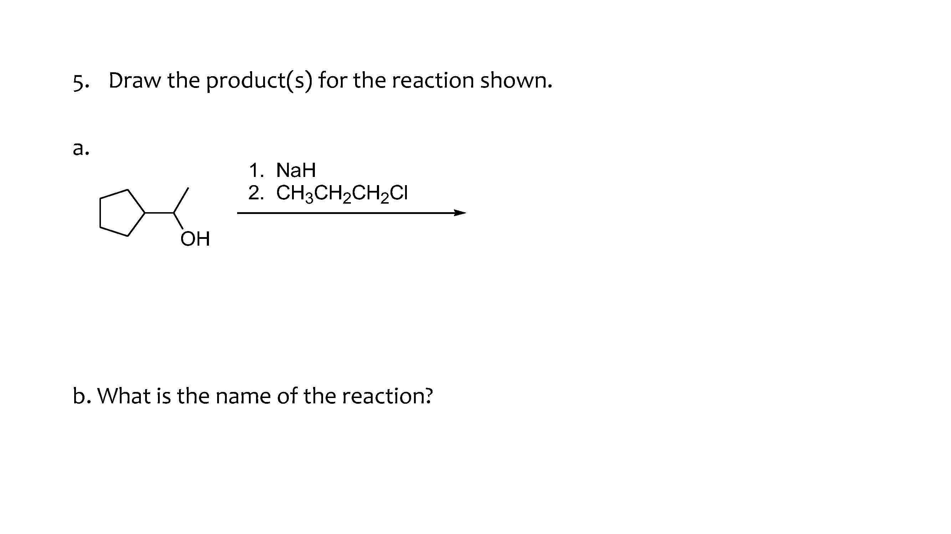
Figure S2. All prompts for group quiz 3

