SUPPLEMENTARY INFORMATION

Using electrostatic potential maps as visual representations to promote better understanding of chemical bonding

Georgios Tsaparlis,* Giannoula Pantazi, Eleni T. Pappa, and Bill Byers

*Corresponding author: Georgios Tsaparlis, Department of Chemistry, University of Ioannina, GR-451 10 Ioannina, Greece, E-mail: gtseper@uoi.gr. https://orcid.org/0000-0002-0856-747X
Giannoula Pantazi, Science Laboratory Center (EKPhE) of Preveza, GR-48100 Preveza, Greece, E-mail: liannapantazi@gmail.com
Eleni T. Pappa, 1st ‘Agios Athanasios’ General Senior High School (Lykeion), GR-57003
Thessaloniki, Greece, E-mail: elenpappa@yahoo.gr
Bill Byers, Ulster University, School of Health Sciences, Jordanstown, BT37 0QB, UK, E-mail:
w.byers@ulster.ac.uk

CONTENTS

SECTION S1: Definition of electron probability density

SECTION S2: Method of construction of isodensity surfaces and of electrostatic potential maps for chemical structures resulting from accurate quantum mechanical calculations

SECTION S3: Section D of the examination paper for the science education course (and marking scheme)

SECTION S4: further information about the SOLO taxonomy and the employed marking scheme

SUPPLEMENTARY INFORMATION S1:
Definition of electron probability density

For a system (atom or molecule) with a single electron (electron-1), which is in a state described by the wavefunction ψ₁(r₁), the electron probability density (or simply the electron density) ρ(r₁) at a specific point r₁ = (x₁,y₁,z₁) in three dimensional space is proportional to the ‘square’ of its wavefunction|ψ₁(r₁)|².* From this, the probability of finding the electron at any chosen location r₁ in space, in an infinitesimal volume dV₁ = dx₁dy₁dz₁ around r₁, is given by |ψ₁(r₁)|²dV₁,** which is required to integrate to unity over all configuration space (normalization condition):

∫ | ψ₁(r₁)|² dr₁ = q_{e} = 1 (1)

This is because the total charge arising from the charge distribution of a single electron over all space must be unity (that is, the charge of one electron).
A many-electron system, such as a many-electrom atom or a molecule, is described by a many-electron wave function Ψ(r₁, r₂, r₃,…,r_{N}), which when squared gives the probability of finding electron-1 at r₁, electron-2 at r₂, …, electron-N at r_{N} simultaneously. The probability of finding, say, electron-1 at r₁, irrespective of the positions of the N – 1 remaining electrons, is found by integrating Ψ over the coordinates of all electrons except electron-1:

∫...∫ |Ψ(r₁, r₂, … r_{N})|² dr₂ dr₃...dr_{N}

that is, we integrate out the functions of electrons 2, 3 ,,, N This is the probability of finding a single electron, no matter which, at the specific spatial position r₁ = (x₁,y_{1,}z₁). Since electrons are indistinguishable, what is true for electron-1 is true for any electron in the system, and if we multiply the latter integral by the number of electrons N in the system, we obtain a one-electron density function, commonly known as the electron probability density (EPD) or simply electron density:***

ρ(r₁) = N ∫...∫ |Ψ(r₁, r₂, … r_{N})|² dr₂ dr₃...dr_{N} (2)

The electron density is interpreted as a cloud of negative charge that varies in density throughout the system (atom or molecule).****
It follows that

∫ρ(r₁) dr₁ = N ∫...∫ |Ψ(r₁, r₂, … r_{N})|² dr₁dr₂ dr₃...dr_{N} = N

provided that Ψ is normalized. This means that the integral of the density over all space yields the total number of electrons in the system.
To make clearer the logic of the above definition [eq. (2)] for the EPD ρ(r₁), let us take each single electron wave function as normalized to unity (that is, ∫|ψ₂(r₂) |²dr₂ = 1, and so on), and let us assume that we approximate the many-electron wave function Ψ as a (Hartree) product of single-electron wave functions (orbitals)

Ψ(r₁, r₂, … r_{N}) ≈ ψ₁(r₁)ψ₂(r₂)… ψ_{N}(r₁)

This is the independent particle approximation, that is, we assume that each electron behaves as if the N─1 other electrons were not present. In such a case, the EPD would be equal to

ρ(r₁) = N|ψ₁(r₁)|² ∫|ψ₂(r₂) |²dr₂∫|ψ₃(r₃) |²dr₃…∫|ψ_{N}(r_{N}) |²dr_{N} = N|ψ₁(r₁)|²

that is, N times the electron density arising from electron-1 (actually from any of the N electrons of the system, because of the indistinguishability of the electrons). This is consistent with the independent-particle approximation and is in agreement with the result for a single-electron system (N = 1, see above).
For a full discussion of molecular electron densities see Matta and Gillespie (2001, 2002). For crystalline compounds, X-ray diffraction crystallography is one experimental technique which is used to measure electron density in three-dimensional space.

REFERENCES

Matta, C. F. and Gillespie, R. J., (2001). Teaching the VSEPR model and electron densities. Chem. Educ. Res. Pract., 2(2), 73-90.
Matta, C. F.; Gillespie, R. J. (2002). Understanding and interpreting molecular electron density distributions, J. Chem. Educ., 79(9), 1141-1152.
Pilar, F. L. (1967). Elementary quantum chemistry. McGraw-Hill: New York.

SUPPLEMENTARY INFORMATION S2: Method of construction of isodensity surfaces and of electrostatic potential maps for chemical structures resulting from accurate quantum mechanical calculations

A three-step procedure is followed for the construction of an electrostatic potential map and this is described below for the case of the water molecule (see figure S2.1).

Step 1: A “ball-and-stick” or a “tube” model is used for the molecule, to show the nuclei and their arrangement. Then we define a set of points [r_{i} ≡ (x_{i}, y_{i}, z_{i})] where the electrostatic potential will be calculated. A common approach is to find points at which the electron density equals 0.002 au. This is a very low level of electron density and such points are typically found near the outermost boundary of the molecular electron cloud. Therefore, these points approximately define the size and shape of the molecule, which corresponds roughly to the molecular volumes measured for small gas-phase molecules. All points where electron density = 0.002 au form a three-dimensional surface around the molecule, which is called the 0.002 isodensity surface.
Step 2. On this isodensity surface, we superimpose the electrostatic potential, that is, we calculate the electrostatic potential at all chosen points r_{i}. The electrostatic potential (EP) at point r_{i} is given by the electrostatic potential energy between an imaginary positively charged
(+1) ion located at r_{i} and the molecule. If the ion is attracted to the molecule then the potential is taken as negative. If the ion is repelled by the molecule then the potential is taken as positive. Since the ion has a +1 charge it will be attracted to electron-rich regions of the molecule and repelled by electron-poor regions. Thus, electron rich regions usually have negative potentials and electron-poor regions usually have positive potentials. The electrostatic potential is usually expressed in units of kcal/mol.
Step 3. Finally, the surface is mapped by color, where different colors are used to identify
different potentials. The most positive potential is colored blue, while the most negative potential is colored red. Intermediate potentials are assigned colors according to the standard color spectrum:

red (most negative) < yellow < green < light blue < dark blue (most positive)
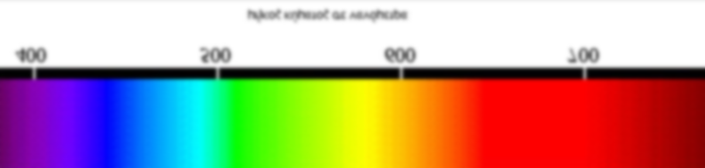
(+) (−)

This is the default color scale. Note that different maps have different extremes, so it is important and useful to compare structures with the same EP ranges. If we don’t know the numerical value of the extreme potentials, we might be wrongly thinking that we are looking at large extremes (and large differences between extremes) when we are not. For this reason, it is essential to state the EP ranges used, supplying the values of the extreme potentials for every map.
Red regions of a map are the most electron-rich regions of a molecule (regions of negative charge), and blue regions of a map are the most electron-poor regions of a molecule (regions of positive charge). Intermediate colors (yellow but especially green) show regions with a uniform distribution of electron charge, which are termed as regions of neutral charge. Figure S2.2 provides an electrostatic potential map of a water molecule, also showing how potential varies with color. Oxygen is relatively electron-rich in this molecule, and the hydrogens are relatively electron-poor. The potentials on this map range from −46 to +48 kcal/mol. The red region near oxygen shows the location of the most negative potential,−46 kcal/mol (this region attracts the +1 probe). The dark blue regions near the hydrogens show the locations of the most positive potential, +48 kcal/mol (these regions repel the +1 probe).

 | 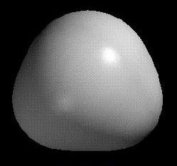 | 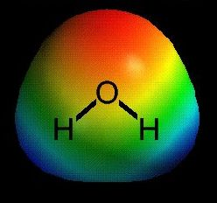
Figure S2.1: The three step process for constructing an electrostatic potential map for the water molecule.
(Left) Step1. Tube model and collection of points at which the electron density equals 0.002 a.u. | (Middle) Step 2. The 0.002 a.u. isodensity surface. | (Right) Step 3. Electrostatic potential map, superimposed on the 0.002 isodensity surface, mapped by color.

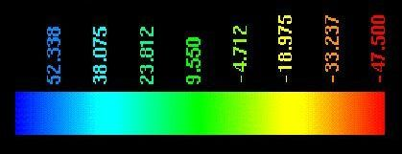
Figure S2.2. Electrostatic potential map (upper left) and space-filled model (upper right) for water molecule, with color spectrum and values (kcal/mol) of electrostatic potential.

For more information about various color coding scales, the reader can consult the following sources.
REFERENCES
Anslyn, E. V.; Dougherty, D. A. (2006). Modern physical organic chemistry. University Science Books: Sausalito, California.
Reed College: Organic Chemistry (ROCO) Online, Chapter 4 – Electrostatic Potentials:
http://www.reed.edu/chemistry/ROCO/Potential/electrostatic_maps.html (accessed 17-May-2021)

SUPPLEMENTARY INFORMATION S3: Section D of the examination paper* for the science education course (and marking scheme**)

Question D1 (20 marks). Draw as many visual representations as you know about the hydrogen molecule (H₂) and the water molecule (H₂O). Note that both the H₂ and H₂O molecular formulas are visual representations. (6 marks for H₂ + 14 marks for H₂O).
Question D2 (60 marks). The following (electrostatic potential) maps are given:
Maps (a)  Theoretical (quantum mechanical)  calculation of the geometry of the H atom (left) and the H₂ molecule (right) |  | 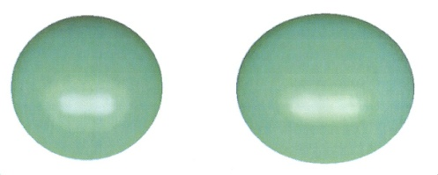
Maps (b)  Theoretical (quantum mechanical) calculation of the geometry of the lithium atom (Li) (left)  and the lithium ion (Li⁺) (right) | 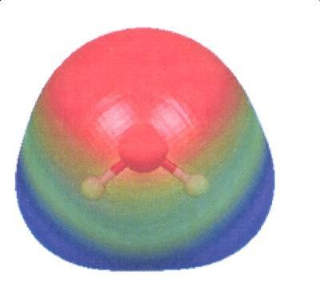  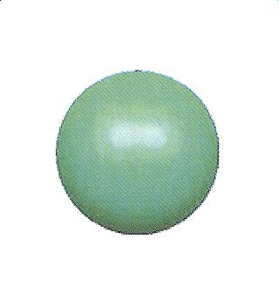 |  |  | 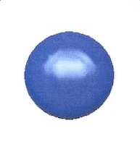

Maps (c)

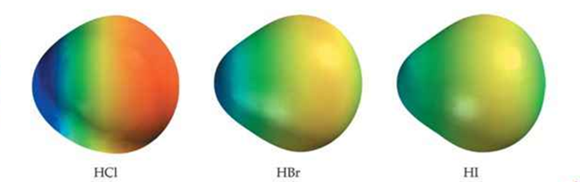
The structure of the hydrogen molecule (H₂) (left) and the structure of the water molecule (H₂O) (right), as they are calculated quantum-mechanically
 | 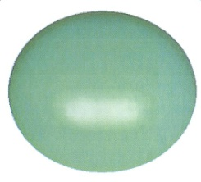
Maps (d)
The structure of the
hydrogen halide
molecules,
HCl, HBr and HI
Map (e)  Geometry of the system which consists of one lithium atom and one hydrogen atom (lithium hydride, Li-H) as it is calculated quantum-mechanically. |  |  | 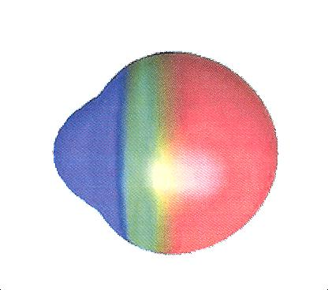
A color code scale for the polarity of electrostatic potential is also provided:
(+) (−)

Part D.2a (15 marks). Compound lithium hydride is ionic (it is a crystalline solid, for which the melt is a conductor of electricity).
- Which are the cation and the anion in this compound? (0.5 marks)
- With the aid of: maps (a) (left), maps (b) and map (c), explain why this compound is ionic. (1.5 marks)
Part D.2b (10 marks). What do the color differences of the HCl, HBr and HI hydrogen halide molecules show? [maps (d)]
Part D.2c (10 marks). Which of the structures of maps (c), (d) and (e) show a chemical bond polarity?
Part D.2d (15 marks). State in which one of the maps (a), (b), (c), (d) and (e), the structures demonstrate the continuity between the covalent and the ionic bond, and why.
Part D.2e (10 marks). Mention two features that the color visual representations (VRs) help us understand.
Question D.3 (10 marks). If the following visual representations of chemical structures refer to: methyllithium (CH₃Li) and chloromethane (CH₃Cl), which do you think corresponds to CH₃Li and which to CH₃Cl and why?
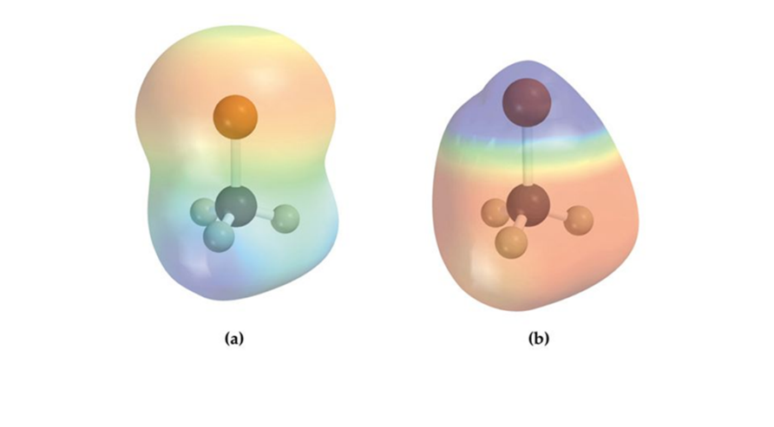
- Structure (a) corresponds to compound …………… because …………………. (1+4 = 5 marks)
- Structure (b) corresponds to compound ……………because ………………….. (1+4 = 5 marks)
Question D.4 (10 marks). Compare the visual representations for the hydrogen molecule and the water molecule that you drew in answering question (1) with the corresponding colorful visual representations in maps (c). That is: which do you consider as being the features and the advantages of each of these visual representations? (5 marks for H₂ + 5 marks for H₂O = 10 marks)

SUPPLEMENTARY INFORMATION S4: Further information about the SOLO taxonomy and the employed marking scheme

We start by providing some information about the five levels of the SOLO taxonomy.

Pre-structural level: Learning outcomes show that the respondent has lack of
relevant knowledge. Also (s)he may use irrelevant information.
Uni-structural level: Learning outcomes show that the respondent is focusing only on
one particular area, referring only to one factor or aspect of the task.
Multi-structural level: Learning outcomes show that the respondent knows a lot
about a specific conceptual area and/or that (s)he focuses on more than one factors or
aspects of the task. However, (s)he has not been able to relate or connect the various
factors/aspects to each other.
Relational level: In addition to demonstrating knowledge at the multi-structural level,
the respondent relates/connects the various factors/aspects of the task to arrive at appropriate explanations. (S)he demonstrates an in-depth understanding of the subject.
Extended abstract level: The responded is able to use his/her multi-structural and
relational knowledge as a basis for prediction, generalization, derivation of
conclusions, critical thinking, problem-solving, and even creation of new knowledge.
The SOLO marking scheme employed in the present study
The following scale of marks was applied for the SOLO assessment, with a total of 20 hypothetical marks to be distributed. Depending on the number of levels involved in a question, we distinguished between three marking schemes. Marking scheme A corresponds to the presence of all five SOLO levels, while marking schemes B and C allow for absence of (i) the extended abstract and (ii) the extended abstract plus relational levels, respectively.
Marking scheme A: pre-structural level: 0-1 marks; uni-structural level: 2-6 marks; multi-structural level, 7-11 marks; relational level: 12-15 marks, and extended abstract level: 16-20 marks.
Marking scheme B: pre-structural level: 0-1 marks; uni-structural level: 2-6 marks; multi-structural level, 7-11 marks; relational level: 12-15 marks. The outcome is multiplied by a factor of 20/15= 1.333
Marking scheme C: pre-structural level: 0-1 marks; uni-structural level: 2-6 marks; multi-structural level, 7-11 marks. The outcome is multiplied by a factor of 20/11= 1.818.
Note that the scaling of marks within a given SOLO level allows for an optimum assessment of an answer depending on the degree of coverage of the topic, including the quality and precision of style.
The actual mark to be allotted to a question follows by appropriate adjustment to the actual marks of the question.
We provide below some examples of students’ answers. First, we consider Part D.2.b What do the color differences of the HCl, HBr and HI hydrogen halides show? The complete answer should be at the multi-structural level, so marking C was used (maximum mark = 11):
Student #8 (complete answer, mark: 11/11): “The color difference show the change in bond polarity (HCl > HBr > HI). The larger the electronegativity difference, the more polarized the bond is: HCl, large difference, much polarized; HBr, moderate difference, little polarized; HI, small difference, the least polarized.
The following answers were limited to the use of only one feature:
Student #10 (vague, mark: 3.5/11): “The color difference of the HCl molecule shows that from positive becomes negative, for HBr shows that from positive becomes neutral, while HI is a neutral molecule”.
Student #17 (short, mark: 2/11): “[It shows] where the charge is displaced”.

* In general |ψ|² ≡ ψ*ψ, where ψ* is the complex conjugate of ψ, if ψ is a complex function of its coordinates. If ψ is a real function, then |ψ|² = ψ².
** From the definition of the density of a substance for a homogeneous material d ≡ m/V, it follows that m = dV , that is mass =( density) × (volume). In the case of an inhomogeneous material, we define a local density, d(x, y, z), in which case m = ∫dm = ∫d(x,y,z)dV. (Recall that integration is equivalent to a sum of infinitely small quantities, dm). Similarly, for a homogeneous charge distribution we have charge = (charge density)×(volume), q = ρV, while for an inhomogeneous charge distribution with local charge density ρ(x, y, z), such as that of an electron cloud, we have q = ∫dq = ∫ρ(x,y,z)dV, where q stands for charge.
*** Strictly speaking, space and spin co-ordinates τ_{i} ≡ (r_{i}, σ_{i}) should be used. In that case, ρ(τ₁) = N ∫...∫ dτ₂ dτ₃...dτ_{N} |Ψ(τ₁, τ₂, τ₃… τ_{N}|². Spin wave functions are immaterial as far as expectation values of spin-free operators are concerned. For this reason, we restrict the discussion here only to space coordinates.
**** Equation (2), which defines the EPD, is equivalent to the definition of the first- order (or one-particle) density matrix (Pilar, 1967, p. 358). Note that the expectation value of a one-electron operator depends only on the first-order density matrix.
* Examination of June 2019
** Total marks: 100.

