In-silico evaluation of triazole derivatives as antimicrobial agents against Pseudomonas aeruginosa

Maymoun Ghizlan^{1, 2}, Hsaine Zgou^{1, 2}, Meriem Khedraoui ³, Lafridi Hind^{1, 2},
Sabour Abderahman^{1, 2}, Hakem Adnane⁴, El Houate Brahim⁵, Samir Chtita ^{(3, *)}

¹Applied Chemistry, Geo-Mines and Modelisation, Polydisicplinary Faculty of Ouarzazate, Ibn Zohr University, B.P. 8106, 80090 Agadir, Morocco.
² Faculty of Sciences, Ibn Zohr University, Agadir, Morocco.
³Laboratory of Analytical and Molecular Chemistry, Faculty of Sciences Ben M’Sik,
Hassan II University of Casablanca, Morocco.
⁴Laboratory of Computer Systems and Vision, Faculty of Sciences,
Ibn Zohr University, Agadir, Morocco.
⁵Higher Institute of Nursing and Health Professions Errachidia, Ouarzazate, Morocco.
* Corresponding author: samirchtita@gmail.com

Material supplementary
Table S1. Optimized molecular structures of triazole derivatives A-U.
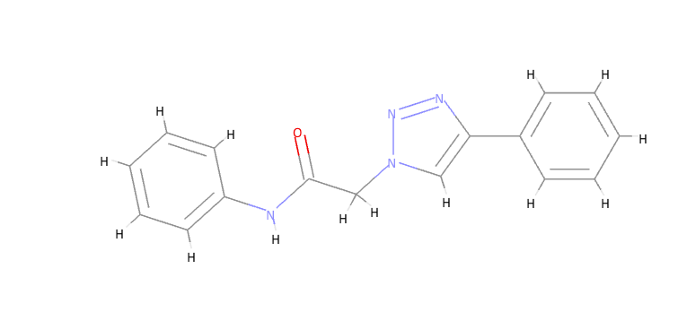 | 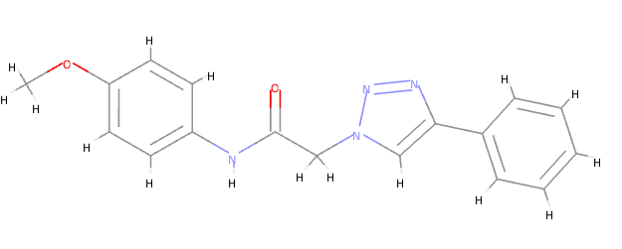
(A) N Phenyl 2 (4 phenyl 1H 1,2,3 triazol 1 y-l)acetamide (C16H14N4O) (pIC₅₀= 6.745) | (B) N (4 Methoxyphenyl) 2 (4 phenyl 1H 1,2,3 triazol 1 yl)acetamide (C17H16N4O2) (pIC₅₀= 7.090)
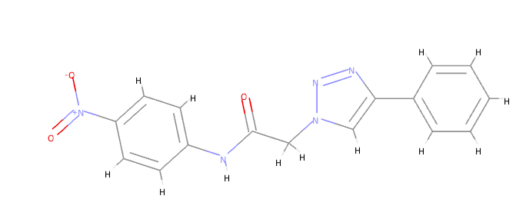 | 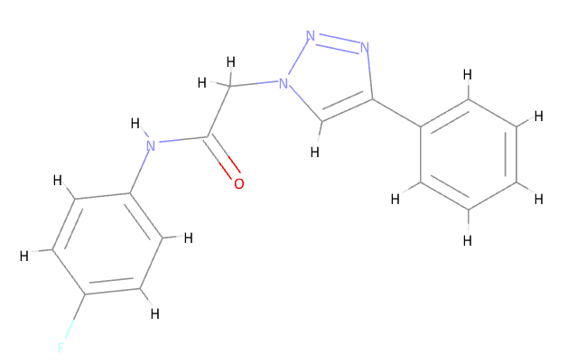
(C)N (4 Nitrophenyl) 2 (4 phenyl 1H 1,2,3 t-riazol 1 yl)acetamide (C16H13N5O3) (pIC₅₀= 7.412) | (D)N (4 Fluorophenyl) 2 (4 phenyl 1H 1,2,3 triazol 1 yl)acetamide (C16H13FN4O) (pIC₅₀= 7.675)
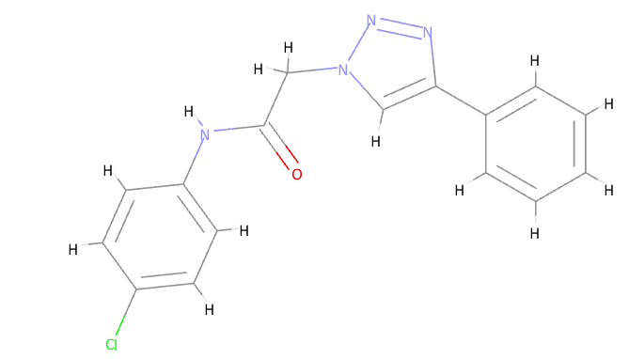 | 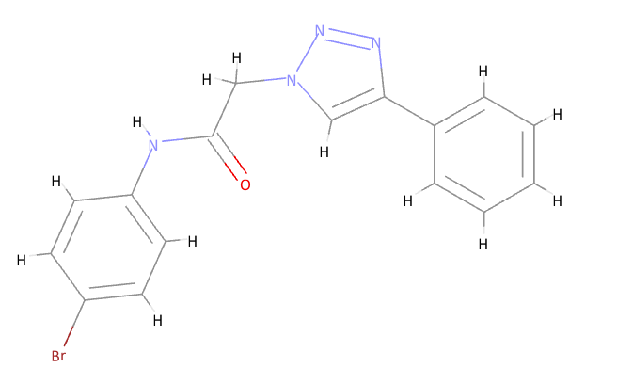
(E)N (4 Chlorophenyl) 2 (4 phenyl 1H 1,2,3 triazol 1 yl)acetamide (C16H13ClN4O) (pIC₅₀= 7.397) | (F)N (4 Bromophenyl) 2 (4 phenyl 1H 1,2,3 triazol 1 yl)acetamide (C16H13BrN4O) (pIC₅₀= 7.455)
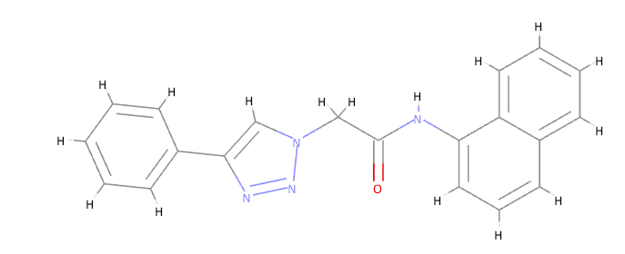 | 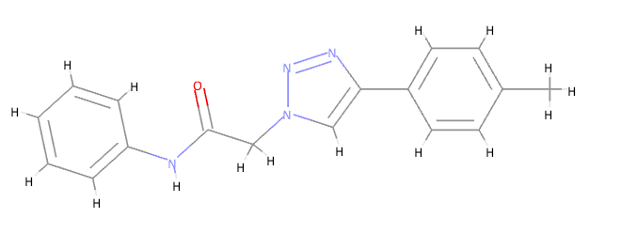
(G)N (Naphthalen 1 yl) 2 (4 phenyl 1H 1,2,3 triazol 1 yl)acetamide (C20H16N4O) (pIC₅₀= 7.419) | (H) N Phenyl 2 [4 (p tolyl) 1H 1,2,3 triazol 1 yl]acetamide (C17H16N4O) (pIC₅₀= 7.068)
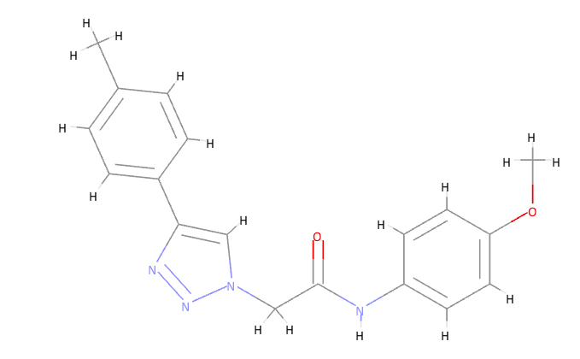 | 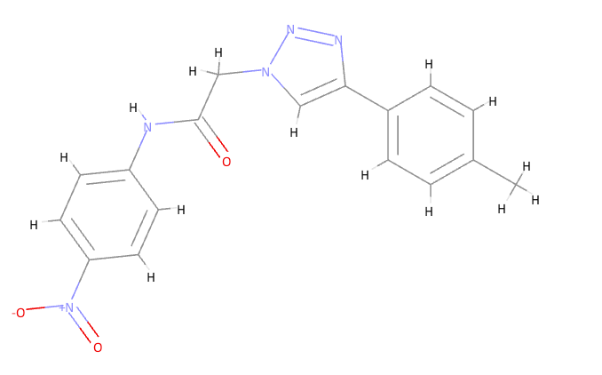
(I) N (4 Methoxyphenyl) 2 [4 (p tolyl) 1H 1,2,3 triazol 1 yl]acetamide (C18H18N4O2) (pIC₅₀= 7.110) | (J) N (4 Nitrophenyl) 2 [4 (p tolyl) 1H 1,2,3 t-riazol 1 yl]acetamide (C17H15N5O3) (pIC₅₀= 7.430)
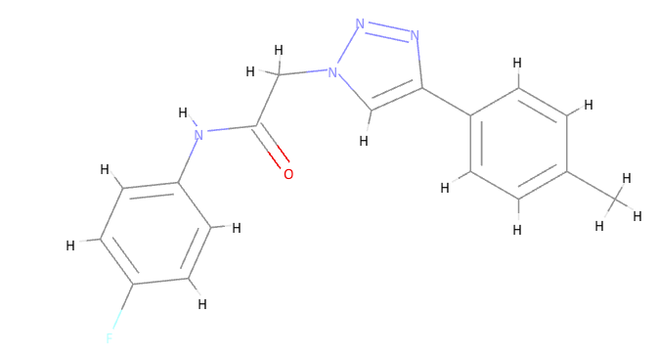 | 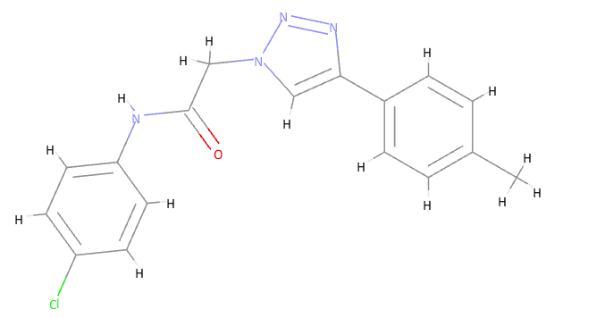
(K)N (4 Fluorophenyl) 2 [4 (p tolyl) 1H 1,2,3 triazol 1 yl]acetamide (C17H15FN4O) (pIC₅₀=7.093) | (L)N (4 Chlorophenyl) 2 [4 (p tolyl) 1H 1,2,3 triazol 1 yl]acetamide (C17H15ClN4O) (pIC₅₀= 6.514)
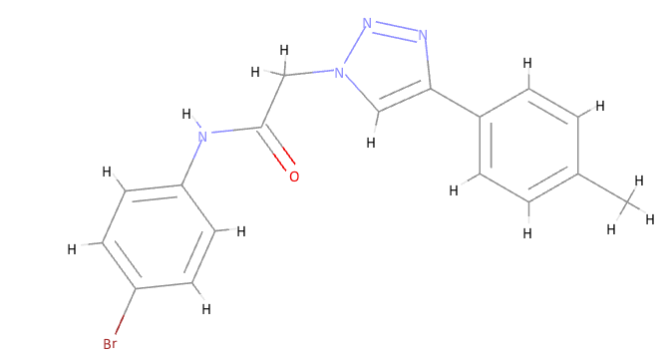 | 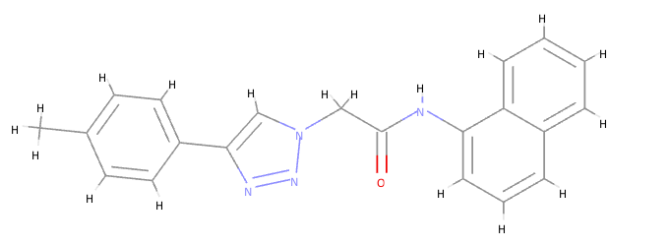
(M)N (4 Bromophenyl) 2 [4 (p tolyl) 1H 1,2,3 triazol 1 yl]acetamide (C17H15BrN4O) (pIC₅₀= 7.774) | (N)N (Naphthalen 1 yl) 2 [4 (p tolyl) 1H 1,2,3 triazol 1 yl]acetamide (C21H18N4O) (pIC₅₀= 6.835)
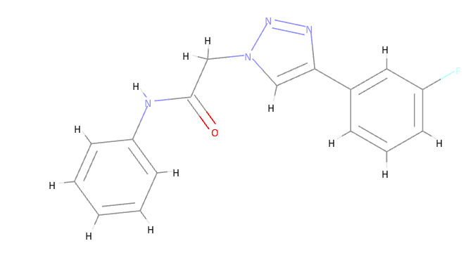 | 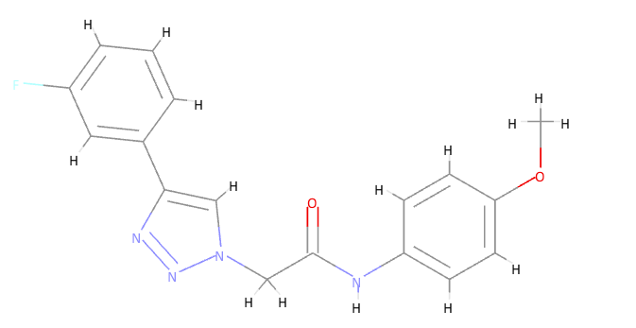
(O)2 [4 (3 Fluorophenyl) 1H 1,2,3 triazol 1 yl] N phenylacetamide (C16H13FN4O) (pIC₅₀= 7.376) | (P)2 [4 (3 Fluorophenyl) 1H 1,2,3 triazol 1 yl] N (4 methoxyphenyl)acetamide (C17H15FN4O2) (pIC₅₀= 7.416)
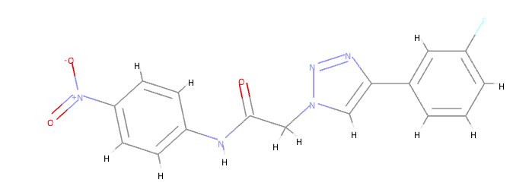 | 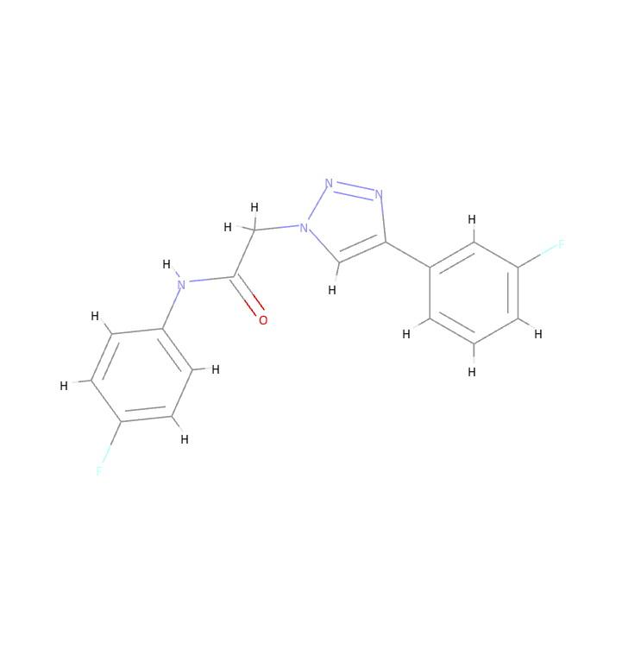
(Q) 2 [4 (3 Fluorophenyl) 1H 1,2,3 triazol 1 yl] N (4 nitrophenyl)acetamide (C16H12FN5O3) (pIC₅₀= 7.436) | (R)N (4 Fluorophenyl) 2 [4 (3 fluorophenyl) 1H 1,2,3 triazol 1 yl]acetamide (C16H12F2N4O) (pIC50= 7.701)
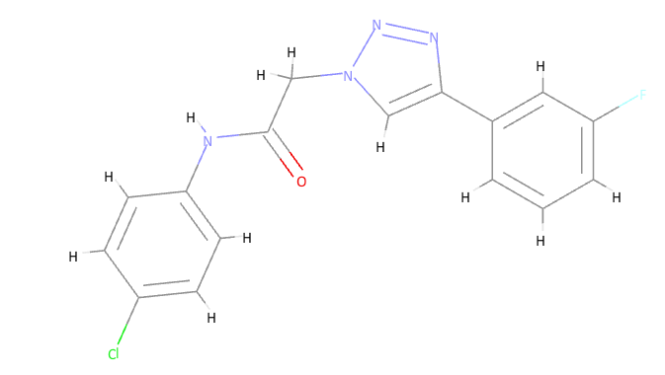 | 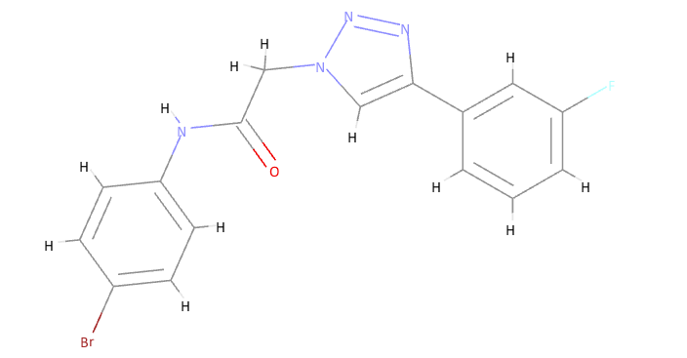
(S)N (4 Chlorophenyl) 2 [4 (3 fluorophenyl) 1H 1,2,3 triazol 1 yl]acetamide (C16H12ClFN4O) (pIC50= 7.422) | (T) N (4 Bromophenyl) 2 [4 (3 fluorophenyl) 1H 1,2,3 triazol 1 yl]acetamide (C16H12BrFN4O) (pIC₅₀=7.477)
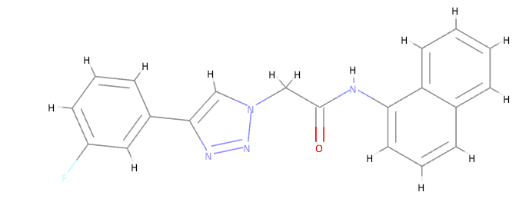
(U)2 [4 (3 Fluorophenyl) 1H 1,2,3 triazol 1 yl] N (naphthalen 1 yl)acetamide (C20H15FN4O) (pIC50= 7.442)

