**Supplementary Information**

**Study of Municipal Solid Waste treatment using Plasma Gasification by application of Aspen Plus**

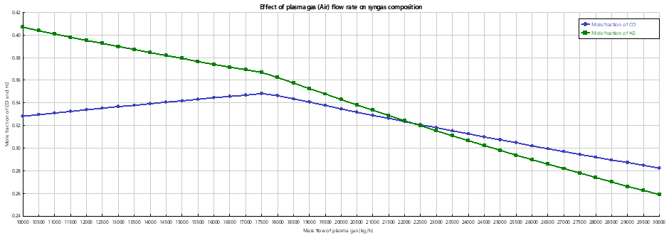

Fig.S1. Effect of plasma gas (Air) flow rate on syngas composition

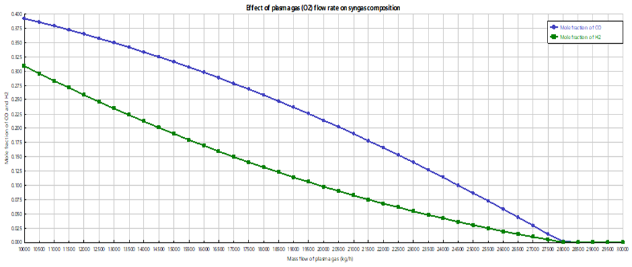

Fig.S2. Effect of plasma gas (O2) flow rate on syngas composition

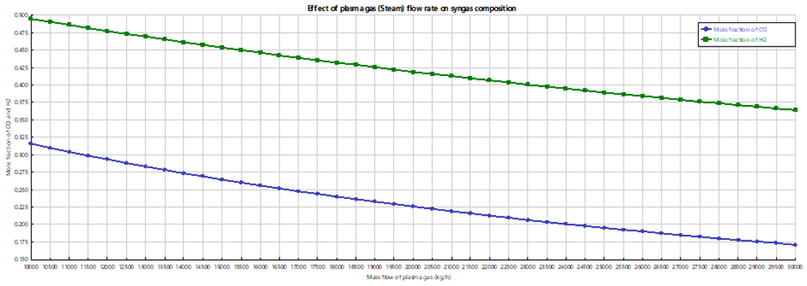

Fig.S3. Effect of plasma gas (Steam) flow rate on syngas composition

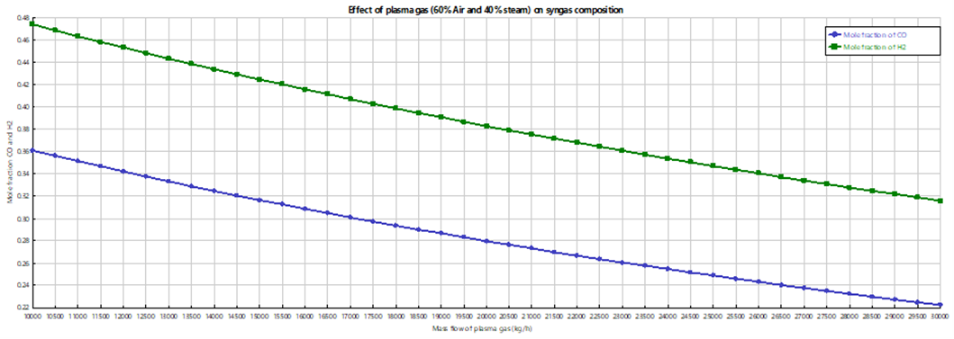

Fig.S4. Effect of plasma gas (60% Air + 40% Steam) flow rate on syngas composition

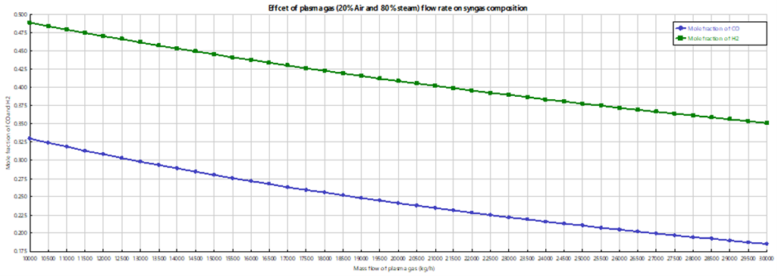

Fig.S5. Effect of plasma gas (20% Air + 80% Steam) flow rate on syngas composition

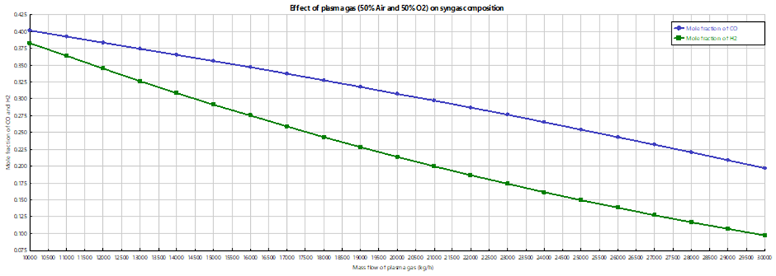

Fig.S6. Effect of plasma gas (50% Air + 50% Oxygen) flow rate on syngas composition

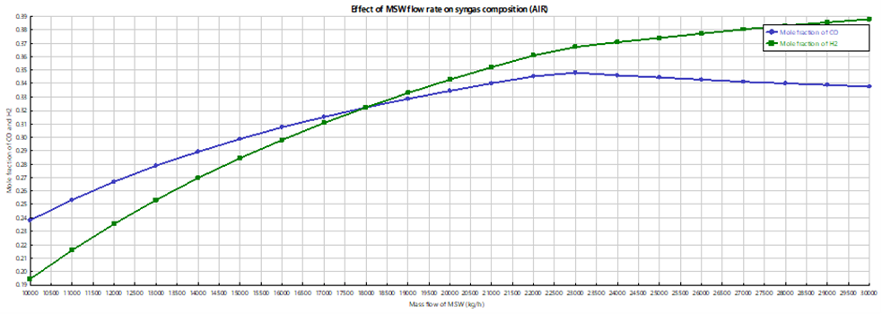

Fig.S7. Effect of MSW flow rate on syngas composition (Air)

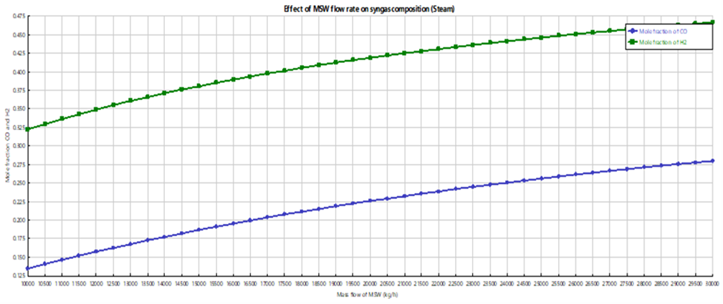

Fig.S8. Effect of MSW flow rate on syngas composition (Steam)

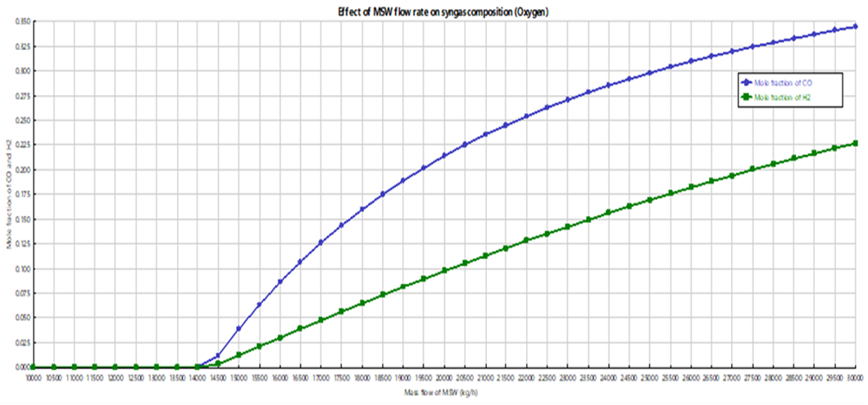

Fig.S9. Effect of MSW flow rate on syngas composition (oxygen)

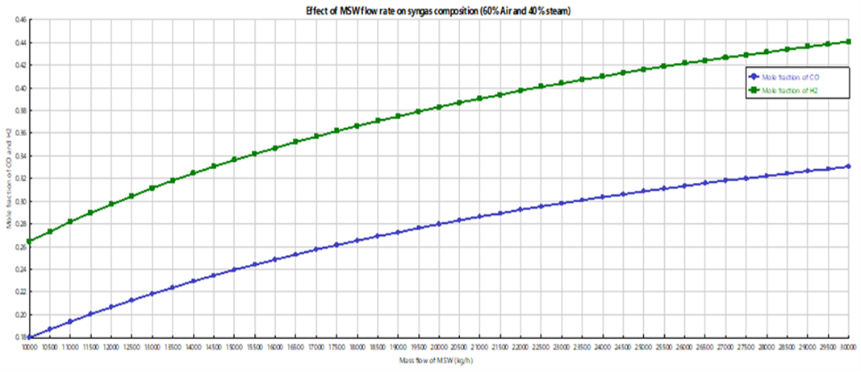

Fig.S10. Effect of MSW flow rate on syngas composition (60% Air + 40% steam)

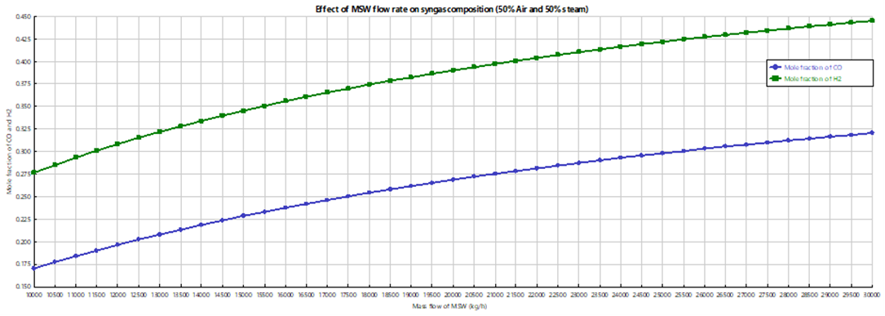

Fig.S11. Effect of MSW flow rate on syngas composition (50% Air + 50% steam)

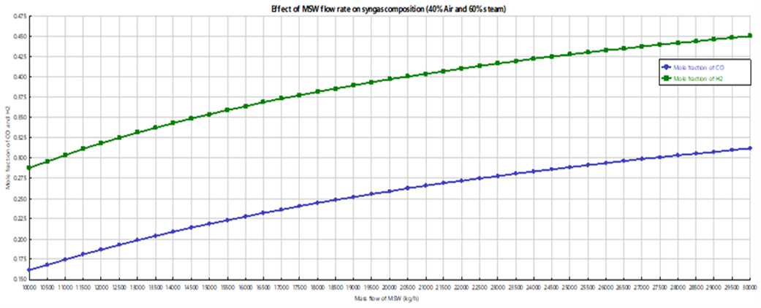

Fig.S12. Effect of MSW flow rate on syngas composition (40% Air + 60% steam)

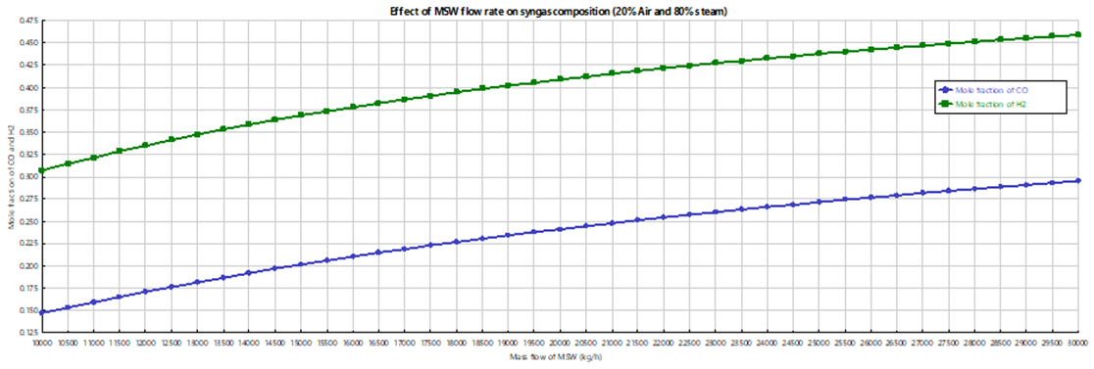

Fig.S13. Effect of MSW flow rate on syngas composition (20% Air + 80% steam)

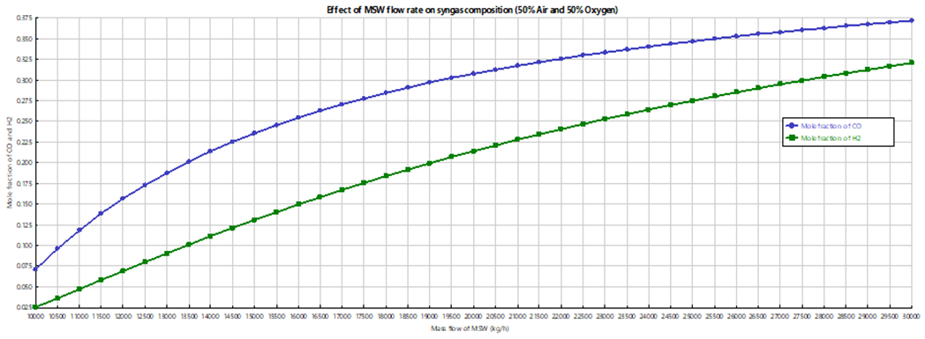

Fig.S14. Effect of MSW flow rate on syngas composition (50% Air + 50% Oxygen)