SUPPLEMENTARY MATERIAL
Recurrent Neural Network Based Modelling and Control of a Bioreactor for Ethanol Production
P. Sathiya¹, P. Venkatesh¹, T.K. Radhakrishnan^{1*}, P. Kalaichelvi¹
¹ Department of Chemical Engineering,
National Institute of Technology, Tiruchirappalli – 620015, Tamilnadu, India
*Corresponding author: T.K. Radhakrishnan

APPENDIX - A

1. Modelling of Bioreactor System
In a bioreactor, biomass encompasses the collective mass of all microorganisms, predominantly Saccharomyces cerevisiae, suspended within it. The substrate, on the other hand, represents the entirety of the glucose solution contained within the reactor. This substrate serves as the nourishing medium for the cells, facilitating their metabolic processes and the conversion of raw materials into the desired end product. In this context, the product signifies the ultimate goal of the bioprocess, namely ethanol, synthesized through the activities of the microorganisms within the bioreactor. The large-scale production of ethanol is usually a continuous process and its schematic diagram is shown in Fig. 1.
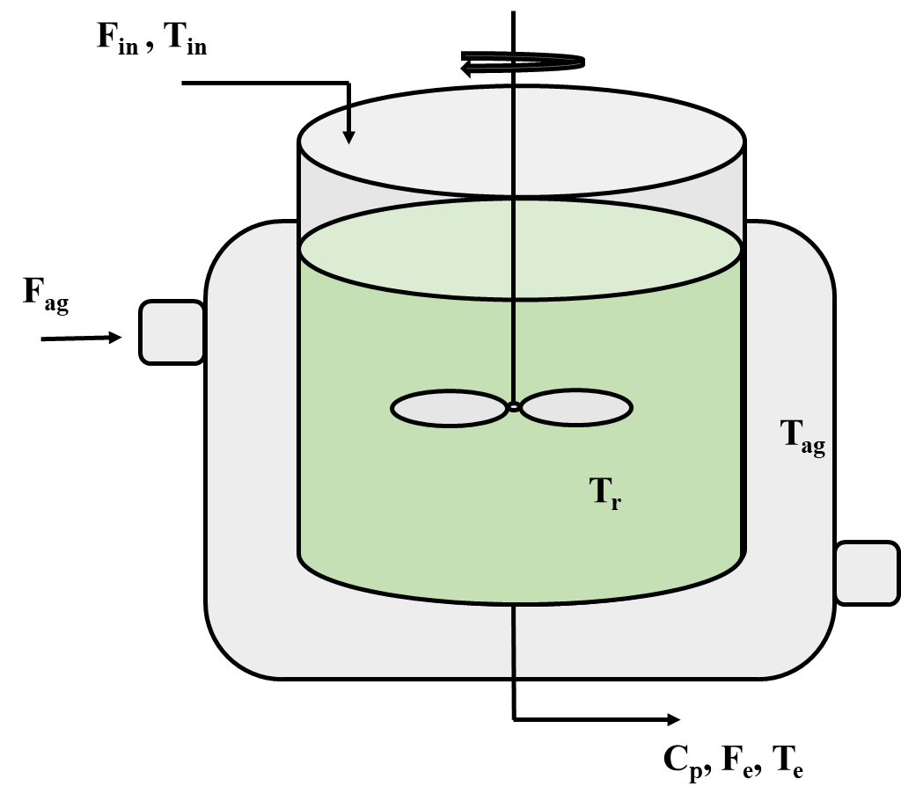
Fig. 1 Schematic diagram of a bioreactor
The reactor temperature is maintained properly such that the flow of cooling agent is manipulated and making continuous growth of biomass. Using the mass and energy balance equations, a mathematical model is developed.
The total mass balance of the reactor is given by:
[rate of accumulation] = [input flow rate] – [output flow rate]
$$\begin{aligned}\frac{dv}{dt}=F_{in}-F_{e} \#\left(1\right)\end{aligned}$$
1.1 Mass Balances for bioreactor
$$\text{Mass balance for biomass:}$$
[rate of change of biomass concentration] = [production of biomass in fermentation] – [biomass leaving the reactor]
$$\frac{{dC}_{X}}{dt}= μ_{X} C_{X} \frac{C_{S}}{K_{S}+C_{S}}e^{-(K_{p}C_{p})}-\frac{F_{e}}{V}C_{X} (2)$$
Where $μ_{X}$= specific growth rate given by Eq. (3)
$$μ_{x}=A_{1}e^{\left[\frac{E_{a1}}{-R\left(T_{r}+273\right)}\right]}-A_{2}e^{\left[\frac{E_{a2}}{-R\left(T_{r}+273\right)}\right]} (3)$$

$$\text{Mass balance for}\text{ end}\text{ product}\text{ [ethanol]}\text{:}$$
[rate of change of product concentration] = [production of product in fermentation reaction] - [product leaving the reaction]
$$\frac{{dC}_{p}}{dt}= μ_{P} C_{X} \frac{C_{S}}{K_{S_{1}}+C_{S}}e^{-\left(K_{P_{1}}C_{p}\right)}-\frac{F_{e}}{V}C_{p} (4)$$
$$\text{Mass balance for substrate:}$$
[rate of change of substrate] = - [substrate consumed for growth of biomass] - [substrate consumed for ethanol production by biomass] + [glucose supplied by feed] - [glucose leaving the reaction]
$$\frac{{dC}_{S}}{dt}={\frac{-1}{R_{S}}}_{X}\left[μ_{X}C_{X}\frac{C_{S}}{K_{S}+C_{S}}e^{-\left(K_{p}C_{p}\right)}\right]-{\frac{1}{R_{S}}}_{P}\left[μ_{P}C_{X}\frac{C_{S}}{K_{S_{1}}+C_{S}}e^{-\left(K_{P_{1}}C_{p}\right)}\right]+\frac{F_{in}}{V}C_{S,in}-\frac{F_{e}}{V}C_{S} (5)$$
$$\text{Mass balance for dissolved oxygen:}$$
$$\frac{ {dC}_{O_{2}}}{dt}=\left(k_{la}\right)\left(C_{O_{2}}^{*}-C_{O_{2}}\right)-r_{O_{2}} (6)$$
The liquid phase equilibrium concentration of oxygen is $C_{O_{2}}^{*}$ given by Eq. (7)
$${ C}_{O_{2}}^{*}=\left(14.16-0.3943T_{r}+0.007714T_{r}^{2}-0.0000646T_{r}^{3}\right)*{10}^{-\sum{H_{i}I_{i}}} (7)$$
The global effect of ionic strengths is given by Eq. (8)
$$\sum{H_{i}I_{i}}=0.5H_{Na}\frac{m_{NaCl}}{M_{NaCl}}\frac{M_{Na}}{V}+2H_{Ca}\frac{m_{CaCO_{3}}}{M_{CaCO_{3}}}\frac{M_{Ca}}{V}+2H_{Mg}\frac{m_{MgCl_{2}}}{M_{MgCl_{2}}}\frac{M_{Mg}}{V}+0.5H_{Cl}\left(\frac{m_{NaCl}}{M_{NaCl}}+2\frac{m_{MgCl_{2}}}{M_{MgCl_{2}}}\right)\frac{M_{Cl}}{V}+2H_{{CO}_{3}}\frac{m_{CaCO_{3}}}{M_{CaCO_{3}}}\frac{M_{{CO}_{3}}}{V}+0.5H_{H}{10}^{-pH}+0.5H_{OH}{10}^{-(14-pH)} (8)$$
$$K_{la}=K_{la0}*{\left(1.024\right)}^{\left(T_{r}-20\right)} (9)$$
$$r_{O_{2}}=μ_{O_{2}}\frac{1}{Y_{O_{2}}}C_{x}\frac{C_{O_{2}}}{K_{O_{2}}+C_{O_{2}}}*1000 (10)$$
1.2 Energy Balances
$$\text{Energy balance for the reactor temperature:}$$
[Heat accumulated in reactor] = [Heat at inlet] – [Heat at outlet] + [Heat generated from reaction] – [Heat transferred to the jacketed]
$$\frac{{dT}_{r}}{dt}= \frac{F_{in}}{V}\left(T_{in}+273\right)-\frac{F_{e}}{V}\left(T_{in}+273\right)+\frac{r_{O_{2}} ∆H_{r}}{32 ρ_{r} C_{heat,r}}+ \frac{K_{T}A_{T}\left(T_{r}-T_{ag}\right)}{Vρ_{r} C_{heat,r}} (11)$$
$$\text{Energy balance for the jacket temperature:}$$
[Heat accumulated in jacket] = [Heat at coolant inlet] + [Heat at coolant outlet]
$$\frac{{dT}_{ag}}{dt}= \frac{F_{ag}}{V_{j}}\left(T_{in,ag}-T_{ag}\right)+ \frac{K_{T}A_{T}(T_{r}-T_{ag})}{V_{j}ρ_{ag} C_{heat,ag}} (12)$$

The operating and model parameters of the bioreactor are shown in Table 1 and Table 2 respectively
Table 1 Operating conditions of bioreactor
S.NO | Parameter | Value
1 | F_{in} – Inlet flowrate | 51 $l{hr}^{-1}$
2 | F_{e} – Outlet flowrate | 51 $l{hr}^{-1}$
3 | $T_{in}$ – Inlet flow temperature | 25˚C
4 | $T_{e}$– Outlet flow temperature | 25˚C
5 | $C_{S,in}$– substrate inlet conc. | 60 $gl^{-1}$
6 | $T_{in,ag}$– Temperature of inlet flow cooling agent | 15˚C
7 | pH | 6
8 | F_{ag} – Flow rate of cooling agent | 18 $l{hr}^{-1}$

Table 2 Model parameters of bioreactor
$A_{1}$= 9.5x10⁸ | $K_{p}$= 0.139 gl⁻¹ | $ρ_{r}$= 1080 gl⁻¹
$A_{2}$= 2.55x10³³ | $K_{P_{1}}$= 0.07 gl⁻¹ | $m_{NaCl}$= 500 g
$A_{T}$= 1 m² | $K_{S}$= 1.03 gl⁻¹ | $m_{CaCO_{3}}$= 100 g
$C_{heat,ag}$= 4.18 Jg⁻¹K⁻¹ | $K_{S_{1}}$= 1.68 gl⁻¹ | $m_{MgCl_{2}}$= 100 g
$C_{heat,r}$= 4.18 Jg⁻¹K⁻¹ | $K_{T}$= 3.6x105 J h⁻¹ m⁻² K⁻¹ | R= 8.31 Jmol⁻¹K⁻¹
E_{a1}= 55,000 Jmol⁻¹ | $R_{S_{P}}$= 0.435 | $M_{Na}$= 23 g mol⁻¹
E_{a2}= 22,000 Jmol⁻¹ | $R_{S_{X}}$= 0.607 | $M_{Ca}$= 40 gmol⁻¹
$K_{{la}_{0}}$= 38 h⁻¹ | $Y_{O_{2}}$= 0.970 | $M_{Mg}$= 24 g mol⁻¹
$K_{O_{2}}$= 8.886 mgl⁻¹ | $∆H_{r}$= 518 KJmol⁻¹O₂ | $M_{Cl}$= 35.5 gmol⁻¹
$μ_{p}$= 1.79 h⁻¹ | $μ_{O_{2}}$= 0.5 h⁻¹ | $M_{{CO}_{3}}$= 60 gmol⁻¹
V=1000 l | $V_{j}$ = 50 l | $ρ_{ag}$= 1000 g l⁻¹

The bioreactor model based on Eqs. (1) – (12) is developed in MATLAB 2023a, and the operating conditions and model parameters are shown in Table 1 and Table 2 respectively. By using ordinary differential equation (ODE) solver in MATLAB, steady state for the bioreactor is found to be [${C_{X}, C_{p}, C_{s,},C}_{O_{2}},T_{r},T_{ag}]$ = [0.9065, 12.528, 29.705, 3.1068, 29.5983, 27.086].

