**Supporting Information**

**Efficiency of Micro and Nano-γ-Al2O3 Sintered Adsorbents for Organic Chloride Removal from the Naphtha Fraction of Crude Oil**

*Behnam Hosseingholilou a, Samad Arjang b, Majid Saidi a[1]*

a School of Chemistry, College of Science, University of Tehran, PO Box 14155−6455, Tehran, Iran

b Department of Chemical Engineering, Arak University, Arak, Iran

This document includes the following parts:

**List of Tables**

**Table S-1.** Adsorbents characteristics

**Table S-2.** Crude oil samples main characteristics

**Table S-3.** Organic chloride concentration of five different contaminated crude oil samples

**Table S-4.** EDS analysis of calcined alumina micro- and nano-particles

**List of Figures**

**Figure S-1.** Schematic diagram of adsorption setup

**Figure S-2.** XRD pattern of sintered γ-Al2O3 nano-particle

**Figure S-3.** (a) SEM image of sintered γ-Al2O3 nano-particles, (b) SEM image of sintered γ-Al2O3 micro-particles

**Table S-1**

|  |  |  |  |  |
| --- | --- | --- | --- | --- |
| Adsorbent | Average Particle Size (APS) | Specific Surface Area (SSA) | Appearance | Purity |
| γ-Al2O3 nano-particles | 20 nm | 230-400 m2/gr | White Powder | 99.9% |
| γ-Al2O3 micro-particles | 0.4-1.5 µm | 70-100 m2/gr | White Powder | 99.9% |

**Table S-2**

|  |  |  |  |
| --- | --- | --- | --- |
| Characteristics | Units | Result | Test Method |
| Specific Gravity @ 15.56°C | --- | 0.8750 | ASTM D5002 |
| API Gravity | °API | 31 | ASTM D4294 |
| Sulfur Content(Total) | wt.% | 1.83 | IP 170 |
| H2S Content | ppm | 1 | UOP 163 |
| Mercaptan Content | ppm | 185 | ASTM D5762 |
| Nitrogen Content (Total) | wt.% | 0.23 | ASTM D4007 |
| Water & Sediment | vol.% | <0.05 | ASTM D4006 |
| Water Content | vol.% | <0.025 | ASTM D3230 |
| Salt Content | PTB | 10 | ASTM D445 |
| Kinematic Viscosity @ 10°C | mm2/s | 29.07 | ASTM D445 |
| Kinematic Viscosity @ 20°C | mm2/s | 18.40 | ASTM D445 |
| Kinematic Viscosity @ 40°C | mm2/s | 9.218 | ASTM D5853 |
| Pour Point (Upper) | °C | -12 | ASTM D323 |
| Reid Vapor Pressure | Psi | 6.25 | IP 143 |
| Asphaltene Content | wt.% | 3.4 | BP 237 |
| Wax Content | wt.% | 5.7 | IP 133 |
| Drop Melting Point of Wax | °C | 55 | ASTM D189 |
| Conradson Carbon Residue | wt.% | 6.2 | UOP 565 |
| Total Acid Number | mg KOH/g | 0.15 | ASTM D5863 |

**Table S-3**

|  |  |  |  |  |  |
| --- | --- | --- | --- | --- | --- |
| Sample No. | No.1 | No.2 | No.3 | No.4 | No.5 |
| Week | 5th | 7th | 8th | 1st | 3rd |
| Average Initial Organic Chloride Concentration (mg/L) | 105 | 82 | 55 | 27 | 8.5 |

**Table S-4**

|  |  |  |
| --- | --- | --- |
| Element | Wt% | At% |
| Al K | 51.81 | 38.93 |
| O K | 48.19 | 61.07 |
| Matrix | Correction | ZAF |

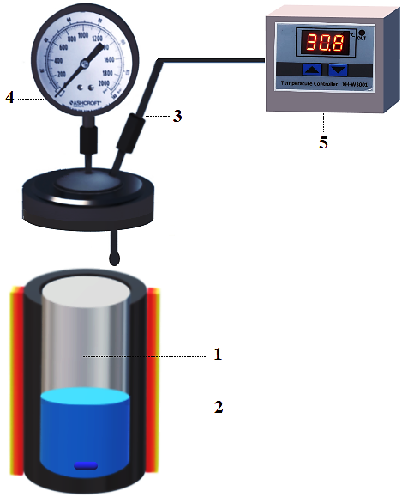

**Figure S-1**

[440]

[400]

[311]

**Figure S-2**

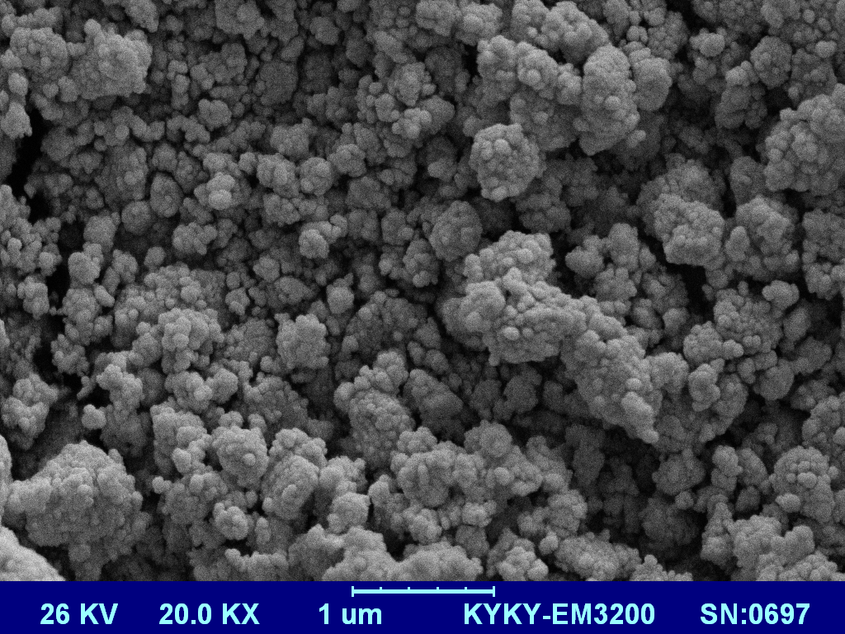

**Figure S-3-a**

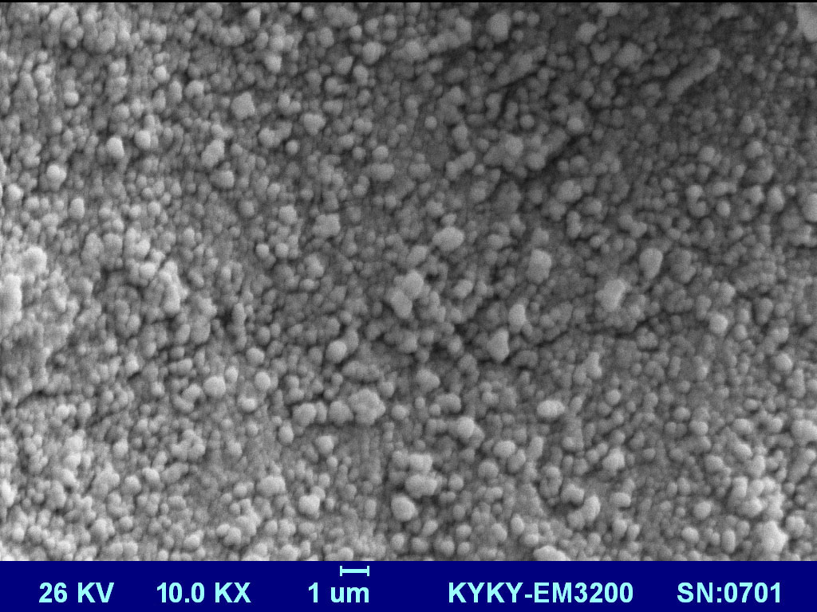

**Figure S-3-b**

1. Corresponding Author: Dr. Majid Saidi (Email: [majid.saidi@khayam.ut.ac.ir](mailto:majid.saidi@khayam.ut.ac.ir) ; [majid.saidi@ut.ac.ir](mailto:majid.saidi@ut.ac.ir) )

  