Table S1. Model efficiency indices

$$R^{2}=1-\frac{\sum_{i=1}^{N}{{\left(Z_{pred}^{i}-Z_{exp}^{i}\right)}^{2}}}{\sum_{i=1}^{N}{{\left(Z_{exp}^{i}-Z_{exp}^{m}\right)}^{2}}}$$ | Coefficient of determination
$$MSE=\frac{\sum_{i=1}^{N}{{\left(Z_{pred}^{i}-Z_{exp}^{i}\right)}^{2}}}{N}$$ | Mean squared errors
$$RMSE=\sqrt{\frac{\sum_{i=1}^{N}{{\left(Z_{pred}^{i}-Z_{exp}^{i}\right)}^{2}}}{N}}$$ | Root mean square values
$$SSE=\sum_{i=1}^{N}{{\left(Z_{pred}^{i}-Z_{exp}^{i}\right)}^{2} }$$ | Sum of squared errors
$$SAE=\frac{\sum_{i=1}^{N}{\left|Z_{pred}^{i}-Z_{exp}^{i}\right|} }{N}$$ | Sum of the absolute errors
N : Number of actual data
$Z_{exp}^{m}$: Average of the actual value
$Z_{exp}^{i}$ : Actual values of the ith experiment
$Z_{pred}^{i}$ : Predicted values of the ith experiment

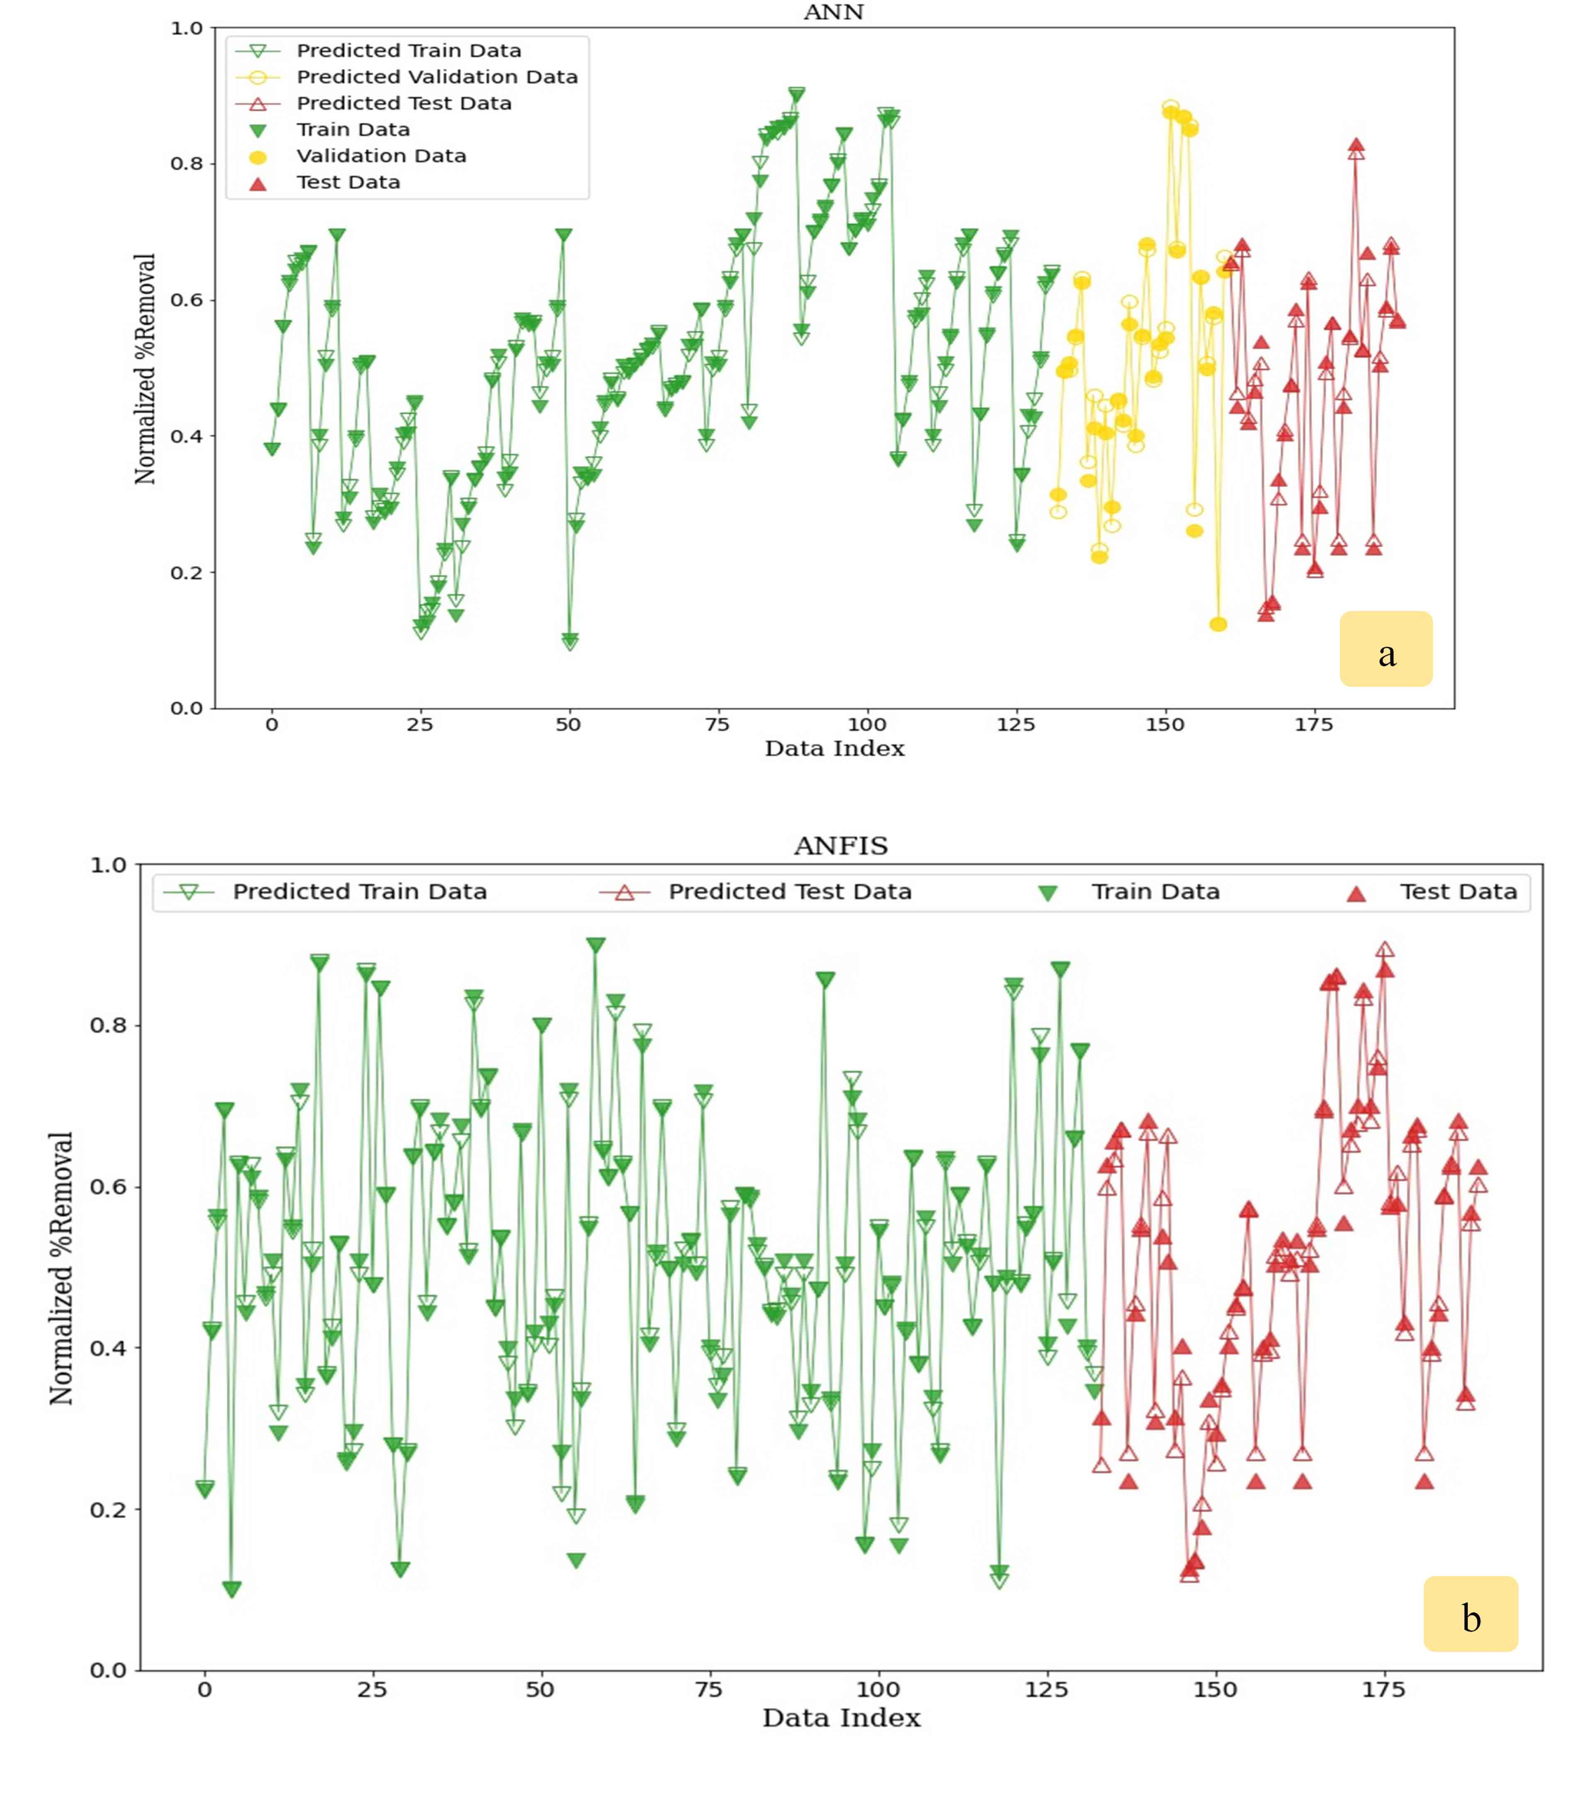
Fig. S1. Comparison of the observed data and the predicted values of (a) ANN and (b) ANFIS for all data set points

Table S2. The optimal values of hyperparameters for the ANN and ANFIS tools.

Method | Type | Value/comment
ANN | Number of hidden layers | 1
ANN | Number of hidden neurons | 15
ANN | Number of data used for training | 134
ANN | Number of data used for testing | 28
ANN | Number of data used for validating | 28
ANN | Training algorithm | Back propagation (LM)
ANN | Activation function | Tansig
ANN | Number of epochs | 49
ANFIS | Number of nodes | 135
ANFIS | Number of linear parameters | 63
ANFIS | Number of nonlinear parameters | 108
ANFIS | Total number of parameters | 171
ANFIS | Number of training data pairs | 133
ANFIS | Number of testing data pairs | 57
ANFIS | Number of fuzzy rules | 9
ANFIS | Training maximum epoch number | 80
ANFIS | Fuzzy structure | Sugeno
ANFIS | Initial FIS for training | Subtractive clustering
ANFIS | MF type | Gaussian
ANFIS | Output MF | Linear
ANFIS | Optimization method | Hybrid
ANFIS | Radius | 0.6

