# Section One

# SI Material

**The chemical compositions of the prepared catalysts**

|  |  |  |  |  |
| --- | --- | --- | --- | --- |
| **Sample\ Compounds** | **SiO2 (%)** | **Al2O3 (%)** | **Fe2O3 (%)** | **Sum** |
| CAT-1 | 8.990 | 72.020 | 3.480 | 84.500 |
| CAT-2 | 16.350 | 65.430 | 3.210 | 85.000 |
| CAT-3 | 22.200 | 56.980 | 3.200 | 82.400 |

# Section Two

# S.1) Surface Area and Pore Volume Measurements

## (BET of support-1)

Sample: support-1

Operator: Hussam Jumaah

Submitter: mustafa

File: C:\2020\DATA\000-122.SMP

Started: 12/03/2020 8:07:29? Analysis Adsorptive: N2

Completed: 12/03/2020 11:04:32? Analysis Bath Temp.: -195.876 °C

Report Time: 19/05/2020 12:16:32? Thermal Correction: No

Sample Mass: 0.3027 g Warm Free Space: 27.8239 cm³ Entered

Cold Free Space: 90.6075 cm³ Equilibration Interval: 10 s

Ambient 22.00°C Low Pressure Dose: None

Temperature:

Automatic Degas: No

## Comments: Degasssing Cond. 250 C 6 hr

### Summary Report Surface Area

Single point surface area at p/p° = 0.306256287: 275.4787 m²/g

BET Surface Area: 281.4098 m²/g

### Pore Volume

Single point adsorption total pore volume of pores

less than 48.0332 nm radius at p/p° = 0.979423060: 0.354260 cm³/g

### Pore Size

Adsorption average pore width (4V/A by BET): 5.03550 nm

**Isothermal Tubular Report**

Relative Pressure

(p/p°)

Absolute Pressure

(kPa)

Quantity Adsorbed (mmol/g)

Elapsed Time (h:min)

Saturation pressure (KPa)

|  |  |  |  |  |
| --- | --- | --- | --- | --- |
| 0.003036435 | 0.3049263 | 2.44951 | 00:18  02:13 | 100.3880322 |
| 0.016798815 | 1.6870085 | 2.89453 | 02:19  02:24 | 100.4242597 |
| 0.029581666 | 2.9707169 | 3.04028 | 02:29 |  |
| 0.040102296 | 4.0272434 | 3.12359 | 02:34 |  |
| 0.049097253 | 4.9305552 | 3.18284 | 02:38 |  |
| 0.114451546 | 11.4937118 | 3.47929 | 02:43 |  |
| 0.177624868 | 17.8378459 | 3.69043 | 02:48 |  |
| 0.241549609 | 24.2574407 | 3.88149 | 02:52 |  |
| 0.306256287 | 30.7555609 | 4.06967 | 02:56 |  |
| 0.979423060 | 98.3578357 | 10.21801 | 03:15 |  |

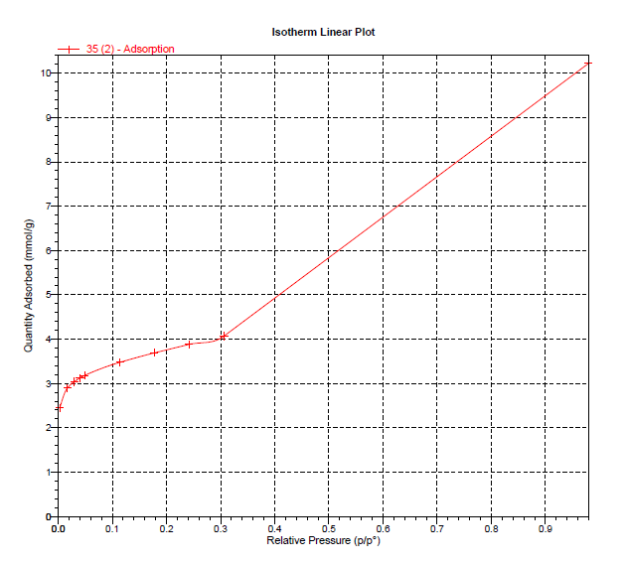

**Figure S.1: Isotherm linear plot for support-1**

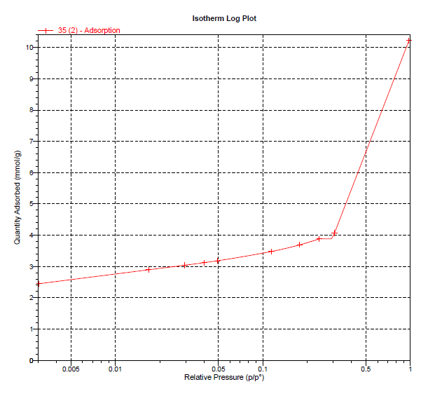

**Figure S.2: Isotherm log plot for support-1**

### BET Surface area report

BET Surface Area: 263.9134 ± 1.1687 m²/g Slope: 0.368877 ± 0.001636 g/mmol

Y-Intercept: 0.000839 ± 0.000055 g/mmol

C: 440.484903

Qm: 2.70478 mmol/g

Correlation Coefficient: 0.9999902 Molecular Cross-Sectional Area: 0.1620 nm

Relative pressure (p/po)

Quantity Adsorbed (mmol/g)

1/[Q(p°/p - 1)]

|  |  |  |  |  |
| --- | --- | --- | --- | --- |
| 0.003036435 |  | 2.44951 |  | 0.00124 |
| 0.016798815 |  | 2.89453 |  | 0.00590 |
| 0.029581666 |  | 3.04028 |  | 0.01003 |
| 0.040102296 |  | 3.12359 |  | 0.01337 |
| 0.049097253 |  | 3.18284 |  | 0.01622 |
| 0.114451546 |  | 3.47929 |  | 0.03715 |
| 0.177624868 |  | 3.69043 |  | 0.05853 |
| 0.241549609 |  | 3.88149 |  | 0.08205 |
| 0.306256287 |  | 4.06967 |  | 0.10847 |

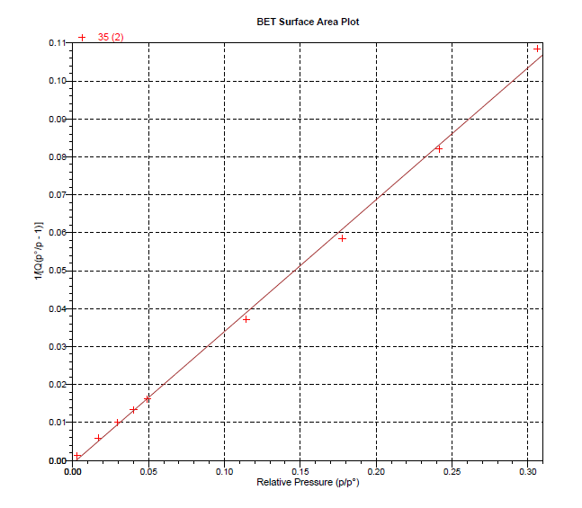

**Figure S.3: BET surface area plot for support-1**

## (BET of support-2)

Sample: support-2

Operator: Hussam Jumaah

Submitter: mustafa

File: C:\2020\DATA\000-122.SMP

Started: 20/05/2020 8:50:29? Analysis Adsorptive: N2

Completed: 20/05/2020 12:28:02? Analysis Bath Temp.: -195.876 °C

Report Time: 20/05/2020 1:01:53? Thermal Correction: No

Sample Mass: 0.2497 g Warm Free Space: 27.8239 cm³ Entered

Cold Free Space: 90.6075 cm³ Equilibration Interval: 10 s

Ambient 22.00°C Low Pressure Dose: None

Temperature:

Automatic Degas: No

## Comments: Degasssing Cond. 250 C 6 hr

### Summary Report Surface Area

Single point surface area at p/p° = 0.306256287: 333.9503 m²/g

BET Surface Area: 333.8146 m²/g

### Pore Volume

Single point adsorption total pore volume of pores

less than 48.0332 nm radius at p/p° = 0.979423060: 0.429453 cm³/g

### Pore Size

Adsorption average pore width (4V/A by BET): 5.14600 nm

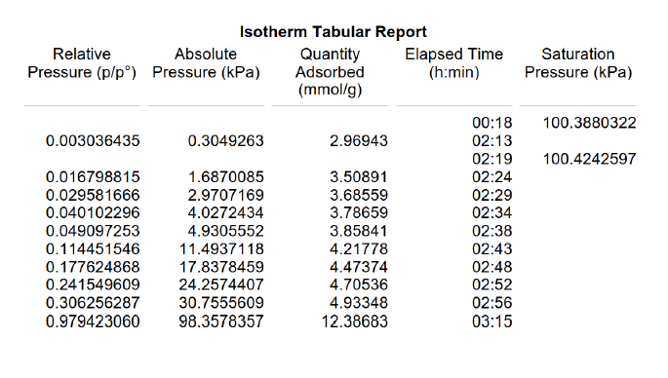

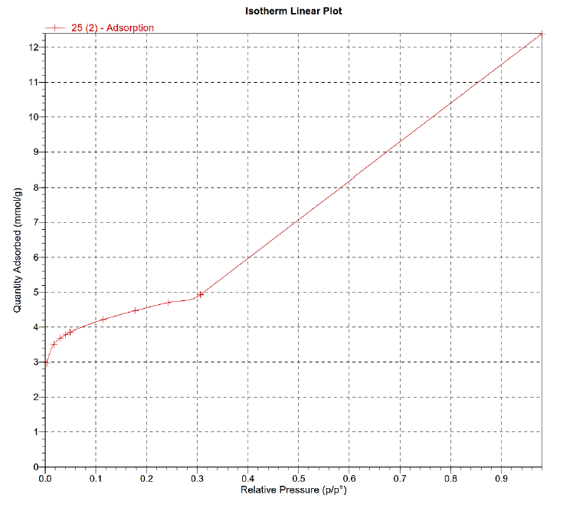  
**Figure S.4: Isotherm linear plot for support-2**

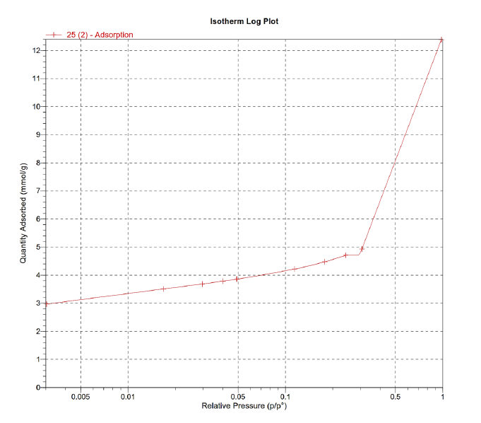

**Figure S.5: Isotherm log plot for support-2**

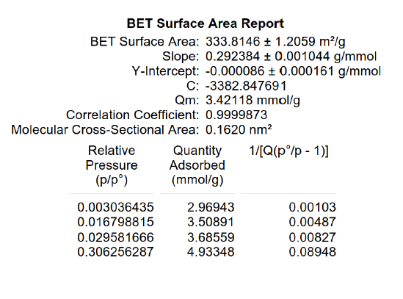

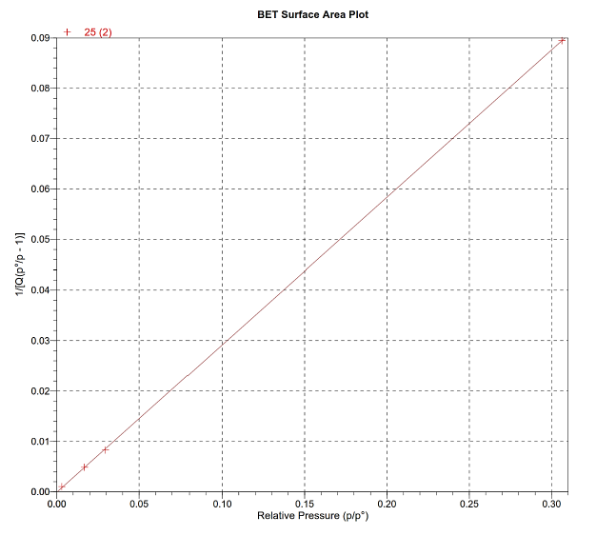

**Figure S.6: BET surface area plot for support-2**

## (BET of support-3)

Sample: support-3

Operator: Hussam Jumaah

Submitter: mustafa

File: C:\2020\DATA\000-122.SMP

Started: 25/05/2020 8:50:41? Analysis Adsorptive: N2

Completed: 25/05/2020 12:28:02? Analysis Bath Temp.: -195.876 °C

Report Time: 25/05/2020 1:03:02? Thermal Correction: No

Sample Mass: 0.2497 g Warm Free Space: 27.8239 cm³ Entered

Cold Free Space: 90.6075 cm³ Equilibration Interval: 10 s

Ambient 22.00°C Low Pressure Dose: None

Temperature:

Automatic Degas: No

## Comments: Degasssing Cond. 250 C 6 hr

### Summary Report Surface Area

Single point surface area at p/p° = 0.241549609: 348.2168 m²/g

BET Surface Area: 348.5755 m²/g

### Pore Volume

Single point adsorption total pore volume of pores

less than 48.0332 nm radius at p/p° = 0.979423060: 0.429453 cm³/g

### Pore Size

Adsorption average pore width (4V/A by BET): 4.92809 nm

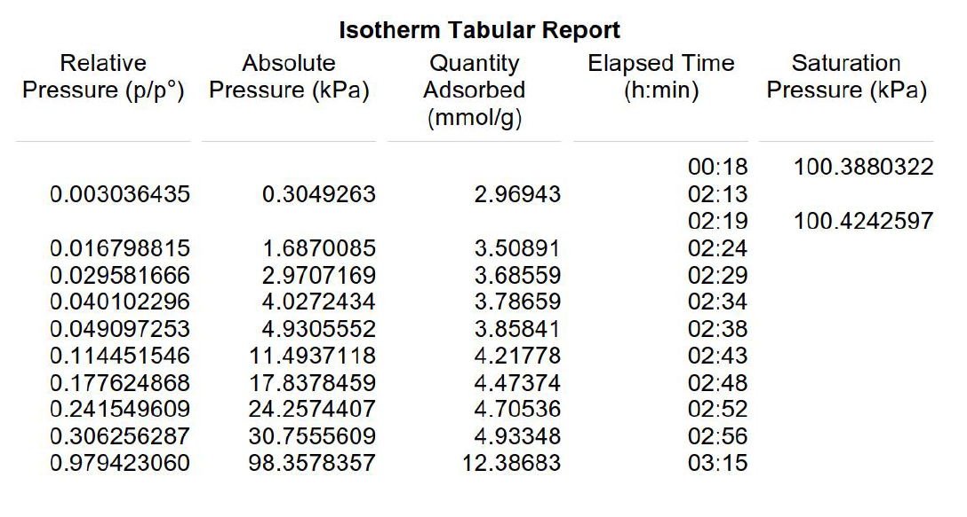

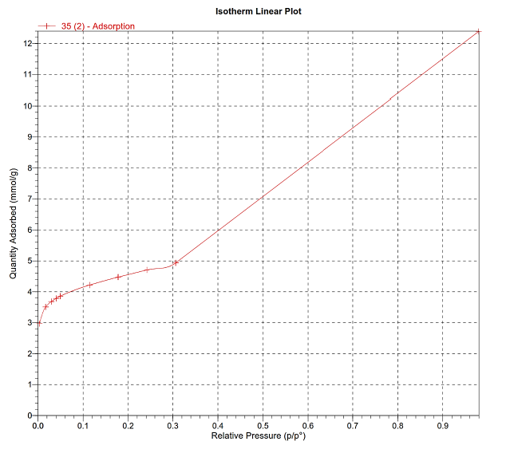

**Figure S.7: Isotherm linear plot for support-3**

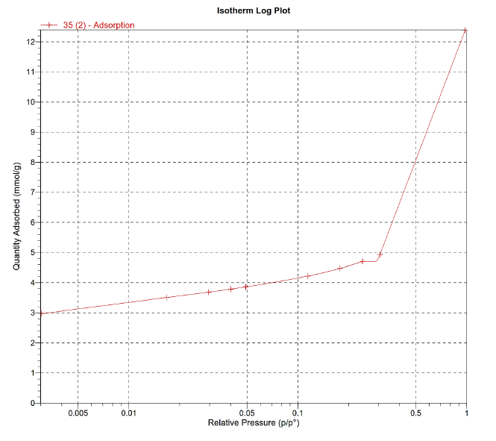

**Figure S.8: Isotherm log plot for support-3**

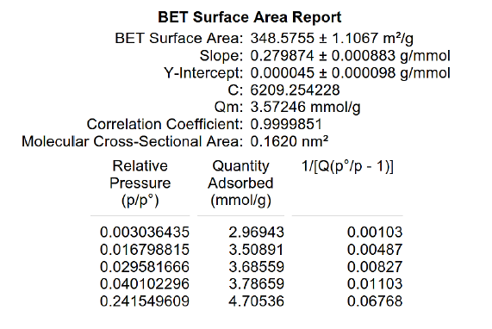

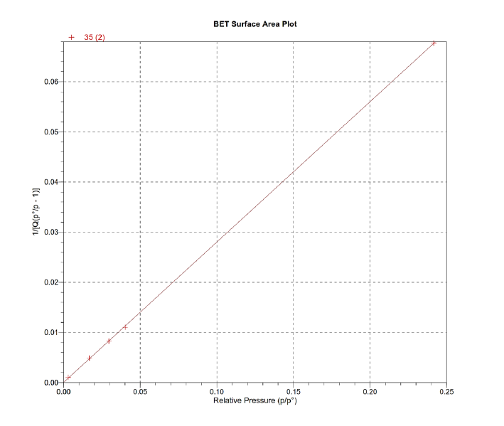

**Figure S.9: BET surface area plot for support-3**

## (BET of CAT-1)

Sample: CAT-1

Operator: Hussam Jumaah

Submitter: mustafa

File: C:\2020\DATA\000-122.SMP

Started: 16/06/2020 7:34:34? Analysis Adsorptive: N2

Completed: 16/06/2020 11:13:28? Analysis Bath Temp.: -195.876 °C

Report Time: 16/06/2020 1:04:00? Thermal Correction: No

Sample Mass: 0.3027 g Warm Free Space: 27.8239 cm³ Entered

Cold Free Space: 90.6075 cm³ Equilibration Interval: 10 s

Ambient 22.00°C Low Pressure Dose: None

Temperature:

Automatic Degas: No

## Comments: Degasssing Cond. 250 C 6 hr

### Summary Report Surface Area

Single point surface area at p/p° = 0.106944808: 268.5355 m²/g

BET Surface Area: 271.2595 m²/g

### Pore Volume

Single point adsorption total pore volume of pores

less than 119.9626 nm radius at p/p° = 0.991885077: 0.306242 cm³/g

### Pore Size

Adsorption average pore width (4V/A by BET): 4.51586 nm

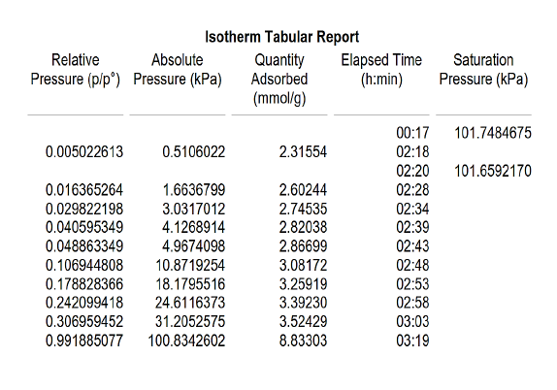

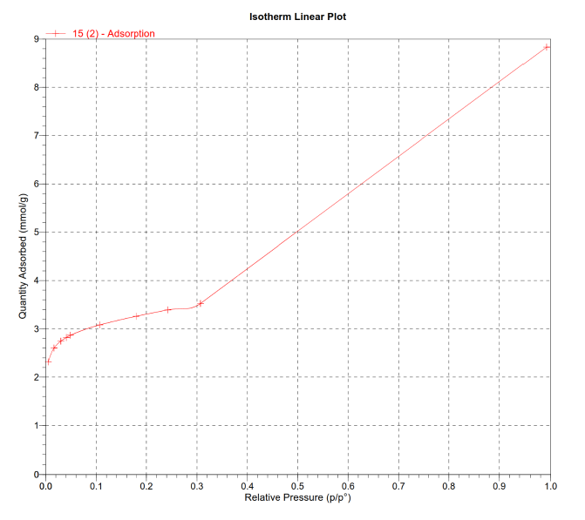

**Figure S.10: Isotherm linear plot for CAT-1**

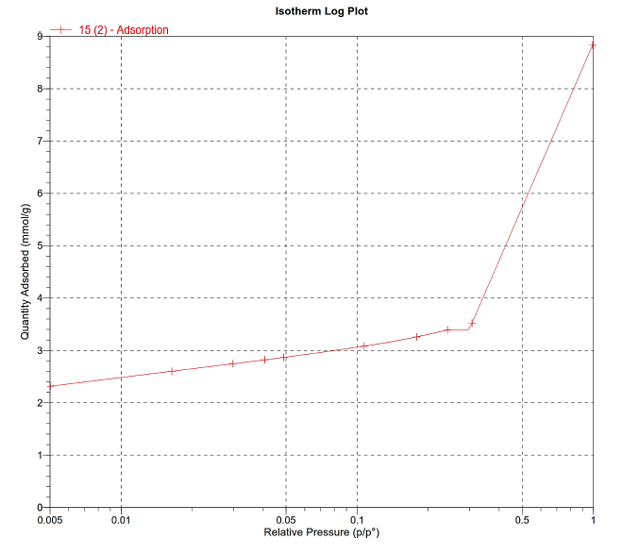

**Figure S.11: Isotherm log plot for CAT-1**

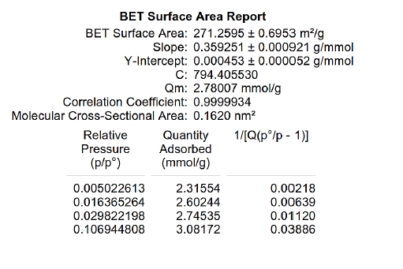

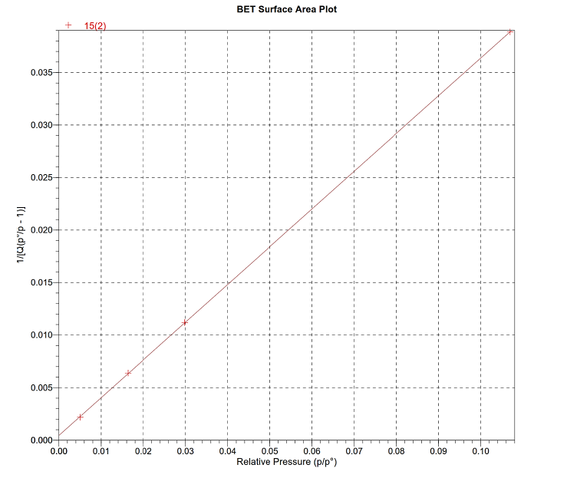

**Figure S.12: BET surface area plot for CAT-1**

## (BET of CAT-2)

Sample: CAT-2

Operator: Hussam Jumaah

Submitter: mustafa

File: C:\2020\DATA\000-122.SMP

Started: 22/07/2020 7:34:34? Analysis Adsorptive: N2

Completed: 22/07/2020 11:13:28? Analysis Bath Temp.: -195.876 °C

Report Time: 22/07/2020 11:20:05? Thermal Correction: No

Sample Mass: 0.2592 g Warm Free Space: 27.8239 cm³ Entered

Cold Free Space: 90.6075 cm³ Equilibration Interval: 10 s

Ambient 22.00°C Low Pressure Dose: None

Temperature:

Automatic Degas: No

## Comments: Degasssing Cond. 250 C 6 hr

### Summary Report Surface Area

Single point surface area at p/p° = 0.106944808: 313.6023 m²/g

BET Surface Area: 316.8860 m²/g

### Pore Volume

Single point adsorption total pore volume of pores

less than 119.9626 nm radius at p/p° = 0.991885077: 0.357637 cm³/g

### Pore Size

Adsorption average pore width (4V/A by BET): 4.51439 nm

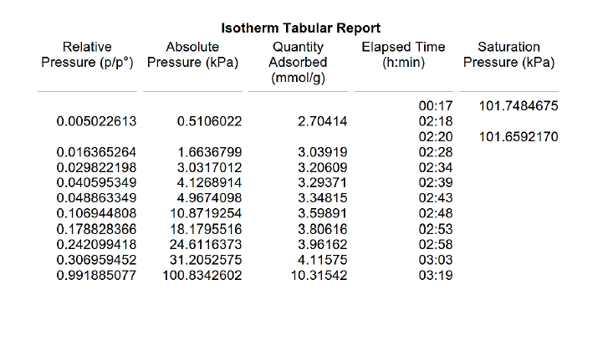

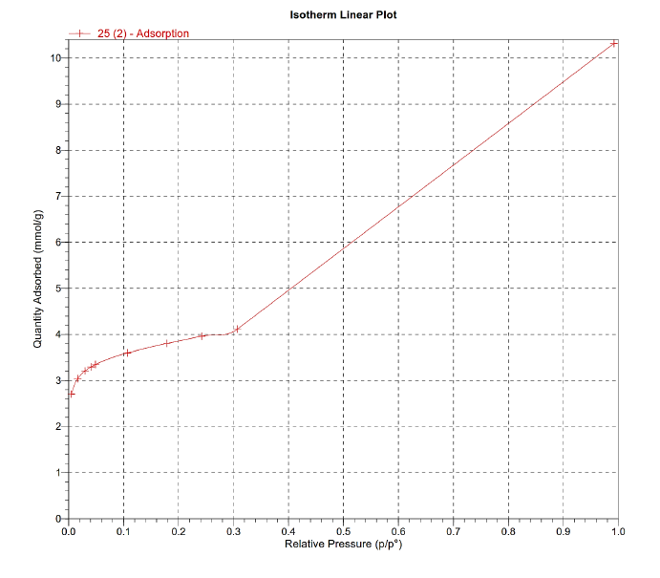

**Figure S.13: Isotherm linear plot for CAT-2**

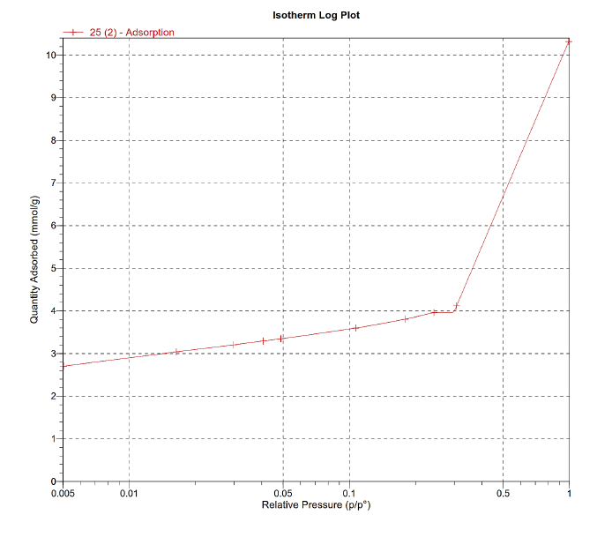

**Figure S.14: Isotherm log plot for CAT-2**

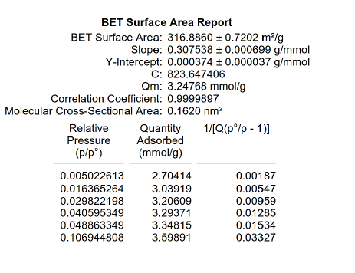

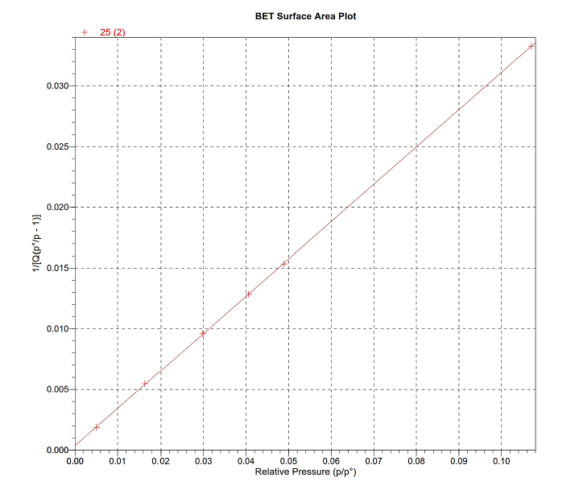

**Figure S.15: BET surface area plot for CAT-2**

## (BET of CAT-3)

Sample: CAT-3

Operator: Dr.Ban

Submitter: mustafa

File: C:\2020\DATA\000-122.SMP

Started: 20/07/2020 8:50:41? Analysis Adsorptive: N2

Completed: 20/07/2020 12:28:02? Analysis Bath Temp.: -195.876 °C

Report Time: 20/07/2020 9:12:52? Thermal Correction: No

Sample Mass: 0.2497 g Warm Free Space: 27.8239 cm³ Entered

Cold Free Space: 90.6075 cm³ Equilibration Interval: 10 s

Ambient 22.00°C Low Pressure Dose: None

Temperature:

Automatic Degas: No

## Comments: Degasssing Cond. 250 C 6 hr

### Summary Report Surface Area

Single point surface area at p/p° = 0.306256287: 333.9503 m²/g

BET Surface Area: 341.1403 m²/g

### Pore Volume

Single point adsorption total pore volume of pores

less than 48.0332 nm radius at p/p° = 0.979423060: 0.429453 cm³/g

### Pore Size

Adsorption average pore width (4V/A by BET): 5.03550 nm

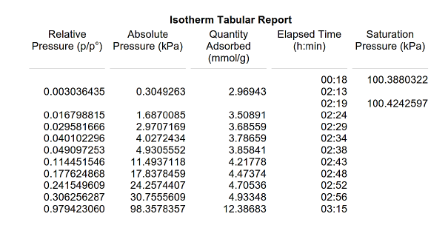

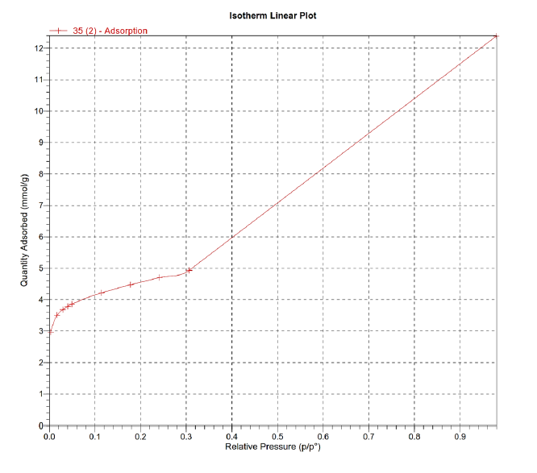

**Figure S.16: Isotherm linear plot for CAT-3**

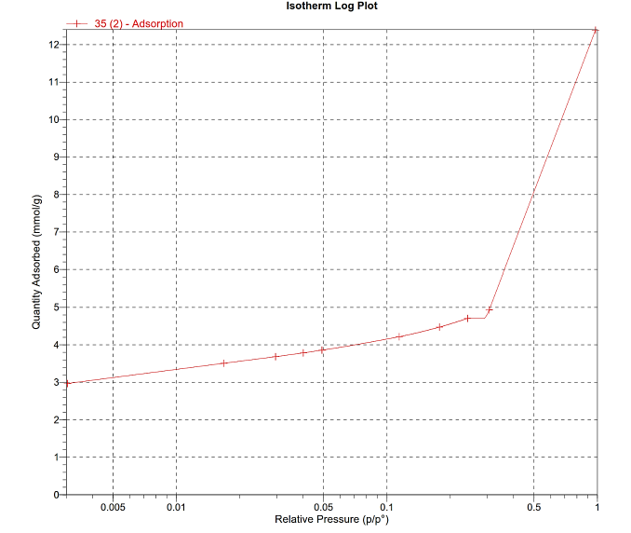

**Figure S.17: Isotherm log plot for CAT-3**

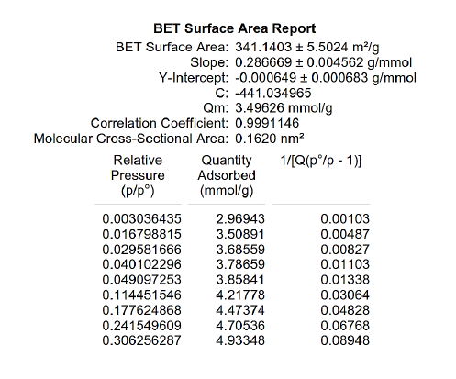

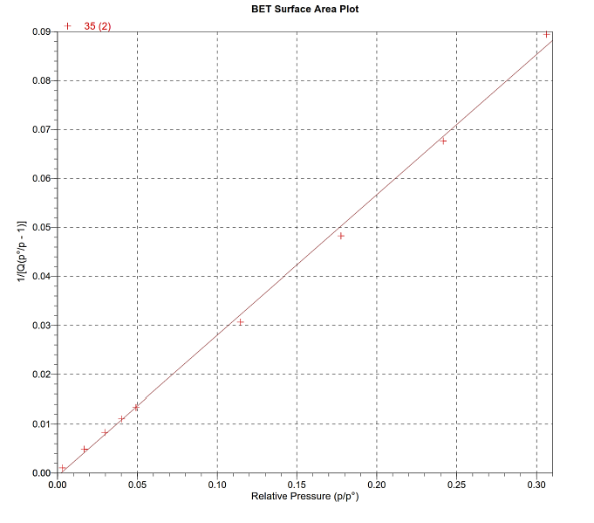

**Figure S.18: BET surface area plot for CAT-3**

# S.2) X-ray Diffraction (XRD)

*** Basic Data Process ***

Group : Mustafa

Data : support-1

|  |  |  |  |  |  |  |  |  |
| --- | --- | --- | --- | --- | --- | --- | --- | --- |
| # | Strongest no. peak | 3 peaks 2Theta | d | I/I1 | FWHM | Intensity | Integrated | Int |
|  | no. | (deg) | (A) |  | (deg) | (Counts) | (Counts) |  |
|  | 1 51 | 66.6322 | 1.40244 | 100 | 1.74000 | 23 | 1794 |  |
|  | 2 35 | 45.8903 | 1.97589 | 83 | 1.68000 | 19 | 1009 |  |
|  | 3 52 | 67.8819 | 1.37963 | 57 | 0.96000 | 13 | 667 |  |
| # | Peak Data  peak | List  2Theta | d | I/I1 | FWHM | Intensity | Integrated | Int |
|  | no. | (deg) | (A) |  | (deg) | (Counts) | (Counts) |  |
|  | 1 | 6.5835 | 13.41512 | 13 | 0.02000 | 3 | 6 |  |
|  | 2 | 7.8620 | 11.23622 | 4 | 0.00000 | 1 | 0 |  |
|  | 3 | 11.5292 | 7.66913 | 9 | 0.40000 | 2 | 48 |  |
|  | 4 | 12.2653 | 7.21048 | 9 | 0.04000 | 2 | 11 |  |
|  | 5 | 12.9422 | 6.83484 | 4 | 0.00000 | 1 | 0 |  |
|  | 6 | 14.5862 | 6.06797 | 9 | 0.18000 | 2 | 34 |  |
|  | 7 | 15.8726 | 5.57897 | 9 | 0.04000 | 2 | 16 |  |
|  | 8 | 16.8903 | 5.24504 | 9 | 0.08000 | 2 | 30 |  |
|  | 9 | 18.1879 | 4.87366 | 13 | 0.04000 | 3 | 19 |  |
|  | 10 | 19.4645 | 4.55680 | 13 | 0.04000 | 3 | 21 |  |
|  | 11 | 20.8570 | 4.25560 | 22 | 0.03330 | 5 | 13 |  |
|  | 12 | 21.6084 | 4.10929 | 26 | 0.46000 | 6 | 241 |  |
|  | 13 | 22.6459 | 3.92332 | 22 | 0.10000 | 5 | 87 |  |
|  | 14 | 23.6836 | 3.75371 | 22 | 0.14000 | 5 | 87 |  |
|  | 15 | 24.3473 | 3.65287 | 17 | 0.31000 | 4 | 84 |  |
|  | 16 | 24.9412 | 3.56722 | 17 | 0.34000 | 4 | 131 |  |
|  | 17 | 26.1390 | 3.40641 | 13 | 0.06000 | 3 | 30 |  |
|  | 18 | 26.8778 | 3.31443 | 13 | 0.06000 | 3 | 26 |  |
|  | 19 | 27.9861 | 3.18564 | 4 | 0.00000 | 1 | 0 |  |
|  | 20 | 28.7051 | 3.10746 | 9 | 0.24000 | 2 | 46 |  |
|  | 21 | 29.4341 | 3.03213 | 9 | 0.18000 | 2 | 38 |  |
|  | 22 | 30.3229 | 2.94525 | 13 | 0.04000 | 3 | 19 |  |
|  | 23 | 31.0620 | 2.87683 | 13 | 0.20000 | 3 | 99 |  |
|  | 24 | 32.0509 | 2.79029 | 22 | 0.06000 | 5 | 43 |  |
|  | 25 | 32.8350 | 2.72543 | 13 | 0.07000 | 3 | 22 |  |
|  | 26 | 33.5393 | 2.66979 | 4 | 0.00000 | 1 | 0 |  |
|  | 27 | 35.2177 | 2.54630 | 13 | 0.12000 | 3 | 57 |  |
|  | 28 | 35.9370 | 2.49697 | 22 | 0.12000 | 5 | 87 |  |
|  | 29 | 36.8263 | 2.43869 | 39 | 0.38000 | 9 | 402 |  |
|  | 30 | 37.7555 | 2.38078 | 22 | 0.00000 | 5 | 0 |  |
|  | 31 | 38.7448 | 2.32223 | 17 | 0.14000 | 4 | 79 |  |
|  | 32 | 39.5642 | 2.27600 | 17 | 0.14000 | 4 | 95 |  |
|  | 33 | 44.0313 | 2.05490 | 30 | 0.32000 | 7 | 156 |  |
|  | 34 | 44.8908 | 2.01753 | 48 | 0.88000 | 11 | 471 |  |
|  | 35 | 45.8903 | 1.97589 | 83 | 1.68000 | 19 | 1009 |  |
|  | 36 | 46.7898 | 1.93998 | 48 | 0.90000 | 11 | 465 |  |
|  | 37 | 47.8992 | 1.89760 | 22 | 0.10000 | 5 | 46 |  |
|  | 38 | 50.0182 | 1.82206 | 9 | 0.10000 | 2 | 22 |  |
|  | 39 | 51.1677 | 1.78380 | 4 | 0.00000 | 1 | 0 |  |
|  | 40 | 51.9074 | 1.76010 | 13 | 0.04000 | 3 | 24 |  |
|  | 41 | 53.7066 | 1.70531 | 4 | 0.00000 | 1 | 0 |  |
|  | 42 | 57.5052 | 1.60136 | 9 | 0.12000 | 2 | 31 |  |
|  | 43 | 58.2349 | 1.58302 | 9 | 0.06000 | 2 | 18 |  |
|  | 44 | 59.1046 | 1.56178 | 4 | 0.00000 | 1 | 0 |  |
|  | 45 | 60.0243 | 1.54003 | 9 | 0.04000 | 2 | 14 |  |
|  | 46 | 60.7441 | 1.52350 | 9 | 0.04000 | 2 | 15 |  |
|  | 47 | 61.7238 | 1.50165 | 17 | 0.20000 | 4 | 53 |  |
|  | 48 | 62.4335 | 1.48627 | 22 | 0.14000 | 5 | 83 |  |

*** Basic Data Process ***

|  |  |  |  |  |  |  |
| --- | --- | --- | --- | --- | --- | --- |
| 49 | 63.6132 | 1.46152 | 9 | 0.14000 | 2 | 25 |
| 50 | 64.9028 | 1.43556 | 30 | 0.32000 | 7 | 166 |
| 51 | 66.6322 | 1.40244 | 100 | 1.74000 | 23 | 1794 |
| 52 | 67.8819 | 1.37963 | 57 | 0.96000 | 13 | 667 |
| 54 | 70.6011 | 1.33301 | 9 | 0.08000 | 2 | 16 |
| 55 | 72.1207 | 1.30862 | 9 | 0.08000 | 2 | 24 |
| 56 | 73.8502 | 1.28219 | 9 | 0.06000 | 2 | 15 |
| 57 | 75.4997 | 1.25822 | 4 | 0.00000 | 1 | 0 |
| 58 | 76.7594 | 1.24068 | 9 | 0.12000 | 2 | 34 |
| 59 | 77.8691 | 1.22575 | 9 | 0.10000 | 2 | 21 |

*** Basic Data Process ***

<Unknown Data>

Group Name : Mustafa

Data Name : support-1

File Name : m2.PKK

Sample Name :

Comment :

Date & Time : 03-29-11 11:18:06

<Raw Data>

<Peak Data/Entry

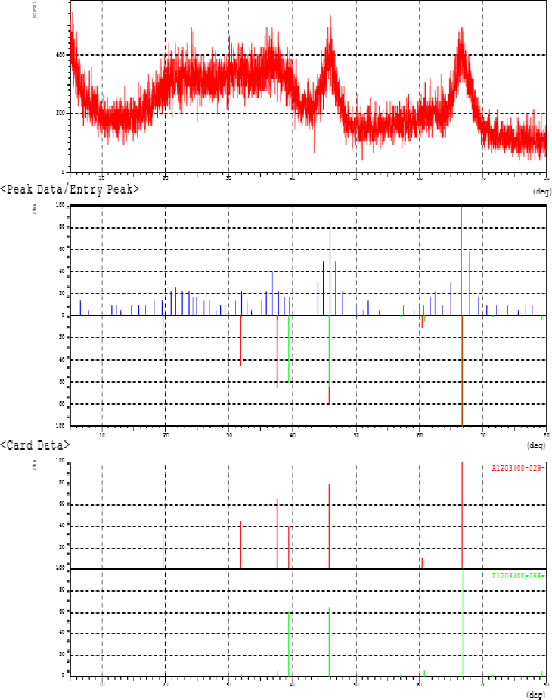

<Card Data>

**Figure S.19: XRD patterns for support-1**

*** Basic Data Process ***

Group Name : Mustafa

Data Name : support-1

File Name : m1.PKK

Sample Name :

465

|  |  |  |  |
| --- | --- | --- | --- |
| Comment : |  | | |
| <Entry Card> |
| No. Card Chemical Formula | S | L | d I R |
| Chemical Name (Mineral Name) 1 00-029-0063 Al2O3 | Dx WT% 0.701 1.000( 7 | | S.G.  / 7) 0.723 0.644 0. |

Aluminum Oxide 3.71 Fd-3m

2 00-056-0457 Al2O3 0.819 0.667( 8/22) 0.733 0.537 0.263

Aluminum Oxide 3.76 Fd-3m

*** Basic Data Process ***

Group : Mustafa

Data : support-2

|  |  |  |  |  |  |  |  |  |
| --- | --- | --- | --- | --- | --- | --- | --- | --- |
| # | Strongest no. peak | 3 peaks 2Theta | d | I/I1 | FWHM | Intensity | Integrated | Int |
|  | no. | (deg) | (A) |  | (deg) | (Counts) | (Counts) |  |
|  | 1 16 | 15.7067 | 5.63752 | 100 | 0.26750 | 34 | 470 |  |
|  | 2 36 | 23.7675 | 3.74065 | 97 | 0.25200 | 33 | 478 |  |
|  | 3 27 | 20.4540 | 4.33853 | 68 | 0.17500 | 23 | 237 |  |
| # | Peak Data  peak | List  2Theta | d | I/I1 | FWHM | Intensity | Integrated | Int |
|  | no. | (deg) | (A) |  | (deg) | (Counts) | (Counts) |  |
|  | 1 | 10.1930 | 8.67128 | 18 | 0.13000 | 6 | 35 |  |
|  | 2 | 10.5752 | 8.35874 | 3 | 0.00000 | 1 | 0 |  |
|  | 3 | 10.9278 | 8.08981 | 12 | 0.09000 | 4 | 34 |  |
|  | 4 | 11.3204 | 7.81011 | 15 | 0.06000 | 5 | 48 |  |
|  | 5 | 11.6286 | 7.60380 | 18 | 0.00000 | 6 | 0 |  |
|  | 6 | 11.9320 | 7.41113 | 50 | 0.23000 | 17 | 282 |  |
|  | 7 | 12.3051 | 7.18724 | 6 | 0.00000 | 2 | 0 |  |
|  | 8 | 12.6236 | 7.00661 | 6 | 0.04000 | 2 | 9 |  |
|  | 9 | 12.9323 | 6.84005 | 6 | 0.06000 | 2 | 11 |  |
|  | 10 | 13.2659 | 6.66878 | 6 | 0.07000 | 2 | 20 |  |
|  | 11 | 13.5249 | 6.54165 | 9 | 0.05000 | 3 | 19 |  |
|  | 12 | 13.9284 | 6.35303 | 9 | 0.04000 | 3 | 14 |  |
|  | 13 | 14.4765 | 6.11371 | 9 | 0.04000 | 3 | 15 |  |
|  | 14 | 14.7656 | 5.99465 | 9 | 0.06000 | 3 | 20 |  |
|  | 15 | 15.3140 | 5.78119 | 21 | 0.10000 | 7 | 54 |  |
|  | 16 | 15.7067 | 5.63752 | 100 | 0.26750 | 34 | 470 |  |
|  | 17 | 16.0721 | 5.51017 | 6 | 0.04000 | 2 | 11 |  |
|  | 18 | 16.3664 | 5.41174 | 9 | 0.03000 | 3 | 6 |  |
|  | 19 | 17.0499 | 5.19630 | 3 | 0.00000 | 1 | 0 |  |
|  | 20 | 17.5290 | 5.05534 | 6 | 0.04000 | 2 | 9 |  |
|  | 21 | 18.3077 | 4.84203 | 3 | 0.00000 | 1 | 0 |  |
|  | 22 | 18.7834 | 4.72047 | 50 | 0.22000 | 17 | 223 |  |
|  | 23 | 19.1554 | 4.62962 | 9 | 0.06000 | 3 | 17 |  |
|  | 24 | 19.4645 | 4.55680 | 3 | 0.00000 | 1 | 0 |  |
|  | 25 | 19.8832 | 4.46177 | 6 | 0.04000 | 2 | 8 |  |
|  | 26 | 20.1723 | 4.39848 | 15 | 0.06000 | 5 | 25 |  |
|  | 27 | 20.4540 | 4.33853 | 68 | 0.17500 | 23 | 237 |  |
|  | 28 | 20.8005 | 4.26704 | 6 | 0.02000 | 2 | 10 |  |
|  | 29 | 21.4189 | 4.14522 | 12 | 0.12000 | 4 | 32 |  |
|  | 30 | 21.6882 | 4.09435 | 12 | 0.06000 | 4 | 25 |  |
|  | 31 | 21.9825 | 4.04020 | 18 | 0.09000 | 6 | 40 |  |
|  | 32 | 22.2917 | 3.98485 | 21 | 0.27000 | 7 | 115 |  |
|  | 33 | 22.9053 | 3.87947 | 35 | 0.26000 | 12 | 174 |  |
|  | 34 | 23.1149 | 3.84476 | 12 | 0.00000 | 4 | 0 |  |
|  | 35 | 23.4741 | 3.78674 | 15 | 0.00000 | 5 | 0 |  |
|  | 36 | 23.7675 | 3.74065 | 97 | 0.25200 | 33 | 478 |  |
|  | 37 | 24.2475 | 3.66768 | 24 | 0.17000 | 8 | 77 |  |
|  | 38 | 24.5918 | 3.61710 | 3 | 0.00000 | 1 | 0 |  |
|  | 39 | 25.1541 | 3.53751 | 12 | 0.07330 | 4 | 24 |  |
|  | 40 | 25.4901 | 3.49163 | 3 | 0.00000 | 1 | 0 |  |
|  | 41 | 25.8645 | 3.44193 | 6 | 0.07000 | 2 | 12 |  |
|  | 42 | 26.1590 | 3.40385 | 15 | 0.06000 | 5 | 31 |  |

*** Basic Data Process ***

|  |  |  |  |  |  |  |
| --- | --- | --- | --- | --- | --- | --- |
| 43 | 26.5084 | 3.35977 | 12 | 0.12000 | 4 | 29 |
| 44 | 26.8279 | 3.32048 | 15 | 0.04000 | 5 | 21 |
| 45 | 27.1873 | 3.27739 | 68 | 0.22000 | 23 | 315 |
| 46 | 27.6865 | 3.21942 | 9 | 0.04000 | 3 | 10 |
| 47 | 27.9661 | 3.18787 | 15 | 0.08000 | 5 | 31 |
| 48 | 28.2158 | 3.16022 | 12 | 0.10000 | 4 | 31 |
| 49 | 28.4055 | 3.13955 | 6 | 0.04000 | 2 | 16 |
| 50 | 28.8798 | 3.08905 | 12 | 0.11000 | 4 | 29 |
| 51 | 29.1844 | 3.05750 | 24 | 0.10000 | 8 | 44 |
| 52 | 29.4890 | 3.02661 | 15 | 0.07000 | 5 | 25 |
| 53 | 29.7602 | 2.99964 | 32 | 0.12670 | 11 | 108 |
| 54 | 30.2330 | 2.95380 | 9 | 0.04000 | 3 | 9 |
| 55 | 30.8023 | 2.90049 | 24 | 0.12000 | 8 | 50 |
| 56 | 30.9821 | 2.88407 | 21 | 0.25340 | 7 | 115 |
| 57 | 31.5734 | 2.83139 | 65 | 0.25600 | 22 | 310 |
| 58 | 32.0009 | 2.79454 | 3 | 0.00000 | 1 | 0 |
| 59 | 32.3506 | 2.76512 | 6 | 0.10000 | 2 | 14 |
| 60 | 32.6219 | 2.74274 | 12 | 0.09670 | 4 | 18 |
| 61 | 32.7967 | 2.72852 | 12 | 0.08670 | 4 | 20 |
| 62 | 33.1597 | 2.69948 | 24 | 0.16000 | 8 | 78 |
| 63 | 33.4894 | 2.67365 | 9 | 0.06000 | 3 | 18 |
| 64 | 33.9589 | 2.63775 | 9 | 0.04000 | 3 | 13 |
| 65 | 34.2436 | 2.61647 | 26 | 0.11000 | 9 | 58 |
| 66 | 34.6083 | 2.58973 | 15 | 0.08000 | 5 | 29 |
| 67 | 34.9495 | 2.56523 | 18 | 0.08330 | 6 | 30 |
| 68 | 35.5524 | 2.52309 | 6 | 0.03000 | 2 | 5 |
| 69 | 36.2168 | 2.47832 | 18 | 0.12000 | 6 | 43 |
| 70 | 36.6764 | 2.44831 | 15 | 0.12000 | 5 | 50 |
| 71 | 36.8762 | 2.43550 | 26 | 0.16000 | 9 | 74 |
| 72 | 37.2360 | 2.41279 | 21 | 0.08000 | 7 | 39 |
| 73 | 37.7056 | 2.38381 | 15 | 0.10000 | 5 | 30 |
| 74 | 38.0386 | 2.36371 | 18 | 0.11330 | 6 | 39 |
| 75 | 38.2634 | 2.35033 | 24 | 0.11670 | 8 | 59 |
| 76 | 39.0146 | 2.30679 | 3 | 0.00000 | 1 | 0 |
| 77 | 39.3293 | 2.28906 | 9 | 0.03000 | 3 | 9 |
| 78 | 39.6374 | 2.27197 | 15 | 0.11330 | 5 | 37 |
| 79 | 39.8565 | 2.25998 | 21 | 0.13500 | 7 | 62 |
| 80 | 40.2787 | 2.23726 | 6 | 0.05000 | 2 | 7 |
| 81 | 40.5751 | 2.22160 | 18 | 0.10330 | 6 | 37 |
| 82 | 40.9032 | 2.20454 | 9 | 0.06000 | 3 | 21 |
| 83 | 41.2430 | 2.18715 | 12 | 0.18000 | 4 | 37 |
| 84 | 41.5828 | 2.17006 | 18 | 0.30000 | 6 | 80 |
| 85 | 41.7627 | 2.16113 | 15 | 0.06000 | 5 | 18 |
| 86 | 42.0425 | 2.14739 | 15 | 0.10000 | 5 | 47 |
| 87 | 42.5272 | 2.12403 | 15 | 0.07000 | 5 | 32 |
| 88 | 42.8620 | 2.10821 | 6 | 0.04000 | 2 | 6 |
| 89 | 43.1518 | 2.09472 | 6 | 0.14000 | 2 | 21 |
| 90 | 43.3617 | 2.08507 | 24 | 0.14000 | 8 | 55 |
| 91 | 43.5682 | 2.07566 | 15 | 0.12670 | 5 | 37 |
| 92 | 43.7514 | 2.06740 | 15 | 0.08000 | 5 | 30 |
| 93 | 44.1712 | 2.04872 | 15 | 0.08000 | 5 | 32 |
| 94 | 44.3561 | 2.04061 | 18 | 0.25000 | 6 | 71 |
| 95 | 44.7609 | 2.02309 | 15 | 0.06000 | 5 | 27 |
| 96 | 45.0307 | 2.01159 | 29 | 0.12000 | 10 | 75 |
| 97 | 45.3239 | 1.99926 | 15 | 0.05330 | 5 | 28 |

*** Basic Data Process ***

|  |  |  |  |  |  |  |
| --- | --- | --- | --- | --- | --- | --- |
| 98 | 45.6454 | 1.98592 | 15 | 0.09000 | 5 | 44 |
| 99 | 46.0352 | 1.97001 | 9 | 0.03000 | 3 | 16 |
| 100 | 46.2551 | 1.96115 | 18 | 0.13000 | 6 | 43 |
| 101 | 46.5699 | 1.94863 | 9 | 0.04000 | 3 | 20 |
| 102 | 46.9897 | 1.93219 | 3 | 0.00000 | 1 | 0 |
| 103 | 47.3445 | 1.91854 | 15 | 0.07000 | 5 | 31 |
| 104 | 47.5694 | 1.90999 | 3 | 0.00000 | 1 | 0 |
| 105 | 48.2790 | 1.88356 | 12 | 0.10000 | 4 | 20 |
| 106 | 48.6089 | 1.87154 | 9 | 0.12000 | 3 | 32 |
| 107 | 48.8987 | 1.86113 | 6 | 0.06000 | 2 | 11 |
| 108 | 49.2252 | 1.84955 | 18 | 0.11330 | 6 | 62 |
| 109 | 49.6434 | 1.83494 | 15 | 0.07000 | 5 | 32 |
| 110 | 50.0482 | 1.82104 | 18 | 0.20000 | 6 | 81 |
| 111 | 50.7729 | 1.79674 | 18 | 0.25000 | 6 | 80 |
| 112 | 51.2077 | 1.78250 | 21 | 0.12000 | 7 | 59 |
| 113 | 51.7674 | 1.76453 | 9 | 0.08000 | 3 | 31 |
| 114 | 52.0306 | 1.75623 | 12 | 0.07330 | 4 | 17 |
| 115 | 52.3122 | 1.74743 | 12 | 0.07000 | 4 | 18 |
| 116 | 52.5971 | 1.73864 | 15 | 0.14000 | 5 | 46 |
| 117 | 52.9819 | 1.72691 | 12 | 0.17000 | 4 | 39 |
| 118 | 53.2268 | 1.71954 | 9 | 0.04000 | 3 | 11 |
| 119 | 53.7316 | 1.70457 | 18 | 0.13000 | 6 | 43 |
| 120 | 54.2164 | 1.69047 | 21 | 0.22000 | 7 | 97 |
| 121 | 54.5529 | 1.68083 | 24 | 0.14670 | 8 | 71 |
| 122 | 54.9961 | 1.66833 | 15 | 0.10000 | 5 | 39 |
| 123 | 55.3460 | 1.65861 | 15 | 0.16000 | 5 | 48 |
| 124 | 55.6509 | 1.65024 | 15 | 0.07000 | 5 | 25 |
| 125 | 56.0057 | 1.64063 | 18 | 0.28000 | 6 | 79 |
| 126 | 56.4756 | 1.62809 | 15 | 0.22000 | 5 | 63 |
| 127 | 56.8154 | 1.61915 | 9 | 0.04000 | 3 | 13 |
| 128 | 57.1053 | 1.61162 | 6 | 0.04000 | 2 | 5 |
| 129 | 57.4102 | 1.60378 | 6 | 0.07000 | 2 | 14 |
| 130 | 57.8451 | 1.59276 | 18 | 0.16000 | 6 | 44 |
| 131 | 58.1450 | 1.58525 | 15 | 0.12000 | 5 | 36 |
| 132 | 58.6498 | 1.57281 | 26 | 0.21000 | 9 | 107 |
| 133 | 59.0596 | 1.56287 | 9 | 0.03000 | 3 | 8 |
| 134 | 59.3911 | 1.55493 | 9 | 0.02670 | 3 | 15 |
| 135 | 59.6644 | 1.54846 | 15 | 0.12000 | 5 | 52 |
| 136 | 59.9493 | 1.54178 | 9 | 0.03000 | 3 | 12 |
| 137 | 60.2642 | 1.53448 | 15 | 0.12000 | 5 | 38 |
| 138 | 60.5641 | 1.52759 | 18 | 0.08000 | 6 | 34 |
| 139 | 60.8041 | 1.52214 | 18 | 0.24000 | 6 | 81 |
| 140 | 61.1589 | 1.51415 | 12 | 0.09000 | 4 | 23 |
| 141 | 61.3589 | 1.50970 | 21 | 0.09000 | 7 | 49 |
| 142 | 61.6188 | 1.50395 | 21 | 0.11000 | 7 | 51 |
| 143 | 61.9137 | 1.49749 | 12 | 0.14000 | 4 | 29 |
| 144 | 62.2986 | 1.48916 | 21 | 0.19000 | 7 | 66 |
| 145 | 62.6185 | 1.48232 | 9 | 0.03000 | 3 | 11 |
| 146 | 62.8984 | 1.47640 | 9 | 0.09000 | 3 | 30 |
| 147 | 63.2683 | 1.46866 | 12 | 0.17000 | 4 | 30 |
| 148 | 63.6232 | 1.46132 | 12 | 0.12000 | 4 | 27 |
| 149 | 63.9331 | 1.45498 | 12 | 0.10000 | 4 | 23 |
| 150 | 64.2430 | 1.44870 | 21 | 0.16000 | 7 | 53 |
| 151 | 64.7628 | 1.43833 | 26 | 0.20000 | 9 | 101 |

*** Basic Data Process ***

|  |  |  |  |  |  |  |
| --- | --- | --- | --- | --- | --- | --- |
| 152 | 65.1643 | 1.43043 | 21 | 0.18330 | 7 | 64 |
| 153 | 65.4226 | 1.42541 | 29 | 0.18000 | 10 | 86 |
| 154 | 65.6225 | 1.42155 | 26 | 0.20000 | 9 | 101 |
| 155 | 66.0524 | 1.41334 | 32 | 0.22000 | 11 | 130 |
| 156 | 66.3723 | 1.40730 | 35 | 0.26000 | 12 | 167 |
| 157 | 66.8688 | 1.39805 | 32 | 0.13330 | 11 | 83 |
| 158 | 67.3020 | 1.39010 | 18 | 0.16000 | 6 | 55 |
| 159 | 67.4920 | 1.38665 | 12 | 0.10000 | 4 | 28 |
| 160 | 67.9269 | 1.37883 | 9 | 0.03000 | 3 | 19 |
| 161 | 68.4617 | 1.36935 | 15 | 0.12000 | 5 | 45 |
| 162 | 68.7916 | 1.36359 | 6 | 0.06000 | 2 | 13 |
| 163 | 69.0815 | 1.35857 | 9 | 0.08000 | 3 | 21 |
| 164 | 70.6011 | 1.33301 | 9 | 0.04000 | 3 | 17 |
| 165 | 71.2709 | 1.32212 | 12 | 0.10000 | 4 | 26 |
| 166 | 71.5558 | 1.31755 | 9 | 0.09000 | 3 | 19 |
| 167 | 71.8257 | 1.31326 | 6 | 0.09000 | 2 | 10 |
| 168 | 72.0807 | 1.30924 | 9 | 0.04000 | 3 | 18 |
| 169 | 72.7405 | 1.29899 | 9 | 0.16000 | 3 | 39 |
| 170 | 73.0137 | 1.29480 | 9 | 0.10670 | 3 | 24 |
| 171 | 73.3853 | 1.28916 | 12 | 0.13000 | 4 | 30 |
| 172 | 73.7102 | 1.28428 | 9 | 0.06000 | 3 | 16 |
| 173 | 74.0001 | 1.27996 | 6 | 0.04000 | 2 | 4 |
| 174 | 74.5200 | 1.27231 | 6 | 0.04000 | 2 | 6 |
| 175 | 74.7399 | 1.26911 | 3 | 0.00000 | 1 | 0 |
| 176 | 75.1598 | 1.26306 | 6 | 0.04000 | 2 | 9 |
| 177 | 75.4498 | 1.25893 | 6 | 0.10000 | 2 | 18 |
| 178 | 75.7397 | 1.25483 | 3 | 0.00000 | 1 | 0 |
| 179 | 76.1196 | 1.24951 | 3 | 0.00000 | 1 | 0 |
| 180 | 76.4345 | 1.24514 | 6 | 0.11000 | 2 | 21 |
| 181 | 76.7794 | 1.24040 | 6 | 0.04000 | 2 | 6 |
| 182 | 77.0793 | 1.23633 | 12 | 0.08000 | 4 | 34 |
| 183 | 77.5192 | 1.23040 | 3 | 0.00000 | 1 | 0 |
| 184 | 77.8191 | 1.22641 | 9 | 0.04000 | 3 | 20 |
| 185 | 78.1890 | 1.22153 | 9 | 0.06000 | 3 | 18 |
| 186 | 78.4789 | 1.21774 | 6 | 0.08000 | 2 | 19 |
| 187 | 78.9488 | 1.21167 | 9 | 0.14000 | 3 | 33 |
| 188 | 79.4187 | 1.20568 | 9 | 0.16000 | 3 | 33 |
| 189 | 79.8486 | 1.20027 | 12 | 0.18000 | 4 | 37 |

*** Basic Data Process ***

<Unknown Data>

Group Name : Mustafa Data Name : support-2 File Name : 1.PKK Sample Name :

Comment :

Date & Time : 03-30-11 05:51:48

<Raw Data>

<Peak Data/Entry Peak>

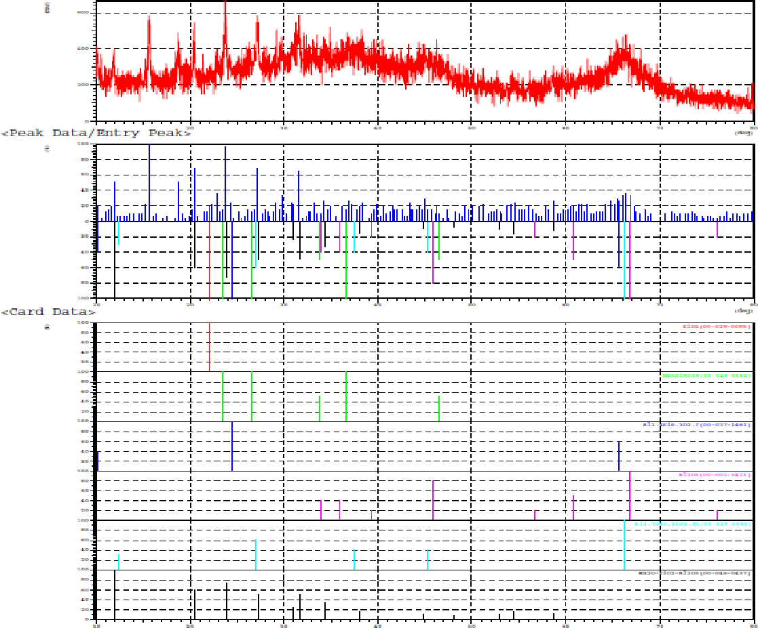

<Card Data>

**Figure S.20: XRD patterns for support-2**

*** Basic Data Process ***

Group Name : Mustafa Data Name : support-2 File Name : 1.PKK Sample Name :

Comment :

<Entry Card>

No. Card Chemical Formula S L d I R Chemical Name (Mineral Name) Dx WT% S.G.

1 00-029-0085 SiO2 0.180 1.000( 1/ 1) 0.998 1.000 0.998

Silicon Oxide ----- -------

2 00-049-0162 Na6Si8O19 0.150 1.000( 5/ 5) 0.876 0.905 0.793

Sodium Silicate ----- -------

3 00-037-1461 Al1.4Si0.3O2.7 0.340 1.000( 3/ 3) 0.844 0.744 0.628

Aluminum Silicate ----- -------

4 00-002-1421 Al2O3 0.305 1.000( 8/16) 0.804 0.755 0.607

Aluminum Oxide 3.75 -------

5 00-029-0086 Al1.7Si0.15O2.85 0.341 1.000( 5/ 5) 0.725 0.810 0.587

Aluminum Silicate ----- -------

6 00-045-0437 Na2O-SiO2-Al2O3 0.871 1.000(13/13) 0.842 0.661 0.556

Sodium Aluminum Silicate ( Faujasite-Na, s Fd-3m

# XRD of catalysts

# Anchor Scan Parameters: (Bookmark1)

Dataset Name CAT-1

File name Z:\hosseinzadeh sara-1062752376\99-05-02 99042923\alz0.ASC

Raw Data Origin ASCII-2Theta-Intensity (.ASC)

Scan Axis Gonio

Start Position [°2Th.] 10.0600

End Position [°2Th.] 79.9600

Step Size [°2Th.] 0.0500

Scan Step Time [s] 1.0000

Scan Type Pre-set time

Offset [°2Th.] 0.0000

Divergence Slit Type Fixed

Divergence Slit Size [°] 1.0000

Specimen Length [mm] 10.00

Receiving Slit Size [mm] 0.1000

Measurement Temperature [°C] 25.00

Anode Material Cu

K-Alpha1 [Å] 1.54060

K-Alpha2 [Å] 1.54443

K-Beta [Å] 1.39225

K-A2 / K-A1 Ratio 0.50000

Generator Settings 0 mA, 0 kV

Diffractometer Number 0

Goniometer Radius [mm] 240.00

Dist. Focus-Diverg. Slit [mm] 91.00

Incident Beam Monochromator No

Spinning No

# 

# Graphics: (Bookmark2)



**Figure S.21: XRD patterns for CAT-1**

**Peak List: (Bookmark 3)**

|  |  |  |  |  |  |  |
| --- | --- | --- | --- | --- | --- | --- |
| Pos. [°2Th.] | Height [cts] | FWHM Left [°2Th.] | d-spacing [Å] | Rel. Int. [%] | Tip Width | Matched by |
| 10.4204 | 104.87 | 0.5904 | 8.48954 | 30.83 | 0.7085 |  |
| 15.7575 | 132.28 | 0.5904 | 5.62410 | 38.89 | 0.7085 |  |
| 20.5455 | 212.41 | 0.5904 | 4.32300 | 62.44 | 0.7085 |  |
| 23.7789 | 263.20 | 0.3936 | 3.74198 | 77.37 | 0.4723 |  |
| 27.2540 | 340.16 | 0.3936 | 3.27222 | 100.00 | 0.4723 |  |
| 31.5512 | 335.04 | 0.9840 | 2.83568 | 98.49 | 1.1808 |  |
| 37.5862 | 311.83 | 1.1808 | 2.39309 | 91.67 | 1.4170 |  |
| 46.4022 | 222.33 | 2.3616 | 1.95689 | 65.36 | 2.8339 |  |
| 66.5449 | 319.50 | 2.7552 | 1.40523 | 93.93 | 3.3062 |  |

# Anchor Scan Parameters: (Bookmark1)

Dataset Name CAT-3

File name Z:\hosseinzadeh sara-1062752376\99-05-02 99042923\alz0.ASC

Raw Data Origin ASCII-2Theta-Intensity (.ASC)

Scan Axis Gonio

Start Position [°2Th.] 10.0600

End Position [°2Th.] 79.9600

Step Size [°2Th.] 0.0500

Scan Step Time [s] 1.0000

Scan Type Pre-set time

Offset [°2Th.] 0.0000

Divergence Slit Type Fixed

Divergence Slit Size [°] 1.0000

Specimen Length [mm] 10.00

Receiving Slit Size [mm] 0.1000

Measurement Temperature [°C] 25.00

Anode Material Cu

K-Alpha1 [Å] 1.54060

K-Alpha2 [Å] 1.54443

K-Beta [Å] 1.39225

K-A2 / K-A1 Ratio 0.50000

Generator Settings 0 mA, 0 kV

Diffractometer Number 0

Goniometer Radius [mm] 240.00

Dist. Focus-Diverg. Slit [mm] 91.00

Incident Beam Monochromator No

Spinning No

# Graphics: (Bookmark2)



**Figure S.22: XRD patterns for CAT-2**

**Peak List: (Bookmark 3)**

|  |  |  |  |  |  |  |
| --- | --- | --- | --- | --- | --- | --- |
| Pos. [°2Th.] | Height [cts] | FWHM Left [°2Th.] | d-spacing [Å] | Rel. Int. [%] | Tip Width | Matched by |
| 12.0696 | 167.12 | 0.3936 | 7.33301 | 27.63 | 0.4723 |  |
| 15.8895 | 354.90 | 0.3936 | 5.57769 | 58.68 | 0.4723 |  |
| 18.8796 | 220.61 | 0.2952 | 4.70051 | 36.47 | 0.3542 |  |
| 20.6040 | 273.05 | 0.2952 | 4.31086 | 45.14 | 0.3542 |  |
| 23.9819 | 604.84 | 0.3444 | 3.71075 | 100.00 | 0.4133 |  |
| 27.3616 | 370.56 | 0.3936 | 3.25960 | 61.27 | 0.4723 |  |
| 31.7905 | 496.27 | 0.2952 | 2.81488 | 82.05 | 0.3542 |  |
| 37.9764 | 278.93 | 3.1488 | 2.36939 | 46.12 | 3.7786 |  |
| 45.5529 | 223.92 | 1.9680 | 1.99138 | 37.02 | 2.3616 |  |
| 66.4806 | 273.76 | 2.7552 | 1.40643 | 45.26 | 3.3062 |  |

# Anchor Scan Parameters: (Bookmark1)

Dataset Name CAT-4

File name Z:\hosseinzadeh sara-1062752376\99-05-02 99042923\alz0.ASC

Raw Data Origin ASCII-2Theta-Intensity (.ASC)

Scan Axis Gonio

Start Position [°2Th.] 10.0600

End Position [°2Th.] 79.9600

Step Size [°2Th.] 0.0500

Scan Step Time [s] 1.0000

Scan Type Pre-set time

Offset [°2Th.] 0.0000

Divergence Slit Type Fixed

Divergence Slit Size [°] 1.0000

Specimen Length [mm] 10.00

Receiving Slit Size [mm] 0.1000

Measurement Temperature [°C] 25.00

Anode Material Cu

K-Alpha1 [Å] 1.54060

K-Alpha2 [Å] 1.54443

K-Beta [Å] 1.39225

K-A2 / K-A1 Ratio 0.50000

Generator Settings 0 mA, 0 kV

Diffractometer Number 0

Goniometer Radius [mm] 240.00

Dist. Focus-Diverg. Slit [mm] 91.00

Incident Beam Monochromator No

Spinning No

# Graphics: (Bookmark2)



**Figure S.23: XRD patterns for CAT-3**

**Peak List: (Bookmark 3)**

|  |  |  |  |  |  |  |
| --- | --- | --- | --- | --- | --- | --- |
| Pos. [°2Th.] | Height [cts] | FWHM Left [°2Th.] | d-spacing [Å] | Rel. Int. [%] | Tip Width | Matched by |
| 12.1432 | 95.52 | 0.5904 | 7.28871 | 22.69 | 0.7085 |  |
| 15.9708 | 241.10 | 0.3936 | 5.54946 | 57.28 | 0.4723 |  |
| 19.0716 | 163.16 | 0.3936 | 4.65363 | 38.76 | 0.4723 |  |
| 20.6987 | 190.03 | 0.2952 | 4.29133 | 45.15 | 0.3542 |  |
| 24.0432 | 420.91 | 0.2460 | 3.70143 | 100.00 | 0.2952 |  |
| 27.4984 | 253.79 | 0.2952 | 3.24370 | 60.30 | 0.3542 |  |
| 31.9434 | 280.58 | 0.3936 | 2.80175 | 66.66 | 0.4723 |  |
| 45.7778 | 77.32 | 1.5744 | 1.98212 | 18.37 | 1.8893 |  |
| 66.7721 | 176.59 | 2.3616 | 1.40100 | 41.95 | 2.8339 |  |