Supplementary Material
High tribo-corrosion resistance of Ni-Cr-5Al₂O₃ thermal spray coating: a comparison of post processing techniques
Mayank Gar et al.
DOI 10.1515/corrrev-2024-0065

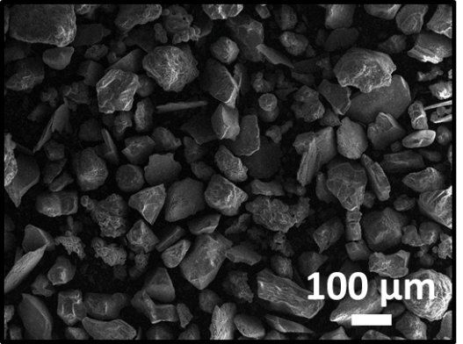

Supplementary Figure S1: BSE image river sand.

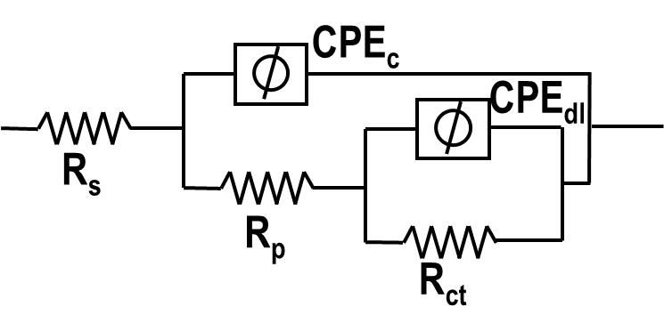
Supplementary Figure S2: Electrical equivalent circuit (EEC) diagram for fitting of impedance spectra.

Supplementary Table S1: Chemical composition of SS316L.
Element | C | Si | Mn | P | S | Cr | Ni | Mo | N
Weight % | 0.09 | 0.28 | 0.92 | 0.01 | 0.01 | 18.82 | 9.89 | 1.93 | 0.00

Supplementary Table S2: Test parameters used for the slurry erosion testing.
Parameters | Value
Stand-off distance | 20 mm
Sand particle concentration | 5000 ppm
Sand particle size | 75-150 µm
Angle of impact | 30°, 90°
Jet velocity | 20 m/s
Test duration | 2 h

