Supplementary Material
Comparison of protective coatings prepared from various trialkoxysilanes and possibilities of spectroelectrochemical approaches for their investigation
Angelja K. Surca and Mirjana Rodošek
DOI 10.1515/corrrev-2022-0007

Supplementary Table S1: Precursors used for the preparation of trialkoxysilane-, PDMS and PDMSTU-based coatings and, references of concerned works.
Coating | Precursors | References
MPTMS | - (3-mercaptopropyl)trimethoxysilane  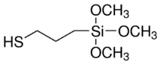 | Mihelčič et al. 2017
BTMSE | - 1,2-bis(trimethoxysilyl)ethane | Rodošek et al. 2016
PDMSU | - Bis-trialkoxysilyl-ureido-functionalised-PDMS | Fir et al. 2007;  Šurca Vuk et al. 2008
PDMSTU | - Bis-trialkoxysilyl-thioureido-functionalised-PDMS  - Bis(triethoxysilylpropyl)tetrasulfide  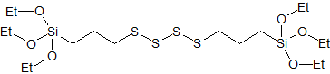  - Trisilanol-heptaisooctyl-POSS  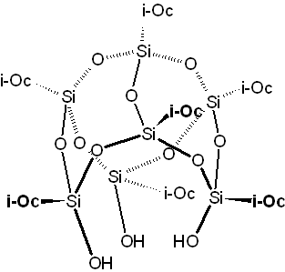 | Surca et al. 2017

Supplementary Table S2: Precursors used for the preparation of sol-gel/epoxy coatings and references of concerned works.
Coating | Precursors | References
GPTMS/AP₄iBu₄POSS | - (3-glycidyloxypropyl)trimethoxysilane  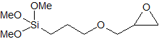  - Tetraaminopropyl-tetraisobutyl-POSS | Jerman et al. 2011
GPTMS/APTMS/POSS/NH₂PDMSNH₂ | - (3-glycidyloxypropyl)trimethoxysilane  - (3-aminopropyl)trimethoxysilane  - Aminopropyl-heptaisooctyl-POSS  - H₂N-PDMS-NH₂  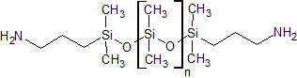 | Rauter et al. 2013
EP-PDMS-EP/APTMS/APiOc₇POSS | - EP-PDMS-EP  - (3-aminopropyl)trimethoxysilane  - Aminopropyl-heptaisooctyl-POSS | Rodošek et al. 2014
Supplementary Table S3: Precursors used for the preparation of trialkoxysilyl-functionalized cyclic tetrasilsesquioxane-based coatings and the reference of the concerned work.
Coating | Precursors | References
CS4 | - Trialkoxysilyl-functionalized cyclic tetrasilsesquioxane | Rodošek et al. 2017
CS4/BTMSE | - Trialkoxysilyl-functionalized cyclic tetrasilsesquioxane  - Bis(trimethoxysilyl)ethane (BTMS) | Rodošek et al. 2017
CS4/BTMSE | - Trialkoxysilyl-functionalized cyclic tetrasilsesquioxane  - Bis(trimethoxysilyl)ethane  - And one of 5 additives  - dimethyldiethoxysilane (DMDES)  - phenyltrimethoxysilane (PhTMS)  - isooctyl trimethoxysilane (IOTMS)  - hexadecyltrimethoxysilane (HDTMS)  - 1H,1H,2H,2H-  perfluorooctyltriethoxysilane (PFOTES) | Rodošek et al. 2017

