Appendix A
Stimulus Materials

1 Immigration control



2 Immigration anti-establishment populism (political elites are blamed)

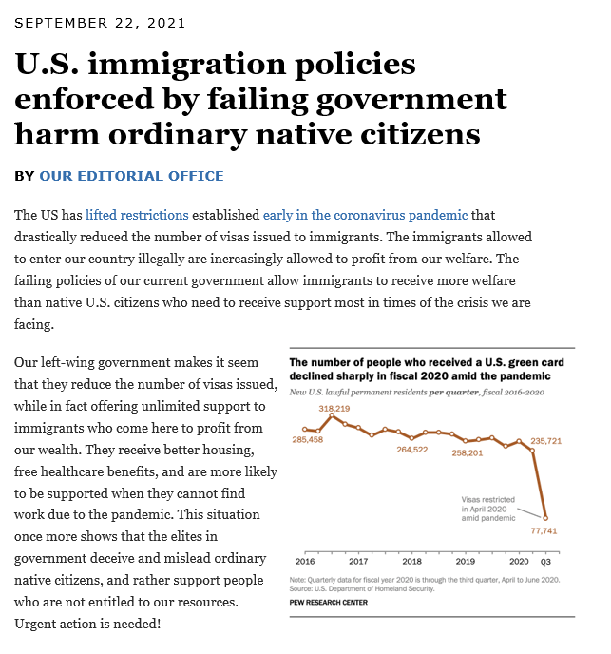

3 Immigration, anti-media populism (media elites are blamed)

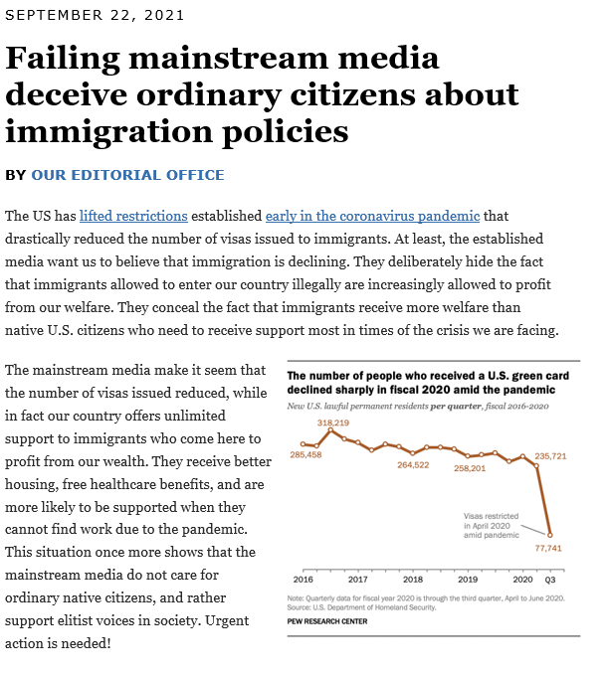

4 Climate change, control condition



5 Climate change, anti-establishment populism (political elites are blamed)


6 Climate change, anti-media populism (media elites are blamed)



Appendix B
Manipulation check and procedures

Participants entered the survey through the digital invitation sent by Dynata. When they entered, they completed the informed consent procedures (all procedures have been approved by the University’s ethical review board under number [anonymized for peer review]). Contingent upon accepting the terms and conditions of the study, participants first answered a block of pre-treatment questions (i.e., age, gender, education) and the questions used as moderators (the batteries of items measuring media (dis)trust and political cynicism). In the next step, they were exposed to the treatments. They more specifically read two news articles: One on immigration and crime rates and one on climate change (the order of appearance was randomized). Depending on the conditions they were randomly assigned to, participants either saw non-populist messages on the two issues, or a populist message that assigned blame to the mainstream media or political elites. A short block of questions followed after each article, including questions on the intentions to select or avoid a variety of media sources as a follow-up of the information they just read. After reading the messages and answering specific questions related to these (manipulated) messages on climate change and immigration, participants answered questions for the general dependent variables: Perceived factual relativism and disinformation beliefs related to the news media. Finally, participants answered questions on the manipulation checks and received a careful debriefing. This debriefing fact-checked all false and manipulated statements, offered the original news articles that were used as a template, informed participants about the nature of the study and the reason for deception, and offered the opportunity to ask any questions related to the nature of the study.
The manipulation checks included at the end of the survey were successful. More specifically, we first of all see that participants exposed to the populist condition in which political elites were blamed were significantly and substantially more likely to associate the message with an emphasis on blame-shifting to politicians (M = 5.11, SD = 1.61) than participants exposed to the control condition (M = 3.46, SD = 1.87) or the anti-media populism condition (M = 3.81, SD = 1.87; F(6, 462) = 11.38, p <.001). Likewise, participants exposed to a populist message in which the media elites were blamed for spreading ‘fake news’ and deceiving the people were more likely to associate the message with an emphasis on anti-media sentiments (M = 5.10, SD = 1.78) than participants in the control condition (M = 3.69, SD = 1.76) or participants exposed to a populist message blaming political elites (M = 4.04, SD = 1.92; F(6, 462) = 6.42, p <.001). We additionally used a manipulation check to ensure that participants perceived that the targeted elites were dishonest and misleading the people – we again see that participants in the experimental conditions were more likely to associate the message with deception and dishonesty than participants in the control groups. We did not exclude participants who failed the manipulation checks. Yet, robustness checks in which we run analyses separately for people failing the checks did not change any of the outcomes reported here.
To ensure that the randomization succeeded, we conducted post-hoc randomization checks for age, gender, level of education, and political ideology. The distributions on these variables are similar across all conditions, and the chi square tests indicate that there are no significant differences in the proportion of age (χ²(25) = 17.95, p = .844), gender (χ²(10) = 6.53, p = .769), education (χ²(25) = 10.63, p = .387), or ideology (χ²(45) = 24.67, p = .421) across the treatment and control conditions.
Appendix C
Regression tables

Table 1: The effects of populist blame attributions on perceived factual relativism.

 | Model I (n = 428) |  |  | Model II (n = 428) |  |  | Model III (n = 428)
 | B | SE | β | B | SE | β | B | SE | β
(Constant) | 4.42 | .12 |  | 1.49 | .17 |  | 1.74 | .53
Politicians blamed | .07 | .17 | .02 | -.10 | .15 | -.03 | -1.18 | .74 | -.39
Media blamed | -.02 | .17 | -.06 | -.08 | .15 | -.03 | .04 | .70 | .01
Media distrust |  |  |  | .26 | .03 | .33*** | .14 | .06 | .18*
Political cynicism |  |  |  | .39 | .05 | .35*** | .42 | .09 | .38***
Distrust × politicians blamed |  |  |  |  |  |  | .16 | .06 | .22*
Distrust × media blamed |  |  |  |  |  |  | .20 | .08 | .29**
Cynicism × politicians blamed |  |  |  |  |  |  | .10 | .11 | .19
Cynicism × media blamed |  |  |  |  |  |  | -.16 | .12 | -.28
Adjusted R² | .009 |  |  | .079 |  |  | .083
F | .144 |  |  | 30.77*** |  |  | 17.26***
F for change in R² |  |  |  | 61.35*** |  |  | 3.14**
*p < .05; **p < .01; ***p < .001
Note. Two-tailed tests. Unstandardized (B) and standardized (β) regression weights.
Table 2: The effects of populist blame attributions on perceived disinformation.

 | Model I (n = 428) |  |  | Model II (n = 428) |  |  | Model III (n = 428)
 | B | SE | β | B | SE | β | B | SE | β
(Constant) | 4.51 | .13 |  | 1.75 | .32 |  | 2.29 | .58
Politicians blamed | .03 | .18 | .01 | -.05 | .16 | -.02 | -1.07 | .81 | -.33
Media blamed | -.17 | .18 | -.05 | -.18 | .16 | -.06 | -.83 | .77 | -.25
Media distrust |  |  |  | .02 | .04 | .03 | .47 | .10 | .18*
Political cynicism |  |  |  | .53 | .05 | .44*** | .42 | .09 | .40***
Distrust × politicians blamed |  |  |  |  |  |  | .06 | .09 | .08
Distrust × media blamed |  |  |  |  |  |  | .17 | .08 | .23*
Cynicism × politicians blamed |  |  |  |  |  |  | .16 | .14 | .27
Cynicism × media blamed |  |  |  |  |  |  | .01 | .13 | .02
Adjusted R² | .009 |  |  | .079 |  |  | .083
F | .710 |  |  | 26.42*** |  |  | 13.97***
F for change in R² |  |  |  | 51.97*** |  |  | 1.42
*p < .05; **p < .01; ***p < .001
Note. Two-tailed tests. Unstandardized (B) and standardized (β) regression weights.

Table 3: The effect of populist cues on selective avoidance of mainstream media.

 | Model I (n = 428) |  |  | Model II (n = 428) |  |  | Model III (n = 428)
 | B | SE | β | B | SE | β | B | SE | β
(Constant) | 3.70 | .15 |  | 1.37 | .35 |  | 1.49 | .65
Politicians blamed | -.18 | .21 | -.01 | .11 | .18 | .03 | 1.07 | .89 | -.27
Media blamed | .18 | .21 | .05 | .30 | .18 | .08* | -.15 | .84 | -.04
Media distrust |  |  |  | .-57 | .04 | .-56*** | -.64 | .07 | -.63***
Political cynicism |  |  |  | -.08 | .06 | -.06 | -.01 | .11 | -.01
Distrust × politicians blamed |  |  |  |  |  |  | .03 | .10 | .04
Distrust × media blamed |  |  |  |  |  |  | .17 | .08 | .18*
Cynicism × politicians blamed |  |  |  |  |  |  | -.20 | .15 | -.28
Cynicism × media blamed |  |  |  |  |  |  | -.02 | .14 | -.03
Adjusted R² | .002 |  |  | .308 |  |  | .311
F | 1.38 |  |  | 52.38*** |  |  | 30.00***
F for change in R² |  |  |  | 102.77*** |  |  | 1.42
*p < .05; **p < .01; ***p < .001
Note. Two-tailed tests. Unstandardized (B) and standardized (β) regression weights.

