Appendix A
List of key events
2015
- 23/24 – 29/30 June: Mayhem at camp Calais as migrants tried to get into the lorries that waited for the ending of the ferry-workers’ strike.
- 22 August: One of the biggest rescue operations up to then (4,400 migrants rescued off the coast of Libya).
- 2 September: Death of Syrian boy Alan Kurdi
- 15/16 September: Hundreds of Migrants got stuck at the barrier and tried to break through when Hungary closed its border with Serbia and declared a state of emergency in those two southern counties, as new laws to stop migrants entering illegally came into force.
- 25 October: An emergency summit in Brussels involving the heads of eleven EU and three non-EU states to discuss the migrant crisis.
- 13 November: Paris terrorist attacks.

2016
- 1 January: New Year’s Eve assault (Cologne).
- 25 January: Death of Alexandra Mezher (A Swedish woman was stabbed to death by an asylum seeker at the refugee center where she worked).
- 9 March: Balkan countries announced tighter restrictions on migrant entry in a bid to close the ‘Balkan route’.
- 22 March: Brussels bombing.
- 10 April: Eruption of clashes at the Idomeni migrant camp on the Greece-Macedonia border. More than 200 migrants and at least 15 police officers were injured.
- 19 December: Berlin Christmas market attack.

2017
- 17 March: Süleyman Soylu (Turkish interior minister) threatens to send 15,000 refugees to the EU monthly, Mevlut Cavusoglu (foreign minister) threatens to cancel the EU-Turkey migrant deal in the wake of tensions between Turkey and several European nations over the 2017 Turkish constitutional referendum.
- 22 May: Manchester arena bombing.
- 17-18 August: Barcelona attacks.
- 24 September: The anti-immigration Alternative for Germany (AfD) becomes the first nationalist party to enter the German Bundestag since World War II, becoming the third largest party overall and single largest opposition party.
Table A1: Distribution of articles and article length across outlets.
 | Print |  |  | Online
 | Der Spiegel | Die Welt | Die Zeit | Der Spiegel | Die Welt | Die Zeit
N | 587 | 4619 | 714 | 4847 | 5431 | 2243
Article length (in characters)
Mean | 3239.07 | 4460.67 | 4681.78 | 3388.69 | 3482.78 | 4757.40
Standard deviation | 2115.40 | 2084.44 | 1999.54 | 1699.21 | 1700.94 | 2021.07
Min. | 301 | 207 | 167 | 263 | 555 | 468
Max. | 8189 | 8191 | 8191 | 8185 | 8183 | 8185
Precision score | 0.833 | 0.784 | 0.762 | 0.862 | 0.908 | 0.806
Note: Precision scores based on manual coding of a 3% random sample for each outlet.
As can be seen in Table A1, there is a clear imbalance between the outlets regarding the total number of published articles as well as their article length. Generally, articles in print media are, on average, significantly longer compared to those released only online (average number of characters in print: 4,366.21 vs. online: 3,674.69). A possible explanation for this is that online news is generally more fleeting, with the purpose of keeping people updated, whereas print news is meant for those who are interested in more background information. To be expected, the weekly print outlets (Der Spiegel and Die Zeit) published the fewest number of articles on the issue throughout the period of investigation, ranging from below 600 to above 700 articles in total (see Table 1). Moreover, the print version of Der Spiegel has significantly shorter articles than the other two print outlets.
Zeit Online released less than half of Spiegel Online or Welt Online, but exhibits significantly longer articles than the other two, being more comparable with its print version. Welt Online published most on the topic with almost 5,500 articles. Perhaps because of its conservative nature, Die Welt and Welt Online showed particular interest in the topic that colludes with such strong social changes. These structural differences between outlets might be kept in mind when investigating the prevalence of frames.

Appendix B
Table B1: Correlation between frames.
 | Fear | Economy | Route | Turkey | Right wing extremism | Crime | Refugee crossing | Terrorism | Border | Accom. | Asylum | Middle East war | Religious conflict | Right wing populism
Fear | 1 | -0.039 | -0.154 | -0.044 | 0.018 | -0.191 | -0.095 | -0.089 | -0.021 | -0.112 | -0.185 | -0.046 | -0.021 | -0.013
Economy |  | 1 | -0.122 | -0.095 | -0.125 | -0.14 | -0.098 | -0.11 | -0.079 | 0.081 | -0.022 | -0.101 | -0.044 | -0.039
Route |  |  | 1 | -0.004 | -0.107 | -0.043 | 0.052 | -0.086 | 0.028 | -0.055 | -0.055 | -0.056 | -0.04 | -0.089
Turkey |  |  |  | 1 | -0.078 | -0.081 | -0.027 | -0.077 | 0.105 | -0.108 | -0.059 | 0.029 | -0.045 | -0.06
Right-wing extremism |  |  |  |  | 1 | 0.068 | -0.093 | 0.027 | -0.143 | -0.004 | -0.137 | -0.085 | -0.065 | 0.042
Crime |  |  |  |  |  | 1 | -0.062 | 0.124 | -0.143 | -0.016 | -0.099 | -0.023 | -0.067 | -0.084
Refugee crossing |  |  |  |  |  |  | 1 | -0.073 | 0.03 | -0.093 | -0.08 | -0.021 | 0.032 | -0.075
Terrorism |  |  |  |  |  |  |  | 1 | -0.103 | -0.048 | 0.049 | -0.009 | -0.075 | -0.044
Border |  |  |  |  |  |  |  |  | 1 | -0.13 | -0.042 | -0.073 | -0.053 | -0.083
Accommodation |  |  |  |  |  |  |  |  |  | 1 | -0.003 | -0.096 | -0.045 | -0.067
Asylum |  |  |  |  |  |  |  |  |  |  | 1 | -0.095 | -0.059 | -0.089
Middle East war |  |  |  |  |  |  |  |  |  |  |  | 1 | 0.095 | -0.076
Religious conflict |  |  |  |  |  |  |  |  |  |  |  |  | 1 | -0.061
Right-wing populism |  |  |  |  |  |  |  |  |  |  |  |  |  | 1

Table B2: All frames.
Family | Fear | Election | Economy | Route | USA/Russia | Turkey | Right-wing  extremism | Crime | Refugee  crossing
kind  famili  alt  erzahlt  weiss  schul  arbeit  haus  jahrig  paar | gesellschaft  angst  burg  demokrati  kris  problem  schaff  gefahr  tatsach  wert | grun  wahl  link  fdp  schulz  wahlkampf  koalition  rot  bad  wurttemberg | milliard  wirtschaft  arbeit  integration  hoh  unternehm  arbeitsmarkt  geld  schul  job | griechisch  griechenland  migrant  polizei  mazedoni  behord  tausend  balkanrout  inseln  gelang | trump  usa  prasident  us  russland  putin  russisch  amerikan  ukrain  donald | turkei  turkisch  erdogan  ankara  prasident  turk  abkomm  tayyip  recep  deal | pegida  facebook  dresd  sachs  rechtsextrem  rassist  demonstration  medi  fremdenfeind  sachsisch | polizei  jahrig  ermittl  verletzt  staatsanwaltschaft  verdacht  mutmass  alt  angab  festgenomm | mittelme  itali  liby  boot  migrant  italien  schiff  kust  libysch  kustenwach
Terrorism | Border | EU pol. | Accommodation | Gov. | Asylum | Middle East  war | Religious  conflict | Aust./Hung. | Right-wing  populism
anschlag  koln  polizei  straftat  behord  ubergriff  islamist  tunesi  attentat  terrorist | griechenland  kommission  brussel  gipfel  pol  aussengrenz  gemeinsam  regierungschef  verteil  itali | frankreich  franzos  grossbritanni  britisch  schwed  brexit  paris  niederland  macron  brit | stadt  kommun  unterkunft  wohnung  hamburg  helf  unterbring  bund  bundesland  gemeind | csu  seehof  kanzlerin  gabriel  chef  fluchtlingspolit  obergrenz  horst  vorsitz  bayer | abschieb  asylantrag  bamf  asyl  maizièr  abgelehnt  bundesregier  migration  bundesamt  asylverfahr | syri  is  syrisch  kampf  islam  al  irak  assad  stadt  soldat | muslim  kind  kirch  un  international  afrika  flucht  christ  nation  gewalt | osterreich  ungarn  orbán  ungar  wien  fpo  budap  tschechi  slowakei  pol | afd  umfrag  befragt  wahl  petry  mehrheit  gauland  anhang  punkt  burg

Table B3: Frame salience across outlets (online and print combined).
 | Spiegel | Zeit | Welt
Fear | 0.052 | 0.127 | 0.087
Economy | 0.058 | 0.064 | 0.084
Route | 0.059 | 0.038 | 0.043
Turkey | 0.036 | 0.036 | 0.033
Right-wing  extremism | 0.052 | 0.056 | 0.047
Crime | 0.085 | 0.033 | 0.06
Refugee  crossing | 0.049 | 0.039 | 0.032
Terrorism | 0.038 | 0.034 | 0.05
Border | 0.051 | 0.039 | 0.055
Accommodation | 0.044 | 0.054 | 0.054
Asylum | 0.074 | 0.062 | 0.09
Middle East  war | 0.042 | 0.04 | 0.035
Religious  conflict | 0.037 | 0.046 | 0.027
Right-wing  populism | 0.024 | 0.027 | 0.032
Note: Mean saliences.

Table B4: Interaction models.
 | Intercept | Online  coefficient | p-value online | Event coefficient | p-value  event | Interaction  coefficient | p-value  interaction
Fear | 0.128 | -0.068 | 0 | 0.003 | 0.348 | 0.002 | 0.664
Economy | 0.1 | -0.04 | 0 | 0 | 0.92 | 0.011 | 0.12
Route | 0.027 | 0.023 | 0 | 0.031 | 0 | -0.02 | 0
Turkey | 0.031 | 0.007 | 0 | -0.01 | 0 | -0.001 | 0.884
Right-wing  extremism | 0.038 | 0.017 | 0 | 0.003 | 0.277 | -0.001 | 0.771
Crime | 0.035 | 0.044 | 0 | -0.008 | 0.036 | 0.003 | 0.71
Refugee  crossing | 0.033 | 0.01 | 0 | -0.006 | 0.043 | -0.006 | 0.307
Terrorism | 0.04 | 0.003 | 0.151 | 0.015 | 0 | -0.009 | 0.065
Border | 0.048 | 0.003 | 0.099 | 0.006 | 0.028 | 0 | 0.93
Accommodation | 0.056 | -0.008 | 0 | 0.005 | 0.118 | 0.003 | 0.555
Asylum | 0.078 | 0.009 | 0.001 | -0.022 | 0 | 0.006 | 0.403
Middle East  war | 0.039 | -0.001 | 0.52 | -0.003 | 0.277 | 0 | 0.918
Religious  conflict | 0.031 | 0.006 | 0 | -0.009 | 0 | 0.001 | 0.755
Right-wing  populism | 0.022 | 0.01 | 0 | 0 | 0.883 | 0.004 | 0.376
Note: Based on regression – model frame salience as a function of online/print-dummy (columns 3 and 4), event-dummy (columns 5 and 6) and an interaction of both (columns 7 and 8).

Table B5: Migration frames in German media (including duplicates).
Fear | Economy | Route | Turkey | Right-wing extremism | Crime | Refugee crossing
gesellschaft  muslim  angst  burg  demokrati  kirch  islam  glaub  wert  freiheit | milliard  wirtschaft  arbeitsmarkt  unternehm  integration  geld  befragt  studi  job  kost | griechenland  osterreich  griechisch  migrant  ungarn  polizei  mazedoni  serbi  zaun  balkanrout | turkei  turkisch  erdogan  ankara  prasident  turk  abkomm  deal  tayyip  recep | afd  pegida  facebook  sachs  dresd  rechtsextrem  petry  npd  demonstration  rassist | polizei  jahrig  ermittl  verletzt  staatsanwaltschaft  verdacht  mutmass  alt  angab  gericht | mittelme  itali  liby  migrant  boot  schiff  italien  kust  libysch  kustenwach
Terrorism | Border | Accomodation | Asylum | Middle-East war | Religious conflict | Right-wing populism
anschlag  koln  polizei  attentat  islamist  straftat  terrorist  ubergriff  paris  amri | kommission  griechenland  losung  brussel  aussengrenz  gemeinsam  plan  gipfel  verteil  treff | stadt  kommun  unterkunft  wohnung  bund  hamburg  unterbring  bundesland  burgermeist  gemeind | abschieb  maizièr  asyl  asylantrag  abgelehnt  bundesregier  antrag  gesetz  asylverfahr  thomas | is  syrisch  kampf  russland  al  irak  russisch  assad  islam  stadt | un  international  flucht  nation  afrika  vereint  bericht  kind  uno  weltweit | csu  grun  seehof  afd  kanzlerin  wahl  gabriel  fluchtlingspolit  fdp  chef

Figure B1: Differences in frame salience between online and print within outlets.
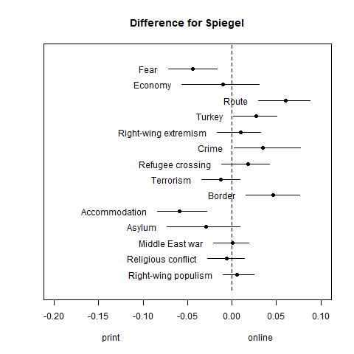 | 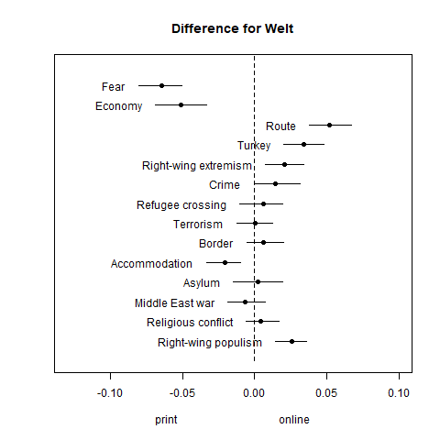 | 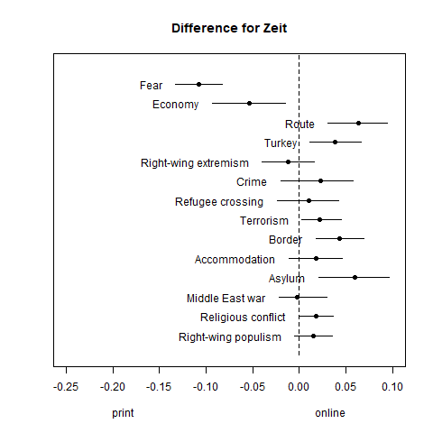

Figure B2: Differences in frame salience between outlets (online and print combined).
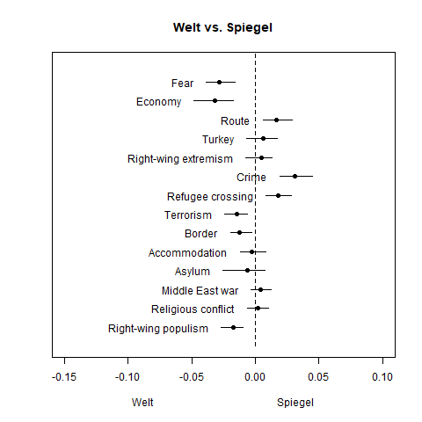 | 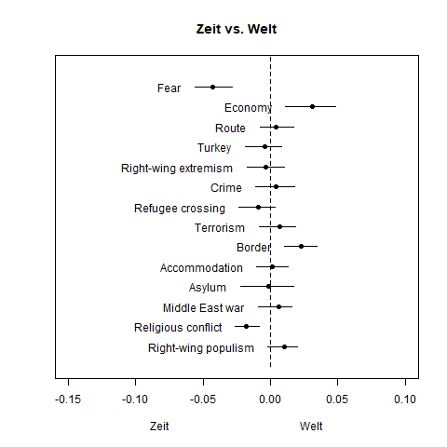 | 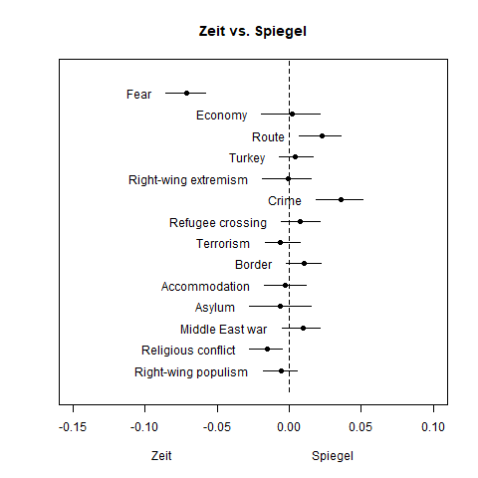

Figure B3: Differences in frame salience between online and print (including duplicates).
