SUPPLEMENTARY DATA

Simultaneous analysis of polar and nonpolar components of cell membrane phospholipids by GC-MS

ªVáclav M. Bierhanzl*, ^{a,b}Miroslava Bursová, ªMartin Ston, ^{a,b}Radomír Čabala, ^{c}Gabriela Seydlová

ªDepartment of Analytical Chemistry, Faculty of Science, Charles University in Prague, Albertov 6, 128 43 Prague 2, Czech Republic

^{b}Institute of Forensic Medicine and Toxicology, First Faculty of Medicine, Charles University in Prague and General University Hospital, U Nemocnice 2, 121 08 Prague 2, Czech Republic

^{c}Department of Genetics and Microbiology, Faculty of Science, Charles University in Prague, Viničná 5, 128 44 Prague 2, Czech Republic

Received 17 September 2015; Revised 10 March 2016; Accepted 11 March 2016

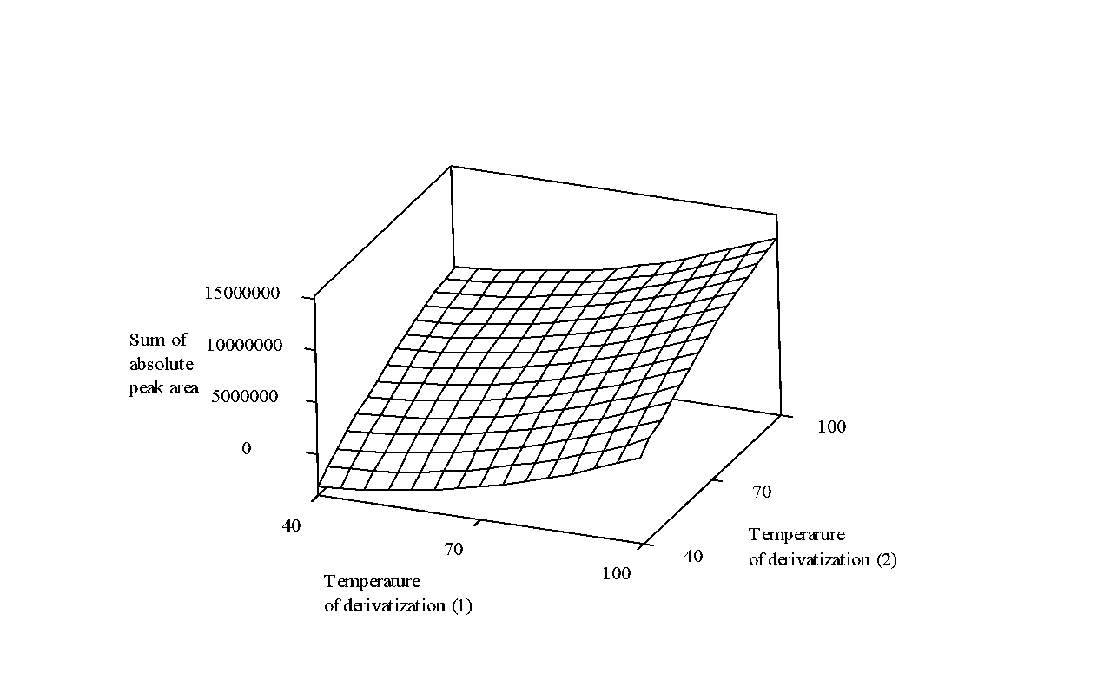
Fig. S1. Response surface plot showing the dependence of the sum of absolute peak areas on the temperature of derivatization (1) and on the temperature of derivatization (2).

Table S1. The values of coefficients of the second-order polynomial equation from the face-centered central composite design.
Parameter | Coefficient
Constant… β₀ | 240600953
Linear
A…Ratio of reaction mixture of HDMS/ACN | -154134774
B... Volume of reaction mixture of HDMS/ACN | -862070
C... Volume of trifluoroacetic acid | -11343017
D... Temperature of derivatization (1) | -8943.42
E... Time of derivatization (1) | 1168342
F... Volume of BSTFA | -515617
G... Temperature of derivatization (2) | 2418097
H... Time of derivatization (2) | 271871
Square
A² | 14281093
B² | 1089.22
C² | 5647313
D² | -3989.08
E² | -42862.6
F² | 994.942
G² | -22872.9
H² | -33832.6
Interaction
CE | 3051.31
CD | -28071.7
DF | -14637.0
DE | 5474.43
GH | 1627.36

*Corresponding author, e-mail: ing.bierhanzl@gmail

