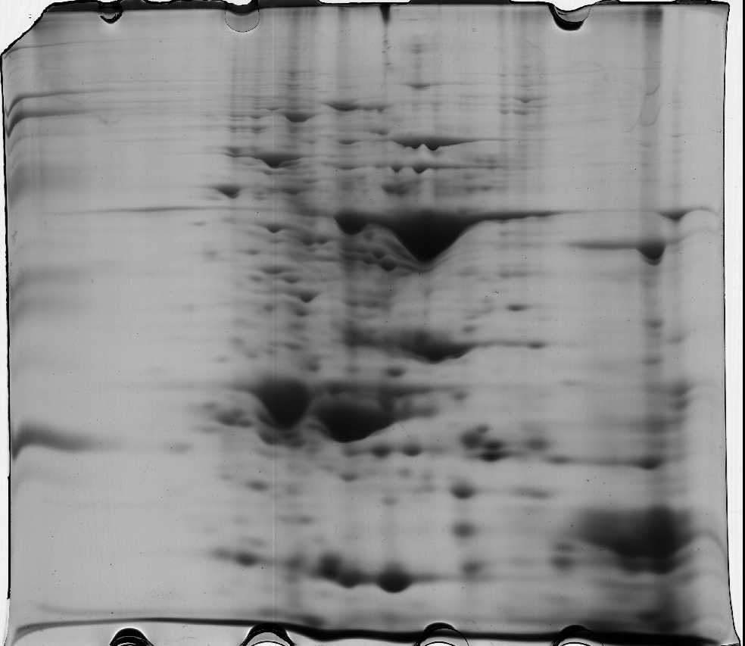
3
10
5
8
Supplemental Figure 1. 2-DE gel image of amaranth grain obtained using IPG strips with pH 3-10.

