SUPPLEMENTARY DATA

Revealing the seed proteome of the health benefitting grain amaranth (Amaranthus cruentus L.)

ªKatarína Klubicová, ^{b}Monika Szabová, ^{c}Ľudovít Škultéty, ªGabrielaLibiaková, ªAndrea Hricová*

ªInstitute of Plant Genetics and Biotechnology, Slovak Academy of Sciences, Akademická 2, P.O. Box 39A, Nitra 95007, Slovakia

^{b}Slovak University of Agriculture in Nitra, Faculty of Biotechnology and Food Sciences, Department of Biochemistry and Biotechnology, Tr. Andreja Hlinku 2, 94976, Nitra, Slovakia

^{c}Institute of Virology, Slovak Academy of Sciences, Dúbravská cesta 9, 84505 Bratislava, Slovakia

Received 3 November 2015; Revised 3 February 2016; Accepted 17 February 2016

Supplementary information
Supplemental Figure 1. 2-DE gel image of amaranth grain obtained using IPG strips with pH 3-10.
Supplemental Table 1. The relative spot volumes (%V) of all 461 quantified proteins presented on 2-DE gels of pH 5-8. The table shows the triplicate analysis data of proteins of Amaranthus cruentus L. grains, average, standard deviation - STDEV.
Supplemental Table 2. The complete list of 249 proteins identified from mature amaranth grains that were classified into 13 functional categories. The table shows: Protein description, Protein name; Accession number, UniProt accession number; Localization, subcellular localization; Spot ID, spot number in gels obtained by ImageMaster analysis; PLGS Score, score provided by Protein Lynx software; Pep/Cov, number of identified peptides/coverage in %; Theor MW/pI, theoretical MW/pI value; Exp MW/pI, experimental MW/pI value.
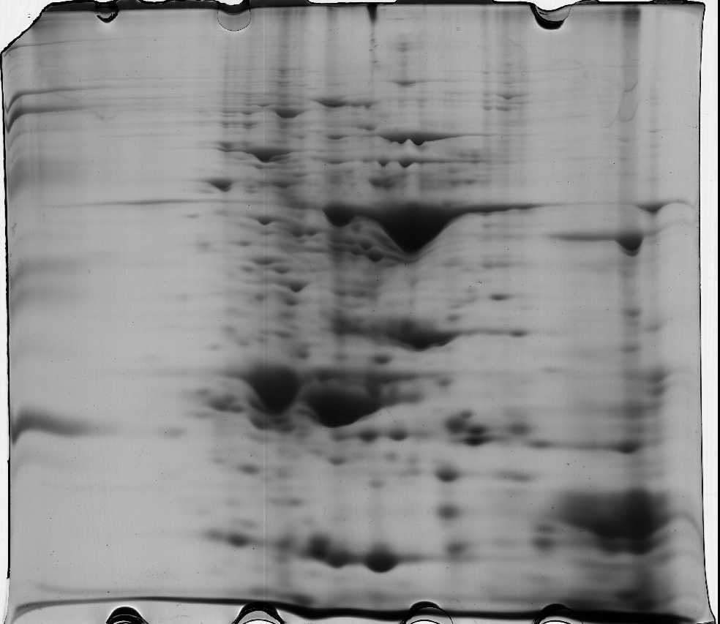
3
10
5
8
Supplemental Figure 1. 2-DE gel image of amaranth grain obtained using IPG strips with pH 3-10.

*Corresponding author, e-mail: andrea.hricova@savba.sk

