SUPPLEMENTARY FILES

Figure 1. SEM photo of adsorbent material (Mag: 5.00 KX)
Figure 2. SEM photo of adsorbent material (Mag: 1.00 KX)
Figure 3. SEM photo of adsorbent material (Mag: 250 X)
Figure 4. Isotherm linear plot of adsorbent material
Figure 5. BET surface area plot of adsorbent material
Figure 6. t plot of adsorbent material

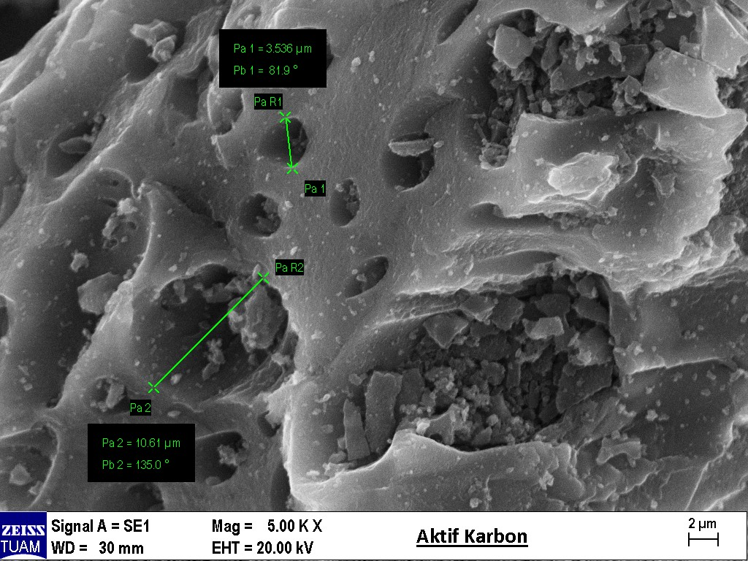
Figure 1. SEM Photo of adsorbent material (Mag: 5.00 KX)

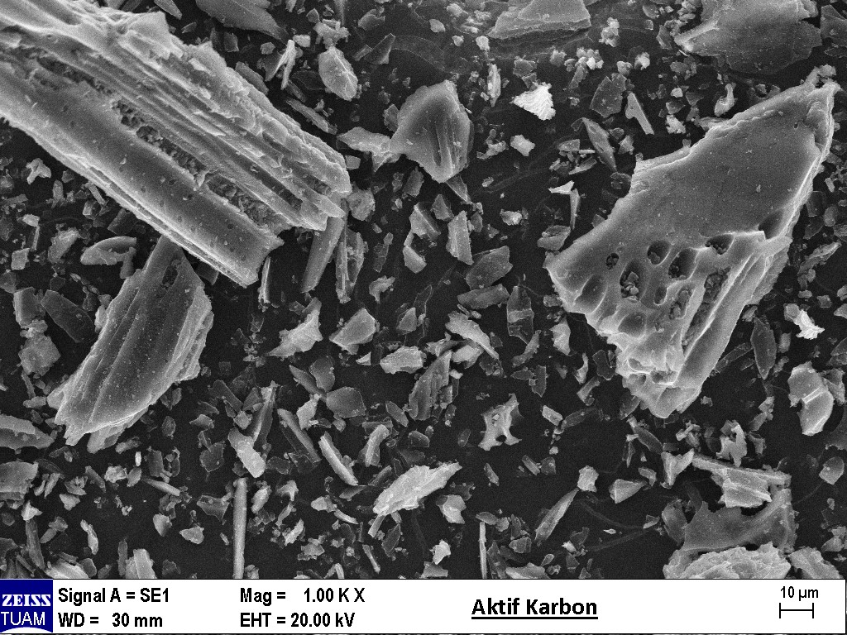
Figure 2. SEM photo of adsorbent material (Mag: 1.00 KX)

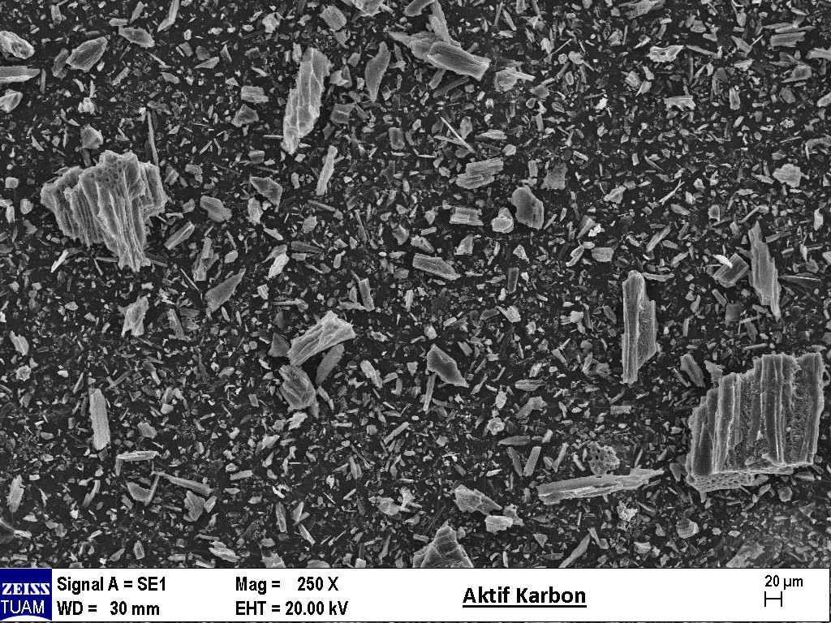
Figure 3. SEM photo of adsorbent material (Mag: 250 X)

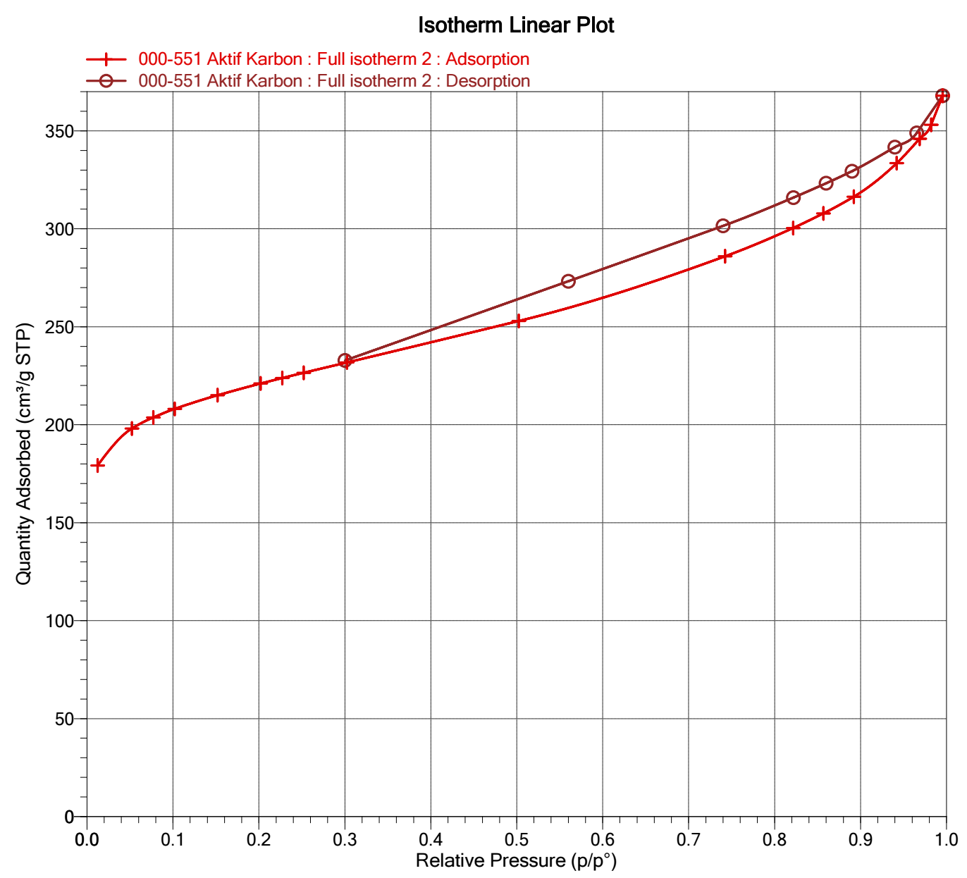
Figure 4. Isotherm linear plot of adsorbent material

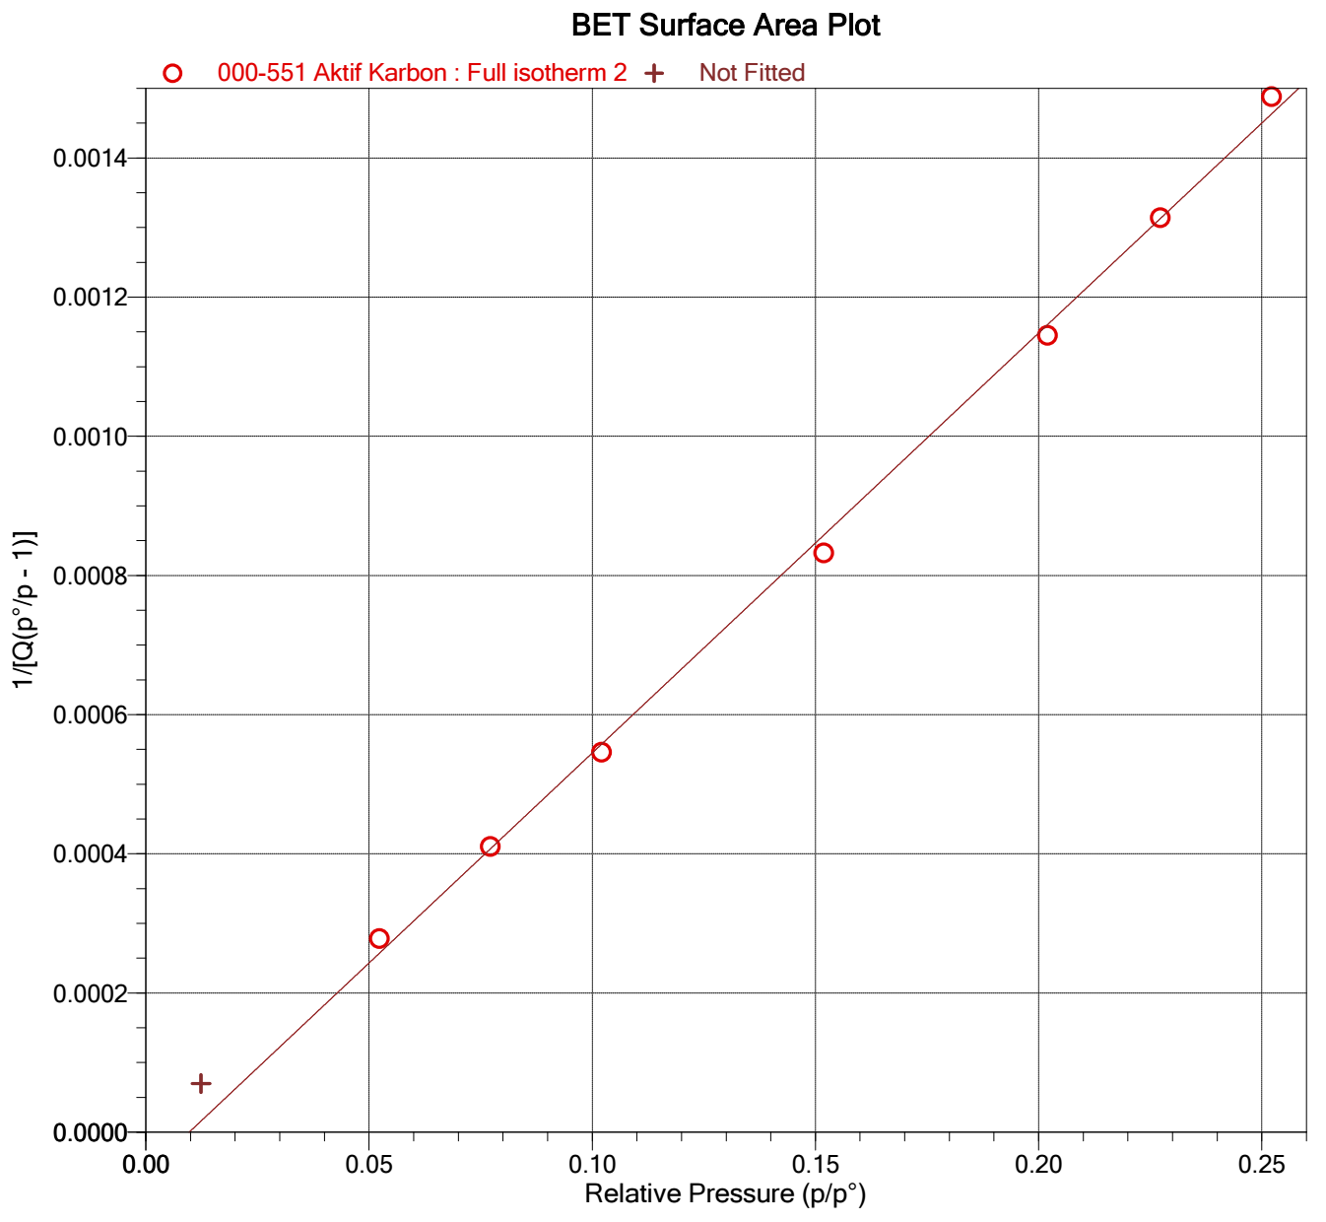
Figure 5. BET surface area plot of adsorbent material
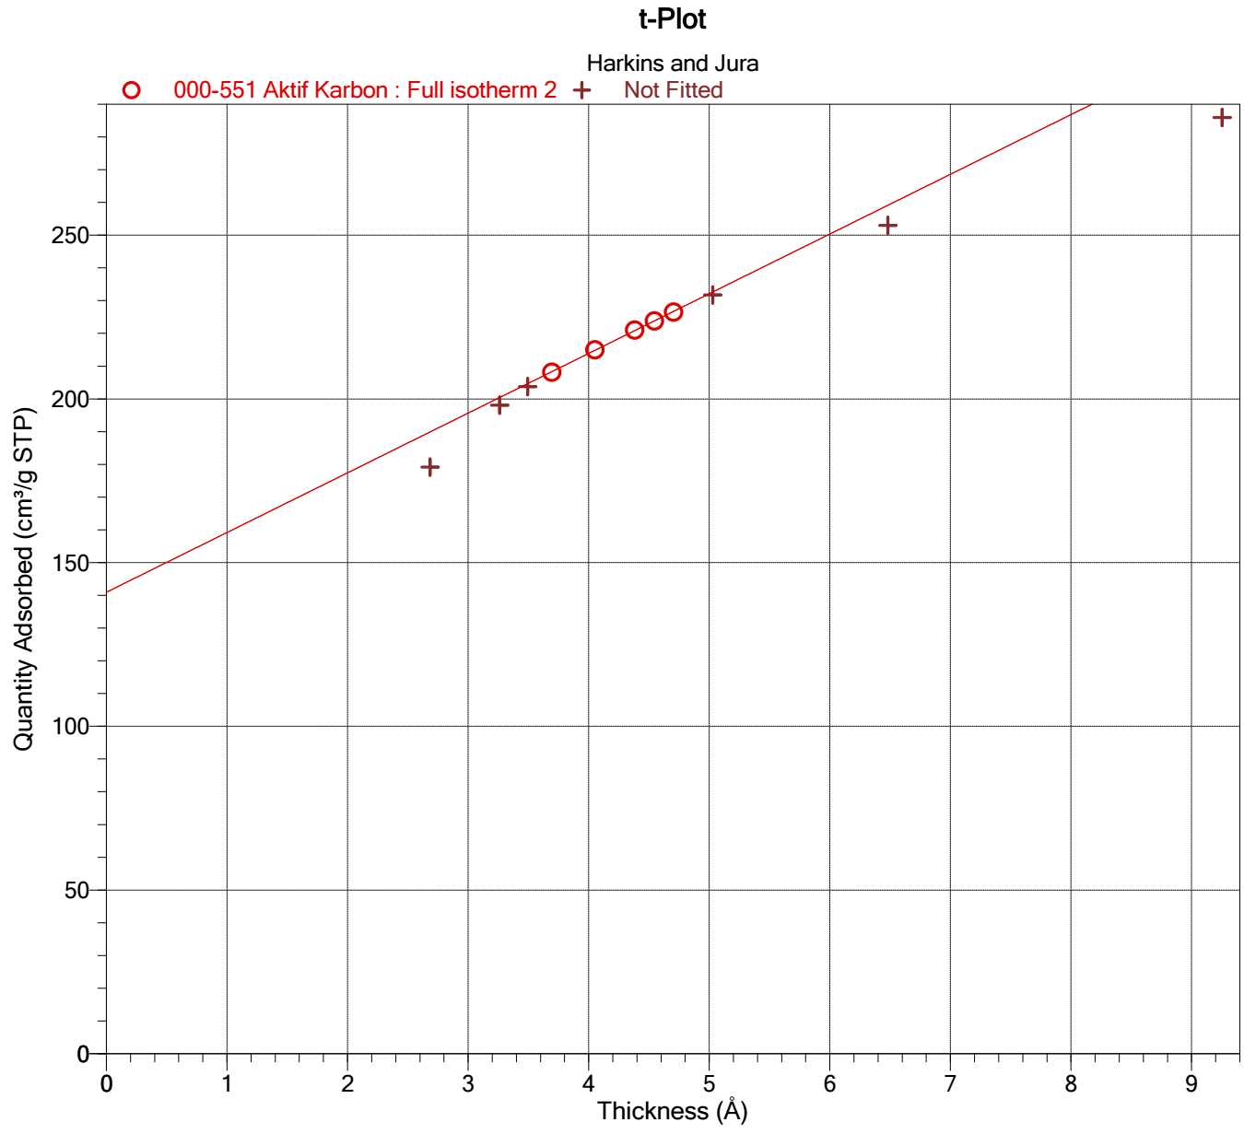
Figure 6. t plot of adsorbent material

