Supplementary material
Serum GFAP as a biomarker for progression in multiple sclerosis: assay comparison and a large reference database of healthy controls
Eline A.J. Willemse, Sofia Sandgren, Pascal Benkert, et al.
Eline A.J. Willemse and Sofia Sandgren share first authorship.

Index Page
Supplementary Table 1 Patient characteristics at initiation of fingolimod
therapy and at index sample 2
Supplementary Table 2 Patient characteristics at initiation of BCDT
and at index sample 3
Supplementary Table 3 Linear regression model to assess a group effect
(HC versus pwMS) of the association between GFAP_{Simoa} and GFAP_{Elecsys} 4
Supplementary Figure 1 Method comparisons of GFAP_{Simoa} and GFAP_{Elescys}
by Passing-Bablok regression analysis in fingolimod and BCDT cohorts 5-6

Supplementary Table 1. Patient characteristics at initiation of fingolimod therapy and at index sample
 | Total
Patients (n) | 414
Sex (women) | 269 (65.0)
Age, years | 40.3 [31.0-47.8]
BMI, kg²/m | 24.1 [21.4-26.9]
EDSS | 2.0 [1.5-3.0]
Disease duration, years | 6.6 [2.0-13.1]
Relapse <1 year before fingolimod initiation | 221 (53.4)
Follow-up duration after initiation of fingolimod, years | 9.1 [7.0-11.0]
PIRA event (n) | 130 (31.4)
Stay on fingolimod  Next DMT*  High efficacy DMT  Orals  Platform  Untreated  Follow-up <6M | 217 (52.4)  113 (27.3)  24 (5.7)  5 (1.2)  47 (11.4)  8 (1.9)
Time to treatment switch, years | 3.2 [1.3-5.9]
Time from treatment initiation to index sample, years | 1.0 [0.9-1.3]
At index sample
GFAP_{Simoa}, ng/L | 75 [54-103]
GFAP_{Elecsys}, ng/L | 38 [27-51]
GFAP_{Simoa} Z score | 0.2 [-0.7-1.0]
GFAP_{Elecsys} Z score | 0.2 [-0.8-1.0]
Variables are expressed as n (%) or median [IQR]. *Patients having interrupted treatment for >6M after fingolimod stop were classified as “untreated”. Eight patients were followed for less than 6M after fingolimod cessation.
High efficacy DMT: alemtuzumab, natalizumab, ocrelizumab, ofatumumab, rituximab. Orals: dimethyl fumarate, teriflunomide, cladribine. Platform: interferon beta-1a and 1b, peginterferon beta-1a, glatiramer acetate.
Abbreviations: BMI, body-mass index; DMT, disease-modifying treatment; EDSS, expanded disability status scale; GFAP, glial fibrillary acidic protein; IQR, interquartile range; M, months; n, number; PIRA, progression independent of relapse activity; y, year.

Supplementary Table 2. Patient characteristics at initiation of BCDT and at index sample
 | Total
Patients (n) | 353
Sex (women) | 232 (65.7)
Age, years | 42.9 [32.9-52.1]
BMI, kg²/m | 24.0 [21.7-27.6]
EDSS | 3.0 [2.0-4.5]
Disease duration, years | 10.6 [4.3-18.6]
Relapse <1 year before BCDT initiation | 134 (38.0)
Follow-up duration after initiation of BCDT, years | 4.8 [3.6-5.7]
PIRA event (n) | 95 (26.9)
Treatment  Ocrelizumab  Rituximab | 251 (71.1)  102 (28.9)
Time from treatment initiation to index sample, years | 1.0 [0.9-1.3]
At index sample
GFAP_{Simoa}, ng/L | 84.7 [59.5-120.8]
GFAP_{Elecsys}, ng/L | 42.1 [30.4-61.5]
GFAP_{Simoa} Z score | 0.3 [-0.6-1.2]
GFAP_{Elecsys} Z score | 0.4 [-0.6-1.2]
Variables are expressed as n (%) or median [IQR].
Abbreviations: BCDT, B-cell depleting therapy; BMI, body-mass index; EDSS, expanded disability status scale; GFAP, glial fibrillary acidic protein; IQR, interquartile range; PIRA, progression independent of relapse activity; y, year.

Supplementary Table 3. Linear regression model to assess a group effect (HC versus pwMS) of the association between GFAP_{Simoa} and GFAP_{Elecsys}
 | Estimate | 95% CI | p value
Log2(GFAP_{Simoa}) | 1.846 | 1.747-1.950 | <0.0001
Healthy controls versus pwMS | 1.340 | 0.871-2.062 | 0.1823
Interaction log2(GFAP_{Simoa}) * HC versus pwMS | 0.946 | 0.885-1.011 | 0.1030
Legend: The dependent variable in the model is log-transformed GFAP_{Elecsys}. Estimates were back-transformed and are presented as percentage changes. The interaction term was not significant, indicating no difference in the association between GFAP_{Simoa} and GFAP_{Elecsys}.
Abbreviations: CI, confidence interval; GFAP, glial fibrillary acidic protein; HC, helathy controls; pwMS, people with multiple sclerosis.

Supplementary Figure 1. Method comparisons of GFAP_{Simoa} and GFAP_{Elescys} by Passing-Bablok regression analysis in fingolimod and BCDT cohorts
A
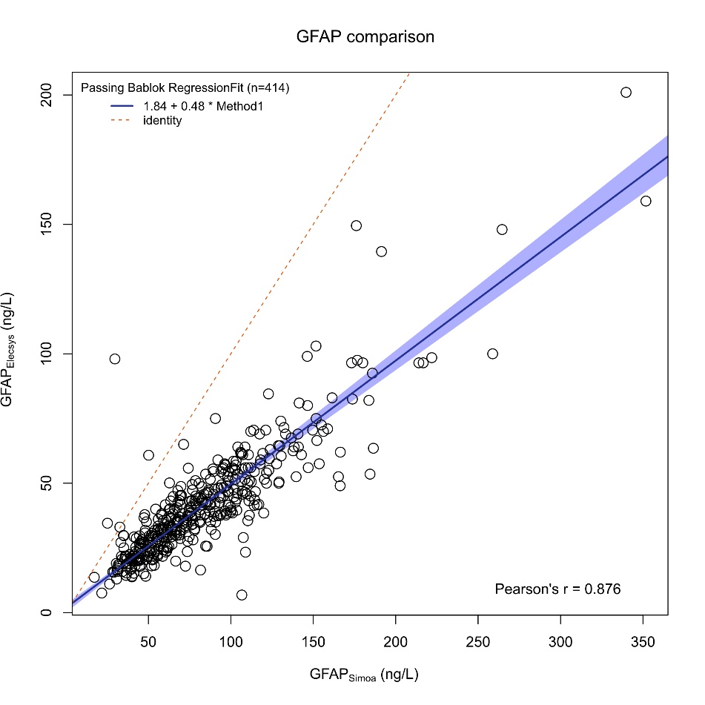
B
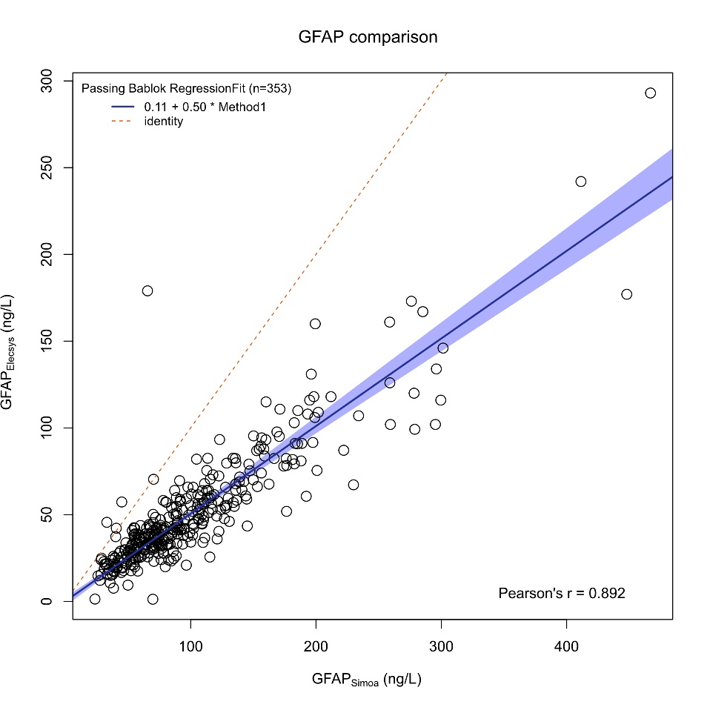
Legend: Scatter plots show individual serum GFAP concentrations measured using Simoa (x-axis) and Elecsys (y-axis) for the (A) fingolimod (n = 414) and (B) BCDT (n = 353) cohorts. Each plot includes the Passing-Bablok regression fit (solid black line) with 95% CIs (shaded area), and the line of identity (y = x, dashed line), indicating perfect agreement. The Pearson correlation coefficient (r) reflects the strength of the linear relationship between the two assays.
The conversion formula for the fingolimod cohort was: GFAP_{Elecsys} = 1.841 [95% CI 0.111 – 3.385] + 0.478 [0.454 – 0.504] * GFAP_{Simoa}, and for the BCDT cohort: GFAP_{Elecsys} = 0.113 [95% CI -2.552 – 2.709] + 0.505 [0.474 – 0.541] * GFAP_{Simoa}.
Abbreviations: BCDT, B-cell depleting therapy; CI, confidence interval; GFAP, glial fibrillary acidic protein; pwMS, people with multiple sclerosis.

